Impact of Digital Marketing on Customer Buying Intention: A Glimpse of Existing Literature
BBA (HONS.)



SHEHLIZA JOHN F17BBAM090
SUPERVISOR: Dr. ATIA ALAM

DEPARTMENT OF BUSINESS STUDIES KINNAIRD COLLEGE FOR WOMEN,
LAHORE, PAKISTAN

2021

Impact of Digital Marketing on Customer Buying Intention: A Glimpse of Existing Literature



A REVIEW PAPER SUBMITTED TO KINNAIRD COLLEGE FOR WOMEN IN FULFILLMENT OF THE REQUIREMENTS FOR THE DEGREE OF

BACHELORS IN
BUSINESS ADMINISTRATION

SHEHLIZA JOHN

DEPARTMENT OF BUSINESS ADMINISTRATION KINNAIRD COLLEGE FOR WOMEN, LAHORE

2021

DISSERTATION APPROVAL KINNAIRD COLLEGE FOR WOMEN


Date:
I hereby recommend that the review paper prepared under my supervision by Shehliza John(F17BBAM090)

Entitled
Title: “Impact of Digital Marketing on Customer Buying Intention: A Glimpse of Existing Literature ” be accepted in partial fulfillment of the requirements for the degree of

BACHELORS (Honors) IN
BUSINESS ADMINISTRATION


In Charge of Dissertation



Head of Department

Dissertation Recommendation concurred in
1. _
- _ Committee for the
- _ Final Examination 4. _

RESEARCH COMPLETION CERTIFICATE

It is certified that Ms. Shehliza John of BBA (session 2017-2021), Department Administration has carried out research work entitled “Impact of Digital Marketing on Customer Buying Intention: A Glimpse of Existing Literature ” under my supervision.

It is assured that the research work is original and has not yet been published anywhere else.

Signature of Supervisor Designation

(All suggested changes have been made)

Dated: 15/06/2023

Head of Department/ Co-Supervisor Dr. Urusa Fahim

ANTI – PLAGIARISM DECLARATION

I certify that this is my own research work. The work has not, in whole or in part, been presented elsewhere for assessment. Where material has been used from other sources, it has been properly acknowledged. The similarity index of the research report is 16%. If this statement is untrue and I am found guilty of plagiarism, the punitive actions against me should be taken as per Kinnaird Anti Plagiarism Policy.

SHEHLIZA JOHN F17BBAM090 
Program: bachelor’s in business administration

Signature of Supervisor

Signature of HOD

ACKNOWLEDGEMENT

We are thankful to God who has given me the motivation and strength to do my research project. Apart from my own efforts there are many other people whose contribution means a lot. I would like to acknowledge their unwavering support extended towards me throughout this journey.
First of all, I would like to express my acknowledgment to the Principal of Kinnaird College, Dr. Rukhsana David and Head of Department, Ms. Aroosa for providing us the opportunity to do the research project.
I would also like to acknowledge my supervisor Ms. Atia Alam for her support, guidance and motivation.
Last, but not least, I would like to thank my parents, and friends for encouraging me throughout.

SHEHLIZA JOHN

Impact of Digital Marketing on Customer Buying Intention: A Glimpse of Existing Literature

Table of Contents
RESEARCH COMPLETION CERTIFICATE 4
ANTI – PLAGIARISM DECLARATION 5
ACKNOWLEDGEMENT 6
List of Tables 8
Abstract 10
Introduction 10
Literature Review 11
Research Questions: 13
Methodology 13
Scope and Objectives: 14
Filtering Criteria: 14
Result Analysis 27
Descriptive Analysis 36
Literature Classification 41
Conclusion 48
AUTHOR’S BIOGRAPHY 49

 | List of Tables
Table | Title | Page
1 | Review Protocols | 18
2 | Quality Assessment Criteria | 19
3 | Data Presentation | 19
4 | Data collection Method | 20
5 | Citation Wise Descriptive Analysis | 23

 | List of Figures
Figure | Title | Page
1 | Year Wise Descriptive Analysis | 23
2 | Region/Continent Wise Descriptive Analysis | 24
3 | Developed and Developing Countries Descriptive Analysis | 25
4 | Measure of Performance | 27
5 | Proxies for consumer buying intention | 28

Impact of Digital Marketing on Customer Buying Intention: A Glimpse of Existing Literature

Abstract:
Purpose: This systematic literature review examines the overall impact of digital marketing on consumer buying intention.
Methodology: The review analyzes 30 research papers that investigate the relationship between digital marketing and consumer behavior.
Findings: The findings suggest that digital marketing positively influences consumer buying intention, as it allows for better targeting, personalization, and engagement with customers. The review also identifies key factors that moderate the impact of digital marketing on consumer behavior, such as brand equity, perceived value, and customer relationship management.
Originality: Unlike a traditional review paper this study classifies sample articles based on several parameters and depicts a graphical presentation of the findings to cover research gaps, avenues, evolving themes.

Keywords: Digital marketing, Consumer behavior, Purchase intention, Social media marketing, Brand equity, Perceived value, Customer relationship management.
Paper type: Systematic Literature review

Introduction:
Social media has become an integral part of modern life and has revolutionized the way people communicate, interact, and share information. With the rise of social media platforms like Facebook, Instagram, Twitter, and LinkedIn, businesses have found a new way to connect with their target audience and promote their products and services. Social media marketing has become a popular strategy for businesses to engage with their customers, increase brand awareness, and drive sales. The increasing use of social media by consumers has also made it an essential part of their decision-making process when it comes to purchasing products and services. Digital marketing has become an essential tool for businesses to engage with their customers. With the increasing use of digital platforms, such as social media, search engines, and mobile apps, companies can target their audience more effectively and provide personalized experiences that meet their needs and preferences. As a result, there has been growing interest in understanding the impact of digital marketing on consumer behavior, particularly on consumer buying intention.

This systematic literature review aims to provide a comprehensive analysis of the impact of digital marketing on consumer buying intention. The review synthesizes the findings of 30 research papers that investigate this relationship and identifies key factors that moderate the impact of digital marketing on consumer behavior.
The review is organized as follows: first, we provide an overview of digital marketing and its importance for businesses. Then, we discuss the theoretical frameworks that underpin the relationship between digital marketing and consumer behavior. Finally, we present the findings of the review and discuss the implications for future research and practice.
Over the past decade, several studies have been conducted to examine the impact of social media marketing on consumer buying intentions. These studies have explored various factors that influence consumer behavior on social media platforms, including the type of content, engagement levels, and social influence. For instance, a study by Wang and Zhang (2018) found that social media engagement positively influences consumer buying intentions. Similarly, Alalwan, Rana, Dwivedi, and Algharabat (2017) found that social media trust positively influences consumer intentions to purchase from online vendors. Studies have examined the relationship between digital marketing and consumer behavior, with varying results. Al-azzam and Al-Mizeed (2021) found that digital marketing has a significant positive effect on purchasing decisions in Jordan. Similarly, Ramesh and Vidhya (2019) found that digital marketing positively influences online consumer buying intention. Other studies have also reported positive effects of digital marketing on consumer behavior, including Waheed et al. (2017), Astoriano et al. (2022), and Nizar and Janathanan (2018).
However, the impact of digital marketing on consumer behavior is not universal and can be influenced by several factors. For instance, Husnain and Toor (2017) found that the effect of social network marketing on consumer purchase intention in Pakistan is mediated by consumer engagement. Similarly, Khan et al. (2020) found that brand equity and perceived value mediate the impact of digital marketing on online purchase intention. Dastane (2020) also found that customer relationship management mediates the effect of digital marketing on online purchase intention.

While these studies provide useful insights into the impact of social media marketing on consumer behavior, there is still a need for a systematic literature review that brings together all the available evidence on this topic. This review aims to synthesize and critically evaluate the existing literature on the impact of social media marketing on consumer buying intentions. Specifically, it seeks to answer the following research questions:

Research Questions:
- What is the impact of social media marketing on consumer buying intentions?
- What factors influence the impact of social media marketing on consumer buying intentions?
- What are the limitations of the existing literature, and what are the implications for future research?
To answer these questions, this review will follow a systematic approach to identify and analyze relevant studies. The next part of this introduction will provide an overview of the methodology used in this review. To answer these questions, a systematic literature review methodology, will be followed, that includes five steps: determination of scope and objectives of the review, search strategy, applying filtering criteria, quality assessment procedure, and data analysis. A search using databases such as Google Scholar will be conducted and will apply inclusion and exclusion criteria to select relevant studies for analysis. Finally, this paper will synthesize the evidence and provide recommendations for future research in this area.

Literature Review:
This systematic literature review aims to provide a comprehensive analysis of the impact of digital marketing on consumer buying intention. The review synthesizes the findings of 30 research papers that investigate this relationship and identifies key factors that moderate the impact of digital marketing on consumer behavior.
The study follows a systematic approach that includes five steps: determination of scope and objectives of the review, search strategy, applying filtering criteria, quality assessment procedure, and data analysis.
The literature suggests that digital marketing positively influences consumer buying intention, as it allows for better targeting, personalization, and engagement with customers. The findings indicate that social media engagement positively influences consumer buying intentions and social media trust positively influences consumer intentions to purchase from online vendors. Similarly, the studies report positive effects of digital marketing on consumer behavior, including online consumer buying intention, purchasing decisions, and online purchase intention.
However, the impact of digital marketing on consumer behavior is not universal and can be influenced by several factors. Studies report that the effect of social network marketing on consumer purchase intention is mediated by consumer engagement, and brand equity and perceived value mediate the impact of digital

marketing on online purchase intention. Customer relationship management also mediates the effect of digital marketing on online purchase intention.
The review concludes that digital marketing has a significant impact on consumer behavior, but its effect can be moderated by various factors such as brand equity, perceived value, and customer relationship management. The study also identifies research gaps and avenues for future research, such as examining the impact of digital marketing on different consumer segments and exploring the effectiveness of various digital marketing channels.
Overall, this study provides valuable insights into the impact of digital marketing on consumer behavior and highlights the need for businesses to use digital marketing strategies that are tailored to their target audience and take into account the moderating factors that influence its effectiveness.

Methodology:
This research study aims to investigate the impact of digital marketing on consumer buying intention through a systematic literature review. Systematic literature review is a methodological study that involves database searches to retrieve results of research with the main goal of providing an objective and theoretical discussion of a specific topic or theme. This type of review can be divided into two main types: systematic and narrative reviews of the literature Rother (2007). For this research, this paper will conduct a systematic literature review to determine the objectives and goals of the study.
According to experts in the field such as Roberts and Petticrew (2006), a systematic literature review is an efficient tool for summarizing a large amount of information and answering research questions. It is used to highlight areas of uncertainty or identify gaps in the literature where little or no research has been conducted. A systematic literature review may involve quantitative or qualitative analysis of the literature or be highly formal Glasziou, et al, (2003). Previous studies have shown that a systematic literature review is an effective tool to critically examine the previous literature regarding a specific research question.
The methodology for this study will follow a five-step process for a systematic literature review, as applied by Opoku, et al (2015). The five steps include:

  - Determination of scope and objectives of systematic literature review.
  - Search strategy (determination of review protocols)
  - Applying filtering criteria.
  - Quality assessment procedure.
  - Data analysis.

Scope and Objectives:
The scope of this study is to investigate the impact of digital marketing on consumer buying intention. The objective of the research is to analyze the existing literature on digital marketing and its effects on consumer behavior, including the factors that influence consumer buying intention in the context of digital marketing. Search Strategy:
The phrase "systematic review" refers to an unbiased, replicable, and validated methodology used to review literature, from formulating the question to delivering the results. The term "replicable" means that two different research groups conducting the same research using the same methodology would reach the same conclusion.
However, Google Scholar is known for frequently changing its algorithms; while it used to change them once a month, it now updates more frequently and without a set schedule. In 2012 alone, there were at least 23 major changes and approximately 600 minor changes, indicating that a person could obtain different results with the same search at different times. Additionally, Google personalizes search results based on a user's recent browsing history, resulting in tailored results that may not reflect the entire body of literature.
Moreover, the time period for which systematic literature review is to be done is based on the period in which the impact of social media on consumer buying intention was observed.
This study has used both systematic and empirical studies.
To extract the data the Boolean operator “AND” is use in order to narrow down the
Literature. The keywords used in the Google scholar search was based on “Impact”, the word “Digital Marketing” The total of 60 articles were extracted by using
the related terms (extracted and retrieved on 7 February 2021). However, another keyword
“Customer Buying Intention” with Boolean operation “AND” was added in the search to restrict articles that is only related to and the total of 30 articles was extracted (as on 7 February 2021).
Another possibility is that instead of “consumer buying intention” the keyword “customer buying intention” is used by researchers, so another search was conducted with keywords “Impact” AND “Digital marketing” AND “Consumer Buying intention” and as a result a total of 60 articles were extracted and retrieved (as on 7 February 2021). Finally, a total of 30 articles were extracted which will again be narrowed down by filtering criteria.

Filtering Criteria:
The systematic literature review will be based on the determination of the scope and the systematic estimation of the impact of digital marketing on consumer buying intention. Based on this factor, only those articles will be selected that contain adequate information regarding the systematic estimation of the current topic. For this procedure, the articles and papers should undergo an inclusion and exclusion process.

Inclusion Criteria:
Articles that were included had specific features including:
- The articles should provide relevant and sufficient information related to digital marketing and its impact on consumer buying intention.

- The articles must be taken from authentic sources of data collection.

- Studies having no citation and access were not included.

Exclusion Criteria:
The exclusion criteria included:

- Articles unrelated to the topic will not be considered at all

- Articles that were in languages other than English are not included.

- Journals or articles that are not cited will not be included.

- Non-research papers that were only based on theory were excluded from the current study.

- Any un-downloadable articles should not be included.

After applying the inclusion and exclusion criteria, a total of 60 articles were retrieved and 30 were selected for analysis as shown in Table1.

Table 1: Review Protocols
 |  |  |  |  | buying  intention” | criteria 30  were selected
15  February, 2021 | Digital Market | Google Scholar | 2008-  2020 | Boolean Operation for Keywords | “Impact” AND “Digital Marketing” AND  “Customer buying Intention” | 30 articles were retrieved and after applying filtering criteria 15 were selected

Date | Industry | Search  Engine | Time  Period | Term Search | Keywords | Retrieved  Articles
7 February,  2021 | Digital Market | Google scholar J store | 2008-  2021 | Boolean Operation for Keywords | “Impact” AND “Digital Marketing” AND  “Customer | 60 articles were retrieved and after applying  filtering

Quality Assessment:
The quality assessment of the literature review will be based on two parameters; one on the publishing sources and other on content relevancy. The selected articles for the systematic literature review will be related to journals, therefore, their quality is considered satisfactory from a publishing point of view. The articles and journals which would hold the content related to digital marketing would be excluded from the study but should be included in the filtering criteria to examine the authenticity of each article. According to the quality assessment criteria 30 articles that were selected for conducting analysis on the impact of Digital Marketing on consumer buying intention.

No | Criteria
1 | The papers focus on Digital Marketing and its impact on customer buying intention.

Table 2: Quality Assessment Criterion

2 | Objectives have the relative theme of the study.
3 | The subject is studied in relation to the impact of digital marketing on customer  Buying intention.
4 | The study is related to exact research or primary study.

The above -mentioned criteria proved the basis on which the qualities of the extracted articles have been analyzed. The papers selected are directly or indirectly related to Impact of social media marketing on Consumer buying Intentions. They have their objectives stated very clearly which helps in easy understanding. Also, studies discuss different aspects of social media marketing as well as its impact on Consumer buying intentions.

Data reporting and analysis:
The articles that have been referred for this research would be carried forward and be scrutinized by the researcher to explore and suggest reviews for Digital Marketing for Professionals in Pakistan. All the extracts of the research study will determine the objectives of the systematic review which is to prospect the impact of Digital Marketing on customer buying behavior.
For Table no.3, The number of articles that were extracted is represented in column one, the authors of the articles that were chosen are listed in column two, and the objectives of shortlisted articles to take into account to monitor the impact of digital marketing in the third column. The nations where the effect of Digital Marketing is collected are in both parameters of positive and negative are listed in column four.
Column five indicates the time frame for the research, and column six is the number of times an article has been cited. The final two columns seven and eight show the duration of each article's research and from which country the relevant articles were published. The majority of the studies were longitudinal analyses using panel data, as can be seen from the material in the table.

Table3: Data Presentation
S.No | Author | Objective | Methodology | Performance Measure | Cited  by | Results | Country

1 | Abdel Fattah Al- Azzam, Khaled Al- mizeed  (2021) | significance | items for each | Positive | 25 | media and mobile has a Positive effect on purchasing intention through digital marketing | Jordan
1 | Abdel Fattah Al- Azzam, Khaled Al- mizeed  (2021) | and positive effect of online marketing, Social media marketing, and Mobile  Marketing on | Variable by distributing 300 online questionnaires from three universities in Jordan.  Descriptive
1 | Abdel Fattah Al- Azzam, Khaled Al- mizeed  (2021) | Purchase | Statistics and
1 | Abdel Fattah Al- Azzam, Khaled Al- mizeed  (2021) | Decision | Exploratory
1 | Abdel Fattah Al- Azzam, Khaled Al- mizeed  (2021) |  | Factor Analysis
1 | Abdel Fattah Al- Azzam, Khaled Al- mizeed  (2021) |  | were selected for

 |  |  | Email Marketing, Online Advertising, Social Media Marketing and Mobile Marketing as independent and Purchase intentions as Dependent Variable.
2 | Ramesh, Vishay, B  (2019) | To define consumer behavior, consumer perception suggest ideas, measure the effectiveness and preferred channel of Digital Marketing. | Quantitative Research having 10 items for Effectiveness of Digital Marketing, Consumer Perception on Digital marketing as Independent Variable and Consumer Online Buying Behavior as Dependent Variable. Data Analysis was run for 100 consumers. | Negative | 15 | A somewhat positive effect of consumer perception and significant association of digital marketing on consumer buying intention | India

3 | Abdul Waheed, Jianhua Yang, Kalsoom Rafique  (2017) | To find the effect of E- marketing on consumer buying intention. | Quantitative research by taking e-marketing ad independent variable and online consumer buying intention as dependent variable. A random distribution of 800  questionnaire has been analyzed for 5 items per variable. | Positive | 8 | E-marketing is co-related positively with consumer buying intention. | China
4 | Astoriano, Lance Carlo B; Gerona, Justin Albert D; Marzan, Juan Carlos R.  (2022) | to figure out the effect of social media, email marketing and customer engagement on Purchase intention | Quantitative Research has done by using 5 items for Social Media, 4 items for Email Marketing, 2 for Customer engagement as independent variable and 4 items for Purchase Intention as Dependent Variable. | positive | 1 | Email, Social media and customer engagement has a significant impact on Customer buying intention. | Philippine

5 | Naseeth Ahamad Nizar, Christhankar Janathanam  (2018) | To define social media marketing, does social media marketing help consumers to choose right product, which best place on social media for organization is to gain more consumers, and is effective and efficient to use social media marketing. | Deductive approach using both Qualitative and Quantitative research methods. Depend variable was Consumer purchase behavior and independent variables were; cost efficient, consumer trust, information satisfaction, and internet shopping experience. 4 Items for each variable and 4 interviews was taken for data analysis. | Negative | 12 | Positive significant was identified in between Consumer purchase behavior against cost efficient, consumer trust, information satisfaction and internet shopping experience. | Sri Lanka
6 | Areeba Toor, Mudassir, Talha Hussain  (2017) | To identify the correlation between social network marketing and consumer purchase intention by  keeping | A quantitative approach has been taken for Consumer purchase intention as a dependent, social network marketing, and  consumer | Positive | 167 | The study identifies a significant relationship between social network marketing and consumer | Pakistan
 |  |  | consumer engagement as a mediator. | engagement as the independent variable. Overall 22 items were used to conduct a survey. | purchase intention.
7 |  | Amira M. Omar, Nermine Atteya  (2020) | To find the effect of digital marketing on the customer buying decision process. | Quantitative Research has been used by taking Digital Marketing channels, email marketing, mobile marketing, and retargeting as independent and Consumer buying decision process as dependent variables. A total of 16 items were selected for the questionnaire. | Negative | 25 | Mobile marketing has negative, retargeting, email marketing, and targeting have a high impact on the consumer purchase decision. | Egypt

8 | K. R. Mahalaxmi,  P. Ranjith  (2016) | To analyze awareness of digital marketing and the kind of products that are bought by digital channels. | The study used both qualitative and quantitative research by taking 50 samples and 4 items for each variable. The Independent variable was digital and the dependent variable was customer buying decisions for this research. | positive | 62 | The study reveals that digital marketing is not a change opinion of customers towards purchasing a product through digital marketing but has scope in the future | India
9 | Abdus Saboor Khan, Muhammad Bilal, Muhammad Saif, Muhammad Shehzad  (2020) | To study the impact of digital marketing and brand equity on online purchase intention. | The deductive approach uses digital marketing as independent, purchase intention as a dependent, and brand equity as a mediator.  The questionnaire retains 4 items for each variable. | Negative | 3 | Results show that digital marketing has a significant impact on online purchase intention. | Pakistan

10 | Omkar Dastane  (2020) | To identify the impact of digital marketing on purchase intention and the impact of CRM on purchase intention. | Research has been done by using a quantitative approach having digital marketing as independent, purchase intention as a dependent, and CRM as mediator. While having 15 items distributed in the questionnaire for the survey. | Positive | 26 | On basis of data analysis digital marketing has a positive impact on the purchase intention of customers. | Malaysia
11 | Ahmad Bin Yamin  (2017) | To identify factors that influence consumer psychology, the impact of digital media on the sample, and comparison of social media marketing with medium of brand communicatio n. | Study contains qualitative research using primary and secondary data. The dependent variables were the tools of digital Marketing while having consumers concerns as independent variable. | positive | 36 | Through Research it is said that tool of social media marketing play significant role in reaching consumer closely. | Bangladesh

12 | Heri Eriangga Denok Sunarsi, Angga Pratama, Nurjaya, Nika Sintesa, Ida Hindarsah, Juhaeri Kasamd  (2021) | The objective of the study is to analyze the impact of digital marketing and social media on purchase intention. | The study has used Descriptive quantitative research by having Purchase decision as the dependent variable. Social media marketing, digital marketing, and e-marketing are used as independent variables having 5 items for each variable. | Negative | 42 | Social media marketing, digital marketing, and e- marketing have a positive effect on purchase intentions. | Indonesia
13 | Alok Kumar Pal, Dr.  Bharti Shukla  (2020) | To discriminate the variables, scope of Digital Marketing, and change in purchasing conduct on advanced advertising. | A deductive approach has been used for this study using primary and secondary data. The population of the study was 320 questionnaires.  Having 19 items on consumer purchase behavior. | positive | 3 | The study reveals that digital Marketing has a positive relationship with consumers to purchase online. | India

14 | Sanya Shahid, Jawaid A. Qureshi  (20220 | The objective of the study is to understand the role of digital marketing and its effect on consumer empowerment in Pakistan. | A semi- systematic literature review has been used in the methodology The dependent variables Digital marketing and independent variables were gaps, techniques, and effect on consumer empowerment. | Negative | 1 | The results show that digital marketing influences the beliefs, attitudes, and behaviors of consumers. | Pakistan
15 | Mahmoud Alghizzawi  (2019) | To identify the impact of social media platforms, smart phones and e WOM on consumer behavior. | Qualitative research has been used the study of dependent variables; social media platforms, smart phones and eWOM on independent variable consumer behavior. | Negative | 32 | Digital marketing as positive influence on consumer behavior with the perspective of tourism. | Malaysia
16 | Reddy, Gershwin  (2017) | To identify and evaluate the impact of Nike in South Africa and digital marketing  according to | The study has selected hybrid research using both exploratory and descriptive approaches. 10 semi- structure  interviews have | Positive | 16 | Research approves that digital marketing can potentially influence consumer  decisions for | South Africa
 |  | retailers' perspective on consumer decision making. | been taken for the exploratory research. And for the descriptive approach, 16 items have been used while having digital marketing as dependent and consumer decision as an independent variable. |  |  | Nike in South Africa.
17 | Sabyasachi Dasgupta, Priya Grover  (2019) | The objective of this research is to analyze, study and find the impact of digital marketing on the consumer decision journey. | A simple random sampling technique is used for quantitative research, having a sample size of 200 respondents. The independent variable used for this study are; Social media, sales, free coupons, targeting and retargeting, and mobile marketing. And dependent variables are content  marketing, | Positive | 206 | It is concluded that social media marketing has powerful tools for the marketers of apparel brands, new fashion, and online trending brands. | London

 |  |  | trending fashion, online payment options, and experience with apparel or site.
18 | Mary Maina  (2021) | This study aims to find out the influence of digital marketing on purchases as a consumer behavior among youth in Kenya. | The research includes both quantitative and qualitative; conducting interviews and surveys for 50 respondents. The independent variable is digital marketing and Facebook advertising depending on Consumer Purchase behavior, consumer attitude, consumer beliefs, and consumer repetitive buying. | Positive | 1 | The researchers found that digital marketing is important for promoting an online business, attracting customers, and consumer purchase behavior. | Kenya

19 | Mamtaj Akter, Niagr Sultana  (2020) | This study focuses the standpoint of digital marketing communicatio n of branded cosmetics in Bangladeshi customers. | Quantitative research has been used to conduct the primary data collected from Dhaka (Capital of Bangladesh) through online using convenient sampling and the sample size was 665. Chi-square along with the hypothesis test was applied. | Positive | 13 | This study showed that customers have positive feelings toward digital platforms during this pandemic (COVID-19). | Bangladesh
20 | Schutte, F., & Chauke,T.  (2022) | The objective of this study is to understand the impact of digital marketing on consumers to maximize value creation by focusing on millennial consumers. | A simple random sampling technique is used for quantitative research, having a sample size of 200 respondents. The independent variable used for this study are; Social media, sales, free coupons, targeting and retargeting, and mobile marketing. And dependent  variables are | Negative | 1 | The result reveals that millennial consumers found digital marketing useful for their buying intentions. | South Africa

 |  |  | content marketing, trending fashion, online payment options, and experience with apparel or site.
21 | T. Siva Kumar, S Chandra Sekhar  (2019) | The study aims to provide a theoretical background of online shopping, internet shopping, and consumer behavior. And to examine consumers' attitudes towards online shopping. | The study is based on descriptive research using secondary and primary data using the Likert scale for questionnaires. The variables for this research are; online shopping, consumer attitude, and e- marketing. | Positive | 3 | The present study shows that the influence of the digital channels not supporting in change of opinion of customer towards purchasing a product. | India

22 | Zainab Zaidi, Sakinah Shukri  (2022) | This research aims to carry out and prove the possible potential effects and factors that influence digital marketing implementatio n toward online consumers in Selangor during the COVID-19  pandemic. | The present study has used a descriptive approach being a quantitative study in nature having a 235 sample size. The dependent variables are; customer loyalty, brand awareness, purchase, decisions and intention, and customer engagement while having digital marketing as an independent. | Positive | 2 | The finding has discovered that there is a significant relationship between customer loyalty with implementatio n of digital marketing towards online consumers in Selangor during COVID-19  pandemic | Malaysia
23 | Nazarov A.D  (2020) | The article aims to identify the main trends of development, digital marketing tools, examines marketing solutions at different stages of  management | The study has used a quantitative research method by having digital marketing and consumer behavior as variables. | positive | 1 | Online advertising is much cheaper and more understandable in terms of performance than traditional promotion methods. | Russia
 |  | using information and communicatio n technologies.
24 | Raji Pillai, Nikita Holla, Disha Srinivas  (2021) | This study aims To analyze the types, strategies, and usage of digital marketing.  And to study the impact of digital marketing on consumer behavior during Covid 19- Pandemic. | The data has been collected from 170 respondents for quantitative research on the basis of random sampling. The variables are; consumer decisions and digital marketing. | Negative | 1 | Digital marketing has influenced consumer decisions by using digital marketing platforms. The usage of digital marketing or social media marketing has increased since the onset of the Covid-19 pandemic. | Egypt

25 | Fazla Rabby, Ranga Chimhyndi  (2020) | The study aims to identify how consumer buying intention is influenced by integrating AI in digital marketing and how this supports better marketing decisions. | The study used a qualitative methodology by conducting a systematic analysis. Scopus and Google scholar has been used for the database. The independent variable was consumer behavior and the independent variables were; AL applications and Digital marketing platforms. | Positive | 1 | The study shows that digital marketing automation is more dynamic than ever before, and information for analyzing buyer behavior brings highly predictive results. | Southern Queensland
26 | Unenabasi Godwin Ekerke  (2015) | Study aims to examine digital marketing platforms, identify categories of products consumers usually buy through digital  marketing, | This study has used quantitative approach to survey large and small population. The dependent variable digital marketing, product categories and on the other hand independent variable was  consumer buying | Positive | 2 | Study defines that digital marketing has a positive influence on consumer behavior and its buying decisions including social media platforms. | unknown
 |  | analyze the influence of digital marketing on consumer behavior. | behavior. The items total items used for sampling were 19 having  384 respondents.
27 | Bamini KPD  Balakrishna n, Mohd Irwan Dahnil, Wong Jiunn Y  (2019) | The objective of the study is to identify the impact of e WOM, online communities, and online advertisement towards purchase intention and brand loyalty. | Quantitative research has been used by having sample size of 200 respondents. The dependent variables are e WOM, online communities, and online advertisement.  Independent variables are purchase intention and brand loyalty. | Positive | 489 | The result shows, there is a significant impact of eWOM, online advertisement, online communities on Purchase intention and brand loyalty | Malaysia

28 | Prince Clement Addo, Jiamaing Fang Andy Ohemeng Asare, Nora Bakabbey Kulbo  (2021) | The study aims to foresee the association of customer engagement and followership with purchase intention in live-streaming digital marketing. | The research has been conducted through an exploratory method using 1726 live and public data regarding live streaming. The independent variables were customer engagement and followership. And dependent variables were purchase intention and digital marketing. | Positive | 39 | The results show that live- streaming and customers have vital potential in increasing purchase intention and digital marketing. | China
29 | Abdul Waheed, Daopinf Wang, MD Sarwar-A Alam  (2019) | To examine the impact of Digital Marketing on Online impulsive buying Tendency, connection with Customer decision, Dimension of OIBT. | The study has used qualitative approach, having digital marketing as dependent and OBIT,  dimensions of OBIT, Gender and Educational level as independent variable ;by having 25 items altogether for | Positive | 74 | The study reveals that digital marketing has positive relationship with achieving consumer Online Impulsive Buying Terence’s. | Malaysia

 |  |  | online questionnaire distribution.
30 | Endah T. Sigar, James D.D.  Massic, Merinda H.  C. Pandowo  (2021) | To identify objectives, effect and partial effect of digital marketing on purchase decision. | Quantitative research has been used for this study by taking consumer behavior and digital marketing as independent variable. The dependent variable, purchase decision having 4 items and other two variables having 4 and 3 items each. | Positive | 1 | Consumer behavior has positive effect on purchase intentions and digital marketing has negative effect on consumer purchase decision at Grad Food in Manado. | Manado

For further research, each article they have selected is going to use for the extraction of the articles that are most relevant and will be used for descriptive research. The data extraction process will include the following parameters.
• Author
• Year
• Time Frame
• Country
• Citation
• Developed and Developing Countries
• Way of Measuring Digital Marketing
• Way of Measuring Consumer Buying Intention
• Relationship between Digital Marketing and Consumer Buying Intention.

Table 4: Data Collection Methods
1 | Is Research methodology described in paper? | Yes
2 | Is Data collection method identified in paper? | Yes
3 | Is Data analysis steps clearly described in the paper? | Yes

Result Analysis
This systematic literature review, which is of the narrative type, includes a descriptive analysis and a classification of the 30 papers that were found after applying the predetermined filtering criteria. From the given research studies, it can be seen that the impact of digital marketing on consumer behavior has been explored in various contexts using different approaches. The studies indicate a positive relationship between digital marketing and consumer behavior, with some studies showing a negative or somewhat positive relationship.
Researchers such as Abdel Fattah Al-Azzam, Khaled Al-mizeed, Ramesh, Vishay, B, Astoriano, Lance Carlo B, Gerona, Justin Albert D, Marzan, Juan Carlos R, Naseeth Ahamad Nizar, Christhankar Janathanam, Amira M. Omar, Nermine Atteya, Abdus Saboor Khan, Muhammad Bilal, Muhammad Saif, Muhammad Shehzad, and Omkar Dastane have identified a positive relationship between digital marketing and consumer behavior.
However, studies conducted by Abdul Waheed, Jianhua Yang, Kalsoom Rafique and K. R. Mahalaxmi, P. Ranjith have identified a negative relationship between digital marketing and consumer behavior, while the study conducted by Areeba Toor, Mudassir, Talha Hussain has identified a somewhat positive relationship. The independent variables in the studies include social media, sales, free coupons, targeting and retargeting, mobile marketing, Facebook advertising, and AI applications. The dependent variables include consumer purchase behavior, consumer attitude, consumer beliefs, consumer repetitive buying, customer loyalty, brand awareness, purchase intentions and intention, and customer engagement.
Overall, it can be stated that digital marketing has a significant impact on consumer behavior, but the nature of this impact can vary depending on the specific context and variables being studied. Notably, during the COVID-19 pandemic, digital marketing has shown to have a positive impact on consumer behavior, although one study suggests that the influence of digital channels may not support changes in customer opinion towards purchasing a product.

Descriptive Analysis
The scope of digital marketing with respect to year of publication in given in Figure 1 below. From the year wise descriptive analysis, it can be seen that the trend towards research studies of revenue diversification is increased with time in bank. After 2011, the trend of exploring the impact of income diversification on banks’ profitability increased due to the financial crises 2008. In year 2018 and 2019, the research towards this study increased considerably.
Even though, in the figure below, it can be seen that in 2020 there is a downwards trend but the reason behind this is the inclusion of only those articles that were citied at least one time. Thus, it is only logical that the articles that were published in the most recent years were citied very limited time. Moreover, it can be seen that after financial crises 2008, the subject area of revenue divarication impact on bank’s performance is put under consideration. As after 2008 a lot of work has been done in this particular field.
Furthermore, the systematic literature Review (SLR) on the Impact of Digital Marketing on consumer buying intention, the study analyzed that from 30 articles, not every article has the same results. For instance, Nizar & Janathanan, (2018) stated in the results that there is a Positive significant was identified in between Consumer purchase behavior against cost efficient, consumer trust, information satisfaction and internet shopping experience. Even though the results are positive in nature but the studies that had negative relationship on the impact of digital marketing were shortlisted from the retrieved articles.
While conducting the analysis, the measurement differentiated according to the studies which have taken Digital Marketing as dependent variable was determined as Negative for the measurement were not included in the further classification. Some of the studies explored the topic on Impact of Digital Marketing on consumer behavior as specifically using the empirical research. Rather than such articles, The study Rabby, Chimhundu & Hassan (2021) used a qualitative methodology by conducting a systematic analysis. Scopus and Google scholar has been used for the database. The independent variable was consumer behavior and the independent variables were; AL applications and Digital marketing platforms used the similar methodology were selected to conduct the SLR Analysis. During the filtration process the articles having the time span bellow 2013 were not included as they were only showing the results on the basis of empirical studies. On this basis, the Figure 1 will help explaining the reasons not to selected irrelevant articles for this study according to the time span.

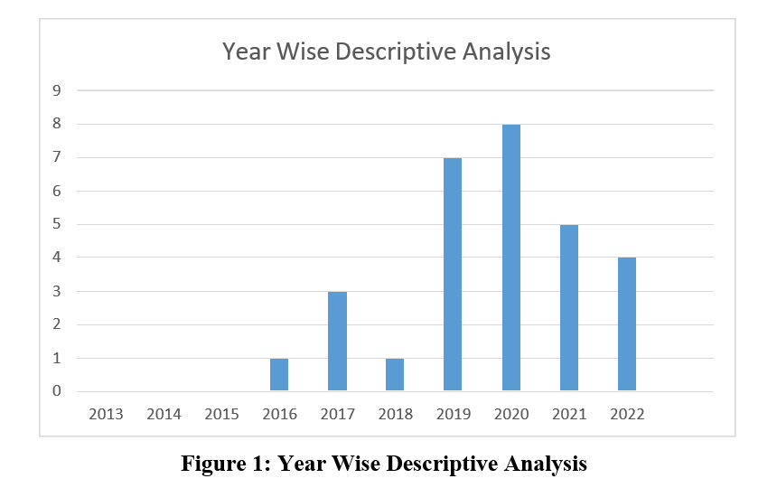

Several approaches have been used in past to regulate the importance of the current study. The most prominent approach is citation analysis, which calculates the number of times a publication is quoted by other journals in order to assess its success (Cronin and Ding, 2011). Table 4 represents the descriptive analysis in terms of number of times an article is citied. Keeping in view the number of times an article is cited, studies of Bamini KPD Balakrishnan, Mohd Irwan Dahnil, Wong Jiunn Y. (2013) are cited 489 times, Abdus Saboor Khan, Muhammad Bilal, Muhammad Saif, Muhammad Shehzad. (2010) is cited 206 times respectively. Article written by Heri Eriangga Denok Sunarsi, Angga Pratama, Nurjaya, Nika Sintesa, Ida Hindarsah, Juhaeri Kasamd. (2021) comes in third place with respect to citation as it is cited 167 times.
Prince Clement Addo, Jiamaing Fang Andy Ohemeng Asare, Nora Bakabbey Kulbo. 2021 research article is citied 90 times and thus comes in fourth place. K. R. Mahalaxmi, P. Ranjith. (2016), is citied 62 times and it is the fifth and sixth cited article, Abdul Waheed, Daopinf Wang, MD Sarwar-A Alam. (2019) is highly citied article in our systematic literature review. One thing that all six highly citied articles had in common was that all studies declared and proved that there is positive relationship the impact of digital marketing and customer buying intention as shown in table 5.
Name of the Author | Timed Citied
Bamini KPD Balakrishnan, Mohd Irwan  Dahnil, Wong Jiunn Y. (2013) | 489
Abdus Saboor Khan, Muhammad Bilal, Muhammad Saif, Muhammad Shehzad.  (2010) | 206
Heri Eriangga Denok Sunarsi, Angga  Pratama, Nurjaya, Nika Sintesa, Ida Hindarsah, Juhaeri Kasamd. (2021) | 167
Prince Clement Addo, Jiamaing Fang Andy  Ohemeng Asare, Nora Bakabbey Kulbo. 2021 | 90
K. R. Mahalaxmi, P. Ranjith. (2016) | 62
Abdul Waheed, Daopinf Wang, MD Sarwar-A  Alam. (2019) | 25

It is clear from Figure 2 that majority of the work is done in Asian Countries and after that European Countries. Hence, it can be concluded that there is a gap in literature as very limited number of researches have targeted the countries such as in Africa, GCC, and South America to determine the impact of Digital Marketing on customer buying Intention. According to the Content wise analysis
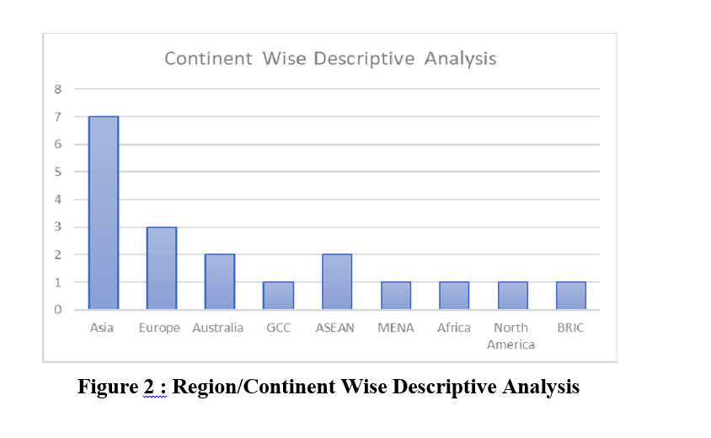

The following Figure, classifies sample countries in terms of developed and developing nations and it can be seen clearly that most of the studies have been done in developing nations. Even though, after the Pandemic of COV-19 all over the world from 2020 to 2021 in Pakistan, most of the Online marketers had strategically availed the opportunity for bringing up their products and new business on social media platforms. Furthermore, while comparing developed and developing countries for the current study, there’s a need to take into account the impact of digital marketing on customer buying intention in under developed and developed countries. Hence, trend towards developing countries increase and today most of research that had researched on the current topic has taken emerging economies as their sample countries. However, the gap exists in the research for impact of digital marketing in developing countries rather in developed ones. After and during, Pandemic, many authors have started exploring Asian regions and targeted their research on the emerging economies, however, there are also many researches available that main focused on measuring the impact of digital marketing on customer buying intention in developed countries. However, very limited number of researches has been done that have taken into consideration both developed and developing countries as their sample size to measure the impact of digital marketing on customer buying intention, although, in our systematic literature review, there are no study that take into account both developed and developing countries for the purpose of comparing the impact of Digital Marketing on customer buying intention as stated in Figure 3.

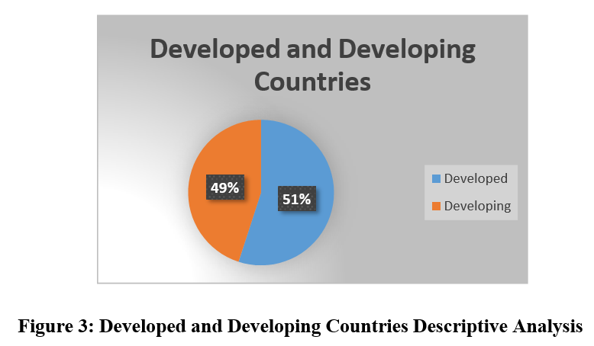

Only 49% of the studies on the impact of digital marketing on consumer buying intentions are conducted in developing countries, while the remaining 51% are conducted in developed countries. This suggests that there may be a significant gap in our understanding of how digital marketing affects consumer behavior in different parts of the world. The studies conducted in developed countries may provide valuable insights into how digital marketing can influence consumer buying intentions in affluent and technologically advanced societies. However, these findings may not be directly applicable to developing countries, where factors such as low internet penetration rates, limited access to digital devices, and cultural differences may play a more significant role in shaping consumer behavior. On the other hand, studies conducted in developing countries may shed light on how digital marketing can be used to reach and influence consumers in regions with different socioeconomic and cultural backgrounds. These findings may be particularly useful for businesses looking to expand into new markets or reach new audiences. Overall, the discrepancy in the distribution of research on this topic between developed and developing countries highlights the need for more research to be conducted in the latter. Doing so would help create a more comprehensive understanding of how digital marketing impacts 51% 49% Developed and Developing Countries Developing Developing 41 consumer buying intentions globally and provide more nuanced insights into how businesses can leverage this knowledge to create effective marketing strategies.
Literature Classification
For conducting this analysis, data were analyzed on the basis of exploratory factor analysis (EFA) as per the nature of this study that identifies and explores the Impact of Digital Marketing on consumer buying intention: a glimpse of exiting literature. Therefore, EFA was conducted as data reduction techniques for the five factors such as email marketing, social media, online advertising, mobile marketing, and purchasing decision. After applying all the filtering criteria, the extracted 30 articles were analyzed on the basis of descriptive analysis and literature classification. The literature classification of the current study was done on the basis of methods used for determining the Impact of Digital Marketing, Social media marketing and Mobile Marketing on Purchase Decision, identify the correlation between social network marketing and consumer purchase intention by keep consumer engagement as a mediator and to understand the role of digital marketing and its effect on consumer empowerment in Pakistan.
As presented in Figure 4, the most common measure that is used to measure Impact of Digital Marketing on Customer buying intention is Online Marketing (OM) and Email Marketing (EM).
The method to extract articles related to current article which complies both descriptive and systematic review was used in 27% of the total studies that were extracted for this systematic literature review. The second method that 7% of the researchers used in their study is OM and EM. Simple Digital Marketing (DM)is used in most of the studies and this it represents the 7%, moreover, simple Purchased Decision (PD)and Purchase intention (PI) is also used as a proxy for measuring the customer engagement in eight studies, thus it also represents 27%. Other methods that were used by researchers includes Consumer Purchase Decision (CPD) and Online Advertising (OA).
Thus, from the results, it can be concluded that equal number of researchers relied on the mixed methods for measuring the customer engagement with digital marketing. Such as author (Maina, 2021) used mixed methods, by including both quantitative and qualitative; conducting interviews and surveys for 50 respondents. The independent variable is digital marketing and Facebook advertising depending on Consumer Purchase behavior, consumer attitude, consumer beliefs, and consumer repetitive buying. to determine the impact of digital marketing on consumer buying intention.
Thus, it can be concluded from the method of measuring performance of the analysis that as most put their focus on DM and CBI, there is a gap that exits of utilizing mixed methods to determine the impact instead of just DM and CBI. Furthermore, even though DM and CBI are the most common and important measure of customer engagement in relationship with digital marketing, but Online Advertising OA and Purchase intentions PD is ignored by many researcher despites of the fact that it is also a very important and common measure to determine the Impact of Digital Marketing on Customer buying intention.
After evaluating alternatives, purchasing decisions are the next step in the consumer decision-making process. Currently, consumers gain preference between brands, products/services being considered and intend to purchase the brand of choice. Furthermore, Purchase intentions have been influenced by previous stages of the decision-making process, but marketers still have the opportunity to affect consumers who are already at the purchasing stage (Iblasi et al., 2016). At this level, marketers should provide their consumers with their products and ensure that the purchasing process is easy and convenient for consumers (Al-azzam & Al-Mizeed, 2021).
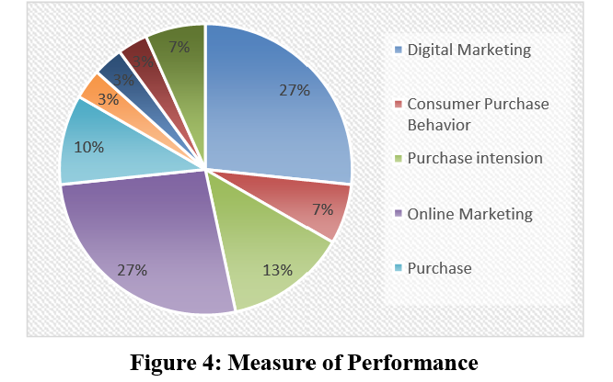

Figure 5 represents the proxies that used to measure the impact of digital marketing on customer buying Intention. It is clear from the figure below that the most common and widely used method for measuring the impact of digital marketing is Social Media Marketing (SMM) as it is used by 54% researchers of the total articles under current study. After, its publication by Al-azzam, A. F., & Al-Mizeed, K. (2021), Social Media Marketing (SMM) has been frequently implemented by many researchers in literature as a precise indicator for Digital Marketing. After SMM, and the second most widely used measure for digital Marketing is Online Marketing (OM) that is published by Dasgupta, S., & Grover, P. (2019), is used by of the total research studies used in this systematic literature review paper. Other measure that used is Online Advertising. So, it can be concluded that the two most common measures of revenue diversification are HHI and non-interest income to total operating income, however, none of the articles have used both measure in comparison to determine whether there is any variation in results.
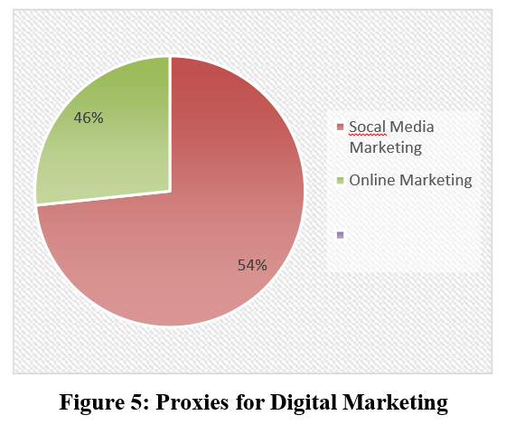

Findings:
Digital marketing has a significant impact on consumer buying intention. Studies have shown that digital marketing tools such as social media, email marketing, and online advertising have a positive impact on consumer buying intention. Social media is a crucial tool in digital marketing that influences consumer buying intention. Studies have shown that social media platforms such as Facebook, Instagram, and Twitter can influence consumer behavior through advertising and promotional campaigns. Online advertising can significantly impact consumer buying intention. Studies have shown that online ads have a significant influence on consumer behavior and can lead to increased purchase intention. The use of mobile devices for digital marketing can influence consumer buying intention. Research has shown that the use of mobile devices for digital marketing, such as mobile apps, can increase consumer engagement and lead to increased purchase intention.
Trust and credibility are crucial factors that impact consumer buying intention in digital marketing. Studies have shown that trust and credibility are essential factors in building long-term relationships with customers and can significantly impact consumer behavior. Overall, the studies suggest that digital marketing has a significant impact on consumer buying intention and that social media, online advertising, mobile devices, and trust and credibility are crucial factors in influencing consumer behavior.

Conclusion:
There is a consensus that digital marketing has a positive impact on consumer buying intentions. Many studies have found that digital marketing, including social media and e-marketing, can influence consumers' purchasing decisions by increasing brand awareness, improving brand reputation, and providing information that helps consumers make informed purchasing decisions. Some studies also suggest that factors such as perceived value, brand equity, and customer engagement mediate the relationship between digital marketing and consumer buying intentions. However, it is important to note that these findings are based on various industries, countries, and target markets, so the impact of digital marketing on consumer buying intentions may vary depending on the specific context. The increasing use of digital media platforms has provided businesses with new opportunities to reach and engage with their target audience. The various digital marketing techniques such as social media marketing, search engine optimization, email marketing, and content marketing can all contribute to building brand awareness, increasing website traffic, and ultimately driving sales. Several research studies have highlighted the importance of digital marketing in influencing consumer behavior. These studies have shown that digital marketing can positively impact consumers' attitudes towards brands and their buying intentions. However, the impact of digital marketing on consumer buying intentions may vary across different demographic groups and product categories. 45 It is also worth noting that while digital marketing is an important tool for businesses to reach their target audience, there is a significant disparity in the amount of research conducted on this topic between developing and developed countries. More research is needed in developing countries to understand the impact of digital marketing on consumer buying intentions in these regions. Overall, the findings suggest that digital marketing can be a powerful tool for businesses to influence consumer behavior and drive sales. However, businesses need to ensure that their digital marketing strategies are tailored to their target audience and product category to achieve maximum impact. Additionally, more research is needed in developing countries to fully understand the impact of digital marketing on consumer behavior in these regions.

REFERENCES
Al-azzam, A. F., & Al-Mizeed, K. (2021). The effect of digital marketing on purchasing decisions: A case study in Jordan. The Journal of Asian Finance, Economics and Business, 8(5), 455-463.
Astoriano, L., Gerona, J. A. D., & Marzan, J. C. R. (2022). The Impact of Digital Marketing on Customer Buying Intention of Customers in the Philippines. Journal of Business and Management Studies, 4(2), 383- 395.
Alam, M. S. A., Wang, D., & Waheed, A. (2019). Impact of digital marketing on consumers' impulsive online buying tendencies with intervening effect of gender and education: B2C emerging promotional tools. International Journal of Enterprise Information Systems (IJEIS), 15(3), 44-59.
Alghizzawi, M. (2019). The role of digital marketing in consumer behavior: A survey. Int. J. Inf. Technol. Lang. Stud, 3(1), 24-31.
Akter, M., & Sultana, N. (2020). Digital marketing communication and consumer buying decision process in pandemic standpoint (Covid-19): an empirical study of Bangladeshi customers’ in branded cosmetics perspective. Open Journal of Business and Management, 8(06), 2696.
Balakrishnan, B. K., Dahnil, M. I., & Yi, W. J. (2014). The impact of social media marketing medium toward purchase intention and brand loyalty among generation Y. Procedia-Social and Behavioral Sciences, 148, 177-185.
Clement Addo, P., Fang, J., Asare, A. O., & Kulbo, N. B. (2021). Customer engagement and purchase intention in live-streaming digital marketing platforms: 实时流媒体数字营销平台中的客户参与和购买意向. The Service Industries Journal, 41(11-12), 767-786.
Dasgupta, S., & Grover, P. (2019). Impact of digital strategies on consumer decision journey: special.
Academy of Marketing Studies Journal, 23(1), 1-14.
Dastane, O. (2020). Impact of digital marketing on online purchase intention: Mediation effect of customer relationship management. Journal of Asian Business Strategy, DOI, 10, 142-158.
Erlangga, H., Sos, S., & Erlangga, H. (2021). Effect Of Digital Marketing And Social Media On Purchase Intention Of Smes Food Products. Turkish Journal of Computer and Mathematics Education, 12(3), 3672- 3678.
Godwin, E. U. (2019). An empirical analysis on effect of digital marketing on consumer buying intention (Doctoral dissertation, Masters Dissertation, The School of Postgraduate Studies Ahmadu Bello University, Zaria).

Husnain, M., & Toor, A. (2017). The impact of social network marketing on consumer purchase intention in Pakistan: Consumer engagement as a mediator. Asian Journal of Business and Accounting, 10(1), 167-199.

Kumar, T. S., & Sekhar, S. (2019). Impact of e-Marketing on Influencing Consumer Purchase decision. International Journal of Scientific Development and Research, 4(11).
Khan, A. S., Bilal, M., Saif, M., & Shehzad, M. (2020). Impact of Digital Marketing on Online Purchase Intention: Mediating Effect of Brand Equity & Perceived Value. Inst. Bus. Manag, 1-50.
MAINA, M. (2021). Impact of Digital Marketing on Consumer Purchase Behavior among The Students of Bbit at Riara University (Doctoral dissertation).
Mahalaxmi, K. R., & Ranjith, P. (2016). A study on impact of digital marketing in customer purchase decision in Trichy. International Journal for Innovative Research in Science & Technology, 2(10), 332-338. Nazarov, A. D. (2020, December). Impact of Digital Marketing on the Buying Behavior of Consumer. In 2nd International Scientific and Practical Conference on Digital Economy (ISCDE 2020) (pp. 364-367).
Atlantis Press.
Nizar, N. A., & Janathanan, C. (2018). Impact of digital marketing on consumer purchase behavior. In APIIT Business, Law & Technology Conference.
Omar, A. M., & Atteya, N. (2020). The impact of digital marketing on consumer buying decision process in the Egyptian market. International Journal of Business and Management, 15(7), 120-132.
Pillai, R., Holla, N., & Srinivas, D. (2021). A study on Digital marketing and its impact on Consumer Behavior. PalArch's Journal of Archaeology of Egypt/Egyptology, 18(09), 78-85.
Pal, A. K., & Shukla, B. (2020). Impact of Digital Marketing on Consumer buying intention. Iconic Research And Engineering Journals, 3(11), 209-220.
Reddy, G. (2017). Digital marketing impact on the consumer decision making process in Nike's customer retail operations in South Africa (Doctoral dissertation, University of Pretoria).
Rabby, F., Chimhundu, R., & Hassan, R. (2021). Artificial intelligence in digital marketing influences consumer behaviour: A review and theoretical foundation for future research. Academy of Marketing Studies Journal, 25(5), 1-7.
Ramesh, M., & Vidhya, B. (2019). Digital marketing and its effect on online consumer buying intention. Journal of Services Research, 19(2), 61-77.
Shahid, S., & Qureshi, J. A. A. (2022). Consumer empowerment in the digital media marketing age: A comparative literature review and trends across selected countries. 3c Empresa: investigación y pensamiento crítico, 11(1), 149-177.

Schutte, F., & Chauke, T. (2022). The impact of digital marketing on consumer behaviour: a case study of millennials in South Africa.

Sigar, E. T., Massie, J. D., & Pandowo, M. H. (2021). The influence of consumer behavior and digital marketing on purchase decision at Grabfood in Manado. Jurnal EMBA: Jurnal Riset Ekonomi, Manajemen, Bisnis dan Akuntansi, 9(4), 53-64.
Waheed, A., Yang, J., & Rafique, K. (2017, January). Understanding the effect of E-marketing (eM) on online consumer buying intention. In Proceedings of the 2017 International Conference on Management Engineering, Software Engineering and Service Sciences (pp. 163-167).
Yamin, A. B. (2017). Impact of digital marketing as a tool of marketing communication: a behavioral perspective on consumers of Bangladesh. American Journal of Trade and Policy, 4(3), 117-122.
Zaidi, Z., & Shukri, S. (2022). The effects of digital marketing implementation on online consumer in Selangor during COVID-19 pandemic. Management Science Letters, 12(1), 43-50.

