ROLE OF MANAGERIAL SUPPORT ON CAREER COMMITMENT


QUDSIA AMJAD AWAN (F19BBAM027)
MOMINA PIRZADA (F19BBAM040)
MUNEEBA NAVEED (F19BBAM067)
NAMEERA NAEEM (F19BBAM071)

DEPARTMENT OF BUSINESS STUDIES

KINNAIRD COLLEGE FOR WOMEN,
LAHORE, PAKISTAN
MAY, 2023

ROLE OF MANAGERIAL SUPPORT ON CAREER COMMITMENT

A DISSERTATION SUBMITTED TO
KINNAIRD COLLEGE FOR WOMEN
IN FULFILLMENT OF THE REQUIREMENTS
FOR THE DEGREE OF

BACHELOR IN BUSINESS ADMINISTRATION

By

QUDSIA AMJAD AWAN, MOMINA PIRZADA, MUNEEBA NAVEED,NAMEERA NAEEM

DEPARTMENT OF BUSINESS ADMINISTRATION KINNARID COLLEGE FOR WOMEN, LAHORE 2023

DISSERTATION APPROVAL


KINNAIRD COLLEGE FOR WOMEN

Date: May-2023

I hereby recommend that the dissertation prepared under my supervision by
Momina Pirzada
F19BBAM040

ROLE OF MANAGERIAL SUPPORT ON CAREER COMMITMENT

be accepted in partial fulfillment of the requirements for the degree of

BACHELOR IN BUSINESS ADMINISTRATION
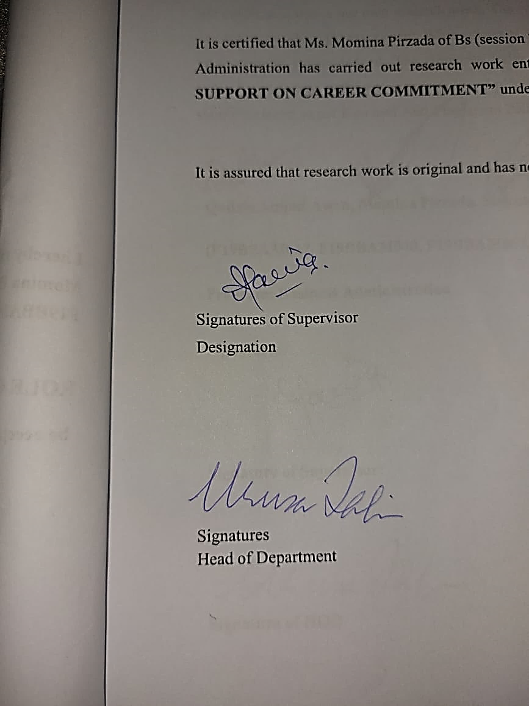



In Charge of Dissertation

Committee for the Final Examination

Recommendation concurred in

RESEARCH COMPLETION CERTIFICATE

It is certified that Ms. Momina Pirzada of Bs (session 2019 – 2023), Department of Business Administration has carried out research work entitled “ROLE OF MANAGERIAL SUPPORT ON CAREER COMMITMENT” under my supervision. “All changes suggested by the examiner during defense are incorporated in this final copy”.

It is assured that research work is original and has not yet been published anywhere else.

Signatures of Supervisor Dated: June 2023
Designation

Signatures
Head of Department

iv

ANTI-PLAGIARISM DECLARATION

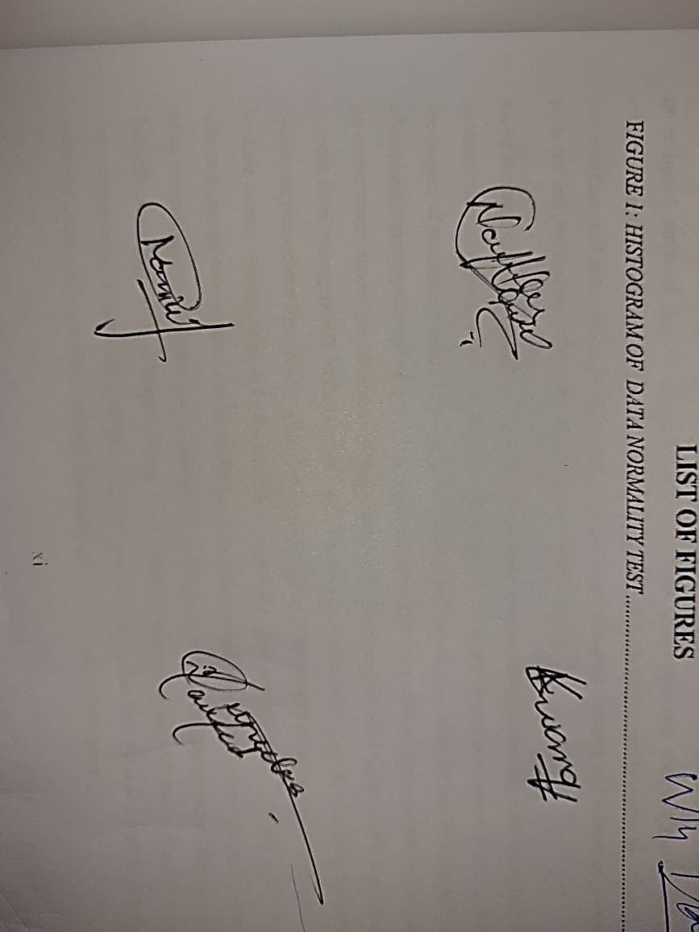
We certify that this is our own research work. The work has not, in whole or in part, been presented elsewhere for assessment. Where material has been used from other sources, it has been properly acknowledged. The similarity index of the research report is 3%. If this statement is untrue and I am found guilty of plagiarism, the punitive actions against me should be taken as per Kinnaird Anti Plagiarism Policy.

Qudsia Amjad Awan, Momina Pirzada, Muneeba Naveed, Nameera Naeem
(F19BBAM027, F19BBAM040, F19BBAM067, F19BBAM071)
Program: Business Administration

Signature of Supervisor:



Signature of HOD
v

ACKNOWLEDGEMENT

We are grateful to Almighty Allah, Whose boundless blessings made it possible for us to complete this enormous task. Without the dedication, help, and time of several people, this dissertation would not have been able to be finished. We thus like to thank them all for their contributions. We would want to express our sincere gratitude to our parents for devoting all of their energy to helping us contribute much as we can today. They constantly wished us well and offered their encouragement. They all deserve a heartfelt thank you.
We take great delight in thanking our supervisor, Dr. Anum Tariq, for providing insightful advice, an understanding perspective, moral support, motivational remarks, and strong encouragement to handle the issues we ran into while doing our research. Her suggestions and directives helped us to think critically and extensively, which strengthened our academic skills. We are really grateful to our friends for their advice and assistance. Without their assistance and encouragement, we would not have been able to successfully finish our research.
We gratefully recognize Momina Pirzada, Muneeba Naveed Nameera Naeem, and Qudsia Amjad working together, courteous treatment, unwavering friendship, and leadership of one another. Being a part of this outstanding cohort makes us feel really proud. We have supported and encouraged one another, and we will never forget how difficult this journey has been for us as a team. I must admit that I am really fortunate and appreciative of each and every one of you for your participation and distinct talents.

vi

ABSTRACT
The influence of managers on employees' career commitment has gained considerable attention in recent years, as it significantly impacts long-term success and job satisfaction. This study investigates the relationship between managerial support and employee career commitment, while considering the mediating effects of employee learning and self-efficacy. Specifically focusing on the telecommunication industry, the research aims to explore the role of managerial support in fostering career commitment among employees. The ultimate objective is to encourage managers to actively support the career development of their staff, leading to a more engaged and effective workforce. Drawing on surveys and interviews conducted with a sample of telecommunication industry workers, this study collects quantitative data to examine the impact of managerial support on employees' career growth and its potential to enhance their learning. The findings highlight the significance of managerial support in providing employees with the necessary tools and opportunities to expand their knowledge and skills. Moreover, the research explores how employee self-efficacy, supported by managerial guidance, can further contribute to career commitment. The results demonstrate that managerial support acts as a motivational factor, positively influencing employee self-efficacy. It provides recommendations on how managers can better support employee career development and cultivate a learning culture in the workplace. By acknowledging the critical role of managerial support, organizations can foster an environment that encourages continuous learning and career commitment among employees.
vii
TABLE OF CONTENTS

DISSERTATION APPROVAL III
RESEARCH COMPLETION CERTIFICATE IV
ANTI-PLAGIARISM DECLARATION V
ACKNOWLEDGEMENT VI
ABSTRACT VII
CHAPTER I 1
INTRODUCTION 1
1.1 STATEMENT OF TOPIC AND PURPOSE: 1
1.2 SIGNIFICANCE OF STUDY: 2
1.3 RESEARCH GAP: 2
1.4. PROBLEM STATEMENT: 3
1.5. RESEARCH OBJECTIVES: 4
1.6. RESEARCH HYPOTHESIS: 5
1.7. THEORRETICAL FRAMEWORK: 6
CHAPTER II 7
LITERATURE REVIEW 7
2.1 THEORETICAL BACKGROUND 7
2.2 CAREER COMMITMENT 8
2.3 MANAGERIAL SUPPORT AND CAREER COMMITMENT 8
2.4 MEDIATING ROLE OF EMPLOYEE LEARNING 9
2.5 MEDIATION ROLE OF SELF-EFFICACY 10
2.6 UNDERPINNING THEORY 11
CHAPTER III 12
METHODOLOGY 12
3.1 RESEARCH DESIGN AND STUDY SETTING 12
3.2. STUDY VARIABLES: 12
3.2.1. DEPENDENT VARIABLE: 12
3.2.2. INDEPENDENT VARIABLE: 12
3.2.3. MEDIATING VARIABLE: 12
3.2.4 MEDIATING VARIABLE: 12
3.2.5 CONTROL VARIABLES 12
3.3 TIME HORIZON, UNIT OF ANALYSIS AND PARTICIPANTS: 13
3.4 POPULATION AND SAMPLING 13
3.4.1 TARGET POPULATION 13
3.4.2 SAMPLE SIZE SELECTION 13
3.4.3 SAMPLING TECHNIQUES 13
3.5 THE INSTRUMENT DEVELOPMENT 14
3.6 DATA COLLECTION PROCEDURE 14
3.7 ADMINISTRATIVE PROCEDURE 14
3.8 CONSIDERATION OF ETHICS 14
3.9 MEASUREMENTS AND SCALES 14
3.10 ANALYTICAL APPROACH 16
CHAPTER IV 17
DATA ANALYSIS 17
4.1 DESCRIPTIVE STATISTICS 17
4.2 DESCRIPTIVE STATISTICS OF THE STUDY VARIABLES 18
4.3 RELIABILITY ANALYSIS 18
4.3.1 ASSUMPTIONS OF LINEAR REGRESSION 19
4.4 CORRELATION MATRIX: 21
4.5 REGRESSION ANALYSIS 22
CHAPTER V 26
RESULTS AND CONCLUSION 26
5.1. DISCUSSIONS OF RESULTS: 26
5.2. THEORETICAL CONTRIBUTION: 27
5.3 PRACTICAL IMPLICATIONS 28
5.4 LIMITATIONS AND FUTURE DIRECTIONS 29
5.5 CONCLUSION 30
REFERENCES 31
APPENDICES 37
EMPLOYEES SURVEY QUESTIONNAIRE 37
PLAGIARISM REPORT 40

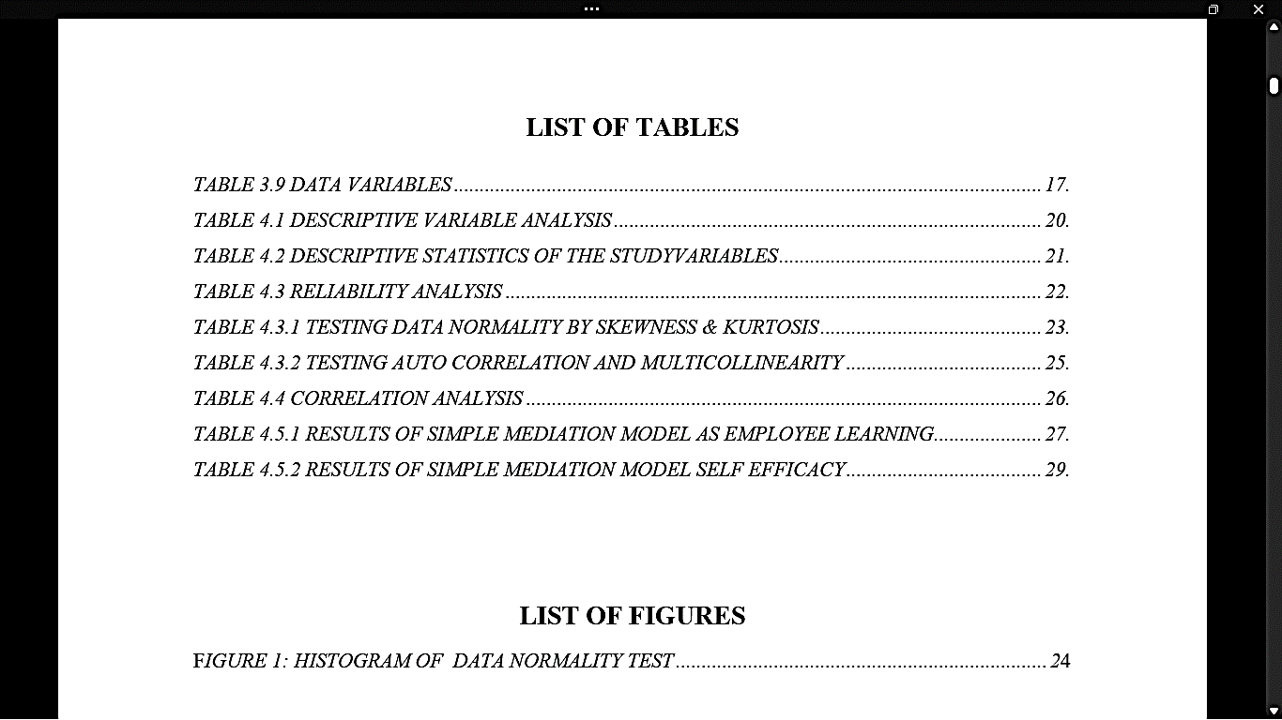

CHAPTER I

INTRODUCTION

1.1 STATEMENT OF TOPIC AND PURPOSE
Managerial support plays an important part in employees' positive attitude, inspiring them, and fostering their self-belief. The manager's emotional support can help employees commit to their careers and become more interested in their work. It has come to light that everyone who succeeds and shows a keen interest in it does so because, if they work hard and give it their all, their manager will be there to support them, mentor them, and help them grow. A different kind of help for the people working in workplace is known as managerial support (Akpan, 2022). Managerial support is considered as a special component of organizational support which is referred as how much intrinsic motivation, appreciation and self-actualization is given to employees by top management and how much care top management shows towards their employees. (Torp, 2015) Today's managers are not encouraging enough and think that ordering people around and making them follow orders is the only way to get them to work. On the other hand, a successful organizational manager knows how to deal with the staff, develop them, and evaluate their professional growth. Even a supportive organization manager can boost employees' self-esteem and inner belief, allowing them to advance in their careers. Employees can complete their tasks more effectively and efficiently thanks to managerial support. Employees are frequently unable to maintain their perseverance and consistency toward work as a result of unpleasant attitudes and behaviors, as well as personal and professional pain, which leads to poor performance.
Good managerial support not only helps employees build their personalities but also start taking an interest in things they have never known before. “A role of managerial support on career commitment”, examine the impact of managerial support on employee career commitment, as well as the mediating impact effects of employee learning and self- efficacy. The study aims to explore the mediating role of managerial support on career commitment in telecommunication companies. This research sheds light on the significance of support from managers with reference to the positive impact on the career growth of employees and their consistency in a career that is led by self-efficacy and employee learning that helps them to stay committed to their career. Additionally, it looks into how employees view support from managers and how that affects them and their careers. As the world has changed its employees focus to strategic long-term goals of its company, causing a huge barrier between top management and lower management. (Bandura, 2017). Self-efficacy significantly influences career commitment. The employees with the highest self-efficacy were committed to their careers, which resulted in career growth. The belief and acceptance of goals and values by managers make them inspired, satisfied, and committed to their career.

1.2 SIGNIFICANCE OF STUDY
Nearly everyone acquires an entirely different and unusual series of responsibilities, duties, career paths and experiences which differs from person to person and organization to organization (Coetzer, 2017). In terms of career commitment, managers play a leading role because their support can help them improve and they can learn many things under their orders. When employees receive support from their manager, they’ll improve themselves and work harder to maintain their image and feel more confident in their work. As a result of the support, managers know how they will carry out all assigned tasks and duties efficiently. For that reason, self-efficacy and learning among employees have the ability to influence employees' motivation. This research will examine the leading role of managers' support in employees' career commitment and, with the help of their support, how employees boost their confidence and how they'll seek learning. In organizations, employees are given targets to achieve, and with no guidance, it will result in pressure to achieve targets and result in giving up on their career. Whereas, if managers support them, understand them, help them, and make it easier for them to achieve goals, it will result in the self-efficacy of employees, which then results in career commitment. Every individual working in a workplace goes through a series of phases of career development phase, and each of them are identifies by a set of responsibilities, duties, career paths and experiences (Hall, 2019).This sequence of the career development process can only be achieved by encouraging and supportive managers who increase employee confidence, learning, and, most importantly, career consistency.

1.3 RESEARCH GAP

The existing literature has recognized the importance of managerial support in shaping employees' career commitment. However, there is still a need to delve deeper into the specific dynamics and mechanisms underlying this relationship. The previous research gap fails to clearly define the problem and address the comprehensive understanding of the interplay between managerial support, self-efficacy, employee learning, and career commitment. Thus, this study aims to bridge this research gap by providing a more precise investigation into the following areas:

The Impact of Managerial Support on Career Growth: Previous studies have acknowledged the significance of managerial support in employees' career development. However, there is a lack of comprehensive research exploring the specific ways in which managerial support influences employees' career growth and their subsequent commitment to the organization. This research aims to uncover the direct impact of managerial support on career growth, thereby contributing to a deeper understanding of the role played by managers in fostering employees' career commitment.

Employee Learning and Career Commitment: While the literature recognizes the positive relationship between employee learning and career commitment, there is a need to explore the mediating role of employee learning in the link between managerial support and career commitment. By investigating how managerial support affects employee learning and subsequently influences their commitment to their careers, this study aims to shed light on the underlying mechanisms through which managerial support impacts career commitment.

Self-Efficacy and its Influence on Career Commitment: Although prior research has established the importance of self-efficacy in career development, its specific role in the context of managerial support and career commitment requires further investigation. This study seeks to examine how self-efficacy, as a personal resource, mediates the relationship between managerial support and career commitment. Understanding the mediating role of self-efficacy will provide insights into the psychological processes through which managerial support affects employees' commitment to their careers.

Comprehensive Understanding of Factors Affecting Career Commitment: While previous studies have examined various factors influencing career commitment, there is a need to establish a more comprehensive understanding of the determinants, particularly focusing on the interplay between managerial support, employee learning, self-efficacy, and career commitment. By considering these factors collectively, this study aims to contribute to the existing literature by offering a more holistic perspective on the factors that impact employees' commitment to their careers.

By addressing these research gaps, this study aims to advance the current knowledge and provide practical insights for organizations. The findings will assist organizations in enhancing their management support practices, fostering employee learning, and promoting career commitment, thereby improving overall employee performance and organizational effectiveness. Furthermore, this research will contribute to the existing literature by offering a more comprehensive understanding of the relationship between managerial support, employee learning, self-efficacy, and career commitment, paving the way for future research in this field.

1.4. PROBLEM STATEMENT:

In today's dynamic work environment, the commitment of employees to their careers is crucial for organizational success and competitiveness. However, there is a prevailing lack of loyalty and commitment among employees in many organizations. To address this issue, it is important to investigate the underlying factors that contribute to this lack of career commitment. Existing literature suggests the need for further research to determine whether this lack of commitment stems from employees' reluctance to improve themselves or if it is a result of insufficient managerial support in fostering belief and confidence in their abilities. While prior research has highlighted the positive relationship between managerial support and career commitment, there is a lack of clarity on whether the current level of managerial support provided is adequate to meet employees' expectations and foster their commitment. It is necessary to delve deeper into the specific aspects of managerial support that are most impactful in enhancing employee learning and self-efficacy, ultimately leading to increased career commitment.

1.5. RESEARCH OBJECTIVES:
The major goal of managers is to unite the heterogeneous collection of individuals under one roof, and making sure that every individual is fulfilling its responsibilities and duties in order to achieve goals of organization. For it’s necessary for managers to regularly communicate with the employees and to give them proper guideline, motivation and feedback on daily basis. When the employees follow the guideline provided by the manager then only they accomplish the given tasks without making any error, mistake and blunder. Further upper management can exhibit the responsibilities by the outcomes and results of the activities performed by the employees.
The capacity to ensure the completion of the tasks performed, control on suggestion and recommendations and staying motivated is defined as self-discipline, which is characterized by leader’s tenacity and resolve to focus on a specific task of the organization till its completion. Self-determination and self-discipline are the major qualities that needs to be in manager which helps managers to stay on track instead of getting distracted because of the pressure of attaining goals in a short time. They struggle to maintain control over time as it continues slipping away. Managers can’t make the clock run according to them so they have to speed up their efforts to achieve long term and short-term goals of the company. For all these reasons, managers need to be responsible and time efficient. There must not be a barrier or glass ceiling between managers and employees, mentoring needs to be normalized and the work-life balance programs also need to be conduct by managers inside the organization.
Communication practices must be improved which means ensuring that the workers have the enough knowledge, skills, and equipment to accomplish their duties and satisfying the needs and wants of their customers accordingly making sure that your employees have the information and resources they need to do their jobs well and give your customers the positive experience they deserve. Big-picture thinkers frequently consider the long-term effects of a project, while detail-oriented thinkers focus on short-term priorities.
The objectives of this research are as follow:
- To investigate the impact of managerial support on employee career commitment within telecommunication companies.
- To explore the mediating role of employee learning in the relationship between managerial support and employee career commitment.
- To examine the mediating role of self-efficacy in the relationship between managerial support and employee career commitment.

1.6. RESEARCH HYPOTHESIS:
Hypothesis 1: There is a significant relationship between managerial support and career commitment.
Hypothesis 2: Employees learning mediates a relationship between managerial support and career commitment.
Hypothesis 3: Self efficacy mediates a relationship between managerial support and career commitment.

1.7. THEORRETICAL FRAMEWORK:
The theoretical framework is a crucial component of research as it helps in directing the investigation and research process. So the model of our research study is as follows:
H2
Employee Learning

(MEDIATING VARIBALE I)
Career Commitment
Managerial Support

H1 h1
(DEPENDENT VARIBALE)
(INDEPENDENT VARIBALE)
(MEDIATING VARIBALE I1)
Self-Efficacy

H3

CHAPTER II

LITERATURE REVIEW
The logic driving our model creation, as well as reasons in favor of the proposed linkages, is being discussed in this section. The relationship that exists between managerial support and the mediators, self-efficacy and employee learning is discussed to give our reasoning that support how these leads to career commitment. We contend that managerial support has the potential to positively impact employee career commitment which is followed by a discussion that self-efficacy and employee learning plays a mediating role, both of which we claim strengthen the beneficial effect on employee career commitment.

2.1 THEORETICAL BACKGROUND
Finding and keeping passionate workers who identify with the company in the current changing work atmosphere is extremely difficult for executives. (Abid, 2016). Organizations require dedicated workers that go above and beyond to accomplish duties which are not usually outlined under position profile but most of times necessary for the organization's smooth operation. According to research findings, businesses that hire people with favorable mindsets and practices do better than those that lack. (Bakker, 2018). The theory of social exchange (SET), upon which such claims are based, (Balu, 2020) that asserts if a particular body gets anything useful, it seeks to return the favor with values that are at least as great as those received. Such connections are built on the principles of reciprocal (Mazzetti, 2019). According to this viewpoint, when employees see management assistance, they’re greater inclined towards reward the company along with its greatest benefaction with the shape in employee learning, which boosts their confidence. This method may boost employees' self-efficacy and engagement at work, hence increasing their career commitment.
Researchers have paid a lot of focus on managerial assistance since it influences how well people perform at workplace (Chen, 2008). Because they oversee employees, they are most directly impacted by supervisors. Administrators have responsibility for establishing a link between the activities of their division and its staff's effectiveness and the larger company objectives. That plays incredible role in shaping organizational customs. Learning and career commitment are inextricably linked. Because employee learning was shown to have better levels of work satisfaction and organizational commitment than others. Studies have come to understand the importance of workers' constructive mindsets and actions for an organization's performance, productivity, and competitive edge over time (Akpan, 2022). Seminal work of (Kautish, 2021), which three elements—organizational commitment, on-the-job work effectiveness, as well as attitudes to go beyond—are necessary for good functioning of organizations. Positive commitment, which refers to a workers perception of affiliation and feelings of attachment to his or her organization, counteracts numerous unfavorable behaviors including disengagement and absences. (Meyer, 2018) along with promote good behaviors including organizational citizenship behavior as well as how they perform, in addition to create beneficial mindsets including volunteerism and professional enthusiasm. (Stanley, 2002).

2.2 CAREER COMMITMENT
Career commitment is the term used to describe a worker's contentment with their work and willingness to stay in it, with an emphasis mostly on psychological aspects (Balu, 2020). However (Colarelli, 2005) personal, devoted to a career Professionals are going to establish professional objectives, engage these initiatives, and get interested in them. Employees that have poor career commitment, on the other hand, are probably to have lower satisfaction with their jobs and career commitment. (Pei, 2015), that is not conducive to genuine individual performance. In our study we will investigate how career commitment is an outcome of managerial support. Career commitment comprises the development of personal career objectives, as well as identification with and engagement in those objectives.
Many researchers have discovered that managerial support is essential elements determining career commitment. Employees who receive greater assistance from their bosses are more dedicated to the organization, compared to those employees who receive less management support. According to (Wesarat, 2014) career commitment remains a crucial idea for workers to understand since it helps employees match their careers with evolving company circumstances. Furthermore, supervisory actions have a significant influence on commitment, and supervisors who ignore their subordinates create a lack of confidence among employees, which affects employee commitment to the organization. When the firm gives enough assistance in return, the employee will have a favorable impression of their employer. Employees who believe their manager is knowledgeable, capable as well as reliable supposed to be greater inclined towards organization's goals along with values. Pleasant interactions between supervisors and employees boost workers ‘propensity to stay longer in the organization and so increase career commitment.

2.3 MANAGERIAL SUPPORT AND CAREER COMMITMENT
Managerial Support comes to a supervisor's willingness to work with a worker's agenda and duties and to offer support which may assist them manage his or her position and improve it. (Kim, 2016). This could reflect a significant organizational atmosphere component that affects employees' views and actions relating to the organization (increases efficiency, satisfaction, and loyalty (Saridakis, 2018). (Khalid, 2020), suggested that it might be justified that Managerial Support had a substantial impact on fostering organizational commitment because it has been hypothesized that career commitment demonstrates corporate leading competency.
Many different types of managerial support may be given to employees, such as direct observations upon how they perform, participation in important choices by employees, and aid with challenging tasks. The finest administrators give managerial support because they understand what inspires their employees and keep it in mind when their people do well. They motivate their employees by being upbeat and filtering out stress and negativity. When examining the relationship between affective dedication (i.e., psychological commitment) and worker productivity, particularly in Middle Eastern nations, this emerged that more emotionally dedicated workers often had greater productivity standards. (Zeffane, 2017). Employees are respected, valued, and favored when they work for a leader who provides exceptional assistance. People are more ready to maintain a good view of competent learning and development and exhibit its success when they are supported.
In an organization, a manager is in charge of several duties. Someone who leads establishes an objective for the company, inspires workers, directs them along their projects, and boosts spirit. (Turk, 2007). Supportive managers are valuable for organizations. Managerial support not only improves the work environment, but it is also a critical tool for promoting the right attitude among employees, which fosters positive relationships between employees. Finally, it empowers employees to develop their professional skills and work well autonomously or with little supervision and instruction. When workers believe their managers care about their welfare, they are more dedicated towards their firms. (Kwenin., 2013)
Hypothesis 1: There is a significant relationship between managerial support and career commitment.

2.4 MEDIATING ROLE OF EMPLOYEE LEARNING ON MANAGERIAL SUPPORT AND CAREER COMMITMENT
Employee learning plays a mediating role in this model. According to study on development programs, (e.g., management support and job characteristics) important for employee learning. The move to proactive employee development where self-learning is promoted and frequently completed in tandem with carrying out some responsibilities, suggests that these elements have even greater significance. (Parker, 2006).Employees may provide learning and development that is related to the knowledge, skills and expertise they wanted their employees to have. Learning programs may be help staff to learn new skills which will help them to boost their level of productivity. Numerous business and employment-related issues have altered the workplace atmosphere and continuously learning and adapting changes in the environment. Firstly they changed the design of employment, moving away from traditional workplace environment and offering more stable jobs. (Harrison, 2000). Employee education is defined as a continuous process in which workers' working behaviors, levels of knowledge, abilities, and motivation improve as a result of learning based on various methods. It minimizes the gap between the standards placed on employees and their current level of expertise. (Hroník, 2007). Your employees are encouraged to build their own skill sets and career aspirations as employees. Managerial support, regardless of management style, is vital to employee performance. The learning cycle is continuous procedure of 4 steps which includes determining the true requirement of education, plan to implement on it, monitor it and assess how well education is helping. (Buckley, 2004). The success of education is heavily influenced by the selection of suitable employee learning techniques (such as classes, workshops, instructional materials, online learning, project work, instruction, supervision experiential education, training, video conferencing, examination and so on.) that are used to transmit and gain knowledge, expertise, mindsets, and skills. There is a considerable link between management support and employee learning that promote performance, such as a desire to stay with the organizational commitment in the long term. For example, if you're friendly and kind, you're most likely a supportive boss. Managers look after their employees, treat them with respect and consider them assets for the organization in return these employees will also respect their managers and work with dedication. Hypothesis 2: Employees learning mediates a relationship between managerial support and career commitment.

2.5 MEDIATION ROLE OF SELF-EFFICACY ON MANAGERIAL SUPPORT AND CAREER COMMITMENT:
Research suggests that managerial support can have an impact on employees' career commitment (Yan, 2021). One potential mechanism through which this effect may occur is self-efficacy, which refers to a person’s own trust in his capacity to complete any work or situation (Bandura, 2017).Self-efficacy serves as a bridge that allows an individual to believe in him/her and his/her abilities, and it may be achieved via excellent management and managerial assistance.
Self-efficacy has been presented as an important indicator of career commitment (Tziner, 2015), and may mediated the connection between managerial support and career commitment. For example, a study by (Li, 2020) found that self-efficacy partially mediated the connection between perceived managerial support and career commitment among Chinese employees. They discovered that perceived management support was associated to self-efficacy, which is also related to career commitment. Furthermore, the direct effect of perceived management support on career commitment was considerable via self-efficacy.
Similarly, a study by (Lee, 2020) found that self-efficacy mediated the relationship between supervisor support and career commitment among Korean employees. They found that supervisor support was positively interconnected to self-efficacy, which in turn was positively related to career commitment. Additionally, the indirect effect of supervisor assistance on career commitment through self-efficacy is also significant.
Persons with strong self-efficacy are more likely to regard problems as surmountable given their opinion of their talents; hence, these persons are more willing to try the given activity. If a person lacks self-efficacy, they will interpret the obstacles as a barrier based on their perceived skills, making them less inclined to participate in the given activity. Our research will look into how employee self-efficacy, with the aid of management support, may lead to employee career commitment. Overall, our data show that self-efficacy may be a key way through which management support influences workers' career commitment. Managers may assist employees commit to their professions by encouraging them to believe in their own skills.
Hypothesis 3: Self efficacy mediates a relationship between managerial support and career commitment.

2.6 UNDERPINNING THEORY
Social learning theory, developed by psychologist Albert Bandura, suggests that people learn by observing others and imitating their behavior. It emphasizes the role of social interactions, modeling, and reinforcement in the learning process. According to this theory, individuals acquire knowledge, attitudes, and behaviors through a combination of direct experience and vicarious learning, where they observe others' actions and the consequences of those actions.
Social learning theory suggests that employees' learning and career commitment can be influenced by observing and imitating the behaviors of others, including their managers. When managers provide supportive behaviors such as mentoring, coaching, and providing resources for learning and development, employees are more likely to perceive these behaviors as positive models to emulate. Managerial support acts as a key factor in social learning, as it provides employees with the opportunity to observe and learn from supportive and effective managerial behaviors. This support can include providing feedback, offering growth opportunities, recognizing achievements, and fostering a positive work environment. When employees perceive strong managerial support, they are more likely to pay attention to the behaviors displayed by their managers and model them in their own work.
Furthermore, social learning theory emphasizes the importance of self-efficacy, which refers to an individual's belief in their own capabilities to successfully execute a particular behavior or task. When employees observe managers providing support and demonstrating successful behaviors, it can enhance their self-efficacy beliefs. This increased self-efficacy, in turn, can positively influence their learning efforts, as they feel more confident in their ability to acquire new knowledge and skills.
Employee learning, influenced by managerial support and self-efficacy, acts as a mediator in the relationship between managerial support and career commitment. As employees learn and acquire new competencies through supportive managerial behaviors, they become more engaged and committed to their careers. Their increased learning experiences and self-efficacy beliefs contribute to a sense of growth, development, and fulfillment, which in turn leads to higher levels of career commitment.
In summary, social learning theory provides a theoretical framework to understand how managerial support, employee learning, self-efficacy, and career commitment are interconnected. It suggests that employees learn and develop their career commitment through observing and imitating the behaviors of supportive managers, while their self-efficacy beliefs and learning experiences play a mediating role in this process.

CHAPTER III

Methodology
This chapter discussed our study's research strategy and methodology. This comprised the study setting, study variables, sample method, time frame, data collection procedure, and scale measurement.

3.1 RESEARCH DESIGN AND STUDY SETTING
Our research looked primarily at the relationship between study variables such as managerial support, employee learning, self-efficacy, and career commitment. As a result, in this study the research approach that is used is quantitative. the research design is correlational and it is a non-experimental research approach.. Without any form of intervention, the research is carried out. data is collected from the target respondents in their regular job settings and routines throughout the period. The researcher's participation was restricted to explaining questionnaire questions and the study's intended to attendees.

3.2. STUDY VARIABLES:

3.2.1. DEPENDENT VARIABLE:
Career commitment is the (dependent) variable in the proposed research. According to its definition, Career commitment is the term used to describe a worker's contentment with their work and willingness to stay in it, with an emphasis mostly on psychological aspects (Kautish, 2021).

3.2.2. INDEPENDENT VARIABLE:
Managerial support is the (independent) variable, which can be defined as the actions, behaviors, and resources provided by managers to facilitate the success and well-being of their employee (Eisenberger, 2020) It involves creating a supportive work environment, offering guidance and assistance, advocating for employee needs, and empowering employees to achieve their goals.

3.2.3. MEDIATING VARIABLE:
In the current study, Employee Learning works as a mediating variable or intervening variable that links the independent variables (managerial support) with the dependent variable (career commitment. Employee learning, also known as workplace learning or employee development, refers to the process of acquiring new knowledge, skills, and competencies by individuals within an organization to enhance their job performance and personal growth. It involves various activities and initiatives designed to improve employees' knowledge, abilities, and effectiveness in their roles (Coetzer, 2007).

3.2.4 MEDIATING VARIABLE:
Another mediator in our study that ties the independent variable (Managerial Support) to the dependent variable (Career Commitment) is (self-efficacy). Self-efficacy, which refers to a person’s own trust in his capacity to complete any work or situation self-efficacy serves as a bridge that allows an individual to believe in him/her and his/her abilities, and it may be achieved via excellent management and managerial assistance" (Bandura, 2017).

3.2.5 Control Variables
A few of the controlling demographic factors are age, gender, education level, working tenure, and income level, since these may have an influence on research variables. The average age of the participants was monitored in order to identify the generation that requires higher dedication at work. According to the ageing theory, as people age, their requirements, the role they play at workplace and their personal life become more complex (Petkova, 2011). Gender is monitored because it determines differences in employee learning and self-efficacy. Workplace structures of authority, customs, and standards are based on stereotypes about men and women, resulting in income and career development disparities (Acker, 2012). At work, people of various educational levels display a variety of views and actions. (Bakker, 2018). Finally, because income level is connected to career commitment, it was added as a control variable. Employees with lower earnings are less pleased with and devoted to their employment than those with greater incomes. So, income level can be very useful to understands employee workplace motivation that ultimately link with career commitment.

3.3 TIME HORIZON, UNIT OF ANALYSIS AND PARTICIPANTS:
In order to eliminate prevalent method bias, the time-lagged structure was applied by adhering to (Podsakoff, 2003) suggestions to gather data on the criterion and predictor variables at various times. Furthermore, because information was acquired from respondents all at once, this research is cross-sectional (Sekaran, 2013). Since the participants in our research were employees of telecommunication companies. Hence the units of analysis are employees..

3.4 POPULATION AND SAMPLING

3.4.1 Target Population
Data was collected from employees of telecommunication companies operating in Lahore city. The motive behind targeting Lahore was that it is the capital of the most developed province of Pakistan. Moreover, it is the center of many economic and business activities and is the second largest financial hub of Pakistan after Karachi. All these companies have their branches in Lahore which also imply the significance of Lahore city in telecommunication sector.

3.4.2 Sample Size Selection
To generalize our study results, we chose a sample size based on (Kline, 2015), who
suggested that having about ten participants for each item in the following form
(No. of items in questionnaire)× ( 10 respondents from targeted population)
Taken from the target population. This is a basic requirement for inferring the best possible results for the target group. Because the questionnaire form had 32 questions, a sample size of 321 people was sufficient for analyzing our hypothesis and generalize our findings. We sent survey instruments to 400 employees while know the possibility of incomplete data and the non-respondents. Out of 400 responds received, 321 complete and legitimate result were chosen for further analysis. The response rate is therefore 321/400, or 80%.

3.4.3 Sampling Techniques
For sample selection, we utilized multistage sampling technique. At first telecommunication companies were selected using simple random sampling because this particular technique provides each company having the same probability of being chosen from the sample. One more reason to prefer this method here is that it includes a minimum number of biases with the highest level of generalizability (Sekaran, 2013). Then, using proportionate sampling, the number of branches for each telecoms company was determined (i.e., the number of branches drawn/selected would be proportional to the total number of that particular company's branches in Lahore).

3.5 THE INSTRUMENT DEVELOPMENT
The questionnaire consists of closed-ended questions which was an English-language assessment. There were two sections to the survey. The first sections consist of basic information of respondents including: name, gender, income level, qualification, year of birth, working place, tenure of working, working as, and experience. The second section consists of demographic data that includes questions related to our study variable including Managerial Support, Self-efficacy, Employee Learning and Career Commitment. This section contained 5 items of Managerial Support, 8 items of Employee Learning, 10 items of self-efficacy and 9 items of Career Commitment.

3.6 DATA COLLECTION PROCEDURE
The first phase of collection of data, a random sampling strategy is employed because it gives each participant access to every feasible sample of the same size. The participants in the current study were employees from Lahore-based telecommunications companies. Additionally, we were able to gather data utilizing internet surveys and voluntary survey questionnaires (to improve credibility).

3.7 ADMINISTRATIVE PROCEDURE
The most important and time-consuming task is data collection. Because the mentioned collection method cannot be used without permission, the researcher needs to make a call before using the collection method. Employee cooperation was required throughout the whole process, and the survey could only be carried out with the approval of administrators. Most employees prefer online surveys, which take a little more time to complete. The total number of questionnaires needed to complete the data requirement is 321. The estimated time to collect this data is approximately 3 months. Once the data is complete, 321 samples are used for further statistical analysis.

3.8 CONSIDERATION OF ETHICS
The study's participants received assurances from the individual conducting the study that their information would not be public. and used only for academic and research, and they were fully aware of the study's objectives. The information was acquired with integrity and truthfulness. Furthermore, the researcher did not manipulate the gathered data in any way (e.g., data fabrication, data falsification).

3.9 MEASUREMENTS AND SCALES
To measure the 321 questionnaire results specifically for employees in the telecommunications industry, some additional considerations should be taken into account. Once the questionnaire is customized, it can be administered to the employees, and the responses collected and recorded. The responses can be scored using the appropriate scale, depending on the specific aspects of behaviour being measured. The questionnaire comprised of 32 5-point Likert-scale items. So, following methods we use to get responses we use online questionnaires, phone-based questionnaire and paper-based questionnaire. The respondents were required to select a number and a scale that accurately represented them and their preferences.
Variables | Items | Scale
Managerial support | 5 | 5-point scale
Employee learning | 8 | 5-point scale
Self-efficacy | 10 | 5-point scale
Career commitment | 9 | 5-point scale
The Table:3.9 below show the measure that will be taken into account for the collection of data. Table 3.9: Data variables

3.9.1 Managerial Support
Managerial support was assessed using 5 items scale developed by (Torp, 2015). To measure the influence of managerial support on employees, a questionnaire can be designed using a Likert scale. Depending on the number of items the questionnaire may contain pertaining to management support, employees may rate their level of acceptance or disapproval with each question on a scale of, say, 1 to 5, with 1 representing strongly disagree and 5 representing strongly agree. As in "Manager appreciates employees for offering an innovative concept. This metric has an internal consistency of 0.92.

3.9.2 Employee Learning
The questionnaire can contain several questions related to the employees' perceptions of managerial support and how it affects their job satisfaction, motivation, and productivity and their learning. (Coetzer, 2007) 5-items scale used to measure how managerial support influences employees, a questionnaire can be designed using a scale i.e., 5-point Likert scale. Selecting the number that most accurately reflects an employee's degree of acceptance or disapproval with each statement is one way to reply to these questions. Scores of 1 and 5 denote strong agreement and extreme disagreement, respectively. This has a reliability analysis of "0.92", which is quite high.

3.9.3 Self-Efficacy
To measure how managerial support influences employees' self-efficacy proposed by (Schwarzer, 2012), a questionnaire can be designed using a Likert scale. Numerous questions on how employees feel that their managers support them and how it impacts their confidence and trust in their talents is possible included in the questionnaire. For example, how much do you agree “My manager recognizes and appreciates my contributions to the team"? Selecting the number that most accurately reflects an employee's degree of acceptance or disapproval with each statement is one way to reply to these questions. Scores of 1 and 5 denote strong agreement and extreme disagreement, respectively. This scale's internal consistency was "0.94".

3.9.4 Career Commitment
A 5-item scale was used to assess the employee's commitment to their career, developed by (Hayday, 2003) measure how managerial support influences employees' career commitment, a questionnaire can be designed using a Likert scale. The questionnaire may ask a number of questions on how the employees feel their supervisors support them and how it influences their commitment to their careers. Selecting the number that most accurately reflects an employee's degree of acceptance or disapproval with each statement is one way to reply to these questions. Scores of 1 and 5 denote strong agreement and extreme disagreement, respectively. This scale's internal consistency is "0.89," which is "very good." The results can be used to identify areas where improvements can be made, such as providing more opportunities for career development or recognition, to enhance managerial support and, in turn, boost employee career commitment.

3.9.5 UNIT OF ANALYSIS
In the proposed research, the unit of analysis is employees of telecommunication companies. Responses is gathered from the working employees in telecommunication companies. The individual’s own point of view that how managerial support help them to be career committed is taken.

3.10 ANALYTICAL APPROACH
Beginning with the analysis of the proposed relationships in our theoretical model, Using SPSS version 24, the research variables, the means, the standard deviations, and Cronbach's alphas were computed. Regression analysis was carried out to look at the link between all research variables and the control variables. The validity, reliability, and internal consistency of managerial support, the mediator: employee learning, the other mediator: self-efficacy, and career commitment were evaluated using the Hayes Process Macro Model 4: A Mediation Analysis. Two different hypotheses were explored. First, one mediator—employee leaning—was used to explore how support from managers affected career commitment. (Managerial support—employee learning—career commitment). Then, the managerial support impact on career commitment were examine through 2 mediators i.e., self-efficacy (managerial support—self-efficacy—career commitment).

CHAPTER IV

DATA ANALYSIS
This section includes the data analysis, as well as results and clarification of the study's findings. The data is examined to determine, investigate, and explain the relation between our study variable as well as control variable. In examining the study's findings, we employed descriptive and inferential statistics.

4.1 DESCRIPTIVE STATISTICS

4.1.1 Demographic Variable Analysis
Table 4.1 Descriptive Variable Analysis
 | Frequency | Percentage
Gender
Male | 177 | 55.1
Female | 143 | 44.5
Age
Maximum | 1965
Minimum | 2006
Tenure
0-10 year | 220 | 68.7
10-20 | 100 | 31.25
The analysis Table4.1 provides analysis of research participants by their gender, age and work tenure. The findings show that the ration of male (177, 55.1) participant is greater than the female(143, 44.5) participants. The maximum and minimum age of participant range from 1965 to 2006, with the standard deviation 7.893, mean 1992.0, and standard error 0.441. The majority of the participant belong to 20-30 age group and had work experience less than 10 year i.e., 68.7%, 31.25% of participant had more than 10 years of experience. Table 4.1 results show that our participants had a significant period of working with their recent job so they can provide reliable information.

4.2 DESCRIPTIVE STATISTICS OF THE STUDY VARIABLES
Variables | Max | Min | Mean | SD
1. Managerial Support | 5.00 | 1.63 | 4.18 | 0.71
2. Learning | 5.00 | 1.50 | 4.21 | 0.66
3. Self-Efficacy | 5.00 | 1.40 | 4.20 | 0.72
4. Career Commitment | 5.00 | 1.40 | 4.00 | 0.69
Table 4.2 Descriptive Statistics
The table above (4.2) provides a summary of descriptive statistics for our research variable. The study variable is assessed using a 5-point Likert scale. The statistical findings suggest that the study variable has a minimum value of responses in the interval of 1.40 to 1.63 and a maximum range exceeding 5. The series of mean values for our variable ranged from 4.00 to 4.21, while the standard deviations of our target population lie between 0.66 and 0.72. The mean average value for items analysing managerial support, learning, self-efficacy, and commitment results is high and exceeds the midpoint. The table actually concludes that employee’s commitment at work had a mean of 4.18 and a SD of 0.71, which implies that sampled employees feel enthusiastic and motivated at work. The managerial support sample resulted in a mean of 4.20 and a SD of 0.72, suggesting that our target respondents exhibit that they are motivated to benefit their fellow workers and employees and have a positive impact on others’ lives. Additionally, employee learning items produced a mean of 4.21 and a SD of 0.66, which indicate that participants who have managerial support have a positive outlook towards their career advancement. Finally, career commitment items reported a mean of 4.00 and a SD of 0.69, exhibiting that employees feel a high level of life satisfaction and fulfilment.

4.3 Reliability Analysis
Variable | No. of items | Cronbach’s α  value | Level of  Reliability
Managerial support | 5 | 0.928 | Excellent
Employee learning | 8 | 0.923 | Excellent
Self-efficacy | 8 | 0.942 | Excellent
Career commitment | 9 | 0.894 | Very good
Table 4.3 Reliability of Study Variables

The Table 4.3 show Cronbach’s alpha to check the reliability of our data and consistency between items of our study variable (i.e., managerial support, employee learning, self-efficacy, and career commitment). According to Cronbach (1951), the threshold value to verify the reliability and internal consistency of a scale’s items is equal to or greater than 0.7. Kline (1998) suggests that the range of Cronbach’s (reliability-coefficient) must be higher than or equal to 0.90 to be considered "excellent"," and the value that is near or equal to approx. 0.80 is considered "very good," and the value that is approximately equal to or less than 0.70 is considered "adequate".
The table above displays the results of our findings on reliability and consistency for the current study and Cronbach’s value to know whether our data is reliable and can we depend on it for all variables that met the threshold value that means above 0.7, ranging from very good to excellent (i.e., 0.894 to 0.942). The results show that all variables have internal consistency above 0.70, and there are no reliability problems in our data. The reliability of managerial support is 0.928, self-efficacy is 0.942, career commitment is 0.894, and employee learning is 0.923. All reliability is not above 0.7, its 0.8 which is considered an excellent or very good alpha value.

4.3.1 ASSUMPTIONS OF LINEAR REGRESSION

4.3.2 Data Normality
 | Minimum | Std. Deviation | Skewness |  | Kurtosis
 | Statistic | Statistic | Statistic | Std. Error | Statistic | Std. Error
Managerial Support | 1.00 | .97174 | -.428 | .136 | -.694 | .271
Self-Efficacy | 1.00 | .87361 | -.482 | .136 | -.450 | .271
Career Commitment | 1.00 | .89493 | -.518 | .136 | -.559 | .271
Employee Learning | 1.00 | .85331 | -.390 | .136 | -.681 | .271
Total
4.3.1.1 Testing data normality by skewness and kurtosis

A normality test is basically considered a statistical tool that researchers use to know whether a set of sample data is part of a population, which means samples taken from the targeted population are considered normally distributed data, and for that, a test is performed. It is crucial to have an idea to make sure that the errors found in the statistical data are also normally distributed or considered normal. To know about this or to have an idea whether the data is correct, we can look at the shape of the histogram from our standardized data, which we can find in the output chart section. If the histogram of the sample of the research is bell-shaped, it means that the errors are normal and the data is error-free. This could help to ensure that the sample taken is appropriate for the data and that the results obtained from it can be trusted.
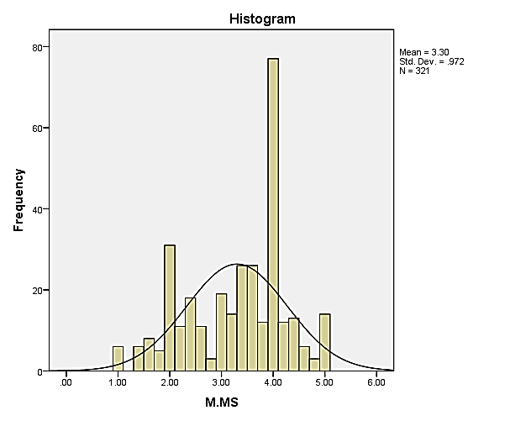
Given below is the histogram of our data, which can be helpful in assuming our data is significant. It portrays the data file, which shows a shape that is similar to a normal distribution or a bell-curve. We can conclude that our sample data is accurate, that the assumptions are reliable, and that normally distributed errors are error-free. This suggests that the statistical model that we are assuming is suitable for our data and that the results we obtained from it are dependable, so we can depend on this data and continue with our study.
Figure 1: Histogram of Data Normality Test
To estimate our findings about whether the sample of our data is error-free and we can depend on it, a normality test was performed. The p-value, which should be less than 0.05, indicates that the data is normal. However, to confirm the findings and verify the normality assumption, skewness and kurtosis were checked. Kurtosis is considered the tail of the sample distribution. The skewness values for all study variables were close to 0, which is indicative of a roughly symmetric distribution. Similarly, the kurtosis values for all our study variables were within the measure that is considered accepted, i.e., within -3 to +1, which suggests that the tails of the distributions are not too heavy or too light. The z-scores for skewness and kurtosis were also calculated and found to be within the range of -1.96 to +1.96, which further supports the normality assumption.
In conclusion, while the normality test initially indicated that the data is normally distributed, further analysis using skewness, kurtosis, and z-scores suggested that most variables in the dataset are normally distributed.

4.3.3 Auto Correlation & Multicollinearity Statistics

Table 4.3.3 Testing Auto Correlation and Multicollinearity
Variable | Co linearity Statistics |  |  | Autocorrelation Statistics
Variable | Tolerance | VIF | Condition Index | Durbin-Watson
Managerial Support Career Commitment | 1.000 | 1.000 | 6.948 | 1.853

The results of our study aim to examine the manager’s support for career commitment while testing for multicollinearity and autocorrelation in a linear regression model. To assess the presence of multicollinearity, the value of tolerance considered should be greater than 0.2, and the VIF value should be less than 10. Our analysis shows that the tolerance and VIF values meet these criteria, indicating no significant multicollinearity problem exists. However, a condition index value of around 10 or less suggests that the level of multicollinearity in the regression model may be acceptable. Our analysis shows 6.948, which is below the threshold, indicating an acceptable level of multicollinearity.
The study also checks for autocorrelation using the Durbin-Watson value.
The Durbin-Watson value should lie between 1 and 3 to indicate no significant autocorrelation. The analysis shows that the value of Durbin-Watson is 1.853, which lies within the permissible range, indicating no significant autocorrelation exists. Overall, the study of the research indicates that the linear regression model is valid, and it is significantly evident that there is a positive association or some kind of relationship between managerial support and employee career commitment.

4.4 Correlation Matrix:
 | 1 | 2 | 3 | 4
Managerial Support | 1
Employee Learning | 0.860** | 1
Self-Efficacy | 0.813** | 0.836** | 1
Career Commitment | 0.827** | 0.865** | 0.843** | 1
Total | 321 | 321 | 321 | 321

Table 4.4 Correlation Analysis
**. Correlation at the 0.01 level (2-tailed), considered significant.
Before conducting hypothesis testing, a bivariate correlation analysis was conducted among study variables of our research. The summary of the analysis performed for correlation are represented in above table. The obtained correlation coefficients were consistent with our direction of our research and provide the support for our research data and hypotheses. The analysis performed for correlation supported all of our study hypothesis which is discussed in our research.
Specifically, the findings showed that managerial support has a positive impact and relationship with career commitment (r=0.827, p<0.01), which supports H1. Furthermore, the results indicated that there is a relationship exist in between managerial support and learning in organization (r=0.860, p<0.01), providing support for H2. Lastly our findings revealed that employee learning is favorably associated with career commitment (r=0.865, p<0.01), thus supporting H3.
Overall, the bivariate correlation analysis provides a preliminary indication of the association in between the study variables and supports the hypothesis proposed in the study. These results lay the groundwork for further hypothesis testing and provide insight into the potential role of managerial support and employee learning on career commitment.

4.5 Regression Analysis

X M1 Y

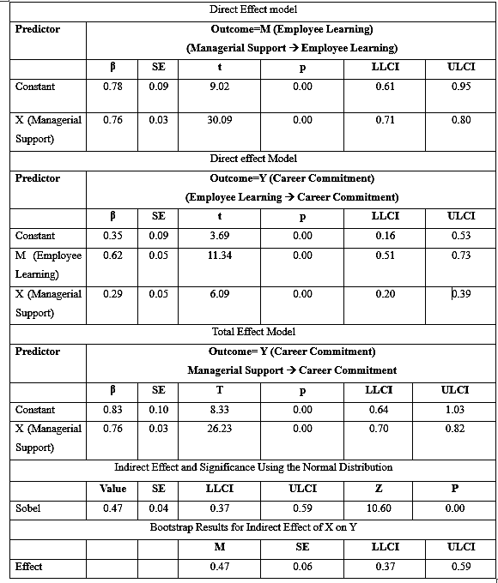
Table 4.5 Results of Simple Mediation Model as Employee learning as mediator
Note: n= 321; β = Unstandardized Regression Coefficient; SE = Standard Error; Bootstrap Sample Size =2,000; LL = Lower Limit; CI = Confidence Interval; UL = Upper Limit
INTERPRETATION
The findings support our assumptions for above mediation model. The association effect of managerial support & employee learning on career commitment can be explained as follows: if the value of LLCI or ULCI is positive or both the values are negative, then the relationship is significant; if one is positive and the other is negative, then the relationship is insignificant. Similarly, if the value of beta is positive, then the relationship is positive, and if it is negative, then the relationship is negative.
From the above results, when we see the impact of manager’s support on employee learning, we can see that the values of LLCI and ULCI are both positive, so the relationship is significant such that LLCI is 0.71** and ULCI is 0.80**, where P is equal to 0.000, which means it’s less than 0.05 (P<0.05). Now if we see the impact of manager’s support on employees career, the values of LLCI and ULCI are both positive, so the relationship is significant such that LLCI = 0.20** and ULCI = 0.39**.
The employee learning effects on career commitment of employees is also in the same direction, which means the association between the two variables is significant as the value of LLCI is positive and ULCI is also positive, and p shows it’s significant. The total effect relationship between managerial support and career commitment is also significant, as the value of LLCI and the value of ULLCI are both positive. The effect of X on Y shows they are indirect indicates that they significant and positively associated because the LLCI and ULCI values are both positive, which supports H1, resulting in the value P, which shows significance of the result, which supports all hypotheses.

Regression Analysis
X M2 Y
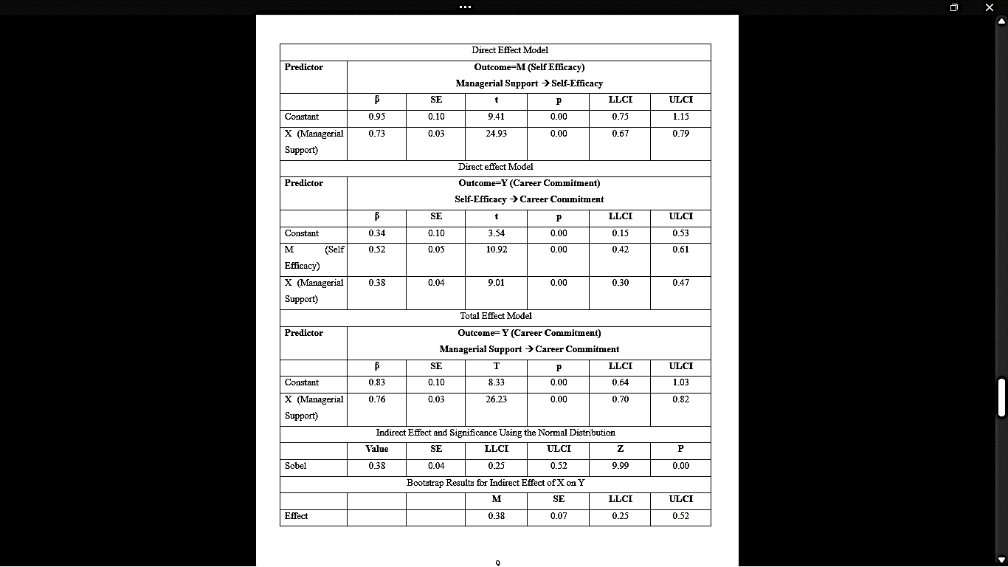
Table 4.5.2 Results of Simple Mediation Model Self efficacy as a mediator
Note: n =321; β = Unstandardized Regression Coefficient; SE = Standard Error; Bootstrap Sample Size =2,000; LL = Lower Limit; CI = Confidence Interval; UL = Upper Limit
INTERPRETATION:
The findings support our assumptions for the mediation model for hypotheses. The effect or association of managerial support & self-efficacy upon career commitment can be explained as follows: if the value of LLCI or ULCI is positive or both the values are negative, then the relationship is significant; if one is positive and the other is negative, then the relationship is insignificant. Similarly, if the value of beta is positive, then the relationship is positive, and if it is negative, then the relationship is negative.
From the above results, when we see the effect of managerial support on self-efficacy, we can see that the values of LLCI and ULCI are both positive, so the relationship is significant such that LLCI is 0.67** and ULCI is 0.79**, where P is equal to 0.000, which means it’s less than 0.05 (P<0.05). Now if we see the impact of manager’s support on employees career, the values of LLCI and ULCI are both positive, so the relationship is significant such that LLCI = 0.30** and ULCI = 0.47**.
To understand the relationship of self-efficacy on employee career advancement or commitment is also in the same direction, which means the association between the 2 variables results as significant because the value of LLCI is positive & ULCI is also positive, and p shows it’s significant. The total effect in between managerial support and employees career-commitment is also significant, as the value of LLCI and the value of ULLCI are both positive. The effect of X on Y indicates indirect and shows relationship is significant because the LLCI and ULCI values are both positive, which supports H1, resulting in the value P, which shows the significance of the result, which supports all hypotheses.

CHAPTER V

RESULTS AND CONCLUSION

5.1. DISCUSSIONS OF RESULTS
According to the research's findings, managerial support most has a substantial effect on career commitment. Likewise, Employees do believe that their managers encourage their career development is more inclined to be devoted to their work and professions compared to those that do not. If support helps them to improve at work then it can be said that managerial support has direct impact of the factors such as , motivation, self-efficacy, learning and commitment.
Additionally, the most important thing to consider is the specific types of managerial support that are most effective in promoting career commitment. For example, research has shown that providing employees with opportunities for skill development and training i.e., Employee learning, and mentorship that will boost their confidence i.e., Self-Efficacy can all contribute to increased employee’s career commitment.
The result is showing the ration of male (177, 55.1) participants is greater than the female (143, 44.5) participants. The maximum and minimum age of participant range from 1965 to 2006, with the standard deviation 7.893, mean 1992.0, and standard error 0.441. The majority of participant belong to the 20-30 age group and had work experience less than 10 years. Findings using descriptive statistics showed that the minimum range of responds for all variables under study is between the ranges of 1.40 and 1.63, and the maximum value is 5. Support, learning, self-efficacy, and commitment were all evaluated with high mean scores that considerably exceeded the midpoint. The sampled employees' commitment statements had a mean of 4.18 and an SD of 0.71, which suggests that they are extremely enthused and driven at job. Mean = 4.20 and SD = 0.72 for the managerial support items indicate that survey respondents are driven to help their coworkers and employees and have a good influence on others' lives. Additionally, the mean score on the employee learning tasks was 4.21. The reliability test results for this research and Cronbach's alpha for the scales of all variables met the threshold for acceptable, falling between very good and excellent. Bivariate correlation analysis among our study variables revealed that Managerial Support is positively and significantly related to Career Commitment (r=0.827, p0.01). In accordance with findings, managerial support and employee learning are positively and significantly related (r=0.860, p0.0).
The results supported Hypothesis 1 and showed a mutually beneficial connection between management support and career commitment. The study discovered a strong and substantial relationship between management support and employee commitment. Because of this, higher management must assist employees in their daily tasks if they hope to distinguish their company from rivals in the marketplace (Ahmad, 2020). The only way to stifle the competition is in this way.
In support of hypothesis 2, the results disclosed that managerial support is more effective in promoting career commitment through employee learning. The expansion in the skills and knowledge of the employees is really an essential element in increasing the organizational performance, effectiveness and help organization in longer-run. (Wallo, 2021). Favoring hypothesis 3, managerial support that are most effective in promoting career commitment is mentorship that will help them to boost confidence i.e., self-efficacy. An improved level of confidence in the employees skills motivates them to be devoted to their organizational goals, missions and objectives, a sense of self-efficacy also helps the employees to stay responsible, devoted and loyal to their organization. (Pacheco, 2023). It is also important to keep in mind that other elements, such as an employee's amount of job autonomy, organizational culture, and personal beliefs, may have an impact on the link between management support and career commitment. Therefore, it could be advantageous to look at these factors more in future studies. Overall, the results of the research point to the importance of management assistance in encouraging employee career commitment. by offering staff the tools and direction they require to succeed, or by providing them with feedback, an evaluation, or appreciation. An engaged and dedicated workforce may be developed with the support of managers.

5.2. THEORETICAL CONTRIBUTION
In several aspects, our research extends and supports earlier findings, making a significant contribution to the field. Our study enlightens that managers are responsible and in charge of all the coordinated departments and personnel working together in the organization for the sake of its profitability, which clearly states that top management and lower employees have the direct connection with one another. (vroom, 2017). Learning programs have been found to possess greater levels of organizational commitment and work satisfaction than other programs, as it not only boosts the self-esteem in them but also boosts and enhance their knowledge and skills Learning also helps employees become more open to change, leading to improved profitability and stability of the company. Equity theory suggests that employees find their compensation is good enough and that makes them highly satisfied. (Adams, 2007). Employees adjust their work productivity and performance in relation to their revenue, and those who earn more work harder to achieve high performance levels.
Our study examined managerial integrity and employee commitment in organization to identify those integrity variables and their effect on employee commitment (Akpana, 2022). Managers must not commit themselves to actions for which they have no power or authority to implement, and should only focus on help employees in employee learning, promote training and development of employees and employee career goals.
A distinctive feature of the research we conducted is the fact that managerial support may take many different forms, such as good communication between employees and managers, including employees in crucial decisions, meeting with them, and giving them feedback based on their results. It promotes and inspires the team members by constructing self-esteem, self-determination and self-confidence in them and providing equipment for maintaining of the management system. Supportive managers are valuable for organizations as they make improvement in the work area and promote the right attitude. The continuous change in the managerial styles, workplace environments, technological advancements and many other elements have and contributed in the evolution of the career development and the development programs.
Our study extends that Employee learning is a program that helps workers to acquire specialized information, abilities and skills to do their jobs goodlier. On any position in which employee working helps him to learn new skills and gain massive experience which will help them increase effectiveness. The performance and effectiveness of the employees can only be increased by the assistance of upper management as managerial support and performance of employees are interconnected to each other and have direct relation with one another. Upper management needs to guide the lower management to keep them in one track and to remind them to accomplish their respective tasks in order to help organization to make profit. Career commitment is an outcome of managerial support and is defined as identification with and participation in one's vocation. Our Research found that the employee who received support from their supervisors seems to be more inclined to the organization then those who received less. Also , managerial decisions have a direct and great impact on commitment, leading to a low level of confidence among the staff. When the company provides ample support in return, the employee will have a positive opinion toward their organization. Since the social exchange theory (Balu, 2020) framed that employees would give back to management if it displays interest in their professional development. Our study states that employee analyses their problem logically before evaluating their ability to handle the obstacle.

5.3 PRACTICAL IMPLICATIONS
For managers and practitioners who wish to develop and maintain their managerial and the employer roles in order to work together and have a shared understanding of the commitment to a career, this study offers a variety of consequences. Employees need managers who will serve as mentors. Establish a culture of learning where each employee feels inspired to pick up a new skill every day. To them, act like a good leader. There are no casualties at all if a manager additionally takes part in other training initiatives (Doe, 2022) .
The manager's role as a mentor could be effective, especially for young employees who have just begun their careers. They received particular knowledge, critical contacts, or skills from their mentors. A good manager should incorporate coaching into his or her management style in order to guide employee thoroughly. The effect of managerial style on employee commitment, and suggests that transformational leadership is an effective leadership style in enhancing employee commitment in the public sector (Abayomi, 2017). The level of support an employee receives can directly impact their level of commitment to their tasks. Clearly communicating objectives and goals by a manager can increase commitment, while inadequate guidance on job requirements can lead to decreased commitment among employees.
As our study suggest that the manager who are supportive and motivating towards employees have more satisfied workforce that proven to be more productive for organizational performance. Those managers who adopt transformational leadership practices can enhance employee creativity, leading to improved organizational performance (Sultana, 2018). Furthermore, managers that offer employees with rewards have highly motivated workforce, which has a favorable impact on the firm's overall profitability. Managers may achieve organizational success only when they recognize the value of employee productivity and dedication. Getting supportive managers contributes to a sense of community and professionalism, as well as to the collective experience. Manager support has also been proven to lower role stress, which is a negative predictor of career commitment, as well as to boost job satisfaction.
As our findings suggest that career committed workers are much more flexible than organizationally committed workers due to Self-driven factors like satisfaction so poor manager role in a work setting will lead to a loss of valuable organizational employees. As a result, practitioners must grasp the importance and pervasiveness of career commitment, as well as how to motivate and retain career-committed employees.

5.4 LIMITATIONS AND FUTURE DIRECTIONS
Future research can solve a few shortcomings that should be taken into account when evaluating the results of our study.
The individuals were recruited using an easy sample technique, which is the first constraint. Because it is impossible to establish a causal relationship between the research variables, the conclusions cannot be generalized widely. Generalizability is the degree to whose research findings may be used on individuals, environments, and eras other than those that were the subject of the study. (Babbie, 2016) . The unique traits of an organization, including its culture and the individuals who manage it, may deviate from those of other settings, thus restricting the generalizability of our conclusions. As a result, future research efforts could explore the causal relationships between the variables under investigation by employing longitudinal and experimental methods.
The second possible limitation is that because this is cross-sectional research, any generalization of the results must be done with caution. Future studies should solicit responses from a broader geographical range. The association between managerial support and professional commitment has been found to be considerable, although it is impossible to say if the support preceded the commitment or if other variables had a role. Effective leadership is crucial for successful organizational outcomes (Johnson, 2021).
Third, Pakistan—a non-Western nation—is the location of this investigation. Urban and rural areas have profoundly different cultures, and these variations have an impact on both commercial practices and human relationships (Malik, 2020). The working setting and customs in Pakistan are different from those in Western countries like Europe and North America, which makes generalizing this challenging. In order to confirm the results of our study, other studies that replicate our work in Western contexts are needed. The association between management support and career commitment has been found to be considerable, although it is impossible to say if the support preceded the commitment or if other variables had a role.
Fourth, because only workers of telecommunications businesses with offices in Lahore City participated in the survey, the sample may not accurately reflect the situation across the entire nation. The generalizability of our findings can be improved by repeating the current study in different locations and with businesses from different industries. Additionally, self-report questionnaires were used to collect data from respondents. However, these surveys are susceptible to biases in response and social desirability as well as other forms of measurement error (Jones, 2021). It is advised that future research collect data utilizing a variety of methods, including telephone or in-person interviews. After removing any potential ambiguity and providing clarification, this may help in gathering more accurate data.

5.5 CONCLUSION
This research sheds light on the significance of support from managers with reference to the positive impact on the career growth of employees and their consistency in a career that is led by self-efficacy and employee learning that helps them to stay committed to their career. The study is about how employees feel about the support they receive from their bosses and how this affects their commitment to their job. Many organizations nowadays focus more on their goals rather than their employees' needs, making it difficult for managers to support their staff. This study aims to find out how managers can support their employees better, so they feel committed to staying in the organization. This is important because it can help organizations keep talented staff and make their employees happier. The study emphasizes the need for organizations to prioritize their employees' well-being and career development. The research leads us to believe that employees work in a pleasant environment, but that due to the large number of employees, individual tasks can be difficult at times. The main issue is a lack of loyalty or commitment to a career. Employees at Jazz must meet targets or goals in order to advance in their careers. They need the support of a top manager to stay on track with their career. If top management did not show support and belief in them, they would eventually give up and have no opportunities for advancement. It also sheds light when employee is trusted and backed by organization they become more confident in their abilities. This confidence can lead to a sense of accomplishment and achievement, which can foster greater career commitment. Learning and development opportunities can help employees perform better in their current roles. When employees feel supported and equipped to handle their job responsibilities, they are more likely to succeed and feel fulfilled in their work. This sense of satisfaction can lead to increased career commitment.

REFERENCES

Abayomi, S. (2017). The influence of managerial leadership style on employee commitment in the public sector. International Journal of Academic Research in Business and Social Sciences.
Abid, G. (2016). Multifaceted Thriving Scale (MTS): Theoretical Refinement, Measurement, and Construct Validation. Ph.D. Thesis, National College of Business Administration & Economics, Lahore, Pakistan.
Acker, j. (2012). Hierarchies, jobs and bodies: a theory of gendered organizations.”. Gender & Society, 3(1), 71–92.
Akpan. (2022). Managerial integrity and employee commitment in organization.
Andreas Wallo, H. K.-E. (2021). How do managers promote workplace learning? Learning-oriented leadership in daily work. Journal of Workplace Learning.
Andrew, S., & León-Cázares, F. (2016). Mediating effects of organizational citizenship behavior on organizational performance: Empirical analysis of public employees in Guadalajara, Mexico.
Ashfaq, P. B. (2020). Impact of management support on employee commitment in hotel Sector.
Babbie, E. (2016). Basics of social research. Journal of Management Research 2014.
Bakker, A. B. (2018). Towards a model of work . Career Development International.
Bal, P. &. (2011). The relations between work centrality, psychological contracts, and job attitudes: the influence of age. European Journal of Work and Organizational.
Balu. (2020). Impact of management support on employee commitment in hotel sector. Review of Applied Management and Social Sciences (RAMSS)Vol. 3, 391-397.
Bandura. (2017). Exploring the Relationship between Self-Efficacy and Career Commitment among Early Career Agriculture Teachers. Journal of Agricultural Education.
Buckley, C. (2004). Trénink a Školen. Computer Press: Brno, Czech Republic, 168-278.
Carson, B. (2018). Career commitment, subjective career success and career satisfaction in the context of hazelnut processing industry in Giresun/Turkey. International Journal of Business and Management; Vol. 9.
Chen, C. a. (2008). An integrative model linking supervisor support and organizational citizenship behavior. Journal of Business and Psychology Vol. 23.
Cherif, f. (2020). The role of human resource management practices and employee job satisfaction in predicting organizational commitment in Saudi Arabian banking sector. International Journal of Sociology And Social Policy, 57(2), 173-203.
Chughti,(2016). Career Commitment among Pakistani academics :Examining the mediating role of perceived organizational support and employee engagement. Journal of Applied Research in Higher Education., 8(1),34-48.
Coetzer, A. (2017). Employee perceptions of their workplaces as learning environments. Journal of Workplace Learning 19(7):417-434, 19.
Colarelli, a. B. (2005). Career commitment: functions, correlates, and management. Group Organization study 15, 158–176.
Doe, J. (2022). The role of managers in employee development: creating a positive work environment for growth and learning. Journal of Management and Leadership.
Donaldson, S. I. (2011). Applied positive psychology: Improving everyday life, health, . New York, NY: Routledge.
Eisenberger. (2020). Perceived supervisor support: contributions to perceived organizational support and employee retention. . Journal of Applied Psychology.
Emerson, R. M. (2008). Social exchange theory. Annual Review of Sociology, 2: 335-362.
Gouldner, A. (2001). The norm of reciprocity: A preliminary statement. Am. Soc. Rev.
Gursory,(2008). General differences: An Examination of work values and generation gaps in the hospitality workforce. International Journal of Hospitality Management, 27(3),448-458.
Hall, 1. (2019). Career commitment, subjective career success and career satisfaction in the context of hazelnut processing industry in Giresun/Turkey. International Journal of Business and Management; Vol. 9.
Hall, D. T. (2019). A theoretical model of career sub identity development in organizational settings. Organizational Behavior and Human Performance, vol. 6,pp. 50–76.
Harrison, J. (2000). Changes in technology, teamwork and diversity; new directions for new century of absenteeism research. Research in personal and human resource management.
Hayday, S. (2003). Questions to Measure Commitment and Job Satisfaction. The Institute for Employment Studies.
He., L. K. (2011). Linking organizational support to employee commitment: Evidence from hotel industry of China. International Journal of Human Resource Management.
Holtom,(2008 ). Turnover and retention research: A glance at the past, a closer review of the present, and a venture into the future. . Academy of Management Annuals.
Hroník. (2007). Rozvoj a Vzdˇelávaní Pracovníkú;. Grada Publishing: Prgue, Czech Republic.
Johnson, B. (2021). Transformational leadership and employee engagement: A multilevel examination. Journal of Organizational Behavior.
Jones, S. (2021). Limitations of self-report questionnaires in psychological research. Journal of Personality Assessment.
Katz, D., & Kahn, R. (1978). The social psychology of organizations; Wiley: New York, USA.
Kautish, P. W. (2021). The moderating influence of social support on career anxiety and career commitment: an empirical investigation. Travel Tour. Mark. . 38, 782–801.
Khalid, K. (2020). The impact of managerial support on the association between pay satisfaction, continuance and affective commitment, and employee task performance.
Kim, T. &. (2016). How does supervisor support and diversity management affect employee participation in work/ family policies? Review of Public Personnel Administration,36(1).
Krishna, C. N. (2019). Employer branding: perceived organizational support and employee retention – the mediating role of organizational commitment.
Kwenin., M. &. (2013). The influence of employee rewards, human resource policies and job satisfaction on the retention of employees in Vodafone Ghana limited. European. Journal of Business and Management, 5(12),13-20.
Lee & Park. (2020). The mediating role of career self-efficacy in the relationship between supervisor support and career commitment. Journal of Career Development.
Luthans,(1998). Self-efficacy and work-related performance: A meta-analysis. Psychological Bulletin. 124(2),240-261.
Malik, Z. (2020). Cross-cultural differences in business practices and interpersonal relationships in Pakistan. Journal of Cross-Cultural Management , 7 (1), 95-107.
Mazzetti, e. A. (2019). Managerial support and innovative work behavior in B corps: Examining the effect of female employee work engagement and corporate reputation. 809- 831.
Meyer, J., & Allen, N. (2018). Commitment in the Workplace: Theory, Research, and Application. Sage: Thousand Oaks, CA, USA.
Meyer, J., Stanley, D., Herscovitch, L., & Topolnytsky, L. (2002). Affective, continuance, and normative commitment to the organization: A Meta-Analysis of Antecedents, Correlates, and Consequences.
Micheal, G. a. (2004). “Outcomes of Perceived Supervisor Support for Wood Production Employees”.
Paola Ochoa Pacheco, D. C.-M. (2023). Psychological Empowerment and Job Performance: Examining Serial Mediation Effects of Self-Efficacy and Affective Commitment. 777-780.
Parker, W. &. (2006). Modelling the antecedents of proactive behavior. journal of Management, 636-652.
Pei, ,. a. (2015). Study on knowledge workers’ calling, career commitment and job attitudes. 28, 103–114.
Podsakoff, O. (2003). Common method biases in behavioral research. Applied Psychology, Vol 88(5), 879-903.
Reynolds, R. (2021). The Transfer of Learning, Handbook of Research on Advancements in Organizational Data Collection and Measurements,.
Russell Cropanzano, M. S. (2005). Social Exchange Theory: An Interdisciplinary Review. Journal of Management, 36(1), 77- 93.
Saridakis, L. (2018). Exploring the relationship between job satisfaction and organizational commitment: An instrumental variable approach. The International Journal of Human Resource Management. Advance online publication.
Schwarzer, R. (2012). Is General Self-Efficacy a Universal Construct? European Journal of psychological assessment, 242-251.
Schwarzer, R. (2012). The general self-efficacy scale (gse). The General Self-Efficacy Scale (GSE), 4.
Sekaran, U. a. (2016). Research method for business: A skill-building approach . (6th ed.), New York, NY: John Wiley and Sons.
Stephen M., C. (2012). . Career commitment. Research Journal of Human Resource, 1(7), 38-47.
Sultana, N. (2018). Transformational leadership and its impact on employee creativity. Journal of Innovation and Entrepreneurship , 15(4), 957-977.
Torp, S. &. (2015). The mediating effect of top management support on the relationship between organizational culture and enterprise risk management effectiveness among Malaysian public listed companies: A Conceptual Framework. Research Journal of Finance and Accounting, 10(2):103-111.
Tsarenko. (2018). When and why do social resources influence employee advocacy? The role of personal investment and perceived recognition. business research, vol.82, pp. 260-8.
Turk. (2007). Manager or leader? . Defense at and L, 36(4), 20.
Tziner, ,. &. (2015). The impact of self-efficacy and career success on turnover intentions. Journal of Managerial Psychology, 30(8), 1022-1034.
Vanburen. (2017). Managerial support: Renewing the role of managers amidst declining union support for employees,24-32.
vroom, v. (2017). Work and motivation. Wiley. Journal of General Management, 43(1), 24-32.
Wesarat, ,. S. (2014). A Review of Organizational and Individual Career Management: A Dual Perspective. International Journal of Human Resource Studies, 4(1), 101.
Yan, ,. &. (2021). Perceived managerial support and employee career commitment: A moderated mediation model of perceived employability and proactive personality. Journal of Management & Organization, 82(4), 582–593.
Zeffane, &. B. (2017). Trust, job satisfaction, perceived organizational performance and turnover intention: A public-private sector comparison in the United Arab Emirates. Employee Relations, 39(7), 1148–1167.
Zhou,(2022). Understanding the influence of supervisor support on employee career commitment: The roles of self-efficacy and perceived employability. Journal of Business Research , 145,328-338.

APPENDICES

Employees Survey Questionnaire
The purpose of this survey is to better understand employee commitment to the organization and the mediating role of manager coaching behavior. This data is only used for research purposes. The information will be kept private.
Gender |  | Working place
Income level |  | Tenure of working
Qualification |  | Working as
Year of birth

Statement | Strongly Agree | Agree | Neutral | Disagree | Strongly Disagree

Managerial Support

Managerial support is the extent to which managers appreciate employees' contributions, care about their subordinates' well-being and are attentive to employee needs (Eisenberger, 2002).
- My manager actively seeks employee opinions and ideas on strategic issues.
- My manager is open to new ideas and initiatives from team member.
- My manager appreciate employee on sharing new idea.
- My manager is considered employee making regulatory decisions.
- My manager encourages it when employees try out innovative ways to provide services.
Employee Learning
Employee learning is a process of acquiring the skills necessary to perform a job and development is the ability to perform both present and future jobs (Reynolds, 2021).

 | Strongly Agree | Agree | Neutral | Disagree | Strongly Disagree
- I have enough opportunities to learn different tasks.
- My ideas for change welcomed.
- Manager provide space to learn skills.
- learning new skills rewarded by manager.
- Managers share learning experiences.
- I am satisfied with what I have learned.
- I am satisfied with my personal development.
- My training didn’t cover basics.

Self-efficacy

Self-Efficacy is a person’s particular set of beliefs that determine how well one can execute a plan of action in prospective situations (Bandura, 2017).
 | Strongly Agree | Agree | Neutral | Disagree | Strongly Disagree
- I can always manage to solve difficult problems if I try hard enough.
- If someone opposes me, I can find means and ways to get what I want.
- It is easy for me to stick to my aims and accomplish my goals.
- Thanks to my resourcefulness, I know how to handle unforeseen situations.
- I can solve most problems if I invest the necessary effort.
- I can remain calm when facing difficulties because I can rely on my coping abilities.
- No matter what comes my way, I'm usually able to handle it.
- I am confident that I could deal efficiently with unexpected events.

Career Commitment

Career commitment is the power of employee motivation to work in the career roles that they have selected (Hall, 2018).
 | Strongly Agree | Agree | Neutral | Disagree | Strongly Disagree
- My career is a central interest in my life.
- Working in my current profession is important to me.
- My career is likely to take me to work for other organizations beyond this one.
- Changing my career would be difficult for me to do now.
- Pursuing my career is important to my self-image.
- I know where my career is going.
- I would recommend my profession as a career.
- I think my profession is a rewarding career.
- I would not want to work outside my profession

Additional Comments:

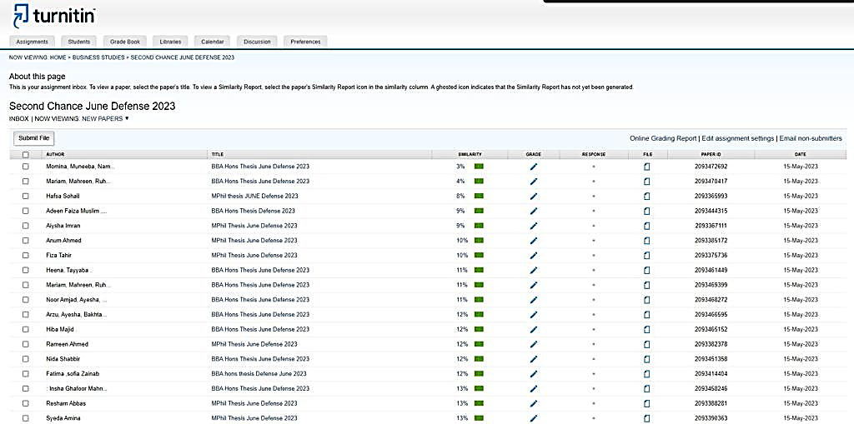
PLAGIARISM REPORT:

