AN EMPIRICAL RESEARCH ON CUSTOMER SATISFACTION OF PEL COMPANY



ZARLISH NADEEM AND NIDA ILYAS
F17BBAM009 AND F17BBAM094

DEPARTMENT OF BUSINESS STUDIES
KINNAIRD COLLEGE FOR WOMEN,
LAHORE, PAKISTAN

BACHELORS IN BUSINESS ADMINISTRATION


ZARLISH NADEEM AND NIDA ILYAS
F17BBAM009 AND F17BBAM094

SESSION: 2017-2021

AN EMPIRICAL RESEARCH ON CUSTOMER SATISFACTION OF PEL COMPANY


A THESIS SUBMITTED TO
KINNAIRD COLLEGE FOR WOMEN
IN FULFILLMENT OF THE REQUIREMENTS
FOR THE DEGREE OF
BACHELORS IN BUSINESS ADMINISTRATION

BY
ZARLISH NADEEM AND NIDA ILYAS
F17BBAM009 AND F17BBAM094

DEPARTMENT OF BUSNIESS STUDIES
KINNAIRD COLLEGE FOR WOMEN,
LAHORE, PAKISTAN
2017-2021

DISSERTATION APPROVAL
KINNAIRD COLLEGE FOR WOMEN

Date: June 2023
I hereby recommend that the dissertation prepared under my supervision by
Name of Candidates: Zarlish Nadeem and Nida ilyas
Registration No: F17BBAM009 and F17 BBAm094

Entitled
Title: “An empirical research on Customer satisfaction of PEL Company” be accepted in partial fulfillment of the requirements for the degree of

BACHELORS
IN
BUSINESS ADMINISTRATION (BBA)



In Charge of Dissertation



Head of Department
Recommendation concurred in
1.
2.
Committee
for the
Final Examination
3.
4.

RESEARCH COMPLETION CERTIFICATE

It is certified that Ms. Zarlish Nadeem and Ms. Nida Ilyas of Bachelors (session 2017-2021), Department of Business Studies has carried out research work entitled “An empirical research on Customer satisfaction of PEL Company” under my supervision.

It is assured that the research work is original and has not yet been published anywhere else.
“All changes suggested by examiners during defense are incorporated in this final copy”.

Dated: June 2023

Supervisor
Anam Tariq
Head of Department
Dr. Urusa Fahim

ANTI – PLAGIARISM DECLARATION

I certify that this is my own research work. The work has not, in whole or in part, been presented elsewhere for assessment. Where material has been used from other sources, it has been properly acknowledged. The similarity index of the research report is 4%. If this statement is untrue and I am found guilty of plagiarism, the punitive actions against me should be taken as per Kinnaird Anti Plagiarism Policy.

Zarlish Nadeem F17BBAM009
Nida Ilyas F17BBAM094

Program: Bachelor’s in business administration

Supervisor
Anam Tariq

Head of Department
Dr. Urusa Fahim

ABATRACT
An organization called Pak Elektron Limited (PEL) specializes in engineering and produces electrical supplies and household appliances. Pak Elektron Limited (PEL) also encourages moral leadership, ethical conduct in the workplace, a safe working environment, and a sense of civic duty. Due to the availability of power products in addition to tools for a more efficient life, Pak Elektron Limited (PEL) improves the daily lives of its customers. Customer satisfaction, brand image, customer services, and marketing communication are all examined in connection to this study's focus on customer satisfaction. Three hundred closed-ended surveys completed by Pak Elektron Limited (PEL) Company the customers in Lahore and submitted electronically form the basis of the main research. With the use of random sampling, the study's population was established. There will be both male and female members of the target demographic. The group of people that make up the target audience range in age from 30 to over 51. The target population were mainly consists of those who regularly buy Pak Elektron Limited (PEL)home goods. In order to better understand how each of the independent variables—brand image, product quality, customer service quality, and marketing communication—relates to customer satisfaction, this study will provide details on those relationships. The study's aim is to understand the several arguments for how to fulfill the expectations or needs of the consumer. It's important to understand the connections between many components in order to buy the things and satisfy customer expectations or wishes. The results will show that high levels of customer satisfaction, which imply that consumers will keep buying Pak Elektron Limited (PEL) products, are brought about by consumers' contentment with the items' high quality, the brand's reputation, its customer support, and its marketing messages.

AN EMPIRICAL RESEARCH ON CUSTOMER SATISFACTION OF PEL COMPANY

Table of Contents
CHAPTER TITTLE PAGE

Dissertation approval certificate
Research completion certificate
Anti – Plagiarism declaration
Abstract

1 INTRODUCTION 3
1.1 Introduction of the Company 4
1.2 Research Rational 5
1.3 Problem Statement 6
1.4 Research Objective 6
1.5 Research Hypothesis 6
1.6 Theoretical Framework 7

2 LITERATTURE REVIEW 8
2.1 Brand Image 8
2.2 Product Quality 9
2.3Customer Service 10
2.4 Marketing Communication 12
2.5 Customer Satisfaction 13

3 RESEARCH METHODOLOGY 15
3.1 Research Design 15
3.2 Target Population 15
3.3 Sample 16
3.4 Sampling Technique 16
3.5 Data Collection 16
3.6 Analysis Technique 17
3.7 Analysis Tool 17
3.8 Definition of the Study Variable 17
Customer Satisfaction
Product Quality
Brand Image
Marketing Communication
Customer Service
3.9 Measure 18

4 RESULTS 19
4.1 Characteristics of the Sample 19
4.2 Descriptive Statistics of Sample 22
4.3 Reliability Analysis 22
4.4 Correlation Matrix 23
4.5 Regression Analysis 24
4.5.1 Assumptions 25
4.6 Multiple Regression 34
4.7 Findings 35
4.8 The Strategic Analysis of the Company 36
4.8.1 SWOT Analysis 36
4.8.2 BCG Matrix 38
4.8.3 PESTEL Analysis. 40

5 DISCUSSION 42
Recommendations 43
Conclusion 44
Limitations 45

6 REFERENCES 4

CHAPTER I

INTRODUCTION
Customer satisfaction is defined as a statistic that indicates how effectively a company's products or services fulfill its clients' requirements. One of the most important indicators of a consumer's willingness to purchase and loyalties are their level of satisfaction. A commitment to providing the best possible customer service can win you the loyalty of your consumers and establish you as a market leader. It is crucial to keep an eye on the quality of customer service you provide in today's world when social media influences so many decisions. You can expect to be displeased if you don't.
If you are not concerned about your customers' pleasure, you shouldn't expect customers to care about your products or services. It is beneficial for the sake of the business to ensure customer satisfaction and increase customer loyalty as marketing serves as a crucial part in keeping a service or good competitive.
The concept of "brand image" refers to how consumers view a company. It may be characterized as how a client sees a brand. This image evolves as time passes. Depending on their interactions with a brand, consumers form views about it. These encounters may take many different shapes and aren't frequently connected to using or buying products and services.
Numerous academics concur that brand value is a substantial indicator of customer loyalty and satisfaction (Wu, 2011). In accordance with marketing research and actual data, reputation has a favorable effect on satisfaction (Yu, Chin, and Hsiao, 2011; Zeithaml et al., 2006)
An important and complex component of an organization's marketing strategy is marketing communication. Marketing contact may take many different forms, including advertisements, direct marketing, branding, packaging, websites, printed materials, PR occurrences, presentations for sales, sponsorships, trade fair appearances, and even more. The right message delivered at the right time can have a huge effect on your customers. It has the potential to make your customers happy with their interactions with you. Customer satisfaction is achieved by making consumers feel heard, cared about, valued, and involved in decision-making. Customers, above all, want to feel informed, particularly when it comes to matters that affect them personally.
By upgrading items and removing any faults or imperfections, functioning that may satiate customer desires and foster customer loyalty is referred to as product quality. Products that are worthwhile must have a compelling value proposition, resolve a genuine problem, be simple to utilize, as rapid and efficient as feasible, get better with each usage, and be harder to stop using. Product quality is the lifeblood of quality management, ensuring that customers can purchase high-quality goods and services with long-term dependability (Feigenbaum, 1945; Feigenbaum & Feigenbaum, 2009). Improved processes that result in a stable and consistent production of goods achieve product quality.
Customer service is the help you give to your clients earlier, during, and after they buy and utilize your products or services with the objective to make it as easy and pleasurable as you can for them. You have to provide outstanding consumer service if you intend to maintain clients and grow your business. Today's world of customer care goes well beyond the traditional phone support worker. It may be accessible through social media, email, the internet, and text messaging. Many companies now offer self-service support, enabling customers to find solutions at any time of day or night. Customer service is a crucial component of the commitment that your business makes to its consumers and goes beyond just responding to inquiries. Customer satisfaction can be achieved by meeting the needs and desires of customers and delivering services that meet industry standards (Gitomer, 1998). Many organizational researchers have indicated that customer service is a good predictor of customer retention and satisfaction. Customer assistance is a crucial element of client happiness and has a significant impact on client loyalty.

1.1 INTRODUCTION OF THE COMPANY

Pak elektron limited (PEL) is an engineering company that manufactures electronic home appliances and supplies that include water dispensers, refrigerators, LED, air conditioners and microwave ovens. It also has a power division that produces three main products including energy meters, converters, and switchgear. The German corporation Allgemeine Elektricitats-Gesellschft (AEG) took control of the Pak Elektron Limited (PEL) Company in 1956; however, the Saigol Group of Companies eventually bought it in 1978. In addition to Pak Elektron Limited, the Saigol Group of Companies also operates Kohinoor Textile Mills, Saritow Spinning Mills, Azam Textile Mills, Kohinoor Power Company Limited, and Kohinoor Energy Limited. After a number of years, PEL agreed upon an agreement with many global juggernauts, such as General Electric, Fujitsu, and Hitachi. PEL also obtained the only distributorship for LG Corporation's home appliance line in 2009. The goal of the PEL Company is to excel at offering engineering items and services by constantly enhancing the caliber of its output. The company's objective is to deliver high-quality goods and services that go above and beyond what consumers expect, desire, and want.
PEL promotes moral leadership, sound business principles, a secure work environment, and a feeling of social responsibility. PEL makes a daily difference in the lives of its consumers since it offers power items in addition to equipment for a more proficient living. In order to produce hundreds of engineers, qualified employees, and technicians, the corporation has set up a training initiative. The business has consistently released a selection of high-quality appliances and electrical equipment. PEL Company's development of the engineering sector and training initiatives in Pakistan have resulted in the production of hundreds of engineers, skilled employees, and technicians. Now a day, marketing or advertising are growing highly. Company tries to innovate its products in developing.
The study describes the connection between independent variables like brand image, product quality, customer services quality and marketing communication on customers satisfaction as a dependent variable (Nethangwe&Shambare, 2008). The reason of this study is, to recognize that whether the independent variables effects on customers satisfaction (Othman et al, 2016).
1.2 Rationale of the study:
The goal of the study is to comprehend the many justifications on how to meet client demands or needs. To meet client demands or wants, it is necessary to determine the relationships among numerous aspects in order to acquire the items. The study's goal is to look at the variables that have an impact on customer satisfaction. Product quality, brand perception, customer service quality, and marketing communication with consumers may all have an impact on a company's product sales. Customer satisfaction signifies priority of success and profit of the company.

1.3 Problem Statement:
To research how a company's brand image, product quality, level of consumer service, and marketing communication affect its consumer happiness. For our research purpose, the interview was conducted from one of the managers of PEL Company. We concluded that customer satisfaction is the main problem of the company, less promotes their products as compare to other competitors and also, they do not use expensive equipment’s for their products.
Consumer satisfaction is an evaluation of how products meet or surpass the client's desires. Customer satisfaction determines the consumer loyalty with its buying behavior pattern. The customer satisfaction is a make or break of a business. The factors that influence customer satisfaction are quality of product, price, deliverability, accessibility etc. Our study aims at elaborating the relationship between each of the independent variables (brand image, product quality, customer services quality and marketing communication) with a consumer satisfaction. Hence, while carrying out hypothesis testing, we shall see how these variables are related to the endogenous variable i.e., customer satisfaction.
1.4 Research Objectives:
- To study the impact of brand image on customers satisfaction.
- To study the impact of advertising on customers satisfaction.
- To study the effect of product quality on customers satisfaction.
- To study the effect of customer service on customers satisfaction.
1.5 Research Hypotheses:
Following hypotheses are formulated for the research:
H1: Customer satisfaction and brand image have a substantial link.
H2: Advertising and consumer satisfaction are significantly correlated.
H3: The degree of consumer happiness and the caliber of the product are closely related.
H4: Customer satisfaction and customer service are strongly correlated.

1.6 Theoretical framework:
Brand Image
H1
H2
Customer satisfaction
Marketing Communication

H3
Product Quality
H4
Customer Services
Figure 1. Theoretical

Figure 1: Theoretical Framework
Independent variables: Brand image, Marketing communication, Product quality, Customer service
Dependent variable: Customer Satisfaction

CHAPTER II

LITERATURE REVIEW
2.1 Brand image:
Brand can make customers satisfied by creating the positive vision of the brand (Nyadzayo, 2016).The consumer perception of a good brand helps to increase the number of customers and in such a way trust of the customer can also be gained. The author states that brand image is treated as a resource which indicates the consumer’s understanding level related to the product (Chao, 2015). Researcher states that brand image has the positive relationship with customer satisfaction and service quality (Rahi, 2016).
The researcher states that the customer perception regarding the brand varies between different networks. The image of brand is promoted on different channels with changed statements so that number of members could be attracted towards the brand. Major cause of difference occurs among brands is due to the customer’s experience with wholesaler or retailer (Matthiesen, 2010).
Brand image identifies the product or services of an organization and experience of the customer from that brand rather than identifying design or jingle of the company (M. Ahmed, 2019). The author states that for creating positive brand image among customers the brand should focus on quick delivery, reliability and stability of the company’s product. The brand image of any organization can be easily identified by its immediate deliveries (Chen, 2017).
The customer's perception of a brand is referred to as its image. Whenever the customer hears about the name of the brand the first thing that comes into his mind are the features of the product and services being offered to them (Saleem, 2014). The researcher states that brand image can also be described as the benefits the brands gives to its customers (Maroofi, 2012).
The store location and design also have the great impact on creating positive brand image of the brand. As a store located at a good location and decorated correctly helps to attract the customers. Customers are more likely to be attracted towards the attractive retail store instead of low maintained stores. Brand image main goal is to fulfill the demands of the customers, retain the customers and identify the customer value. The researcher states that customers having positive perception related to the certain brand are influenced to purchase their products often. The customers are more expected to get attracted towards the low-price product and services of the brand (Rayburn, 2013). Brand image also has the direct influence on the brands loyalty, awareness of the brands products and equity (Šerić, 2012).
2.2 Product Quality:
The literature review includes conversations for explores and examines identified with the mechanical designing theory in overseeing quality and profitability frameworks (Salegna, 2011). The idea of quality systems includes hypotheses key to the development also, execution of work cost-saving strategy, product quality upgrade, and safety measure. Product safety and purchaser fulfillment related with product quality and cost control in the United States is one of the phenomena that have stimulated exploration among researcher professionals. Quality control products the board professionals search for answers for meet buyer item wellbeing and client fulfillment demands (Xu H. , 2013).
Interestingly, paying little heed to cost, low quality makes consumers despise the products (Terpstra, 2014). Henceforth, high item quality is indistinguishable from benefits related with product costs that do not limit item security credits to customer fulfillment related with product safety (Golder, 2012). The researcher state that as a result of product quality and high product costs related with item security includes that have affected serious contributions and product correlations in the market (Natarajan, 2013).
According to the authors, increasing overall administration or production cycles results in more consistent product yield, fewer mistakes, and revisions that ensure customer loyalty and market dominance. (Chalotra, 2012). Also, limiting misuse of labor, machine-time, and materials to improve or support output with less exertion to guarantee purchasers' fulfillment and customer product reliability (Aggogeri, 2015).
The author believed that product quality and product cost mean various things to various buyers (Kim, 2013). The ideas of product quality and product cost envelop an assortment of drivers and suggestions for business exhibitions, which are not yet completely comprehended (Giebelhausen, 2017) .If a product satisfies the customer’s assumptions, the customer will be satisfied and think about that the item is of adequate or even great to use. On the impact of product cost and product security, contended for effective expense moderation without settling product safety and consumer loyalty (Terpstra, 2014).
Customers choose products differently depending on the level of product quality. Due to advancements in prices and product quality levels that unexpectedly have a significant impact on little expenses, quality improvement takes considerable commitment and resources (Farris, 2017). Enhancing product quality control will aid consumer loyalty and dependability in the marketplace. While researching different aspects of the relationship between product quality and consumer loyalty, I discovered that product quality is a factor that influences consumers' loyalty and the desire for safe products from buyers (Waters, 2017).
According to the authors, consumers have the final word on quality, thus efforts to improve quality should ensure that items are of consistently high quality when they are delivered to customers as well as simply satisfying specifics and minimizing flaws and variations (Xu, 2013). Product quality has direct connection with beneficial outcome on piece of the market share (Tellis, 2019). Product caliber is rising Consumer loyalty is increased through understanding the nature of the product (Cameroon, 2019). From this point forward, the effect of quality on customer loyalty affects increasing lifetime incentives for customers and businesses.
2.3 Customer service:
Customer service refers to the care of consumers before, during, and after a transaction. Everyone in the company does one or more of these things, and they may not even realize it.
Author states that the customer services are tangible or intangible value-adding operations that are directly or indirectly linked to goods or services in order to fulfill customer needs and, ultimately, provide customer satisfaction and loyalty (Kursunluoglu, 2011).
Consumer satisfaction can be achieved by ensuring that customer needs are met with the assistance of customer service. Retailers must have outstanding customer service to meet consumers' needs. The author states that the customer service levels are determined by a variety of factors, including retailer characteristics, competitor services, and type of product treated, store price picture, target market revenue, and service cost (al, 2011).
Another author described that the customer satisfaction happens when customer service meets or exceeds the needs of the customer (Berman and Evans, 2010).The researcher states that the standard idea of friendly salespeople providing high-quality customer service has become the minimum prerequisite for attracting customer interest. Customers now expect tailored offerings that cater to their preferences, needs, and lifestyles
(Lim, 2018). Traditional definitions of good customer service include encounters between salesperson and consumers that are kind and beneficial in person. This worldview is evolving due to developments in new technology.
The customer support is crucial in today's active traditional/online business world, and customer service conversation mining can be a valuable source of business intelligence. In light of this, sentiment analysis in customer service discourse is crucial in a variety of applications, including service satisfaction analysis (al G. A., 2017).
Any business with satisfied customers will grow its customer base and, as a result, its sales. Customers who are satisfied with your services can consciously or unconsciously promote your business. As a result, in order to satisfy, sustain, and grow their client base, service businesses must have exceptional customer service.
According to the author, consumer satisfaction is significantly impacted by consumer service behaviors. Both favorable and adverse customer service behaviors are the two categories that make up customer service behaviors. Service actions that go above what is required of them in their roles (al C. e., 2018). Studies have demonstrated that good customer service practices increase client loyalty and overall service effectiveness (Tsaur et al., 2014). According to the author, expected customer service habits include greeting clients by name, thanking them, showing common politeness, and cross-selling firm items. Other examples include offering correct information about the company's goods or services (Chen & al, 2017 2014).
The researcher states that improving performance and lowering prices without sacrificing service quality is a big challenge for customer service (al G. A., 2017)). The simplicity and adaptability of self-service channels are appealing to clients, but they also enjoy the individualized focus that personal service channels provide, according to another author (Scherer et al, 2015). Individuals or automated self-service systems may provide customer service.
2.4 Marketing Communication:
The marketing communication is an interaction where a client sees a contribution, item, administration, organization or individual. It can be deliberated in a form of context or in the head of the customer. It can incorporate insight, measures, exercises setting off esteem being used for the customer, and can comprise of a few simultaneous senders (Finne, 2017). Marketing Communication is the cycle through which the company and the audiences are engage with one another (Chris Fill 2013, 2013 ).
Each and every instrument for example, publicizing SP, sponsorship PR, direct promoting, e-communications through which the organization speaks with its objective gatherings and partners to give its items or the organization overall is known as marketing communications(al., 2013 ).
The Marketing Communication refers to the method embraced by the organizations to pass on messages about the products that the brands want to sell. Either directly or by suggestion to the client with the goal to convince them to buy the product (Elwan, 2012). The primary goal of marketing communications is to increase the ego of the consumer as well as emphasize the significance and benefits of the brand (al., 2015 ).
The great and effective marketing communications can help to resolve many queries of the customers for example, who can utilize the item, where and when the item can be utilized and how it can be well utilized ((Micael Dahlen, 2011). Brand value may be shaped by marketing communications, which can also boost promotional effectiveness (Bogan, 2014). The development of fast-changing marketing communication is not the only or even the primary factor in increasing brand value and generating sales; it may also be a tool for doing so by combining other forms of advertising communication.
Marketing communication is an interaction which coordinate various communication tools. The main purpose of the market communication tools is to communicate efficiently with the targeted audience. There are five main marketing communication tools which are mixed together indifferent combinations to communicate a meaningful message. The main five communication tools are Advertising, Public Relations, Sales advancement, Direct Marketing and Personal Selling (strong, 2017). Marketing communications is an interactive conversation between the organization and its external and internal environment. The main purpose of this conservation is to meet the addressee needs by the company’s market offer.
2.5 Customer Satisfaction:
For satisfying a customer, products should be supplied to them according to their needs and wants. Through this way customers can be satisfied in the competitive market. Dissatisfied customers share their experience with others and create bad status of the company (Ahmed, 2014). Customer satisfaction is achieved by following certain market strategies with the help of which company gains profit and becomes successful in the market (al E. C., 2014).
Author states that there is no consensus among researchers on whether the relationship between customer satisfaction and business performance is direct or indirect (Saeidi, 2015). Nonetheless, the fact that researchers agree on the existence of a connection between customer satisfaction and business performance is important to us.
The author states that customer satisfaction is a metric that measures the difference between real and expected experiences (Nguyen, 2015). The brand must deliver on their commitments to have a clear positive effect on purchasing intention, and if they can continue to deliver levels of integrity above and above what they promised, they can also experience higher levels of customer satisfaction and loyalty (al, 2011). Another author describes that the customers' loyalty and buying intentions are improved by brands using modern social media to share all of the details about the brand that customers want. (al & al, 2020). The author addressed the importance of using a variety of social media elements to increase customer participation in co-creation. (al P. e., 2011).
In reality, today customers are more engaged with brands than ever before, and they want to play a bigger role in the buying process. The author states that to increase purchasing intent, brands must engage with customers on a regular basis (al P. e., 2011). Through author’s instant feedback and peer group reviews are now possible thanks to the semantic web and social media sites, which influence purchasing intentions. (al H. ´., 2012). Author states that to positively impact purchasing habits, brands must have a better experience. (al., 2010).
Consumer satisfaction assumes a significant part in business technique and goes about as a critical factor in the feasible improvement of organizations (Vazifehdust, 2013). Numerous investigations characterize the idea of customer satisfaction. The author says that the degree of consumer satisfaction is evaluated by contrasting a view of a product or service according to the assumption for clients (Kotler, 2015).
Numerous investigations have demonstrated the connection between service quality and customer satisfaction (Singh, 2014). The researcher state that these examinations have concurred that corporate picture positively affects perceived value and consumer satisfaction (Sarstedt, 2013). Likewise, the author recommended that perceived value decidedly influence consumer satisfaction (Young, 2013).

CHAPTER III
METHODOLOGY
This chapter has the purpose to explain the significance of methodology, research type, importance of sampling, sampling size and technique to collect pertinent data and involvement of tests to analyze data.
3.1 Research Design:
Amid multiple approaches, Research design illustrates the all-inclusive strategy adopted by this research that offers a concise as well as logical plan to address the research objectives through collecting, interpreting, analyzing, and conducting data discussion including the type of research (Sileyew, 2019). This study was of empirical nature that undertakes an investigation supported by observation or experimentation that includes scientific methods (Bruns, 2007). While scientific methods are divided into quantitative and qualitative methods. This study chose to follow quantitative method. Justification of pursuing quantitative method was based on wider coverage of population and objectivity in quantifying variables to measure up results. It further involves gathering of facts from general to specific called deduction process (Abdullah, & Kumar, 2012).
The research followed cross-sectional method as it pertains to collection of data at one time and explanatory in setting. Target population was from among the consumers of automobile sector those were more relevant to answer the questions set to advance the research following the survey technique to conduct interview on face-to-face basis (Saunders, Saunders, Lewis, &Thornhill, 2020). The rationale of adopting this approach was to interpret people perception that attracts quantitative method as a best suitable method to analyze perceptive frame of mind of participants (Taherdoost, 2016).
The study setting is non-contrived environment of engineering industry locating in Lahore. Keeping in view of the study objectives, behaviors of individuals those are involved in managing engineering sector i.e., PEL consumers were beset.
3.2 Target Population:
Population is indicative of participants included as subjects or events characterized by properties that have immense value for researcher (Fraenkel and Warren, 2002). Population was determined for the study from the random sampling method. The target population will be both male and female. The target population includes the group age of 30 years to above 51 years. Mostly target population will be the one who usually purchase PEL household products e.g., fridges, air conditioners, water dispensers, LED lighting, microwave ovens, and power division, which comprises of three key items such energy meters, transformers, and switchgears or had intentions to purchase. (Nunnally, 1978) will select sample size as per item response theory.
3.3 Sample
This study is going to acquire primary data using a structured questionnaire from the customers of PakElektron Limited (PEL) located in Lahore. From the population, we chose customers living in Lahore and applied random sampling technique. The sample included 320 responses as a sample size of study was taken based on a theory by Nunnally, (1978) as ten multiply by the number of items in the questionnaire i.e. (30*10=300). As 20 responses were added from the pilot study. The questionnaire was uploaded on Google forms and then revolved around through different social media websites.
3.4 Sampling Technique:
Linked with the above section, this study followed the random sampling technique as it involved selection of selected sample units is based on conveniently available people (Zikmund, 2000). For this study, random sampling method was taken because this technique was helped to collect data more quickly with low cost. It was more convenient, easily available for data collection and access to consumers of PEL Company.
3.5 Data Collection:
For the purpose of data collection, the original source i.e., primary data was relied on to acquire information. The primary data being reliable and having more confidence level in relation to occurrence of events was selected for decision-making. For this study, the primary source of acquiring information was consumers of PEL household products. A pre-defined procedure was followed for data collection (Grinnell, Unrau, 2010) employing a questionnaire to draw out a tally of variables whose effect will be measured up on customer passionate desire to purchase.
The survey questionnaire was thought to design that includes all constructs taken from the proposed model to scrutinize the hypotheses of concern. The questions were developed with the help of pertinent literature review and other works from researches. The survey questionnaire is comprised of five sections. The 1st section looks out to focus sample characterization. The 2ndsection focused to measure the brand image with ten items using five-point Likert-type scale. The 3rd section targets to measure product quality apprising four items to measure on five-point Likert scale. The 4thsection shaped to measure customer services having nine items using five-point Likert scale while the 5th section aimed to measure marketing communication covering four items. The following variables were selected for participating this study:
Customer satisfaction was considered the dependent variable, with brand image, product quality, marketing communication, and customer services being the independent factors.
3.6 Analysis technique:
Data analysis is used in this part, with a focus on numeric and quantitative data evaluation. The methods used to solve the research issues posed in the problem statement are further implicated by data analysis. Utilizing MS Excel and SPSS 26.00, quantitative data from primary sources was examined and evaluated. Prior to beginning analysis, responses are coded. After completion, the data is prepared to be entered into a software program for statistical analysis.
3.7 Analysis tool:
At this level, descriptive statistics and graphical analysis are used to investigate the data. Via group comparison, the analysis explores the relationship between independent and dependent variables as well as the reciprocal impact of data. Tools like cross tabulation/chi square, correlation, and factor analysis are carried out using nonparametric statistics based on previous research.
3.8 Definition of study variables
3.8.1. Customer satisfaction
Customer satisfaction is a function of how effectively the company's services and goods meet the needs of its consumers and how well expectations are satisfied (Oliver, 1980).
3.8.2. Product quality
If the firm's clients think it is doing admirably, or delivering on its service quality claims, this ought to immediately influence increased delight (Harris & Goode, 2004).
3.8.3. Brand image
The consumer's opinion of a company's goods is referred to as its brand image (Saleem and Raja, 2014). The advantages, traits, and characteristics of a brand might be what consumers would like to acquire (Maroofi, Nazaripour and Maaznezhed, 2012).
3.8.4. Marketing communication
The technique of connecting with clients, either directly or indirectly, and luring them in is known as marketing communication (Kotler and Amstrong, 2005). It comprises communicating to consumers the message that drives product development and sales growth through effective marketing communication or marketing strategy.
3.8.5. Customer service
According to the author, providing assistance for consumer complaints and demands constitutes providing customer service (Bauer, Falk and Hammer Schmidt, 2006). Customer satisfaction is crucial for every business, thus management ought to place a strong emphasis on providing top-notch services.
3.9 Measures:
The t-test, correlation, regression analysis, factor analysis, and nonparametric statistics are likely to be used at the data analysis stage of statistical software analysis in order to assure procedural correctness and measurement precision. A linear connection can be detected using the T-test. The non-parametric test helps to compare the model with the observed data to point out error or bias factor exist in data. Application of Exploratory factor analysis i.e., EFA requires the use of five observations against a measurement variable, and the total quantity of observations must be fewer than 100. The survey model has a dependent variable component and four independent variables. As a result, 30*10=300 is obtained by multiplying observations obtained for a sample. Thus, 30 observations were used in this study's survey.

CHAPTER IV
RESULTS
The sample data was collected and then we ran the data on SPSS. The analysis performed were Regression, multiple regression, correlation matrix, reliability analysis, univariate and bivariate analysis. These are as following:
4.1 Characteristics of the sample:
Demographics are the characteristics of the respondent from whom data is collected. It shows the summary of the data and measures that are used. It is performed on control variables, in our data set there are the following demographics:
Table 4.1
Demographics of sample
Univariate Analysis
Table 1: Gender wise description
 | Gender
Frequency | Percent | Percent
Female | 191 | 62.0
Male | 109 | 35.4
Total | 300 | 97.4

Interpretation:
In the above table frequency analysis is performed on gender. There is total 300 respondents out of which 191 are female (62.0%) and 109 are male (35.4%).

Table 2: Marital Status wise description
 | Marital Status
 | Frequency | Percent
Married | 113 | 36.7
Unmarried | 187 | 60.7
Total | 300 | 97.4

Interpretation:
The above table shows the frequency analysis of marital status. There is total 300 respondents out which 113 (36.7%) are married and 187 (60.7%) are unmarried.
Table 3: Age wise description
 | Age
 | Frequency | Percent
less than or equal to 30 | 209 | 67.9
31-40 | 60 | 19.5
41-50 | 25 | 8.1
above or equal to 51 | 6 | 1.9
Total | 300 | 97.4

Interpretation:
Analysis on age demographic is performed in which first age group of respondents is less or equal than 30. The second group of respondent lies from 31 to 40, third group between 41-50 and last group of respondent lies above or equal to 51.

Bivariate Analysis
Table 1: Gender and Income Cross-tabulation
 |  | Income |  |  |  | Total
 |  | less than or equal to 30,000 | 31,000-60,000 | 61,000-90,000 | greater than 91,000 | Total
Gender | Female | 85 | 44 | 39 | 23 | 191
Gender | Male | 19 | 30 | 27 | 33 | 109
Total |  | 104 | 74 | 66 | 56 | 300

Interpretation:
In the above table we performed bivariate analysis on gender and income in which 300 are the respondents. It shows income of 85 females and 19 males lies less than or equal to 30,000. The income of 44 females and 30 males is lies from 31,000 to 60,000. Third group of respondent income lies from 61,000 to 90,000. The fourth group of respondent has income greater than 91,000.

Table 2: Gender and marital status cross-tabulation

 |  | Marital Status |  | Total
 |  | Married | Unmarried | Total
Gender | Female | 65 | 126 | 191
Gender | Male | 48 | 61 | 109
Total |  | 113 | 187 | 300

Interpretation:
The bivariate analysis is conducted on gender and marital status. There istotal 300 respondents in which 191 females and 109 are male. There istotal 113 respondents married in which 65 are females and 48 are males. The total unmarried are 187 in which 126 are females and 61 are males.

4.2 DESCRIPTIVE STATISTICS OF SAMPLE
Table 4.2
To compute mean and the standard deviation of our sample we performed the following analysis:

Variables | Mean | Std. Deviation
Brand image | 3.4697 | 0.66522
Product quality | 3.6433 | 0.81625
Customer service | 3.3819 | 0.74460
Marketing communication | 3.6142 | 0.84135
Customer satisfaction | 3.7164 | 0.86600

The above table shows the mean of BI is 3.4697 and standard deviation is 0.66522. Mean of PQ is 3.6433 and standard deviation 0.81625, CS mean is3.3819 and standard deviation is 0.74460. The mean of MC is 3.6142and standard deviation 0.84135, CSA mean is 3.7164 and standard deviation 0.86600.
4.3 Reliability analysis
The Cronbach's Alpha values that are more than 0.7 and indicate strong dependability are displayed in the table below. Cronbach’s alpha value is calculated to test the reliability and consistency between the items of each variable i.e. Brand image, Product quality, Customer service, Marketing communication and Customer satisfaction. The value if reliability should be equal or greater than 0.7 and 0.90 value can be also accepted. The value near 0.90 is excellent, 0.80 as very good and alpha value approximately 0.70 as adequate.

Table 4.3
Reliability Analysis
Scales | No. of items | Cronbach's Alpha | Level of reliability
Brand image | 10 | .835 | Very good
Product quality | 4 | .754 | Adequate
Customer service | 9 | .836 | Very good
Marketing Communication | 2 | .739 | Adequate
Customer Satisfaction | 2 | .798 | Very good

Interpretation:
In the table the value of Cronbach’s alpha of all the variable is more than 0.7. The range of reliability is from adequate to excellent i.e., 0.739 to 0.836 and the internal consistency is 74% to 83.6%.
4.4 Correlation Matrix
The correlation analysis is carried out to evaluate the direction and potency of the variables. Through the (**) signal the values of correlation shows significant relationship between the variables.

Table 4.4
Correlations Matrix
 |  | M. Brand Image | M. Product Quality | M. Customer Service | M.  Marketing Communication | M. Customer Satisfaction
- M. Brand Image | Pearson correlation | 1
- M. Product Quality | Pearson correlation | .645** | 1
- M. Customer Service | pearson correlation | .768** | .625** | 1
- M. Marketing Communication | pearson correlation | .660** | .607** | .622** | 1
- M. Customer Satisfaction | pearson correlation | .522** | .748** | .433** | .504** | 1

Interpretation:
In the table above it shows diagonal that are all equal to 1 because the variables correlate with each other. The correlation shows the direction of significant relation between the brand image and product quality (r=0.645, p<0.01), brand image also has a strong significant relationship with customer service (r=0.768, p<0.01), brand image and marketing communication has positively significant relation (r=0.660, p<0.01). The value of brand image and customer satisfaction also has a significant relation (r=0.522, p<0.01).
4.5 Regression analysis
Regression analysis evaluates the dependent variable and unbiased variables. The form of regression used often is liner regression that shows the lines which suits the data record. Regression analysis is commonly used for predicting and in case of infer causal relationship between independent and dependent variables.
Data set:
Our data set includes five variables brand image (BI), product quality (PQ), customer service (CS), marketing communication (MC) and customer satisfaction (CSA). Whereas, brand image, product quality, customer service and marketing communication are independent variables and customer satisfaction is dependent variable.
4.5.1 ASSUMPTIONS
Assumption 1:
The first assumption of regression defines that the value of your independent variable and dependent variable should be calculated continuously or quantitatively.
According to our data all the variables have different responses of each item. Therefore, our data fulfills the first assumption with continuous and quantitative values.
Assumption 2:
According to this assumption there should be liner relationship between the two variables. By using SPSS, we performed scatter plot in which dependent variable is plotted against the independent variable and evaluated linearity. The following scatter plot shows the liner relationship between the variables:
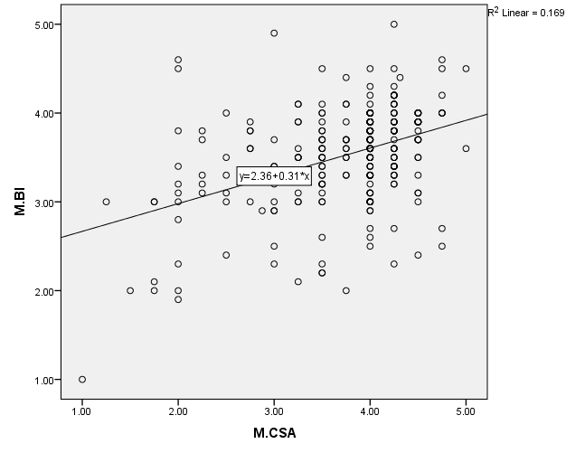

Interpretation:
BI is the independent variable adjusted at y-axis and CSA is the dependent variable adjusted at x- axis. It shows the scatter plot which means there is a liner relationship between the two variables BI and CSA. The above graph shows when y a-axis increase, the x-axis also increases.

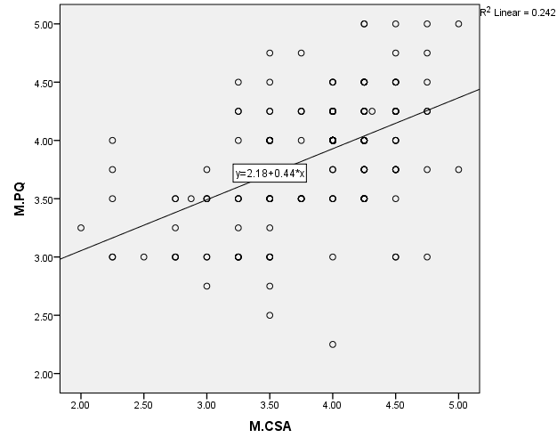
Interpretation:
The independent variable is PQ and CSA on x-axis is dependent variable. It shows scatter plot which means there is a liner relationship between the two variables PQ and CSA. The above graph shows when y a-axis increase, the x-axis also increases.

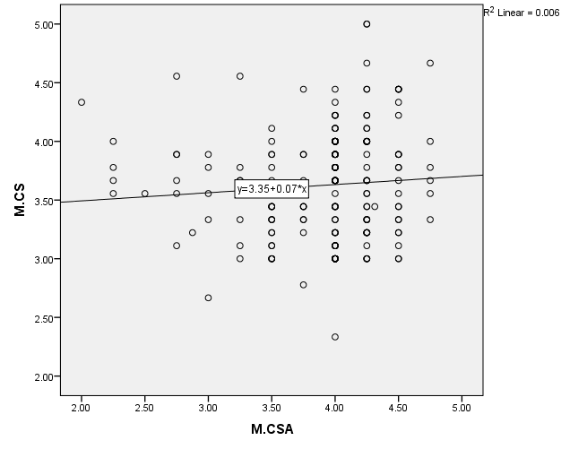
Interpretation:
CS is the independent variable that is on y-axis and CSA is the dependent variable on x- axis. It shows the scatter plot which means there is a liner relationship between the two variables CS and CSA. The above graph shows when y a-axis increase, the x-axis also increases.

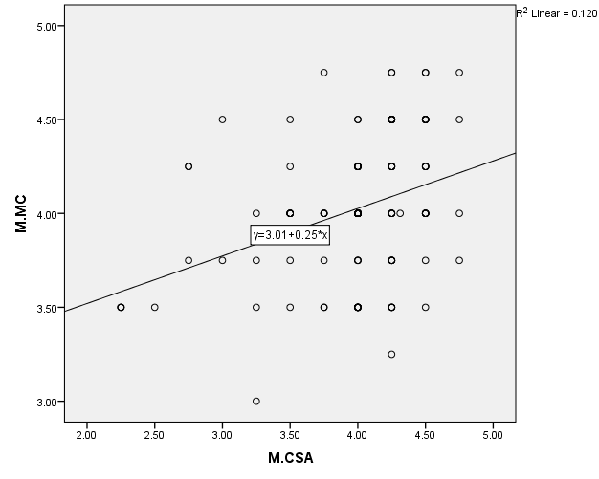

Interpretation:
MC on y-axis is independent variable and CSA on x-axis is the dependent variable. It shows scatter plot which means there is a liner relationship between the two variables MC and CSA. The above graph shows when y a-axis increase, the x-axis also increases.
Assumption 3:
According to the third assumption of regression there should be normality of errors. There are three main ways through which normality can be measured, through histogram or by kurtosis and skewness or KMO test. In our data we used histogram and kurtosis and skewness to check normality.
Checking through Histogram
Histogram of Customer Satisfaction
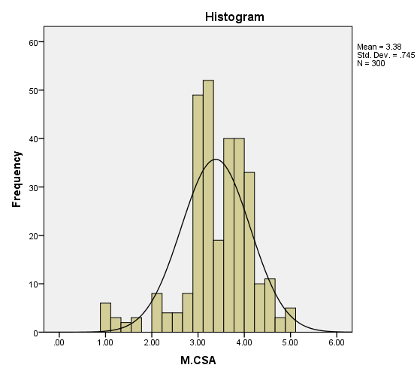

Interpretation:
The data shows normal curves which means data is normally distributed and there are no outliers significant.
Checking normality through kurtosis and skewness:
Another way to calculate normal curve is through kurtosis and skewness. The calculated values are as below:

Descriptive Statistics
 | Skewness | Kurtosis
 | Statistic | Statistic
M.BI | -1.389 | 3.234
M.PQ | -1.364 | 1.906
M.CS | -1.949 | 1.773
M.MC | -1.144 | 1.085
M.CSA | -1.403 | 1.560

Interpretation:
This analysis is performed to check normality of the data set. The range of acceptable kurtosis is +3 and skewness is +1 to -1. In our data the value of skewness of independent variable brand image is -1.389 and kurtosis is 3.234, so it’s acceptable. The skewness of independent variable product quality is -1.364 and kurtosis is 1.906, it’s within the range so acceptable. The skewness of independent variable customer service is -1.949 and kurtosis is 1.773 which is within the range so acceptable. Skewness of independent variable marketing communication is -1.144 and kurtosis 1.085 is that means acceptable range and data is normally distributed. The skewness of dependent variable customer satisfaction is -1.403 and kurtosis is 1.560, so it’s acceptable range and data is normally distributed.
Assumption 4:
In this assumption through Durban-Watson independence of observation is checked by performing it on SPSS. It includes auto correlation, multi –correlation and value of the condition index.
 | Model Summary
R Square | Std. Error of the Estimate | Durbin-Watson
.576 | .56790 | 1.683

Interpretation:
The acceptable range of Durbin-Watson is from 1.50 to 2.5. It evaluates the two variables if they are duplicate. The value of Durbin-Watson less than 1 is positive auto- correlation. The value when is within the range then no correlation and if value is more than range then negative auto-correlation. The value of our data is 1.683 that is within the range so acceptable. There is no auto correlation in our data set so the assumption is fulfilled.
Multicollinearity:
In a data set no multicollinearity is preferred. We check the tolerance values and VIF values for this step.
Coefficients
 | Sig. | Collinearity Statistics
 |  | Tolerance | VIF
M.BI | .000 | 1.337 | 2.970
M.PQ | .002 | 1.504 | 1.986
M.CS | .000 | 1.370 | 2.703
M.MC | .004 | 1.494 | 2.025
a. Dependent Variable: M.CSA

Interpretation:
The tolerance value should be 1 or more while VIF value should be less than 10. In the above table our data set value of VIF is less than 10 and tolerance value is within the range so acceptable. So, this means there is no multi collinearity in the data set.
Assumption 5:
The data set exhibits heteroscedasticity when the independent variable's value is less than 0.05, and homoscedasticity when it is more than 0.05.
Interpretation:
Analysis was performed on SPSS to check homoscedasticity. We generated the value of RES_1 and PRE_1 and then took RES_1 square. Later on, RES_1 square was taken and regression analysis was run on Sq. Res. The results are as following:
 | Coefficients
 | Unstandardized Coefficients | Sig.
 | B
(Constant) | .436 | 0.488
M.BI | -.148 | 0.613
M.PQ | .007 | 0.973
M.CS | .125 | 0.615
M.MC | -.103 | 0.591
a. Dependent Variable: Customer Satisfaction

Interpretation:
The analysis is run on all the independent variables whereas, customer satisfaction is kept as dependent variable in the above table that shows the significance value of brand image 0.613, product quality 0.973, customer service 0.615 and marketing communication 0.591. It means the significant values of independent variables is more than 0.05 which means there is no heteroscedasticity in our data.
Assumption 6:
According to the last assumption of regression residuals of the regression line are allotted commonly. There are two methods to test this assumption by histogram or by Normal P-P Plot.

P-P Plot of Mean BI
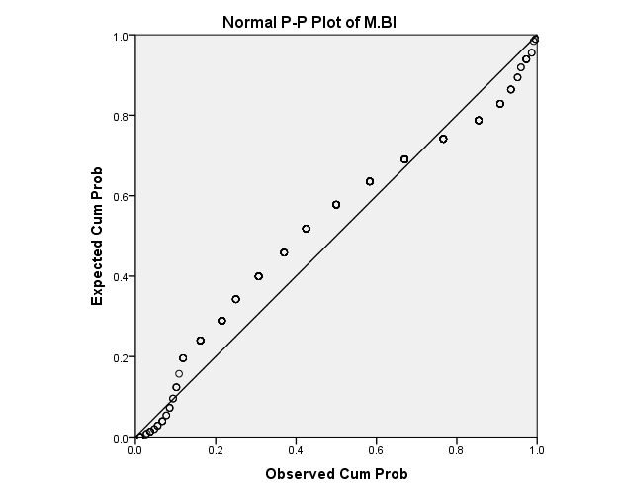

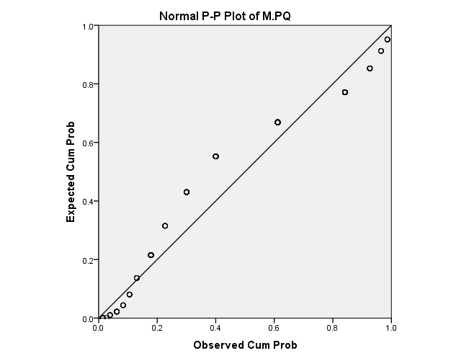

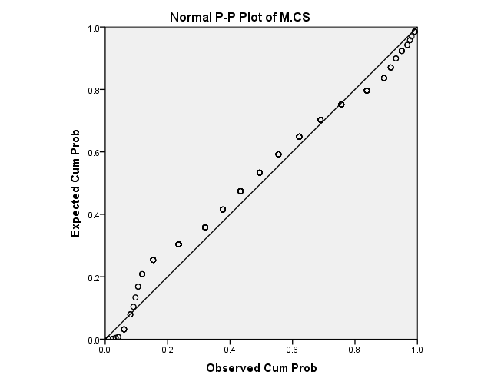

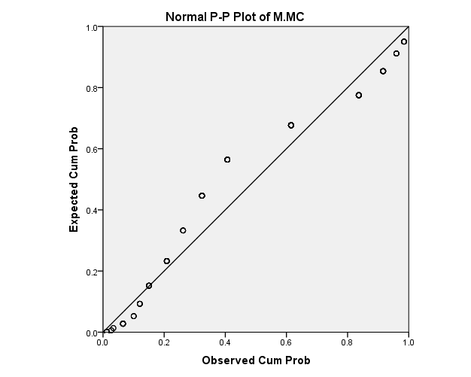

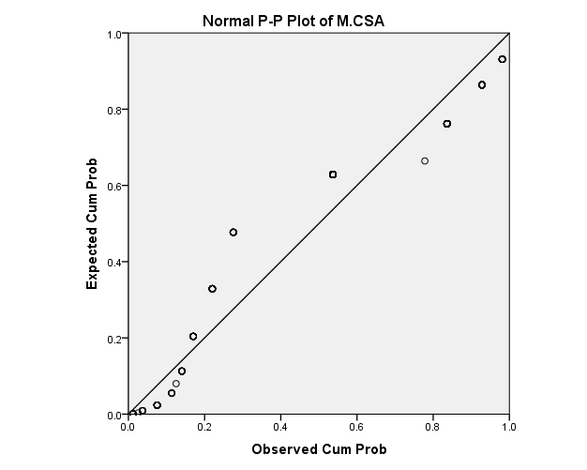
It is shown in the P-P Plots that there are no particular errors in the data set.

4.6 Multiple Regression:
In multiple regression we check the impact of dependent variable more than 1 on independent variables.
Coefficients
 | Unstandardized Coefficients |  | Standardized Coefficients | t | Sig.
 | B | Std. Error | Beta | t | Sig.
(Constant) | .693 | .183 |  | 3.795 | .000
M. Brand Image | .174 | .085 | .134 | 2.045 | .042
M. Product Quality | .760 | .057 | .716 | 13.399 | .000
M. Customer Service | -.201 | .073 | -.173 | -2.767 | .006
M. Marketing Communication | .091 | .056 | .089 | 1.646 | .101

a. Dependent Variable: M. Customer Satisfaction

Interpretation:
We performed multiple regression analysis to check the impact of CSA on BI, PQ, CS and MC. If the p-value (P<0.05) is less than 0.05 then statistics is significant. In the above table, we can see that the significant value of brand image is P < 0.05 (P=0.42) which shows that BI has a significant impact on customer satisfaction. In the view of the p-value of product quality (P= .000) and customer service (P= .006) which are less than P < 0.01 shows that they have also a significant impact on customer satisfaction. When we see the value of marketing communication (P= .101) is greater than 0.05 which means data is insignificant and it has no impact on customer satisfaction. By checking the Beta values of the table, we can see that product quality is majorly contributing.
4.7 FINDINGS
According to the first hypothesis, brand image (BI) and customer satisfaction (CSA) have a positive, statistically significant association. The p-value of BI is P= 0.042 (P < 0.05) that means the relationship is significant. Hence, we reject H0 and accept H1. H1 proves that there is a positive effect of brand image on customer satisfaction.
The H2 hypothesis of product quality (PQ) shows that there is a positive and significant impact of product quality on customer satisfaction (CSA). The p-value of PQ is P= .000 (P<0.01) which prove that there is significant relationship. Therefore, we reject H0 and accept the H1.
The hypothesis of customer service (CS) shows the significant relationship among customer service and customer satisfaction (CSA). The p-value of CS is P= 0.006 (P<0.01) which means the relation is significant so, we reject H0 and accept H1. H3 has the positive effect on customer satisfaction.
The H4 hypothesis has the significant relation with customer satisfaction. As the p-value of marketing communication (MC) is P=0.068 at 1% level but it is significant at 5% level as the value is (P < 0.1). Hence, H0 is rejected and H4 is accepted and H4 has the positive and significant effect on customer satisfaction.

Table 4.7
Hypothesis Summary
Sr.# | Hypothesis | Outcome
H1 | Customer satisfaction and brand image have a substantial link. | Supported
H2 | Advertising and consumer satisfaction are significantly correlated. | Supported
H3 | The degree of consumer happiness and the caliber of the product are closely related. | Supported
H4 | Customer satisfaction and customer service are strongly correlated. | Supported

4.8 THE STRATEGIC ANALYSIS OF THE COMPANY
4.8.1 SWOT Analysis
An organization's SWOT analysis is used to determine its internal strengths and weaknesses as well as its external opportunities and threats. The organization takes help from this analysis to attain their goals and examine their performance.
Strengths:
- The PEL Company produces new technology products and provides customers according to their demands.
- It’s a well-known company and has a strong network of dealer around Pakistan.
- They have monopoly in the market and are rank at number 2 in Pakistan for home appliance.
- They produce good quality of products at affordable price as compared to their competitors.
- A good customer service is the major strength that satisfies the customer and helps to attract more customers.
Weaknesses:
- PEL Company sales is low as compared to its competitors that has led them to some financial problem. In such case they don’t use comperes of high quality as they cannot afford high-rate quality of items to produce their products.
- There is lack of marketing communication of PEL. They do their advertisement once or twice a year that is related to only home appliances and not to power.
- The sales department should focus on elements on which they should work to increase the sales of PEL products.
Opportunities:
- PEL Company is trying to provide its customer with good quality products in affordable prices. So, it can increase its sales and by exploring different markets of Pakistan it is trying to achieve the expectations of their customer.
- PEL Company is providing wide range of products of home appliances and power.
- Through customer service they get to know the feedbacks of the product they have introduced in the market. In such a way they make more investments in the product that helps them to gain more profit.
- The market price of PEL Company is less than its competitors. They have formed such range of their products that could be easily available and inexpensive for the customers.
- PEL Company is making more investment in power products as it’s the only company that is dealing in power and home appliances.
Threats:
- PEL Company has strong competitors in the market like Haier and Greece that produce good quality and has better brand image in the market.
- The government keeps on increasing tax rate therefore, PEL has to gain more profit so it can pay-off its tax easily.
- Increase in the demand of innovative technology and expensive products.
4.8.2 BCG Matrix
RELATIVE MARKET SHARE

Low
High

GROWTH RATE OF MARKET

STAR | QUESTION MARKS  
DOGS   | CASH COWS  
High

Low

The Boston Consulting group (BCG matrix) provides the detail analysis of market share and growth of the company’s product. With the help of the matrix a company gets to know about the opportunity it should avail and in which group it should set its products by examining the market shares of company and also its growth rate in the market. It also helps the company to make a decision that where the new product should be launched, make improvements and continue to produce products or not. Through BCG Matrix the company gets to know about the weakness and strength of the products with consider to the productivity and cash flows.
Relative market share:
The high market share in the market ensures the high return of cash for the company. When the production of a company is high it indicates of high profit that improves the economy of a company. In the same way the company with low productivity gets lower market share.

Market growth rate:
When a company has high growth rate of market it gains higher profit in return. In future it makes more investment in the market to grow its business.
There are the following four groups in this matrix:
- Stars:
The stars group shows the high market share and high growth of the company. The stars are dealing in highly competitive environment by producing new products but can turn into dogs rather than cash cows.
- Question Marks:
Question mark’s role is to hold low market shares in a high-rate growth. In question mark situation a company cannot turn itself to stars or cash cows but by making large investments it can turn into dogs. The investment should be worthy so the company could gain more profit
- Cash Cows:
The cash cow includes high market share with a slow growth business. In other words, this means it is the more profitable stage of the company. The cash generated by cash cows should be invested in stars to increase the growth of the business. Cash cows makes investment in the production of fresh products of the company and later become stars.
- Dogs:
The low market share in a company along with low growth rate is the indication of dogs. In such a situation a company should not make any investment in them as it will not return any profit to the company. Yet, some dogs could result cost-effective for the long-standing as it helps them to determine in which product they should invest more.
According to the study conducted, the PEL Company falls in the Cash Cow set. These products are innovative and new technology is being used but they do not generate high profit rate as compared to their competitors. The cause of such situation is that customer is not fully satisfied by the company’s products. Although their power manufacturer is purchased by customer but their home appliances are less purchased by the customer.

    - PESTEL ANAYSIS
The PESTEL analysis consist of external uncontrollable factors that do not affect a company directly. This analysis includes the following factors:
Political factors help a company to expand and improve its business. The political situation of Pakistan is not stable therefore it effects the business operation of PEL Company.
- The unstable condition of political factor effects the budget of the company that causes less sale of the products.
- The change in high rate of tax ratio also effects the delivery of the products and distribution of the products around the country.
- Due to late deliveries customer are not satisfied and it results to low purchasing that leads to instable economy.
Economic factors have the great impact on the company that can be directly or indirectly. It includes unemployment, inflation, depreciation, and exchange of rate, surplus and deficits.
- The high rate of tax effects the customer to buy the expensive products and customer buys substitute product with low tax rate.
- The currently condition of Pakistan is facing inflation and high taxes are being imposed so the companies cost of production is increased while the customer purchasing and satisfaction is being decreased.
Social factor includes the views and beliefs of the customer so that they can be satisfied. It is the attitude of the customer that buys and their feedback regarding the product. These factors effect the performance of a company.
- PEL Company tries to produce products according to the desires and demands of the customers.
- They should focus on improving their marketing communication like posting the ads or promotion on social media websites. It will help to attract number of customers and get their feedback related to the products.
Technological factor is the important part of any organization as it influences the customers. It includes buying latest machine and new technology techniques.
- PEL Company introduces new products in the market that is produced by using advance technology like air conditioner, refrigerators, transformers and other appliances.
- They gather feedback online and also conducts online sessions in this pandemic condition.

CHAPTER V

DISCUSSION
The conducted study was observed the effect of brand image, marketing communication, and customer service and product quality on customer’s satisfaction. When talking about customer satisfaction, we studied the variables Brand image, Marketing communication, customer service and product quality that were our independent variables.
Brand image is the first variable under the study that has a correlation of 1 and all the values in diagonal are 1 which shows the correlation of variables with each other. Customer satisfaction and product quality are significantly and positively correlated, with a correlation of 0.645 and a p value less than 0.01 for the second variable of product quality. Additionally, there is a positive significant correlation between customer satisfaction and customer service, with a correlation of 0.768 and a p value less than 0.01. Correlation is 0.660 between brand image and marketing communication so there is positively correlation. It is significant. Correlation is 0.833 between customer satisfaction and product quality so there is positive strong correlation between them. It is statistically significant. Brand image and customer satisfaction also has significant relation with correlation of 0.522 and p value less than 0.01.
The data was collected using a closed-ended questionnaire. The questionnaire was accepted without being re-examined. A total of 300 questionnaires were received from the respondent. The information was gathered using Google forms and questionnaires, which were circulated through the internet. The data was coded, and the SPSS was used to perform statistical operations and hypothesis testing on the data. The primary goal of this study was to establish a connection between two variables of interest. At PEL, customers have shown dissatisfaction, prompting us to choose certain variables and conduct extensive analysis.
Overall, the factors addressed have an important effect on the dependent variable, i.e., customer satisfaction, according to this study. As a result, all of the hypotheses were accepted.

RECOMMENDATIONS
Pak Eleckron limited (PEL) is a well-known company which deals with the electronic products in Pakistan. After doing the complete analysis of the company we came to know that there are many factors which needs to be improved so that they can increase their sales. Some of the recommendations for the company are:
- PEL should set up advertising strategies and trustworthy marketing so that this can help them to promote their products.
- PEL should adopt a decentralized organization setup so that they employees of the PEL can also take part in decision-makings.
- The management of the PEL should make sure the proper functioning of the HR department.
- They need to work hard on their promotion activities.
- They should have complete information about their competitors in the market.
- They should also work on their delivery process as their delivery process is very slow.
- PEL should also focus on direct selling of their products to its customers in order to increase their sales.
- They should introduce more products in the market in order to gain the attention of the customers.
- PEL should conduct surveys and researches time to time in order to understand they needs and wants of the customers.
- They should also improve their customer service.
- They should make themselves prominent in the market.
- PEL should work in the packaging of their products and make it safer so that the products do not get damage while delivering them to the customers.

CONCLUSION
Customer happiness is discussed in relation to product quality, brand image, customer services, and marketing communication. The primary study is based on 300 closed-ended questionnaires that were submitted by PEL Company consumers in Lahore via electronic medium (Google Docs). According to studies, customer satisfaction has a substantial impact on the relationships between product quality, brand image, customer services, and marketing communication. This demonstrates how crucial it is for all businesses to prioritize customer happiness. Customer happiness will be influenced by the caliber of the goods, the brand's reputation, customer support, and marketing communications.
Investigation demonstrates that consumers are not pleased with PEL goods due to issues with product quality, brand image, marketing communications, and consumer service. Additionally, it was noted from the findings that there is a significant correlation between product quality, brand perception, client satisfaction, marketing communication, and client satisfaction. The findings showed that it is important to understand how different aspects interact in order to buy items that satisfy customers' requirements and desires. To keep consumers and be competitive in the market, PEL has to improve the quality of its goods, consumer service, brand image, and marketing communications. As research findings have shown, there is a strong positive correlation between customer satisfaction, brand image, product quality, and marketing communication.
The correlation between product quality, customer service, brand image, marketing messaging, and customer satisfaction is shown by statistical techniques such as Cronbach's alpha, regression, reliability, and reliability analysis, as well as descriptive and descriptive analysis. Results demonstrate that strong customer satisfaction, which suggests that customers would continue to purchase PEL goods, results from customer happiness with the product quality, brand image, customer services, and marketing communications.

LIMITATIONS

- The sample size of this study was its initial drawback. Only 300 people could participate in the study. Our research was only done in the Lahore area, however PEL consumers are also found elsewhere.
- The total amount of information was gathered quickly. There was a time constraint.
- Respondents don't offer sincere replies. People behave reluctantly while completing out surveys.
- Due to a lack of funding, the research was not carried out extensively.
- More variables might have been included in the study framework, which would have allowed for more focused and real research.

REFERENCES

Yulisetiarini, D., & Prahasta, Y. A. (2019). The effect of price, service quality, customer value, and brand image on customer’s satisfaction of Telkomsel cellular operators in East Java Indonesia.
Lahap, J., Ramli, N. S., Said, N. M., Radzi, S. M., & Zain, R. A. (2016). A study of brand image towards customer's satisfaction in the Malaysian hotel industry. Procedia-Social and Behavioral Sciences, 224, 149-157.
Dunuwille, V. M., &Pathmini, M. G. S. (2016). Brand image and customer satisfaction in mobile phone market: study based on customers in Kandy district. Journal of Business Studies, 3(1), 1-13.
Malik, M. E., Ghafoor, M. M., & Hafiz, K. I. (2012). Impact of Brand Image, Service Quality and price on customer satisfaction in Pakistan Telecommunication sector. International journal of business and social science, 3(23).
Yang, K. F., Yang, H. W., Chang, W. Y., &Chien, H. K. (2017, December). The effect of service quality among customer satisfaction, brand loyalty and brand image. In 2017 IEEE international conference on industrial engineering and engineering management (IEEM) (pp. 2286-2290). IEEE. (B)
Islam, T., Islam, R., Pitafi, A. H., Xiaobei, L., Rehmani, M., Irfan, M., & Mubarak, M. S. (2021). The impact of corporate social responsibility on customer loyalty: The mediating role of corporate reputation, customer satisfaction, and trust. Sustainable Production and Consumption, 25, 123-135.
Dash, G., Kiefer, K., & Paul, J. (2021). Marketing-to-Millennials: Marketing 4.0, customer satisfaction and purchase intention. Journal of Business Research, 122, 608-620.
Gnewuch, U., Morana, S., &Maedche, A. (2017, December). Towards Designing Cooperative and Social Conversational Agents for Customer Service. In ICIS.
Lee, S. M., & Lee, D. (2020). “Untact”: a new customer service strategy in the digital age. Service Business, 14(1), 1-22.
Wang, J., Wang, J., Sun, C., Li, S., Liu, X., Si, L.,& Zhou, G. (2020, April). Sentiment Classification in Customer Service Dialogue with Topic-Aware Multi-Task Learning. In Proceedings of the AAAI Conference on Artificial Intelligence (Vol. 34, No. 05, pp. 9177-9184).
Teng, H. Y. (2019). Job crafting and customer service behaviors in the hospitality industry: Mediating effect of job passion. International Journal of Hospitality Management, 81, 34-42.
Singh, S.; Sirohi, J.N.; Chaudhary, K. A Study of Customer Perception towards Service Quality of Life Insurance Companies in Delhi NCR Region. Glob. J. Manag. Bus. Res. 2014, 14, 19–31.
Sarstedt, M.; Wilczynski, P.; Melewar, T.C. Measuring repuation in global markets—A comparison of reputation measures’ convergent and criterion validities. J. World Bus. 2013, 48, 329–339.
Young, H.K.; Dan, J.K.; Kathy, W. A study of mobile users engagement (MoEN): Engagement motivations, perceived value, satisfaction and continued engagement intention. Decis. Support Syst. 2013, 56, 361–370.
Vazifehdust, H.; Farokhian, S. Factors influencing customer satisfaction with the success factors identified in the insurance industry. Afr. J. Bus. Manag. 2013, 7, 2026–2032.
Kotler, P. Marketing Management, 10th ed.; Prentice-Hall: Upper Saddle River, NJ, USA, 2015.
Sileyew, K. J. (2019). Research design and methodology. In Cyberspace. IntechOpen.
Sweeney, J. C., &Soutar, G. N. (2001). Consumer perceived value: The development of a multiple item scale. Journal of retailing, 77(2), 203-220.
Saunders, M. N., Saunders, M., Lewis, P., & Thornhill, A. (2020). Research methods for business students, 2011. 5/e.
Taherdoost, H. (2016). Validity and reliability of the research instrument; how to test the validation of a questionnaire/survey in a research. How to test the validation of a questionnaire/survey in a research (August 10, 2016).
Warren, C., Batra, R., Loureiro, S. M. C., &Bagozzi, R. P. (2019). Brand image. Journal of Marketing, 002224291985769. DOI: 10.1177/0022242919857698
Wu, J., Wang, F., Liu, L., & Shin, D. (2020). Effect of Online Product Presentation on the Purchase Intention of Wearable Devices: The Role of Mental Imagery and Individualism–Collectivism. Frontiers in psychology, 11, 56.
Walsh, G., Shiu, E., & Hassan, L. M. (2014). Replicating, validating, and reducing the length of the consumer perceived value scale. Journal of Business Research, 67(3), 260-267.
Zikmund, W. G. (2000). Business Research Methods (6th edition). USA: Harcourt
Finne, Å.,&Grönroos, C. (2017). Communication-in-use: customer-integrated marketing communication. European Journal of Marketing.
Hänninen, N., &Karjaluoto, H. (2017). The effect of marketing communication on business relationship loyalty. Marketing Intelligence & Planning.
Rijal, B., &Bhusal, A. (2019). Marketing communication and customer satisfaction.
Grębosz, M., &Pointet, J. M. (2015). The “retro” trend in marketing communication strategy of global brands. Journal of Intercultural Management, 7(3), 119-132.
Amin, M., &Priansah, P. (2019). Marketing Communication Strategy to Improve Tourism Potential. Budapest International Research and Critics Institute-Journal (BIRCI-Journal), 2(4), 160-66.

Pak Elektron Limited Company (PEL)
Survey Questionnaire
(For Customers)
Dear Sir/Ma’am,
I’m student of Graduation from Business Administration Department of Kinnaird College for Women, Lahore; conducting this survey for my thesis purpose. The study aims at investigating your experiences from the products of PEL Company. We are ethically bound to assure the confidentiality and anonymity. The data will only be used for academic purpose without any individual analysis. We highly appreciate you for extending honest support and sparing precious time in this research endeavor.

Name (optional)
Gender: Male Female
Have you experienced PEL:
Marital status: Married Unmarried
Age: A=(less than or equal to 30 years)
B= (31-40)
C= (41-50)
D= (above or equal to 51 years)

Income: A= (less than or equal to rupees 30,000)
B= (31,000-60,000)
C= (61,000-90,000)
D= (greater than 91,000)
(Please answer these questions honestly and accurately; as the statistical analysis of this research work purely depends on the results of this data)
 | Please read each statement carefully and decide if you feel this way. | Strongly  Disagree | Disagree | Neutral | Agree | Strongly Agree
1 | I think that PEL is friendly | 1 | 2 | 3 | 4 | 5
2 | I think that this brand is modern. | 1 | 2 | 3 | 4 | 5
3 | I think that PEL is popular. | 1 | 2 | 3 | 4 | 5
4 | I think that this brand is useful. | 1 | 2 | 3 | 4 | 5
5 | I think that PEL is gentle. | 1 | 2 | 3 | 4 | 5
6 | 1 think that PEL is artificial. | 1 | 2 | 3 | 4 | 5
7 | It has a very clean image. | 1 | 2 | 3 | 4 | 5
8 | The staff is very kind. | 1 | 2 | 3 | 4 | 5
9 | It has a differentiated image from other. | 1 | 2 | 3 | 4 | 5
10 | I try not to use any other brands | 1 | 2 | 3 | 4 | 5
Indicate the degree of your agreement or disagreement with each statement that best represents your point of view.

 | Please read each statement carefully and decide if you feel this way. | Strongly  Disagree | Disagree | Neutral | Agree | Strongly Agree
11 | PEL is high quality. | 1 | 2 | 3 | 4 | 5
12 | The likely quality of PEL is exceptionally high. | 1 | 2 | 3 | 4 | 5
13 | The likelihood that PEL would be functional is very high.  The likelihood that PEL is reliable is very high. | 1 | 2 | 3 | 4 | 5
14 | PEL must be outstanding quality. | 1 | 2 | 3 | 4 | 5

 | Please read each statement carefully and decide if you feel this way. | Strongly  Disagree | Disagree | Neutral | Agree | Strongly Agree
15 | Location of PEL is convenient | 1 | 2 | 3 | 4 | 5
16 | Service provided by staff is professional | 1 | 2 | 3 | 4 | 5
17 | Staff are friendly and courteous | 1 | 2 | 3 | 4 | 5
18 | Staff perceive customers as queens/kings | 1 | 2 | 3 | 4 | 5
19 | Staff will tell customers about new products | 1 | 2 | 3 | 4 | 5
20 | Promotions to reward customers are regular | 1 | 2 | 3 | 4 | 5
21 | Customers are given individual attention | 1 | 2 | 3 | 4 | 5
22 | Staff have your best interest at heart | 1 | 2 | 3 | 4 | 5
23 | Responsiveness Turnaround time is swift | 1 | 2 | 3 | 4 | 5

 | Please read each statement carefully and decide if you feel this way. | Strongly  Disagree | Disagree | Neutral | Agree | Strongly Agree
24 | PEL is very proactive in the construction of new technical solution to answer my needs. | 1 | 2 | 3 | 4 | 5
25 | PEL intended message is consistently delivered through all communication channels (e.g., advertising packaging, direct mail banner and website) | 1 | 2 | 3 | 4 | 5
26 | PEL maintains consistency in all visual components of its communication (e.g., trademark, logos, model and color) | 1 | 2 | 3 | 4 | 5
27 | PEL maintains consistency in all linguistic components  (e.g., slogans) of communication in all media. | 1 | 2 | 3 | 4 | 5

 | Please read each statement carefully and decide if you feel this way. | Strongly  Disagree | Disagree | Neutral | Agree | Strongly Agree
28 | Overall I am satisfied with specific experience with the brand. | 1 | 2 | 3 | 4 | 5
29 | I am satisfied with my decision to purchase from this brand. | 1 | 2 | 3 | 4 | 5
30 | Are you satisfied with the services? | 1 | 2 | 3 | 4 | 5

