THE INFLUENCE OF GREEN HRM PRACTICES ON EMPLOYEE RETENTION: THE MEDIATING EFFECT OF EMPLOYEE OWNERSHIP.



HUDA RAZA KHAN (F19BBAM026)

SAMEEN RAZA KHAN (F19BBAM025)

DEPARTMENT OF BUSINESS STUDIES
KINNAIRD COLLEGE FOR WOMEN,
LAHORE, PAKISTAN
2023
THE INFLUENCE OF GREEN HRM PRACTICES ON EMPLOYEE RETENTION: THE MEDIATING EFFECT OF EMPLOYEE OWNERSHIP.



A THESIS RESEARCH REPORT SUBMITTED TO
KINNAIRD COLLEGE FOR WOMEN
IN FULFILLMENT OF THE REQUIREMENTS
FOR THE DEGREE OF

BACHELORS
IN
BUSINESS ADMINISTRATION

By
HUDA RAZA KHAN
SAMEEN RAZA KHAN

DEPARTMENT OF BUSINESS STUDIES
KINNAIRD COLLEGE FOR WOMEN,
LAHORE, PAKISTAN
2023

RESEARCH COMPLETION CERTIFICATE

It is certified that Huda Raza Khan & Sameen Raza Khan of BBA (session 2019-2023), Department of Business Studies has carried out research work entitled
“The Influence of Green Hrm Practices on Employee Retention: The Mediating Effect of Employee Ownership” under my supervision.

It is assured that research work is original and has not yet been published anywhere else.

All changes suggested by examiners during defense are incorporated in this final copy.



Signature of Supervisor Dated: June 14, 2023
Designation: Assistant Professor



Signatures
Head of Department

ANTI-PLAGIARISM DECLARATION

This is to certify that I have examined the Turnitin report of the thesis entitled “THE INFLUENCE OF GREEN HRM PRACTICES ON EMPLOYEE RETENTION: THE MEDIATING EFFECT OF EMPLOYEE OWNERSHIP” where material has been used from other sources, it has been properly acknowledged. The overall similarity index obtained from the turnitin software is 15%. Turnitin report is attached at the end of the thesis.

Huda Raza Khan
F19BBAM026
Bachelors in Business Administration
Signature: 

Sameen Raza Khan
F19BBAM025
Bachelors in Business Administration
Signature: 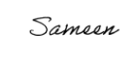

Signature of Supervisor

Signature of HOD



ACKNOWLEDGEMENT

We are grateful to Allah Almighty for the unending blessings; wisdom, perseverance and guidance which He has bestowed upon us throughout our lives without which we couldn’t be able to accomplish this gigantic task. This thesis would not have been completed if not for the efforts, time, and assistance of a number of people. Therefore, we would like to express our sincere gratitude to each and every one of them for their input.
Our deepest appreciation goes to our supervisor Dr. Usamah Billah for his invaluable guidance, mentorship and encouragement which helped us stay focused and motivated. His constructive feedback and insights helped us improve the quality of this work. We sincerely appreciate the encouragement and support we received from the Head of Department (HOD) Ma’am Urusa Fahim.
We are truly indebted to our Buji, Papa and Mama who have been a constant source of support, emotional, moral and of course, financial throughout our studies. Forever grateful for the unending love, prayers and encouragement we got from our loved ones. We extend our appreciation to our siblings Rida & Taha Khan and dear friend Mehak Julius for their willingness to listen, offering suggestions and patience all this time.
Last, but not least, we would like to thank us for believing in ourselves and each other. We are grateful to ourselves for having the courage to embark on this journey, for the discipline to stay the course, and for the determination to see it through to the end.
Huda Raza Khan & Sameen Raza Khan

ABSTRACT

The thesis explores the influence Green Human Resource Management (Green HRM) practices; green involvement, green training & development and green performance management, hold over employee retention in Pakistan’s organizations with mediating effect of employee ownership. The research was done on corporate world. The study is based on survey of employees from various companies. After carefully reviewing existing literature, the survey was designed.
These surveys were distributed to 230 employees, and 200 of those responses were selected for further consideration. The examining technique was comfort based inspecting and the time skyline was a single shot cross sectional review. The individual Pakistani employees who are familiar with Green HRM were the intended audience. We tested the relationships between the variables under study using the two well-known statistical tools, Process Hayes and SPSS, as soon as the data for the analysis was gathered. Recurrence and level of reactions, mean of factors, unwavering quality investigation, correlation test and relapse examination occurred on the information we assembled. The hypothesis was tested by running the research model three times on Process Hayes for model number 4. As per the findings Green HRM practices exhibit positive and significant relationship with employee retention, as of all the hypotheses are supported by the data. The study emphasizes the significant mediation function played by employee ownership. Green HRM practices and employee retention appear to be linked, according to the findings. Employees in particular, are more likely to remain with their green employer than those who do not believe to have robust Green HRM practices. Additionally, employee ownership was found to mediate this relationship, indicating that employees' sense of ownership over their company partially accounts for the positive influence of Green HRM practices over retention. The investigation likewise discovered that various components of Green HRM rehearse varyingly affect worker maintenance. Training and development opportunities, for instance, were found to have the greatest impact on employee retention.
A new avenue is opened by examining the significance of Green HRM in the corporate sector. Overall, the findings suggest that employee ownership plays a interceding job in the connection between employee retention and Green HRM practices. This study has important repercussions for current and future research in this field, as well as for businesses looking to boost sustainability efforts and retain staff.

Table of Contents
THESIS APPROVAL CERTIFICATE Error! Bookmark not defined.
RESEARCH COMPLETION CERTIFICATE 3
ANTI-PLAGIARISM DECLARATION 4
ACKNOWLEDGEMENT 5
ABSTRACT 6
LIST OF ABBREVIATIONS 10
LIST OF FIGURES 10
LIST OF TABLES 10
1. INTRODUCTION 11
1.1. Statement of Topic and Purpose 11
1.2. Research Objectives 13
1.3. Problem Statement 13
1.4. Research Question 14
1.5. Research Hypothesis 15
2. LITERATURE REVIEW 16
2.1 Green HRM 16
2.1.1. Green Training & Development 17
2.1.2. Green Performance Management 19
2.1.3. Green Involvement 21
2.2. Employee Ownership 22
2.3. Employee Retention 25
2.4. Underpinning Theory 26
Conceptual Framework Model 28
3. RESEARCH METHODOLOGY 28
3.0. Design and Approach 30
3.1. Methodology 30
3.1.1. Sample Size 30
3.1.2. Sampling Techniques 31
3.1.3. Unit of Analysis 31
3.1.4. Nature and Setting of Study 31
3.1.5. Type of Study 32
3.1.6. Research Instruments 32
3.1.7 Data Collection Method 33
3.1.8 Data Analysis 34
4. DATA ANALYSIS 35
4.1. Descriptive Analysis: 35
4.1.1. Frequency Analysis of Demographic Characteristics 35
4.1.2. Descriptive Statistics of Study Variables 36
4.2. Measurement Validation 39
4.3. Correlation Matrix 40
4.4. Hypothesis Testing 47
4.4.1. Tests of Mediation 47
❖ Hypothesis 1, 4, 5, 8 47
❖ Hypothesis 2, 4, 6, 9 51
❖ Hypothesis 3, 4, 7, 10 54
5. DISCUSSION 57
5.1. Limitations 57
5.2. Conclusion 58
5.3. Theoretical Implications 59
Practical Implications 60
REFRENCES 61
STUDY QUESTIONNAIRE 64

LIST OF ABBREVIATIONS

HRM | Human Resource Management
GT&D | Green Training & Development
GPM | Green Performance Management
GI | Green Involvement
EO | Employee Ownership
ER | Employee Retention

LIST OF FIGURES

Figure 1 Theoretical Framework 28
Figure 2 Mediation Model 50
Figure 3 Mediation Model 53
Figure 4 Mediation Model 56

LIST OF TABLES

Table 1.1 Rationale Hypotheses  Table 3.1 Variables, Number of Items, Sample Items and References  Table 4.1 Frequency Analysis of Respondents Gender and Age  Table 4.2 Descriptive Statistics of Study Variables  Table 4.3 Reliability of Scales  Table 4.4 Correlation for the Study Variables  Table 4.5 Outcomes of Simple Mediation Model Regressing Employee Ownership as Mediator  Table 4.6 Outcomes of Simple Mediation Model Regressing Employee Ownership as Mediator  Table 4.7 Outcomes of Simple Mediation Model Regressing Employee Ownership as Mediator | ………………...  ………………...  ………………...  ………………...  ………………...  ………………...  ………………...  ………………...  ………………...
CHAPTER 1

INTRODUCTION

Statement of Topic and Purpose

Green HRM is defined by Renwick et al. (2013) as “HRM activities, which enhance positive environmental outcomes”. Green HRM utilizes human resources in the process of applying innovation to achieve environmental performance, waste reduction, social responsibility, and a competitive advantage via continuous learning and development and by embracing environmental goals and strategies that are fully integrated with the goals and strategies of the organization. HRM has the ability to measure and influence employee environment‐related behavior, attitudes, knowledge, and motivation. Hence, organizations can utilize HRM to effectively deliver and implement environmentally friendly regulations (Guziana & Dobers, 2018). The notion about Green HRM is surfacing in management discipline, explaining the integration of environmentally responsible practices within HR department of the organization in order to achieve long-term sustainable growth. To induce pro eco-friendly behaviors, commitment from administration, HR practices, organization and support from personnel in charge/ supervisors, are a must, cognate to general creativity and innovation (Provasnek, 2018) for building sustainable workplace.
According to (Tang, 2018), "Green HRM" refers to practices in human resource management (HRM) which aims at encouraging resource efficiency in order to support general environmental performance and escalate employees’ awareness and commitment towards the management of environmental issues in particular. (Arulrajah, 2014), Green HRM application and the framework as a whole make employees green to do well out of sole, society, the natural habitat, and the commerce. They also guarantee the environmental safety (Santos., 2018). These practices assist businesses in developing a workforce that is capable of appreciating and comprehending green schemes. (Mishra, 2014) affirms that the Green HRM’s implementation throughout the organization’s HRM structure; the planning mechanism, recruitment & selection of employees, training & development, and evolution & compensation, is essential in order to maintain green aspirations.
In addition to raising awareness of environmental concerns (such as reducing waste), the extent to which social and economic well-being (such as work-life balance, maintaining profits) are improved also subsumes in the emergence of Green HRM. The paradigmatic comprehension of the idea of "triple bottom line" has actually been supported by green HRM. To wit, green human resource management involves long-term codes which adhere to the three sustainability pillars of social, economic and environmental balance (Arulrajah, 2014). Green HRM is progressively turning into a road for associations between organization and its employees who are turning out to be bit by bit more naturally cognizant.
Green HRM is concerned with the planned and systematic alignment of practices in human resource management with the environmental objectives of the organization. In contemporary HRM arena, it is common knowledge that by incorporating environmental concerns into HRM policies and procedures (Green HRM) contributes to organizations' overall environmental agenda, which includes corporate social responsibility (CSR). The purpose of the paper is to examine the relationship between green human resource management (GHRM) practices such as green recruitment, green training, green performance management, green reward, green involvement and employee retention).

Research Objectives

- To determine how the employee retention is influences by Green HRM practices.
- To investigate the mediatory function of employee ownership.
- To concentrate on the connection between Green HRM, employee ownership and employee retention.

Problem Statement

The ecological dangers are acquiring the consideration of world in this manner green thoughts and ideas are beginning to accumulate pace in every possible field including the HR space, apart from adding sparkle to the brand, they are highlighting significant advantages for the company. However there lies a theoretical/ hypothetical hole due to the absence of exploration around the objective in Pakistan, lack of research, insufficient information regarding literature.
The main consideration of this study is to look into the potency of Green HRM operations in Pakistan’s corporations.
The problem in espousing Green HRM is that employees are unaware of the ins and outs of environment management. Unfortunately for last two decades the environment has witnessed an alarming need for environment protection worldwide. Industrial waste is the major malefactor deteriorating and draining natural resources very quickly in form of pollution. Therefore, it asserts that green HRM have direct and significant relation with environment sustainability. Practically we can’t stop the practices of corporate world as they fulfill our unlimited wants more over the drastically increase in population and lifestyle changes has worsen it for that reason this study aims to generate awareness about Green HRM in order to stimulate the sustainable use of provided resource within workplace sagely to contribute in environment sustainability and minimize the negative use of resources towards environment.

Research Question

What is the influence of Green HRM operations over employee retention with the mediating role of employee ownership?

Research Hypothesis

Table 1.1
Rationale Hypotheses

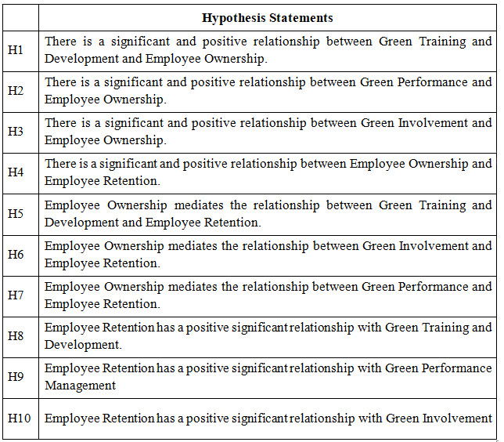

CHAPTER 2

LITERATURE REVIEW

This section set out the variables under study which includes Green human resource management practices (Green HRM); green training & development, green performance management and green involvement, mediating factor employee ownership and their impact on employee retention.

2.1 Green HRM

Green HRM refers to the human resource management (HRM) policies which endorses sustainable utilization of the resources within an establishment (Mishra, 2014). This modern HRM practice seeks to develop and implement a positive and green system persuading the work force to preserve the environmental sustainability goals and be responsible for their actions. GHRM is the whole process involving the designing and approving of job descriptions in coordination with other departments to incorporate and highlight the sustainability goals (Sustainability – Meaning and Definition, 2021). According to the works of past researchers it could be classified into five categories which include the employee’s life cycle, reward, training & development, performance of employee & empowerment and the involvement of management (Md Asadul Islam D. H.-P., 2021). Since it’s a diverse field which offers a wide room for research we have selected three its dimensions; green training & development, green performance management*and green involvement. These exercises may vary as per the organizations, industries or geographies (Md Asadul Islam D. H.-P., 2021). Green human resource management application holds great significance up on the process of developing, putting into practice, and maintaining innovative environmental-related employee behaviors with an appropriate greening mindset. From the existing literature it could be stated that it’s strenuous to accurately establish and cultivate sustainable environmental performance without proper green HRM practices. (Tareq Fayeq Obaid, 2015). According to research, implementing Green HRM practices can enhance organizational performance. For instance, (J Alberto Aragón-Correa, 2007)'s study discovered that businesses with effective environmental management systems outperformed their competitors financially and were more likely to draw in socially conscious investors. Based on previous studies we can say that HRM techniques influenced organizational innovation positively, which can result in competitive advantage.

Green Training & Development

The conventional term of training & development concerns with the development of skills by providing adequate resources. Whereas, the phrase green training & development is traced as a mechanism of facilitating the workforce with progressive perspectives which make sure appropriate resource utilization, waste mitigation, energy conversion and cause reduction of environmental deterioration (IGI Global Publisher of Timely Knowledge). This practice provides the employees with latitude to engage themselves in resolving environmental obstacle, sharpening them to deal with potential environmental problems parallel with planting a favorable environmental culture for the welfare of employee and organization as a whole (HRMI, 2022). As per previous researches conducted training & development plays a vital role in the evolution or transformation of the employees’ attitudes, knowledge, skills and behavior which eventually serves as a rapport between the management and the employees affecting the performance of the organization as a whole (Tareq Fayeq Obaid, 2015). For the innovation the employees needs to be equipped with new and necessary knowledge and skills to build competitive edge for the organization making training and development a continuous process.
The transition of an organization to environmentally friendly (green) work activities can be viewed as a change catalyst that necessitates adequate employee training and reorientation. Employees learn essential environmental management standards through training, which helps them become aware of and interested in environmentally friendly work practices. It is also possible to evaluate the influence of green training over the development and maintenance of employees' green consciousness. Organizations train teams of front-line employees to conduct waste analyses of their work areas, which thought to be key intervention in the waste management (in terms of both prevention and reduction). These employees are thought to be the best staff for identifying and reducing waste because they are closest to squander, yet they must know how to gather the relevant data which could serve as applicable information (Dr. Douglas Renwick, 2008).
Training programs are designed to fill in knowledge gaps about the environment; they may be able to encourage employees to act environmentally friendly. Thus environmental training ought to include hands-on activities that can increase employees' awareness of environmentally friendly initiatives and knowledge. Employees should receive instruction on how to perform a green workspace analysis and be provided with the training of personal abilities necessary to support green initiatives (Raman, 2019). Thus when employees are trained with green practices, they become more proficient about the effect of their activities on the environment and can add to creating reasonable strategic approaches. This sense of employee ownership and responsibility can boost their job satisfaction and increased employee engagement.
Thus hypothesizing the following:
H1: There is a significant and positive relationship between Green Training and development and employee ownership.

Green Performance Management

Performance management can be decoded simply as a process by which employees are encouraged to improve their professional skills in order to assist the organization in better achieving its goals and objectives (HRMI, 2022). Whereas the term green performance management refers to a method for assessing employee performance in environmental management activities (Guiyao Tang Y. C., 2017). The phenomenon of "greening" has an impact on the development of environmental management as well as global business strategies (José Moleiro Martins, 2021). Thus green performance management concerns with the environmental issues and company policies additionally, it focuses on how to use environmental responsibilities (HRMI, 2022). The requisites for effective green performance includes a comprehensive strategy that takes into account the entire organization's impact on the environment; its use of resources, emissions, waste, and energy consumption. According to (Guiyao Tang Y. C., 2017), businesses must determine a methodical approach to the implementation of green performance management because these methods of measuring green performance management are ineffective due to the fact that different businesses possess distinct structural characteristics and resources which employs that the standards across businesses will be arbitrary. As a result, the specific characteristic elements of green performance management, providing feedback and balancing metrics, have been the focus of research (Guiyao Tang Y. C., 2017).
The focus of these practices includes establishing green performance standards for each employee and assessing how well they meet those standards whose primarily aim to inspire employees to exhibit performance behaviors that support the environmental objectives of the company (Chaudhary, 2019). Performance appraisal is the most crucial part of performance management, therefore effective performance appraisal doesn’t only satisfy the stipulation of fairness, reliability, and validity, but they also give employees useful feedback and help the company and workforce to continuously improve its professional and environmental outcomes (HRMI, 2022). Green performance management activities can be divided into four groups based on the existing literature: making green performance pointers, assessing workers' green outcomes, setting of green objectives for all individuals, and using dis-benefits (Guiyao Tang Y. C., 2017). It fundamentally aims to encourage the employees to exhibit performance behaviors which align with the environmental objectives of the organization. (Ahmad, 2015) Suggests that the green objectives and tasks must be communicated well in the job description, the human resource department of the organization should include dimensions of rating individuals over following behavioral and technical competencies for performance appraisal; innovation, diversity, collaboration, teamwork and environmental stewardship.
The unionization of performance appraisal with green management regulates performance behaviors with organization’s sustainability goals (Chaudhary, 2019). As per empirical evidence provided by researchers it could be said that their lays a positive relation among green performance management, employee ownership and organizational citizenship behaviors toward the environment as a whole.
The integration of environmental sustainability into the model of performance management; performance evaluation/ appraisal, of the employees will help in creating a firm culture of employee ownership and accountability around green initiatives. In line with above, it is hypothesized that;
H2: There is a significant and positive relationship between Green Performance and employee ownership.

Green Involvement

Employee involvement is said to be correctly in practice when the employees of an organization actively participate in the management, provides feedback, involve in problem solving and are well aware of the organizations work ethics and value (Rabha, Vantage Circle HR Blog, 2023). On the other hand the term green involvement refers to employees’ involvement in environmental sustainability initiative; like waste reduction, energy consumption, promoting environment awareness programs etc. Green involvement of employees can enhance an organization’s performance and reputation along additional benefits of green involvement and cost saving. This structure of green employee involvement entails a participative culture in which individuals can voice their opinions regarding significant environmental affairs and propose creative solutions. (Chaudhary, 2019). (Muhammad Shoaib, 2022) postulates that higher level of employees’ involvement in the workplace is closely and positively linked to organizational dedication. Active green involvement of employees tends to have better connection with the organization, increasing job satisfaction and loyalty. As advocated by (Muhammad Shoaib, 2022) that commitment viewed as one of most significant aspect of employee involvement thus more active and committed employees in environmental conservation programs would be more focused on environmental responsibilities. Based on prior studies it could be said that employee involvement is vital for the corporation’s sustainability goals. The green framework provides the employees with sense of purpose and meaning rather than just getting a task done or meeting the targets. A constructive work environment that encourages employees to use their up skill environmental knowledge and competency to learn more about environmental-related concerns results in a greater green ability if top management provides employees with opportunities to participate in environmental-related activities and events (Nhat Tan Phama, 2019). The employees embrace the sustainability goals of the organization and feel more inclusive; which strengthens the psychological connection and employee begins to own the company. After a vivid analysis of research it can be proposed that;
H3: There is a significant and positive relationship between Green Involvement and employee ownership.

Employee Ownership

Employee ownership is the sense which makes the employee empowered by believing that their work, contribution is appreciated by the organization. This acknowledgement helps them developing the feeling of ownership and tends to be more committed to their job (Uslu, 2015). Legal and psychological ownership are two separate entities in their meanings where legal refers to lawful possession which are recognized and guaranteed by the society on the other hand psychological ownership is what individuals experience trough mental process (Aihwa Chang, 2010). Individual may acquire a sense of psychological ownership through their psychological experiences, even though they do not have any legal ownership (Aihwa Chang, 2010). This psychological ownership plays a crucial role in encouraging organizations productivity and lead to obtain certain desired employee behavior (Helen Campbell Pickford G. J., 2016). Researchers conducted over employee ownership shows positive relation to job satisfaction and loyalty. When an employee undertakes ownership, as an individual it strengthens him by making him more active and productive, it serves as a building block of trust between the employee and the employer benefitting the organization. (Helen Campbell Pickford G. J., 2016) describes that the concept of psychological ownership is about identification, responsibility, desire to belong and control. It could be said that psychological ownership manifests itself in organizations just as much it does in different settings (Jon L. Pierce, 2001). Thus creation of an organizational structure which values and expects employees opinions will aid in development of sense of ownership which will improve organizations performance as a whole (Simon Torp, 2018). Research suggest that by fostering a culture of ownership in an organization is a great investment and will produce a more motivated, loyal and engaged workforce. As the feeling of ownership is accompanied with sense of responsibilities and organization’s burden sharing (Jon L. Pierce, 2001). For example the employees who perceive themselves as owners and believe that have right to influence the direction of organizations activities will presume that they have deeper responsibility from rest of personnel (Jon L. Pierce, 2001). As ownership is one way to boost an individual's self-esteem, individual are probably more likely to feel like they own the things they value the most (Chantal Olckers, 2015). Employees will put on their best effort and would even stretch their limits to procure their (organization’s) goals. Thus for the purpose to capture individual’s attention and interest (Jon L. Pierce, 2001) suggests that the objective must be noticeable and appealing to individual and must be experienced by the person. The experience of investment in oneself is of great significance. There are many different kinds of self-investment, including time investment; ideas, skills, mental, emotional, and physical energies. Consequently, the individual may begin to believe that the goal of ownership originates within themselves (Jon L. Pierce, 2001).
The actions and behaviors of employees are prompted by obvious needs which are followed by relevant values and objectives, the satisfaction of those needs determine the level of psychological ownership which could be either positive or negative leading to outcomes like employee retention (Chantal Olckers, 2015). The organizations with ownership culture among workforce will boost employee engagement, commitment, and motivation, which results in improve retention rates. Employees are more likely to be satisfied with their jobs and will be averse to leave the organization if they have a sense of ownership over their work and organization. Thus hypothesizing following;
H4: There is a significant and positive relationship between Employee ownership and employee retention.
Research suggests that, psychological ownership may have a significant impact on the adaptation of green HRM practices and their efficacy. For instance, employees who have a strong sense of ownership over their company may be more likely to support and take part in green training & development programs, green employees involvement and green performance management because they believe that these initiatives are in line with their own personal values and objectives. Based on these discussions, the following hypothesis evaluates the mediating role of employee ownership;
H5: Employee ownership mediates the relationship between green training and development and employee retention.
H6: Employee ownership mediates the relationship between green involvement and employee retention.
H7: Employee ownership mediates the relationship between green performance and employee retention.

Employee Retention

The term Employee Retention is an organization’s aptitude to avert employee turnover, as the loss of talent voluntarily or involuntarily have direct impact on the organizations performance as a whole (Holliday, 2021). In simple words it’s the process by which an organization encourages employees to remain with the company and work there longer is known as employee retention (Md Asadul Islam D. H.-P., 2021). It also represents the loyalty and commitment of employees towards the organization. Employee retention is top priority of human resource management to mitigate the cost of replacement and it can be obtained by efficient and effective strategies. Attraction, growth and retention of talent; employees, is significant for an organization (Chantal Olckers, 2015). (Bidisha Lahkar Das, 2013) in study states employee satisfaction and retention as key factors for the success of an organization. When employees leave an organization, they take valuable experience-based knowledge and expertise with them (Chantal Olckers, 2015). Loss of experienced and skillful workforce is a threat to any organization as human resource is an organizations biggest asset. (Bidisha Lahkar Das, 2013) advocates that long term wellbeing and outcome of any organization relies on its ability to retain their key workers.
As per research though employee retention is not influenced by a single factor but it could be said that there are host of factors which play significant role in keeping the employees in an organization hence, management requires to prioritize those factors which includes; reward and compensation (performance management), training and development, working environment etc (Bidisha Lahkar Das, 2013). Employees; the workforce, are the biggest assets of any institution who holds the power to either give organization a competitive edge or ruin it thus it’s important for the top management/ head of organization to retain their skillful workers.
In synopsis, green HRM practices can emphatically influence individual’s decision to either stay or leave the organization by appropriately executing the green applications which will eventually as discussed before lead to expanding individual’s commitment, inspiration, responsibility, fulfillment and awareness of certain expectations. By exhibiting a promise to sustainability, the institutions can entice potential and retain current employees having akin values and convictions, establishing a positive workplace and adding to the institutions lengthen progress.
Thus we suggest following hypothesis:
H8: Employee retention has a positive significant relationship with green training and development.
H9: Employee retention has a positive significant relationship with green performance management
H10: Employee retention has a positive significant relationship with green involvement.

Underpinning Theory

Conservation of resources (COR) theory by Stevan Hobfoll is a motivation theory, the fundamental tenet of is that humans are driven to acquire new resources and preserve their existing ones. COR theory is, at its core, a motivational theory revolves around the evolutionary need to amass and conserve resources for the survival, which is central to behavioral genetics of human. This theory explains a lot of human behavior (Stevan E. Hobfoll, 2018). Where conservation means saving resources. The more work-specific leading theory of organizational stress, the job demands-resources model, is largely based on COR theory (Stevan E. Hobfoll, 2018). Resources fall into four broad categories, according to the COR theory: conditions (such as social support), personal characteristics (such as skills), energies (such as time), and things (such as possessions) People and groups work hard to get and keep these resources, and losing them can cause problems like stress, anxiety, and burnout.
For both individuals and organizations, the COR theory has significant implications. For instance, organizations can assist employees with keeping up with their assets by giving open doors to ability advancement, social help, and balance between work and personal life. In a similar vein, individuals can protect and enhance their resources by engaging in resource conservation behaviors, which may ultimately result in improved performance and well-being in long run.
The COR theory can be connected with Green HRM practices, which are HRM practices that expect to advance feasible turn of events and ecological obligation inside the organization.
Green HRM practices can assist with saving assets by lessening waste, limiting energy utilization, and advancing harmless to the ecosystem ways of behaving among representatives. For instance, associations can execute practices like working from home, paperless workplaces, and green acquisition arrangements to diminish their ecological effect. As per the COR theory, people and associations endeavor to get and keep up with assets, and losing assets can adversely affect their prosperity. Green HRM practices can help save resources, which can eventually result in improved performance and well-being.
Green HRM practices can also guide businesses to build a positive brand image and reputation for environmental responsibility by attracting and retaining the individuals who care about the environment. In conclusion, the Conservation of Resources theory highlights the importance of resource conservation while Green HRM practices can be seen as a way to operationalize the COR theory by promoting sustainable development and environmental responsibility within organizations.

Conceptual Framework Model
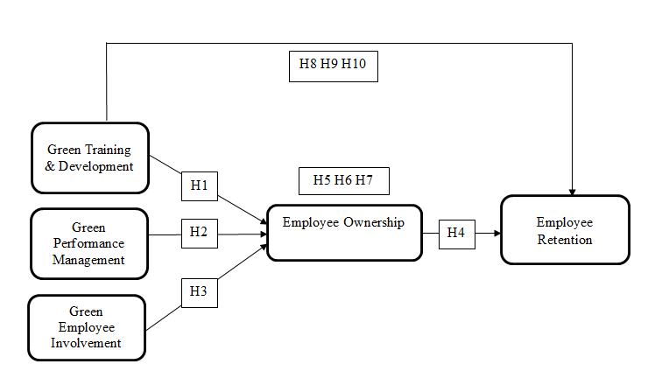
Figure 1 Theoretical Framework

CHAPTER 3

RESEARCH METHODOLOGY

This component characterize the methodology approach of this study, therefore, the nature and idea of study, research design and configuration, study setting, unit of analysis, respondents of the research, time horizon, target population and sampling, sample size selection procedure, measures data collection procedure and control variables.
After our synopsis was approved the time came to elaborate our thesis research and to collect data from population under study. For this purpose we formed a questionnaire to conduct survey to figure out “The influence of green hrm practices (green training development, green performance management, green involvement) on employee retention and the mediating effect of employee ownership”. The main purpose of this survey was to identify if green hrm practices influence employee retention and mediating effect of employee ownership.
The questionnaire was divided into 6 sections. The Likert scale was used to measure the survey variables. The responses were evaluated using a five-point Likert scale with a range of 1 to 5, with 1 representing the absolute minimum and 5 representing the highest level of agreement. The demographic data were gathered in the first section, and the variable items under investigation were covered in the subsequent sections comprising of study variable items under study (which includes green training & development, green performance management, green involvement, employee ownership, employee retention). There were total 20 statements related to variables of the research framework. . Using a Google Forms-designed questionnaire, the data was gathered. A scale to indicate satisfaction or dissatisfaction with a specific statement was given to respondents (1=strongly disagree 2= disagree 3= neutral 4=agree 5= strongly agree). Their responses provide us with a trend at the conclusion of our research, which assisted us in completing our work. The item response theory determines the sample size (Nunnally, 1978). This theory says that the sample size is calculated by multiplying the total number of items by 10 (20*10=200). Since our items are 20 each, 200 responses were collected. Helpful examining technique was utilized to pull out 200 examples from the populace.

3.0. Design and Approach

For accuracy of results we used survey questionnaire to abstract data. Research configuration for this study was a cross-sectional survey will be the research design for this study. The research was carried out in one phase, and information was gathered from people who work for a variety of businesses. The researcher was minimally involved in the research process to prevent data manipulation, and respondents were free to complete the questionnaire on their own. Quantitative methods were used in the research. The final results were derived from the primary data that was gathered.

Methodology

Sample Size

To generalize the findings of our study, the sample size was calculated as follows: Kline (2015) and Field (2013) who suggested that approximately 10 respondents against each items in questionnaire hence number of items in questionnaire * 10 respondent from the population targeted. 20 items were included in our survey so the computed sample size (20*10) was 200. Sample size of 200 is quite sufficient to analyze our model as well as to generalize the findings.

Sampling Techniques

We employed the convenience sampling method. This is a convenient, non-probability sampling strategy that selects the local population for sampling. Pilot testing has shown this mechanism to be quite effective

Unit of Analysis

Individuals were the unit of analysis. The study is cross-sectional since it uses a non-experimental methodology. For minimizing common method bias our study does not feature a temporal restriction structure and many sources. To reduce the probability of error, the data of criteria variables should be collected at the same time. Corporate world people will be respondents in our study.

Nature and Setting of Study

The primary goal of this research is to test hypotheses. As respondents are hesitant to offer information to someone, the study will be conducted in a non-contrived setting with no intervention from the researcher, Respondents will be given assuredly that their information will be confidential and their identity will not be shown.

Type of Study

Quantitative methods were used in the research for cross-sectional, one-shot study. We used the numerical data from Google forms to analyze the pattern and derive the results in order to generalize findings from a larger population. By analyzing the data we were able to better understand the connection between employee ownership's mediating effect and the green HR practices; green training & development, green performance management, and green involvement.

Research Instruments

Structured questionnaire was used for research for obtaining accurate results. The questions for questionnaire were designed using existing literature of our study variables. Dimensions and item scale was streamlined through current study context.
Survey questionnaire was divided into 6 parts. First part was demographic other 5 was based on items with same scale therefore likerts scale ranging from 1 to 5(1=strongly disagree 2= disagree 3= neutral 4=agree 5= strongly agree) capturing wide responses.

Table 3.1
Variables, Number of Items, Sample Items and References

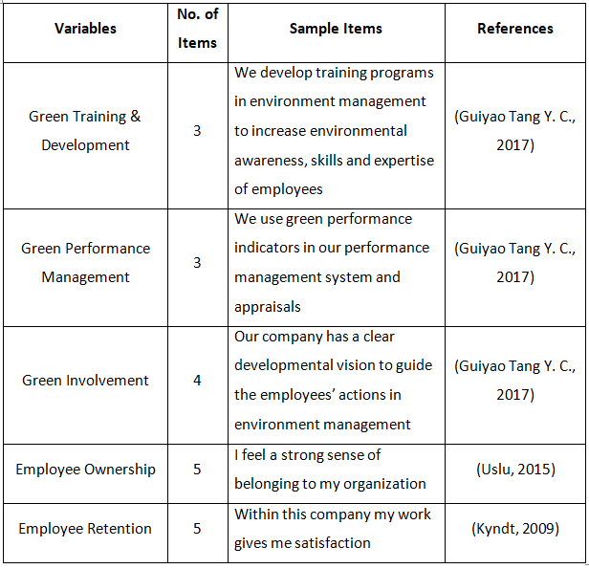

3.1.7 Data Collection Method

The data was collected using Google Forms, a method of data collection that has gained widespread acceptance and is utilized in numerous studies worldwide. It assisted us with social event information without squandering normal assets like paper, fuel. This was an environmentally friendly method in addition to guaranteeing data transparency.
The questionnaire comprised of six sections. A likerts scale ranging from 1 to 5 (where 1 indicates strongly disagree, 2 indicates disagree, 3 indicates neutral, 4 indicates agreement, and 5 indicates strongly agree) was used to collect a diverse range of responses.
The first section consisted of demographic information name was optional followed by industry, gender, age, education, designation if they know about green hrm, if there companies uses green hrm also if they are interested in making their organization green.
The second section comprised of questions related to “Green training and development” which is one of the three independent variables of our research. This variable has items which we adopted from (Guiyao Tang Y. C., 2017) research.
The third section compromised of questions related to “green performance management” which is the second independent variable of our study. This variable has items which we adopted from (Guiyao Tang Y. C., 2017) research.
The fourth section was about “green involvement” which is the third independent variable of our study. This variable has items which we adopted from (Guiyao Tang Y. C., 2017) research.
The fifth section was about “employee’s ownership” which is mediator. This variable has items which we adopted from (Uslu, 2015) research.
The sixth section was about our dependent variable of “employee retention”. This variable has items which we adopted from (Kyndt, 2009) research.

3.1.8 Data Analysis

The SPSS software program was used to inspect the data. The relationships between the variables were discovered using regression analysis. We run model number 4 from model layouts utilized for Cycle of SPSS and SAS. For our independent variables, which are green involvement, green performance management, and green performance management, we run model number 4 three times.

CHAPTER 4

DATA ANALYSIS

Descriptive Analysis:

Frequency Analysis of Demographic Characteristics

Table 4.1 provides frequency analysis of survey respondents by their gender and age. The findings indicated that in terms of Gender majority of the participants were females (108, 54.0%) out of 200 total sample size in comparison to male participants (92, 46.0%) in the corporate sector.

Table 4.1
Frequency Analysis of Respondents Gender and Age

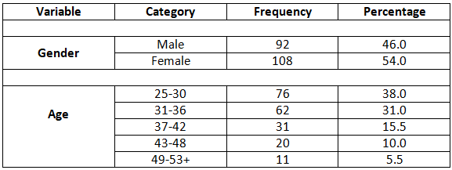

We targeted the individuals who were currently employed in any organization or running their own business and kept the industry open to be more inclusive. While in terms of Age we categorized them into five groups starting from 25- 30 years with the maximum respondents (79, 38.0%) out of 200 participants. Then comes the people in range 31- 36 years (62, 31.0%). The third category is consisting of people in their 37- 42 years (31, 15.5%). Then comes the participant falling under the range of 43- 48 years (20, 10.0%). The least number of respondents were from fifth category ranging from 49- 53+ (11, 5.5%).

Descriptive Statistics of Study Variables

Descriptive statistics represents summary of descriptive quantifiable data that elaborates on data sets detailed information. The process of summarizing, depicting, and simplifying statistical data into a form that is meaningful and easy to comprehend is made easier with the help of descriptive statistics analysis.
It has several sections but the most important is the highlighted range from the lowest to highest point, providing information about the Central Tendency and the mean and standard deviation of the values under consideration.

A summary of descriptive statistics of each of study variable is provided in Table 4.2. Every single variable was assessed applying a five-point Likert scale. Descriptive statistics findings exposed that all study variables ‘minimum range of responses lied between the interval of 1.00 to 2.00 and the maximum value is 5.00. The array of mean values ranged from 3.44 to 4.06 while standard deviations of responses lie between 0.64 and 1.03. The mean score for items evaluating GT&D, GPM, GI, EO and ER were high and significantly exceed from midpoint.

Green Training and development (GT&D)
Average mean value of GT&D is = 3.55 and SD = 0.88. This indicates that GT&D moderate to high impact on employee retention. This statics helped us to argue that GT&D has significant impact on employee retention. Whereas the lower SD and high mean value indicates that responses are consistent.

Green Performance Management (GPM)
Average mean value of GPM = 3.44 and SD = 1.03. This indicates that most of the employees agree that GPM matters when it comes to employee retention and in forming employee ownership.

Green Involvement (GI)
Average mean of GI = 3.53 and SD = 0.89. This indicates that GI have significant impact on employee retention.

Employees Ownership (EO)
Average mean of employee ownership = 4.06 and SD = 0.64. This inclines towards strongly agree opinion. The values highlight the fact that EO plays a major role as mediator in green hr practices. Employee ownership makes the employee empowered by believing that their work, contribution is appreciated by the organization which acknowledgement helps them developing the feeling of ownership and tends to be more committed to their job

Employee Retention (ER)
ER items reported mean = 3.79, SD = 0.72. The value tells that the graph of responses is more towards the agreeable side as per the responses of 200 respondents.

Table 4.2
Descriptive Statistics of Study Variables

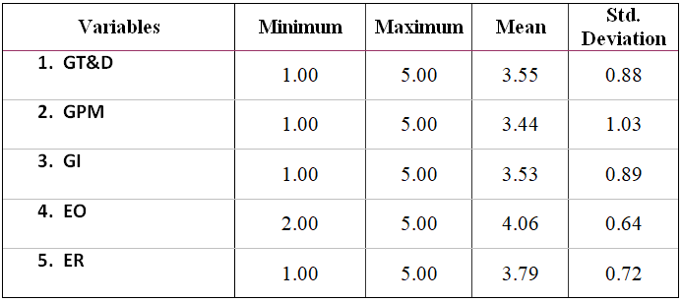

Measurement Validation

We figured Cronbach's alpha values to test the reliability and inner consistency between items of each construct (i.e. green training & development, green performance management, green involvement, employee ownership and employee retention). According to Cronbach (1951), the threshold value to verify reliability and internal consistency of a scale‘s items is that it should be equal to or greater than 0.7. In addition, according to Kline (1998) the value of Cronbach‘s alpha (reliability coefficient) greater than or equal to 0.90 can be regarded as ‘excellent’, an alpha value near to 0.80 as ‘very good’ and an alpha value approximately 0.70 as ‘adequate’.

Table 4.3
Reliability of Scales

Scales | NO. of Items | Cranach’s α Value | Level of Reliability
- GT&D | 3 | 0.83 | Very good
- GPM | 3 | 0.89 | Excellent
- GI | 4 | 0.87 | Very good
- EO | 5 | 0.84 | Very good
- ER | 5 | 0.81 | Very good

The outcomes of reliability test are displayed in Table 4.3 for the current study and Cronbach‘s α value for all variables ‘scales met the threshold values which are ranging from very good to excellent (i.e., 0.81 to 0.89). As indicated through results that all variables have internal consistency of 81% to 89% and there is no kind of reliability issue in our data set.

Correlation Matrix

We carried out bivariate correlation analysis on the study variables prior to testing the hypotheses. Table 4.4 represents correlation values of the variables under consideration. Where the correlation coefficients appear to be pointing in the anticipated directions and provide preliminary support for our study hypotheses.
Table 4.4
Correlation for the Study Variables

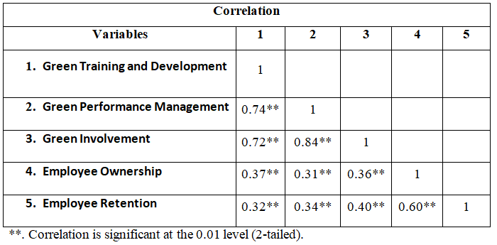

GT&D-GPM
r=0.74 p < 0.05
This relationship is strongly positive meaning that green training & development (GT&D) and green performance management (GPM) are closely linked to each other. The impact of one variable has a good impact on the other. This is considered a best combination where the green training & development is rewarded with green performance management.

GT&D-GI
r=0.74 p < 0.05
This relationship is positive between green training and development (GT&D) and green involvement (GI). The positive relation between GT&D and GI suggests that investing into green training and development can be a good way to make people more environmentally conscious and involved in green projects.

GT&D-EO
r=0.37 p < 0.05
It is a weak positive linear relation between the two variables. Which indicates that there is lack of understanding, awareness, and resources in organizational cultures which divergent priorities and causes a weak connection between green training and development (GT&D) and employee ownership (EO).

GT&D-ER
r=0.32 p < 0.05
It is a moderate positive linear relationship between green training and development (GT&D) and employee retention (ER). Mainly because some companies does not support due to which employees may not prioritize green training and development programs as the management does not actively support them, which as a result influence their decision to stay with the company.

GPM-GT&D
r=0.74 p < 0.05
This relationship is strongly positive between green performance management (GPM) and green training and development (GT&D). The impact of one variable has a positive impact on the other. This is considered a best combination where the green training and development is rewarded with green performance management.

GPM-GI
r=0.84 p < 0.05
The relationship is strongly positive between green performance management (GPM) and green involvement (GI). Hence the strong positive relationship between GPM and GI attributes to the fact that both concepts work together to establish a culture of sustainability within an organization and are essential components for an effective environmental sustainability strategy.

GPM-EO
r=0.31 p < 0.05
It is a weak positive linear relationship between the two variables green performance management (GPM) and employee ownership (EO). This indicates that many companies do not focus on worker inclusion, adjust objectives, and boost representatives to add to green execution objectives.

GPM-ER
r=0.34 p < 0.05
It is a weak positive linear relationship between green performance management (GPM) and employee retention (ER). This is because of limited impact of GPM has little on employee retention as employees appreciate working for a company that cares about the environment and is socially and environmentally responsible, factors like career advancement opportunities, compensation, and work-life balance which has greater impact on their decision to stay with the company.

GI-GT&D
r=0.72 p < 0.05
This relationship is strong positive meaning that Green Involvement (GI) and Green training and development (GT&D) are closely linked to each other. The impact of one variable has a good and positive impact on the other.

GI-GPM
r=0.84 p < 0.05
This relationship is strongly positive between Green Involvement (GI) and green performance management (GPM). Hence to improve environmental performance and boost organizational success there should be a strong positive relationship between GI and GPM. It also emphasizes the significance of actively involving employees in environmental initiatives and decision-making processes.

GI-EO
r=0.36 p < 0.05
It is a weak positive linear relationship between the two variables green involvement (GI) and employee ownership (EO). Environmental sustainability is frequently the primary focus of GI, whereas financial performance is the primary focus of EO. Hence they form a weak relationship because two variables may not be directly related.

GI-ER
r=0.40 p < 0.05
The results of Correlation analysis highlights that there is weak positive linear relationship between Green involvement (GI) and Employee retention (ER). Green involvement is important to employees but it may not be significant enough to influence their decision to stay or leave company there are many other factors affecting employees decisions such as compensation, work life balance, job satisfaction etc which are more important to employees than environmental concerns.

EO-GT&D
r=0.37 p < 0.05
It is a weak positive linear relationship between the two variables employee ownership (EO) and Green training and development (GT&D). Weak relation between EO and GT&D could be because of other factors, such as the size of the company, the industry, and leadership priorities, as they influences the decision to invest in GT&D.

EO-GPM
r=0.31 p < 0.05
It is a weak positive relationship between employee ownership (EO) and green performance management (GPM). It indicates the limited resources of company as carrying out both EO and GPM can be asset escalated, and associations might not have the assets to put resources into both at the same time.

EO-GI
r=0.36 p < 0.05
It is a weak positive linear relationship between the two variables. This relationship between employee ownership (EO) and green involvement (EI) is weak because lack of awareness a number of employees does not fully comprehend the significance of environmental issues as a result, they may not prioritize it.
EO-ER
r=0.60 p < 0.05
This value indicates that there is a strong positive linear relationship between employee ownership (EO) and employee retention(ER). This means that an increase employee ownership (EO) will also increase employee retention(ER) in a positive way.
ER-GT&D
r=0.32 p < 0.05
The results of Correlation analysis highlights that there is weak positive linear relationship between Employee Retention (ER) and Green Training& Development (GT&D). it is because of conflict in Priorities in representatives might have contending needs that overshadow green preparation such as, complying with time constraints and accomplishing deals targets. Employees may not give these kinds of programs high priority as they think they won't have time for them.

ER-GPM
r=0.34 p < 0.05
It is a weak positive linear relationship between the two variables. There are number of reasons for the weak link between green performance management and employee retention. Despite the fact that employees may place a high value on an organization's commitment to sustainability, which itself is not a significant factor in their decision to remain employed. Other Factors, like compensation, employer stability, learning experiences, etc also affect their decisions.

ER-GI
r=0.40 p < 0.05
The results of Correlation analysis highlights that there is weak positive linear relationship between Employee retention and Green Involvement. This relationship is weak because lack of awareness it is possible that a number of employees do not fully comprehend the significance of sustainability issues as a result, they may not prioritize it.

ER-EO
r=0.60 p < 0.05
This value indicates that there is a positive linear relationship between employee retention and employee ownership. This means that an increase in employee retention will also increase employee retention.

Hypothesis Testing

The study hypotheses were examined via simple mediation model. We ran this model three times for 3 independent study variables; Green Training and Development (GT&D), Green Performance Management (GPM) and Green Involvement (GI).

Tests of Mediation

We closely inspected the hold of green HRM applications; GT&D, GPM and GI (independent variable) over their abstract employee retention (dependent variable) could be explained through employee ownership (mediator) with the utilization of SPSS Process macro (model 4, Preacher and Hayes, 2008). 2000 bootstrap resampling was performed and confidence interval is 95%.

Hypothesis 1, 4, 5, 8

The SPSS Process outcomes of Table 4.5 illustrate that GT&D positively impacts EO, as evident from the significant unstandardized regression coefficient* (β = 0.27, t = 5.76, p <0.001*), providing support for Hypothesis 1. Furthermore, the coefficient value (0.27) indicates that, if there is one unit increase in GT&D then there is 0.27 units increase in EO, while keeping all the other variables constant. The P value is less than 0.001 which shows a significant relationship between the variables.
Consistent with our expectation with Hypothesis 8 the total effect of GT&D on ER is positive and significant (β = 0.26, t = 4.74, p <0.001). Furthermore, the coefficient value (0.26) indicates that, if there is one unit increase in GT&D then there is 0.26 units increase in ER, while keeping all the other variables constant.

Table 4.5
Outcomes of Simple Mediation Model Regressing Employee Ownership as Mediator

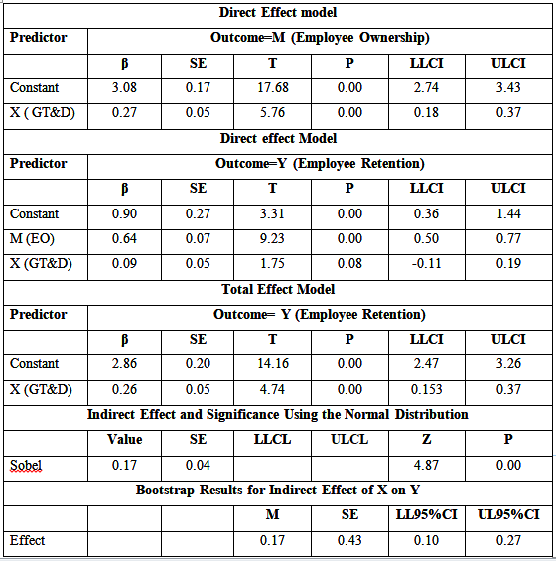

Further, the link between EO and ER (i.e., path b in figure 1) was positive and significant when conducting GT&D (β =0.64, t = 9.23, p < 0.001). Finally, GT&D positively influenced on ER (i.e., path cʹ in figure 3) with EO mediation role (β = 0.09, t = 1.75, p < 0.001). Which back up the Hypothesis 4 and Hypothesis 5.

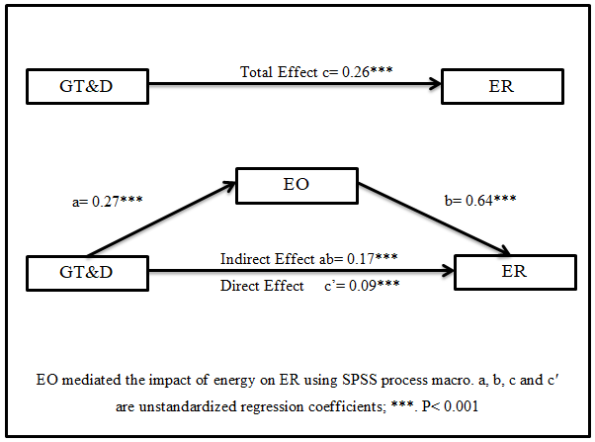
Figure 2 Mediation Model

The Sobel test (Sobel, 1982) was also used to examine the mediation model's outcomes. This test is used to verify whether a mediator can explain the relationship between a criterion and a predictor. The formal two-tailed importance test (expecting an ordinary dissemination) exhibit that the (unstandardized) indirect effect (0.17*) is huge with Sobel Z = 4.87, P < 0.001*. A 95% bootstrap confidence interval for this indirect effect did not contain zero (0.10, 0.27), confirming the Sobel test results (see Table 4.5) with a 0.17 identical indirect effect value. The bootstrapping did not make any assumptions about the shape of the sampling distribution (i.e., normality). This lends credence to Hypothesis 5.

Hypothesis 2, 4, 6, 9

The SPSS Process outcomes of Table 4.6 illustrates that GPM positively impacts EO, as evident from the significant unstandardized regression coefficient (β =0.20*, t = 4.72, p <0.001*), providing support for Hypothesis 2. Furthermore, the coefficient value (0.20) indicates that, if there is one unit increase in GPM then there is 0.20 units increase in EO, while keeping all the other variables constant. The P value is less than 0.001 which shows a significant relationship between the variables.
Consistent with our expectation with Hypothesis 9 the total effect of GPM on ER is positive and significant (β= 0.25**, t = 5.24, p <0.001). Furthermore, the coefficient value (0.25) indicates that, if there is one unit increase in GPM then there is 0.25 units increase in ER, while keeping all the other variables constant.

Table 4.6
Outcomes of Simple Mediation Model Regressing Employee Ownership as Mediator

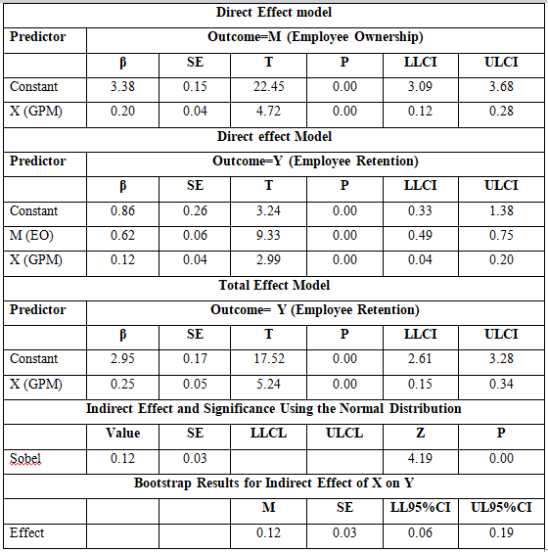

Further, the link between EO and ER (i.e., path b in figure 2) was positive and significant when conducting GPM (β 0.62=, t= 9.33, p < 0.001). Finally, GPM positively influenced on ER (i.e., path cʹ in figure 2) with EO mediation role (β = 0.12, t = 2.99, p < 0.001). Which backs up Hypothesis 4 and Hypothesis 6.

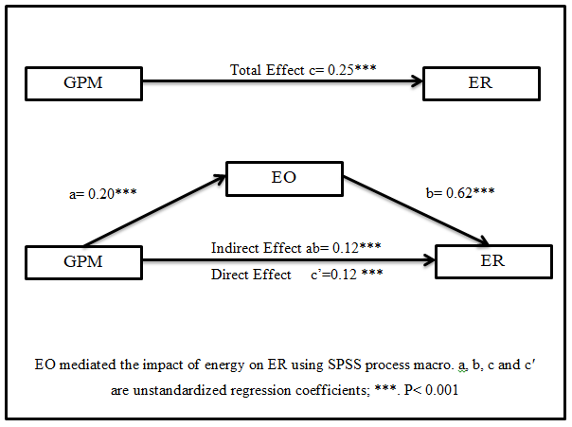
Figure 3 Mediation Model

The Sobel test (Sobel, 1982) was also used to examine the mediation model's outcomes. This test is used to verify whether a mediator can explain the relationship between a criterion and a predictor. Assuming a normal distribution, the formal two-tailed significance test demonstrates that the (unstandardized) indirect effect (0.12) is significant with Sobel Z = 4.19, P <0.001*. A 95% bootstrap confidence interval for this indirect effect did not contain zero (0.06*, 0.19), confirming the Sobel test results (see Table 4.6) with an identical indirect effect value of 0.12. The bootstrapping did not make any assumptions about the shape of the sampling distribution (i.e., normality). This lends credence to Hypothesis 6.

Hypothesis 3, 4, 7, 10

The SPSS Process outcomes of Table 4.6 illustrate that GI positively impacts EO, as evident from the significant unstandardized regression coefficient (β = 0.26, t = 5.58, p <0.001), providing support for Hypothesis 3. Furthermore, the coefficient value (0.26) indicates that, if there is one unit increase in GI then there is 0.26 units increase in EO, while keeping all the other variables constant. The P value is less than 0.001 which shows a significant relationship between the variables.
Consistent with our expectation with Hypothesis 10 the total effect of GI on ER is positive and significant (β = 0.33, t = 6.27, P <0.001*). Furthermore, the coefficient value (0.33) indicates that, if there is one unit increase in GI then there is 0.33 units increase in ER, while keeping all the other variables constant.

Table 4.7
Outcomes of Simple Mediation Model Regressing Employee Ownership as Mediator

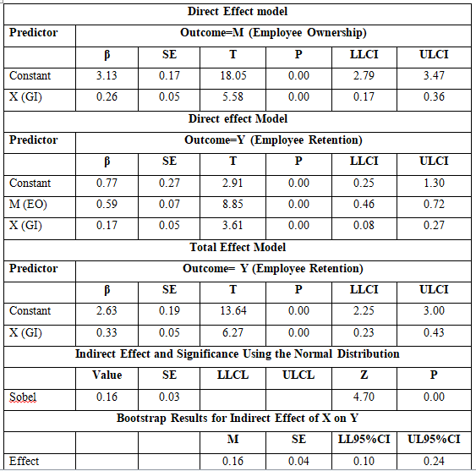

Further, the link between EO and ER (i.e., path b in figure 3) was positive and significant when conducting GI (β = 0.59, t = 8.85, p < 0.001). Finally, GI positively influenced on ER (i.e., path cʹ in figure 3) with EO mediation role (β = 0.17, t = 3.61, p < 0.001). which backs up Hypothesis 4 and Hypothesis 7.

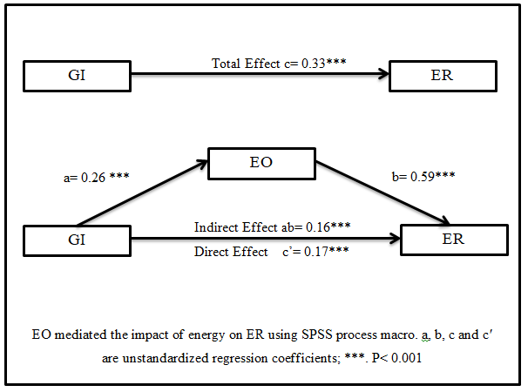
Figure 4 Mediation Model

The Sobel test (Sobel, 1982) was also used to examine the mediation model's outcomes. This test is used to verify whether a mediator can explain the relationship between a criterion and a predictor. Assuming a normal distribution, the formal two-tailed significance test demonstrates that the (unstandardized) indirect effect (0.16) is significant with Sobel Z = 4.70, P <0.001*. A 95% bootstrap confidence interval for this indirect effect did not contain zero (0.10, 0.24), confirming the Sobel test results (see Table 4.6) with a 0.16 identical indirect effect value. The bootstrapping did not make any assumptions about the shape of the sampling distribution (i.e., normality). This lends credence to Hypothesis 7.

CHAPTER 5

5. DISCUSSION

5.1. Limitations

Generalizability: The study is based on a particular region Pakistan, which may limit its regional applicability. The discoveries of the review may not be relevant to associations in other regions.

Sample Size: The study's sample size is 200 which are relatively small, limiting the. The study's validity may be enhanced by a larger sample size.

Self-Report Bias: The information gathered in the review depends on self-revealed reactions, which might be likely to predisposition. The findings' accuracy may have been harmed by participants' responses that were viewed as socially acceptable.

Causality: Due to the cross-sectional design of the study, it is challenging to establish causality between the variables. It is conceivable that different elements not considered in the review might have affected the bond between Green HRM, employee retention and employee ownership.

Size Effect of Mediation: Green HRM framework and employee retention were found to be significantly mediated by employee ownership, but the effect size may be relatively small. The mediation effect's size could be increased in future researches.

Green HRM Conceptualization: The study employs a broad notion of green HRM practices, which encompass a variety of sustainability-related initiatives. Notwithstanding, various associations might have various translations of what comprises green HRM practices, which could influence the legitimacy and generalizability of the discoveries.

5.2. Conclusion

This extensive research sought to inspect the influence of Green Human Resource Management (Green HRM) practices; green involvement, green training & development and green performance management, over employee retention in Pakistan’s organizations with mediating effect of employee ownership.
By conducting a comprehensive literature review and empirical study it is conclusion that green human resource management (HRM) practices have a prominent impact on employee retention. In addition, the rapport between green HRM practices and employee retention is mediated by employee ownership. Through the research it can be seen that employee retention is aided by environmentally friendly HRM practices like eco-friendly policies and procedures, environmental training, and sustainable development initiatives. Employees are given a sense of purpose and pride in their work as a result of these practices, which not only make the workplace healthier and more sustainable but also give them a sense of purpose. Employees are more likely to remain committed to the business if they believe it is committed to environmentally responsible practices.
Moreover, the research discovered that employee ownership plays a critical intervening job in the linkage between green HRM applications and employee retention. Employees are more likely to be committed to the organization and its values, including those that are related to environmental sustainability, when they are given a stake in the business and feel like they own it. This sense of ownership may assist in enhancing the positive impact that green HRM practices have on employee retention.

5.3. Theoretical Implications

The significance of Green HRM implementation over increasing employee retention can be further clarified by this research finding. It can likewise prompt the improvement of new and compelling Green HRM practices to cultivate worker proprietorship and maintenance.
The study findings have the potential to add to the existing literature related to mediating effect of employee ownership. Also it can help in comprehending the notion of how employee ownership’s mediating action in between Green HRM practices and employee retention also how it can be beneficial to researchers.
In order to increase employee retention, the study emphasizes the significance of incorporating sustainability practices into HRM. It urge associations to integrate manageability rehearses into their HRM practices to advance representative commitment and maintenance.
By examining the connection between Green HRM practices, employee ownership, and employee retention, the study can contribute significantly to the Green HRM literature.
The thesis emphasizes how crucial it is to incorporate environmental sustainability into HRM procedures. New theoretical frameworks that take into account the impact of green HRM practices on employee ownership and retention may emerge from this research.
The thesis emphasizes the significance of the organization-employee relationship. In the context of green HRM practices and employee retention, it has the potential to enhance comprehension of social exchange theory.
According to a hypothetical point of view, this research extends how we might interpret the effect of Green HRM rehearses on worker maintenance. In order to achieve positive outcomes for the organization as well as its employees, it emphasizes the significance of aligning HRM practices with initiatives aimed at sustainability. Additionally, the study adds to the body of knowledge regarding employee ownership as a mediator between HRM practices and employee outcomes.

Practical Implications

The findings of the study can assist businesses in developing and putting effective HRM practices into place to boost employee retention. By consolidating Green HRM practices and worker proprietorship, associations can cultivate a feeling of responsibility and commitment among representatives.
The study has the potential to assist businesses in establishing a sustainable culture that encourages employee ownership, engagement, and retention. Organizations can attract and keep employees who are committed to environmental sustainability by fostering a culture of sustainability.
The study may assist businesses in determining which employee benefits can increase employee ownership and retention. Companies have the ability to increase employee engagement and a sense of ownership by offering incentives like stock ownership, profit sharing, and other ownership-based incentives.
The review can urge associations to integrate ecological manageability into their HRM rehearses. By fostering a culture of sustainability, businesses can not only improve their environmental performance but also increase employee retention.
Practically, the findings of the research suggest that organizations can increase employee retention by implementing Green HRM practices. These practices can incorporate drives like harmless to the ecosystem strategies, green preparation, and improvement programs, and advancing supportability as a fundamental belief of the association. Additionally, the study emphasizes the significance of employee ownership as a key factor in employee retention. By giving representatives a feeling of pride, associations can make a more connected with labor force and lessen turnover rates.

REFRENCES

Reviewia.co. (2021). Retrieved from reviewia.co: https://www.reviewia.co/blog/Five-Reasons-Why-Taking-Ownership-is-Important-to-Grow-Professionally
Sustainability – Meaning and Definition. (2021, June 18). Retrieved August 4, 2022, from Youmatter: https://youmatter.world/en/definition/definitions-sustainability-definition-examples-principles/
HRMI. (2022). Retrieved from hrmi.org: https://hrmi.org/green-hrm/
Ahmad, S. (2015). Green Human Resource Management: Policies and practices. Cogent Business & Management.
Aihwa Chang, H.-H. C.-S. (2010). A multilevel investigation of relationships among brand-centered HRM, brand psychological ownership, brand citizenship behaviors, and customer satisfaction. European Journal of Marketing.
Arulrajah, O. &. (2014). bring benefits to the organization.
Bidisha Lahkar Das, D. M. (2013). Employee Retention: A Review of Literature. IOSR Journal of Business and Management.
Chantal Olckers, Y. D. (2015). Psychological ownership as a requisite for talent retention: the voice of highly skilled employees. European J. International Management.
Chaudhary, R. (2019). Green human resource management in Indian automobile industry. Journal of Global Responsibility.
Dr. Douglas Renwick, P. T. (2008). Green HRM: A review, process model, and research agenda. University of Sheffield Management School .
Green HRM. (n.d.). HRMI.
Guiyao Tang, Y. C. (2017). Green human resource management practices: scale development and validity. Asia Pacific Journal of Human Resources.
Guiyao Tang, Y. C. (2017). Green human resource management practices: scale development and validity. Asia Pacific Journal of Human Resources.
Guziana & Dobers, J. e. (2018). Promoting employee's proenvironmental behavior through. Corporate Social Responsibility and Environmental Management.
Helen Campbell Pickford, G. J. (2016 ). Psychological Ownership: Effects and Applications. Mutuality in Business.
Helen Campbell Pickford, G. J. (2016). Psychological Ownership: Effects and Applications. Mutuality in Business.
Holliday, M. (2021). What Is Employee Retention? Benefits, Tips & Metrics. Oracle NetSuite.
IGI Global Publisher of Timely Knowledge. (n.d.). Retrieved from igi-global.com: https://www.igi-global.com/dictionary/green-human-resources-and-sustainable-business-solutions/91391
J Alberto Aragón-Correa, N. H.-T.-M. (2007). Environmental strategy and performance in small firms: a resource-based perspective. Journal of Environmental Management.
Jon L. Pierce, T. K. (2001). Toward A Theory Of Psychological Ownership In Organizations. Academy of Management Beview.
José Moleiro Martins, H. A. ( 2021). Assessing the Impact of Green Hiring on Sustainable Performance: Mediating Role of Green Performance Management and Compensation. International Journal of Environmental Research and Public Health.
KU| The University of Kansas. (n.d.). Retrieved from humanresources.ku.edu: https://humanresources.ku.edu/performance-management
Kyndt, E. D. (2009). Employee Retention: Organisational and Personal Perspectives. Springer Science + Business Media B.V.
Md Asadul Islam, D. H.-P. (2021). Moderating role of psychological empowerment on the relationship between green HRM practices and millennial employee retention in the hotel industry of Bangladesh. Wiley Online Library.
Md Asadul Islam, D. H.-P. (2021). Moderating role of psychological empowerment on the relationship between green HRM practices and millennial employee retention in the hotel industry of Bangladesh. wileyonlinelibrary.
Mishra, S. R. (2014). Green HRM: Practices and Strategic Implementation in the Organizations. IJRITCC .
Muhammad Shoaib, R. Z. (2022). PROMOTING ENVIRONMENTAL PERFORMANCE THROUGH GREEN HRM: MEDIATING ROLE OF EMPLOYEE GREEN INVOLVEMENT. Academy of Strategic Management Journal.
Nhat Tan Phama, T. V. (2019). The role of green human resource management in driving hotel’s environmental performance: Interaction and mediation analysis. International Journal of Hospitality Management.
Provasnek, S. S. (2018). Promoting employee's proenvironmental behavior through green hrm practices.
Rabha, M. (2022). Employee Involvement: Why it Matters in Every Organization. Vantage Circle.
Rabha, M. (2023, March). Vantage Circle HR Blog. Retrieved 2023, from Vantage Circle: https://blog.vantagecircle.com/employee-involvement/
Raman, A. O. (2019). Role of Green HRM Practices in Employees’ Pro-environmental IT Practices. Springer Nature Switzerland AG .
Santos., J. &. (2018). Promoting employee's proenvironmental behavior through gHRM practices.
Simon Torp, B. B. (2018). Psychological ownership and financial firm performance: The interplay of employee stock ownership and participative leadership. Australian Journal of Management.
Stevan E. Hobfoll, J. H.-P. (2018). Conservation of Resources in the Organizational Context: The Reality of Resources and Their Consequences. Annual Review of Organizational Psychology and Organizational Behavior.
Tang, C. J. (2018).
Tareq Fayeq Obaid, D. R. (2015). THE IMPACT OF GREEN RECRUITMENT, GREEN TRAINING AND GREEN LEARNING ON THE FIRM PERFORMANCE: CONCEPTUAL PAPER. International Journal of Applied Research.
Uslu, T. (2015). Innovation Culture and Strategic Human Resource Management in Public and Private Sector within The Framework Of Employee Ownership. Procedia.
Wikipedia. (n.d.). Retrieved 2022, from en.wikipedia.org: https://en.wikipedia.org/wiki/Performance_management
Wikipedia. (n.d.). Retrieved from en.wikipedia.org: https://en.wikipedia.org/wiki/Millennials

STUDY QUESTIONNAIRE

THE INFLUENCE OF GREEN HRM PRACTICES ON MILLENNIAL EMPLOYEE RETENTION: THE MEDIATING EFFECT OF EMPLOYEE OWNERSHIP.

Dear Sir/Madam,
Thank you for taking out time to participate in our research project. Your response will be highly valued and will remain confidential. It will be used only for academic purposes.
Name (optional): ___________________
Please place cross or tick in appropriate box
- Industry  Manufacturing Services  Banking Education  Other  - Gender  Male Female  - Age  25-30 37- 42  31-36 43- 48  49- 53  - Education  Undergraduate Graduate  Post Graduate Doctorate Level | - Designation  __________________  - Do you know about green HRM  Yes No  - Does your company use Green HRM  Yes No  - Are you interested in making your organization Green  - Yes No

Green training and Development (GTD) |  | Strongly Disagree | Disagree | Neutral | Agree | Strongly Agree
1 | We develop training programs in environment management to increase environmental awareness, skills and expertise of employees | 1 | 2 | 3 | 4 | 5
2 | We have integrated training to create the emotional involvement of employees in environment management | 1 | 2 | 3 | 4 | 5
3 | We have green knowledge management (link environmental education and knowledge to behaviors to develop preventative solutions) | 1 | 2 | 3 | 4 | 5

Green performance management (GPM) |  | Strongly Disagree | Disagree | Neutral | Agree | Strongly Agree
1 | We use green performance indicators in our performance management system and appraisals | 1 | 2 | 3 | 4 | 5
2 | Our firm sets green targets, goals and responsibilities for managers and employees | 1 | 2 | 3 | 4 | 5
3 | In our firm, managers are set objectives on achieving green outcomes included in appraisals | 1 | 2 | 3 | 4 | 5

Green involvement (GI) |  | Strongly Disagree | Disagree | Neutral | Agree | Strongly Agree
1 | Our company has a clear developmental vision to guide the employees’ actions in environment management | 1 | 2 | 3 | 4 | 5
2 | In our firm, there is a mutual learning climate among employees for green behavior and awareness | 1 | 2 | 3 | 4 | 5
4 | In our firm, employees are involved in quality improvement and problem-solving on green issues | 1 | 2 | 3 | 4 | 5

Employee Ownership |  | Strongly Disagree | Disagree | Neutral | Agree | Strongly Agree
1 | I feel love for my organization. | 1 | 2 | 3 | 4 | 5
2 | I think it is proud to be an employee of this institution. | 1 | 2 | 3 | 4 | 5
3 | My sense of ownership of this institution is quite high. | 1 | 2 | 3 | 4 | 5
4 | I feel emotionally attached to my work. | 1 | 2 | 3 | 4 | 5
5 | I feel a strong sense of belonging to my organization. | 1 | 2 | 3 | 4 | 5

Employee Retention |  | Strongly Disagree | Disagree | Neutral | Agree | Strongly Agree
1 | I’m not planning on working for another company within a period of three years. | 1 | 2 | 3 | 4 | 5
2 | Within this company my work gives me satisfaction. | 1 | 2 | 3 | 4 | 5
3 | If I wanted to do another job or function, I would look first at the possibilities within this company. | 1 | 2 | 3 | 4 | 5
4 | I see a future for myself within this company. | 1 | 2 | 3 | 4 | 5
5 | It matters if I’m working for this company or another, as long as I have work. | 1 | 2 | 3 | 4 | 5

TURNITIN REPORT

