THE INFLUENCE OF DISCOUNT FRAMING TOWARDS BRAND REPUTATION AND BRAND IMAGE ON PURCHASE INTENTION AND ACTUAL BEHAVIOR IN E-COMMERCE



SANIYAH IMRAN
F19BBAM032

BUSINESS ADMINSTRATION DEPARTMENT
KINNAIRD COLLEGE FOR WOMEN,
LAHORE, PAKISTAN
JUNE 2023

BACHELORS IN BUSINESS ADMINSTRATION



SANIYAH IMRAN
F19BBAM032

SESSION 2019-2023
THE INFLUENCE OF DISCOUNT FRAMING TOWARDS BRAND REPUTATION AND BRAND IMAGE ON PURCHASE INTENTION AND ACTUAL BEHAVIOR IN E-COMMERCE


A THESIS SUBMITTED TO KINNAIRD COLLEGE FOR WOMEN IN FULFILLMENT OF THE REQUIREMENTS FOR THE DEGREE OF BACHELORS
IN
BUSINESS ADMINISTRATION
BY
SANIYAH IMRAN
BUSINESS DEPARTMENT
KINNAIRD COLLEGE FOR WOMEN, LAHORE

2019-2023

DISSERTATION APPROVAL
KINNAIRD COLLEGE FOR WOMEN

Date: JUNE 2023

I hereby recommend that the dissertation prepared under my supervision by Saniyah Imran F19BBAM032, entitled “the influence of discount framing towards brand reputation and brand image on purchase intention and actual behavior in e-commerce” be accepted in partial fulfillment of the requirements for the degree of
BACHELORS IN
BUSINESS ADMINISTRATION
Recommendation concurred in 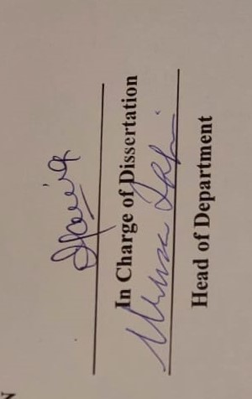
1. _____________________________
2. _____________________________ Committee
3. _____________________________ for the
4. _____________________________ Final Examination

RESEARCH COMPLETION CERTIFICATE

It is certified that Ms. Saniyah Imran (2019-2023), Department of Business Studies has carried out research work entitled “the influence of discount framing towards brand reputation and brand image on purchase intention and actual behavior in e-commerce”, under my supervision.

All changes suggested by examiners during defense are incorporated in this final copy.
It is assured that research work is original and has not yet been published anywhere else.
Dated: June 2023
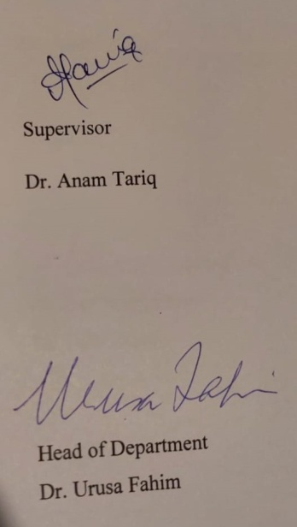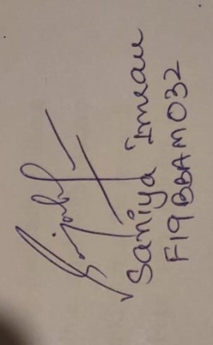

ANTI – PLAGIARISM DECLARATION

We certify that this is our research work. The work has not, in whole or in part, been presented elsewhere for assessment. Where material has been used from other sources, it has been properly acknowledged. The similarity index of the research report is 15%. If this statement is untrue and I am found guilty of plagiarism, the punitive actions against me should be taken as per Kinnaird Anti Plagiarism Policy.

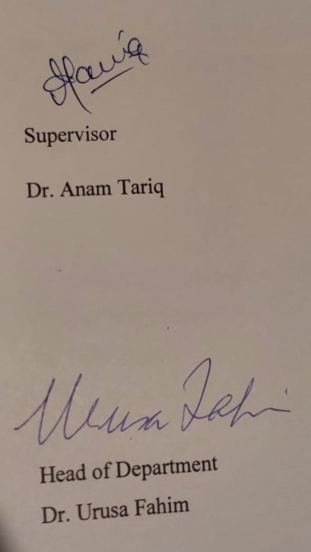

ACKNOWLEDGMENTS

Firstly thank you to Almighty Allah, for bestowing me with strength, motivation knowledge and determination, to complete my research work in a very short spam of days. I would like to thank my parents for providing consistent support, guidance and motivation throughout my thesis.
I would like to express my utmost gratitude to my research supervisor, Dr. Anam Tariq for continually guiding me and providing feedback. Without her help, this research would not have been possible. And with sincere gratitude for the wise criticism and advice you offered during the research process. Your knowledge and leadership have been very helpful in determining the project's quality and course.
Lastly, i would also like to thank all the respondents who took out their time to provide me with valuable data to conduct this research project. Their inputs were highly significant for my analysis work.
Thank you all.

ABSTRACT

The purpose of this study is to analyze how Discount Framing affects Brand Reputation, Brand Image, Purchase Intention, and Actual Behavior in e-commerce. Discount framing is a marketing tactic that highlights a product's price cut, which can affect how people view a brand. There are numerous implementations of discount framing in the context of e-commerce that have an impact on both brand reputation and brand image. It has been observed that both of these two constructs influence consumer Purchasing Intention and Actual Behavior. There are, however, few research that look at the connection between consumers' Actual Behavior and how Discounts are framed in their buy intentions. This study's goal is to investigate how Discount Framing affects consumers' Purchase Intentions and Actual Behavior, which may be influenced by Brand Reputation and Brand Image. With 250 reliable sample data from respondents in the region Pakistan who had ever made purchases on different E-commerce sites. The study's findings indicate that brand reputation and brand image play a role in how discount framing affects both Purchase Intention and Actual Behavior.

TABLE OF CONTENTS

Chapter | Title |  | Page
 | Dissertation Approval  Research Completion Certificate  Anti–Plagiarism Declaration  Acknowledgments  Abstract  Table of Contents  List of Table |  |  | iv  v  vi  vii  viii  ix  xii
1 | Introduction  - Introduction  - Problem Statement  - Rational of Study  - Research Objectives  - Research Hypothesis  - Theoretical Framework |  |  | 1  1  4  5  5  6  7
2 | Literature Review  - Discount Framing  - Brand Reputation  - Brand Image  - Purchase Intention  - Actual Behavior  - Influence of Discount Framing on Brand Reputation  - Brand Reputation influence on Purchase Intention  - Brand Image has positive influence on Purchase Intention  - Purchase Intention has positive effect on Actual Behavior |  |  | 8  8  9  10  11  11  12  13  13  14
3 | Methodology  - Research Design  - Research Approach  - Sample Size Section  - Unit of Analysis  - Time Horizon  - Population and Sampling  - Target Population  - Sampling Technique  - Study Instrument  - Data collection method  - Administrative Procedure  - Ethical Considerations  - Measurement and Scales  - Discount Framing  - Brand Reputation  - Brand Image  - Purchase Intention  - Actual Behavior  - Analytical Approach | 15  16  16 16  16  16  17  17  17  17  18  18  19  19  19  19  20  20  21  22
4 | Data Analysis  - Frequency analysis  - Crosstabs  - Descriptive analysis of Demographics  - Reliability Analysis  - Correlation  - Regression Analysis  - Hypothesis Testing |  |  | 24  26  29  31  32  35  35
5 | Discussion  - Discussion of Results  - Limitations and Future Directions  - Conclusion |  |  | 43  48  49
6  7  8 | References  Appendix  Turnitin Report |  |  | 50  66  67

List of Tables
Table Title Page
4.1 Frequency Analysis 24
4.2 Crosstabs 26
4.3 Descriptive Analysis of Demographics 29
4.4 Reliability Analysis 31
4.5 Correlation Analysis 32
4.6 Regression Analysis 35

CHAPTER I
1.1 INTRODUCTION
Pakistan's e-commerce market would rank as the 37th largest e-commerce market, up to 15% in recent years. Since it is easy for social media users to interact with each other, brand promotion through online forums will also improve brand recognition and brand image by offering encouraging testimonials, persuading others would be easy. (Georgios Et Al, 2014).
Due to numerous economic, social, and cognitive obstacles, Pakistan has been unable to fully use the promise of e-commerce. However, Pakistan has all the necessary indicators to spark an explosive growth in e-commerce thanks to its more than 36 million internet users, over 40 million smart phone users, over 30 million mobile internet users, expanding 4G LTE service coverage, and rapid adoption of social media. The expansion of ecommerce in Pakistan has been greatly impacted by the recent acquisition of Daraz.pk and other major online marketplaces in Pakistan.
The availability of different payment options like Cash On Delivery and mobile payments, as well as enhanced logistical penetration and delivery services, have all contributed to a growing trend in B2C and C2C e-commerce in recent years. The increased traffic on business-to-business and Customer to Customer websites, several of which are now among Pakistan's top 500 domains by traffic, is evidence of this. More proof of this can be found in the diversification of the organized retail sector into e-commerce and the rise of multimillion dollar investment e-commerce portals like Home Shopping, Ishopping.pk, Shopsy.pk, etc. Ecommerce is booming in Pakistan, as seen by the consumer's and nearly every well-known consumer brand's quick adoption of social media.
Since the early 1960s, banks have used the pressure of their personal telecommunications to electronically alter the price ranges for various departments and financial institutions (Ahmed et al,, 2019). This appears to be because the first application in business was the transfer of digital data while under the stress of communication. Compared to physical storefronts and mail-order catalogues, e-commerce is more advantageous. A vast database of products and services is easily accessible to users. In the hopes that someone will make a purchase, they can view the real payment, place an order in more than a day, and email it as a wish list.
With the click of a mouse, consumers can estimate prices and purchase specific products at exceptional savings. In turn, online service providers gain a number of advantages. Users can locate free advertising campaigns thanks to the Internet and its search engines. International markets will be accessible to even modest web enterprises. You can track customer preferences and offer personalized marketing thanks to internet technologies. The idea that the electronic market has the capacity to lower the cost of goods and services based on new information for international information and business partners can serve as the foundation for the transformation of affiliate e-commerce.
Therefore, e-commerce provides producers in developing nations with significant discounts, easy access to developed country markets, particularly B2C markets, and increased profits from these novel opportunities for business. Most Pakistanis have a poor understanding of electronic trade. They have an extremely constrained understanding of e-commerce and forbid receipts, for which they also develop online payment cards, as well as highly profitable goods that can be scanned and transferred online.
The largest barrier to the growth of electronic commerce in Pakistan is mistrust, according to some misunderstandings, due to Pakistani society's conservative nature, inadequate distribution of products, and prevalence of fraud in face-to-face transactions, and low literacy rates, it will take some time for the majority of Pakistanis to understand that they can place orders and make payments online from the comfort of their homes without having to leave: According to government statistics, Pakistan has a literacy rate of 59% (Khan Et Al, 2010). The majority of individuals lack access to or knowledge of technology, including: One must connect to the World Wide Web in order to conduct e-commerce transactions, which is a simple need when using a personal laptop or PC.
Although the price of laptop hardware has dropped recently, most people in the nation can no longer afford non-public laptops. To access the World Wide Web, a person also needs a personal laptop, a cell phone line, or a cable line. As a result, the country's access to internet services is being restricted, which is preventing the growth of e-commerce.
According to some observers, more than 800 cities and towns in Pakistan now require access to the network for around 40% of the population. Pakistan has had consistent growth in network subscribers, channels of distribution or transportation: The availability of inexpensive, quick, and reliable transport means for the physical distribution of goods that cannot be digitally or electronically delivered is a key component of e-commerce. Pakistan's postal service is at least as effective despite having a sizable party and a diversified workforce. On the other hand, costly non-public texting services with a bad reputation are available. Cash on delivery is the favored method of payment in this culture: In Pakistan, the counter of alternative rates has made money despite less people using credit cards and more people engaging in online transactions.
The guide coin chain is time-consuming, hazardous, and expensive in contrast to digital payments. Financial costs: Cost is a significant problem. Small businesses face greater financial constraints than large ones when implementing a fully new generation. The high cost of computers and the internet prevents the widespread use of electronic commerce. Budget-constrained SMEs view the added cost of ICT as a big expense that will not be immediately recouped (Khan Et Al. 2010).

1.2 Problem Statement
Because some e-commerce businesses use discount framing to persuade customers to buy a product, this study explores the effect of discount framing on consumers' purchase intentions and actual behavior. The main issues with consumers' propensity to purchase after viewing discounts offered by internet shops are highlighted in this study. E-commerce would gain more from this study if it understood the influencing factors, brand reputation, and brand image as the consequences trail of discount framing that lead the consumer to purchase the goods.
Additionally, there are many instances of discount framing in e-commerce that have an effect on a brand's reputation as well as its image. The latter two constructs have been found to have an impact on consumers' actual and intended purchase behavior. Few research, however, have examined the relationship between consumers' actual actions and how discounts are phrased in their purchase intentions. In order to better understand how discount framing influences consumers' purchase intentions and actual behavior, which may be influenced by brand reputation and brand image, read this study's findings.

1.3 Rational of the Study
To talk about the significance of discount framing and its impact on brand reputation, purchasing decisions, and actual consumer behavior. Think about providing discounts on purchases to draw visitors into your store right away. When you inform a customer that he can save money, you are more likely to get his attention. Discounts are advantageous for both your customers and your company. Therefore, the purpose of this study is to identify the crucial variables that are impacted by discount framing.

1.4 Research Objectives
The nature of intervening roles of Brand Reputation, Brand Image and Purchase Intention, in understanding the consequence of Discount Framing for Consumer Behavior.

1.5 Research Hypotheses
H1 There is a positive relationship between discount framing, and brand reputation.
H2 There is a positive relationship between discount framing and brand image
H3 There is a positive relationship between brand reputation and purchase intention.
H4 There is a positive and significant relationship between brand image, and purchase intention.
H5 There is a positive relationship between purchase intention and actual behavior

THEORATICAL FRAMEWORK:

M1
Brand Reputation

Discount Framing

H1 H3
Purchase Intention

Brand Image

H4
H2 H5
Actual Behavior

M2

Figure 1.6: Theoretical Framework
Where,
Independent variables = Discount Framing
Dependent Variables = Purchase Intention, Actual Behavior
Mediator = Brand Reputation, Brand Image

CHAPTER II

LITERATURE REVIEW
A literature review in data analysis is a critical assessment and analysis of the body of work in a specific area of data analysis. It entails a methodical search, evaluation, and synthesis of academic journals, books, conference proceedings, published research articles, and other pertinent sources. The major goals of a literature review in data analysis are to give a thorough grasp of the present state of knowledge, to point out areas that need further study, and to choose the research objectives and methods for future investigations. This procedure aids in the development of a thorough grasp of the research issue as well as the selection of the best instruments and methods for data analysis.

2.1 Discount Framing
Discount framing is described as a strategy for framing a specific offer's price promotional. According to Gendall, Philip, Hoek, and Pope (2006), discount framing is the method by which the price of a certain product offer is framed in order to affect consumers' reactions. Most often, discount framing is used by retailers to bundle products. Customers will consider the potential for cost savings when they see specific discounts that compare a crossed-out nominal price with a new, lower price. Therefore, framing a discount can increase consumers' desire to buy any product. According to the previous study, customers do not truly feel bad about purchasing a product with a discount framing.
(Shakti Et Al, 2019) claim that framing is one strategy businesses employ to draw in as many customers as possible without intentionally telling lies. A person's view of decision-making can be impacted by several types of framed information (Frisch, 1993; Pasek Et Al, 2021). According to (Pasek Et Al, 2021), framing and referencing points are closely related. There are reference points in framing that act as a framework for someone to think about a possibility. Consumers won't suffer any losses as a result of price framing, (Shakti Et Al., 2019), because they will be able to distinguish between the point of reference and the price paid.

2.2 Brand Reputation
The phrase "brand reputation" refers to the way in which a consumer feels about an excellent and trustworthy brand. According to Rindell A. a. (2014), it is characterized as consumers' perception of a product's quality in relation to the brand name. When consumers judge a product's quality, whether or not a company is respectable enough, and their view of that product's quality depends on their social status (Martnez Et Al, 2014). Brand reputation is crucial to enhancing the social position and income of consumers. By connecting with a highly regarded business, customers want to improve their social self-actualization. People will think they have a high social position if they choose products from well regarded companies. The study discovered that those who purchase reputable brands do so because they wish to display their social position. Consumers consider brand reputation before making any purchases. With respect to well-known brands, they see less danger.
Customers frequently view reputation as a key component in developing trust (Fedorko et al., 2017). Companies that want to establish a positive reputation should focus on aspects including long-term resource investment, effort, and attention to developing client connections (Qalati et al., 2021). Companies can establish a solid reputation by creating and offering high-quality goods and services, as well as by being dependable and accountable to their clients (Smolg et al., 2016). Brand reputation is a phrase that can be utilized as a signal or characteristic for consumers' sentiments towards trustworthy and good brands, according to (Agmeka et al. 2019).
Today's society's emphasis on materialism frequently drives consumers who use reputable brands to increase their consumption status. Because other people can tell someone's cultural beliefs from the brands they see others buying, consumers believe that consumption status is an important behavior. The majority of consumers who purchase reputable brands do so in an effort to elevate their social standing or prominence. Some of them have raised their income levels to make it possible for them to purchase luxury goods from well-known brands that can speak to their social standing. Thus, brand status and social class of high reputation and quality have an impact on brand reputation, which is related to consumption status (Kremer et al,, 2012).

2.3 Brand Image
According to (Rindell et al, 2014), brand image refers to a consumer's perception of a product that is represents its brand association. One of the most significant intangible assets that affects how customers view a company is its brand image. The functional and emotive dimensions are the two fundamental parts of brand image. The functional dimension is a dimension with quantifiable, observable traits. The emotive dimension, in contrast, deals with psychological issues such as attitudes and sentiments towards the business (Martinez et al 2014). The businesses expand their brand portfolio while also working to improve their brand's image. By adding a new product to their brand portfolio, they can benefit from the well-established brand awareness and image. Additionally, it can increase the awareness of their brand image among prospective customers (Kremer et al, 2012).
2.4 Purchase Intention
According to (Chen et al, 2015), purchase intention is a crucial characteristic that assesses the prospective action that consumers may decide to do. Purchase intention, according to (Sugiharto et al. (2019), is a buying process that takes place prior to the actual purchase. Purchase intention is the buyer's intention to engage in exchange connections on shopping sites, such as information sharing, sustaining business contacts, and establishing business transactions, According to (Dachyar et al 2017).
According to (Pasek et al, 2021), purpose can be a behavioral propensity that is exercised by someone if the circumstances are favorable and manifest in action. The companies may better comprehend the market and alter the products or services they are offering in order to increase sales and profit (Chen et al, 2015) by knowing the purchase intentions of their customers. Additionally, knowing a customer's purchase intent can forecast how long they will stick with a particular brand (Kudeshia et al 2017).
  - Actual Behavior
Actual behavior is defined as consumer behavior that is influenced by a person's attitude and intention to behave (Liu, et al 2017). The way people decide to spend their time, money, and effort on consuming goods or services is referred to as their real behavior (Li et al, 2017). The Theory of Reasoned Action (TRA), which describes how people's perception of others' opinions affects their intentions and attitudes, is tied to actual behavior. TRA is helpful in predicting behaviors as well. This theory, for instance, has been used in a variety of contexts, including public behavioral intentions in Uganda, the intentions of architects to assemble design teams, and the intentions of consumers to select Halal products (Lujja et al, 2016).
According to (Lujja et al, 2016), the primary goal of TRA is to ascertain customer behaviors that would either engage or not engage their objective. Behavior and antecedent intentions, such as attitudes towards subjective behavior and rules, influence human behavior. This study makes use of this theory as a result of these three factors (Lujja et al,, 2016).
2.6 Influence of Discount Framing On Brand Reputation And Brand Image:
There are various discount framing strategies that relate to the product's original pricing. When customers see the original price that has been crossed out and the discounted price as a comparison, discount framing for the costlier goods is more effective. Showing the percentage of price reduction is more effective, however, for the cheaper product. The results of this study demonstrate that when consumers see a discount frame that includes both the price amount and the percentage of price reduction, they will initially notice the brand name before considering the reputation and image of the store brand. Hence, discount framing has an influence on the brand reputation and brand image as formalized into H1 and H2 of the model provided below.
2.7 Brand Reputation’s Influence on Purchase Intentions:
A strong brand reputation is necessary in a highly competitive market like restaurants in order to build consumer confidence and lessen uncertainty. Consumer trust is a determinant of purchasing behavior that might lessen the way customers perceive risk and uncertainty.
Furthermore, when customers trust a brand, they think the food is of high quality. It causes the trusted brand to have an impact on their purchasing decisions. In other words, the likelihood that they will buy the goods is higher when the store's brand recognition is strong, and vice versa. When consumers use a reputable brand, their pride may also rise. According to earlier research, more consumers prefer to purchase reputable brands in order to feel more proud. The theory of Reasoned Action, however does not apply on Brand Image, I believe the theory Information Processing theory applies here, as it states that humans process information that they receive from their senses and store them. Moreover, they then to behave in accordance with the information that is stored in their memory..
2.8 Brand Image Has a Positive Influence on Purchase Intention:
In this subsection of literature review the influence that brand reputation has on consumers purchase intentions would be discussed. I believe, and will prove according to research that brand reputation and brand image are two major factors that are considered when consumers make a decision to purchase. With an example of food industry, as food industry is a highly competitive industry existing today, and with the changes in lifestyles of the consumers, they tend to buy food from branded or well-known restaurants.
According to a study conducted in USA, it was found that high brand reputation and brand image tends to have greater margins as these both aspects can make change the consumer intention to purchase a certain product or not to purchase it. A store having high reputation or image can be convincing for a consumer to purchase, rather than a store without it. Hence, brand image and reputation have a significant value when it is linked with the purchase intentions of the consumers. Additionally, the theory of Reasoned Action, however does not apply on Brand Image, I believe the theory Information Processing theory applies here, as it states that humans process information that they receive from their senses and store them. Moreover, they then to behave in accordance with the information that is stored in their memory..

2.9 Purchase Intention Has A Positive Influence On Actual Behavior:
Purchase intention has a variety of effects on consumer behavior that are tied to the customers' backgrounds. For instance, a buyer with a "green" attitude may respond differently when making a purchase of a green product. Zeithemal says, “"The relationship between consumer value, purchase intentions, and actual purchase behavior is complex." (p. 4). The influence of attitudes towards sponsored recommendation postings on actual behavior in terms of buying the recommended product is notably beneficial for social media users.
According to the Theory of Reasoned Action (TRA), consumers' perceptions of potential risk have a direct detrimental impact on their actual online purchase behavior. As a result, our study applies this theory to forecast what consumers will actually do when they observe discount framing presented by an online retailer
CHAPTER III
METHODOLOGY
The research design and methodology that is used for our research has been described in this area of the study. It covers sampling design, time, target population, sampling process, sample, and unit of analysis, study, measurement, and research design tool. To explain the causal connection between variables chosen for this research the deductive approach is chosen. As the deductive approach includes the testing of theory, a quantitative method is recommended (Bell et al, 2018). Quantitative methods are suitable when trying to generalize findings and adapt it to a bigger population, which is not be possible to do in a similar way with a qualitative method (Bell et al, 2018)

3.1 Research Design

3.1.1 Research Approach
Depending on the research questions and the current state of research in a specific subject area, it is decided how empirical research should be carried out. A distinction is made between two approaches: (1) Deductive, is an approach that shows the relationship between research and theory. Based on previous studies, researchers formulate one or more hypotheses that are being tested empirically; while (2) the Inductive research is making a general statement with the help of an individual case or empirical findings. This type of research tries to derive conclusions for the general public from an observed event (Bell, Bryman, and Harley, 2018).

3.1.2 Sample Size Selection
The sample size is chosen in formula of the number of questionnaire items and multiplying it by 10 respondents from the target population, i.e. (No. of items in the questionnaire 10 respondents from targeted population), in order to get the best results about our target population. 250 respondents is an enough sample size to examine this model and generalize its results because our survey has 25 items.

3.1.3 Unit Of Analysis
Individuals are the unit of analysis in the current study. Because it’s the customer who purchases from the orbit housing and have provided the responses, additionally, because there are a greater number of responses, this will be more instructive.

3.1.4 Time Horizon
The present research will be cross-sectional, where data is collected from participants at one point in time.
3.2 Population and Sampling

3.2.1 Target Population

The 250-person sample size represents the target demographic for this study, which comes from various economic sectors. The assumption that the individuals are familiar with the corporate environment, ideally the E-Business environment, was used to choose the sample population.

3.2.2 Sampling Techniques
Various statistical methods are used in accordance with my research investigation. Non- probability convenience sampling technique, descriptive statistics with graphs, and data analysis are utilized to evaluate the hypothesis.
3.3 Study Instrument:
The questionnaire presented consisted of different sections with limited answer options. The focus is on more close ended questions and used English as our primary language. The wordings of this questions consisted of simple English to make it easier to understand by our respondents. Participants were asked to indicate their level of agreement on a five-point Likert scale, ranging from "strongly disagree" (5) to "strongly agree" (1).
As mentioned before, this questionnaire consisted of different sections, the first section emphasized on the demographics of our respondents; name, age, gender, marital status, education. The second section consisted of questions regarding Discount framing, Brand Reputation, Brand Image, Purchase Intention, and Actual Behavior, which was further divided in 5 parts respectively:
- The first part emphasized on Discount framing and the influence of discount framing in terms of Brand image and brand reputation. This part consisted of 4 questions.
- The second part was in relevance to Brand Reputation and it consisted of 5 questions.
- Similarly, questions about Brand Image, Purchase intention, Actual behavior were asked in 3 different parts with 5 questions, 4 questions and 5 questions respectively. All these questions asked were with the objective to learn and research about different opinions of the respondents, as to how they opinionated the relationship between the above mentioned variable ie Discount framing, Brand Reputation, Brand Image, Purchase Intention and Actual Behavior. It was mandatory for all the respondents to answer all the questions.
3.3.1 Data Collection Method:
The data is collected majorly through electronic means, as well as in-person. We targeted the ages and people that were majorly from business backgrounds or were looking forward to start their own ecommerce businesses. Through electronics was a reasonable decision as it was easier to share the link of our existing questionnaire to a larger number of audiences. Furthermore, we physically handed out questionnaires to students within Kinnaird College that had a background related to Business. The questionnaire we presented in-person as well as through electronic medium consisted of the same contents with the same formatting.
3.3.2 Administrative Procedure:
Collecting responses from the respondents was a critical task as through electronic means, it is important to keep a check as to whether we were getting the responses from the individual we sent the questionnaires to or not. We didn’t face such problems in regards to incomplete questionnaires or absence of response. We did face a lot of delayed responses due to which we had to reschedule our analysis of the responses. We collected in total of 250 responses, which was what we aimed for. With the consent of our respondents and giving them a brief background of the understanding of the variables and statement, it was a successful mission. Lastly, our respondents were given the space and relaxation of contacting us anytime if they faced any issue, which was rare.

3.3.3 Considering The Ethics:
We made sure our respondents knew that their information was to be used only for research purposes, while keeping their privacy intact. The researches were assured to keep the confidentially of our respondents private information. The questionnaires were filled completely and we can say, majorly truthfully. That being said, the responses of the respondents were collected as they were without any modifications or changes in their provided data answers.

3.4 Measurement and Scales:

3.4.1 The First Part: Discount Framing:
The first part, discount framing had further 4 questions, emphasized on how the respondents would prefer buying from companies that offer discounts or those that don’t, moreover, we asked them if a physically existing brand had a price difference in between their physical stores and their online stores, which would they prefer to shop from. These questions were taken from a survey developed by (Kotleret al, 2012). This enabled us to assess the purchase intentions of the respondents, and whether discount framing would have an influence on the consumers buying behaviors.
3.4.2 Second Part: Brand Reputation:
The second part, brand reputation was further divided in 5 parts. We chose an ecommerce brand that is, till now, a mass selling brand. Daraz.pk, an online brand that has emerged to be one of the top online selling brands, was known by all 250 respondents who answered the question. Our question emphasized on whether brand reputation could be influenced, and by what factors. Our respondents answered the question based on their experiences of purchase from said brand. And their experiences and responses helped us analyze how brand reputation could be influences by many factors as many of the respondents could have had very good experience in online shopping from Daraz, and some might have had really bad ones. In accordance to (Creedet al, 1996, “Good news does not become known, but bad news spreads far and wide. Good reputation could lead to positive expectations and bad reputation could lead to negative image of the brand”.
3.4.3 Third Part: Brand Image:
The third part, was emphasizes on brand image with 5 questions. The identification of the brand, and our survey question was emphasized on how our respondents felt about Daraz as an online selling brand through their experiences, and what they thought about that brand based on the quality of its products, the impression they developed in consumers’ minds through marketing and the efficiency of their customer services. Kotler, 2009, observes that “the brand is an offering from an unknown source; therefore simple, the brand can be interpreted as a means of identification.”
3.4.4 Fourth Part: Purchase Intention:
The fourth part of the survey emphasizes on purchase intention and consists of 4 parts. These questions were based on how the consumer would purchase a certain product from a brand based on their experience and whether they would recommend that brand to other based on their experience of the product from a specific brand. And in these terms our questions target Daraz, as mentioned; different consumers have had different experiences from the same brand, making it perfect for our questionnaire as a reference brand. Bagozzi & Warshaw say, "We conceptualize purchase behavior as a goal-directed activity and argue that individuals differ in their motivational orientations to purchase the same product." (p. 128).Our respondents answered all 4 questions giving us a sight of how purchase intention can influence the buying behavior, and overall brand reputation and brand image.
3.4.5 Fifth Part: Actual Behavior:
The fifth part of our survey was emphasized on actual behavior, which further contained 5 questions. We assessed the influence respondents faced on their behavior on buying the products from online brands. We believe there are many factors that can influence a consumers approach to buy something. Here keeping daraz as our reference online selling brand, we analyzed the factors that respondents considered in order to make a decision to buy. we asked the respondents whether they would buy from daraz only as a necessity or if it was convenient, we also asked them if daraz itself made it easier to shop so that consumers could easily do so, and also how often they would be purchasing their products from that brand, based on their own comfort. All these factors influence the buying behavior of consumers as Ajzen, 1991, says, the link between belies and behavior and it has been applied to studies of the relation among beliefs, attitudes, behavioral intention and behavior.
3.5 Analytical Approach:
Before examining the relationship between the variables in the theoretical model, the mean, standard deviation, and correlation of all control variables and study variables were computed using SPSS software..
The study hypotheses were tested at two levels. Firstly, the researchers used the SPSS Process macro developed by Hayes (2013) to analyze the mediation, testing the direct impact of discount framing, on brand reputation and brand image. In the second step, to examine the direct impact of brand reputation and brand image on purchase intention, as well as the impact of purchase intention on actual behavior, the researchers analyzed simple mediation using the SPSS Process macro developed by Preacher and Hayes (2008).

CHAPTER IV
DATA ANALYSIS:
Data analysis is the process of carefully examining and elucidating data to provide insightful conclusions and knowledge. An overview of the results of a data study typically includes statistical indicators like averages, standard deviations, correlations, and regression coefficients. Tables, diagrams, and graphs are typically used to display these results in order to make them easier to understand and analyze.
In my thesis, the section on outcomes typically comprises an overview of the data analysis, relevant statistical evaluations, graphic presentations, and any concluding findings that may be drawn from the data. In this section, I will examine the outcomes of the research that was carried out by interpreting and providing pertinent explanations. To establish the connection between the study and control variables, we utilized both inferential and descriptive statistics.
4.1 Frequency Analysis:
Starting with the following table, shows the frequency analysis of the research based on their marital status, education, gender, and age.

Table 4.1
Frequency Analysis
Marital Status |  | Frequency
 | 1 (SINGLE) | 197
 | 2 (MARRIED) | 52
 | 3 (DIVORCED)  4 (WIDOW) | 1  0
 | Valid | 250
Education
 | 1 (High School)  2 (Bachelors Degree)  3 (Masters Degree)  4 (Doctorate/PHD) | 44  175  27  4
Gender
 | 1 ( Male)  2 (Female) | 73  177
Age
 | 15-25  25-45  45-70 | 210  36  4

Table 4.1 shows the frequency analysis of the marital status of the respondents that participated in the questionnaire. A total of 250 participants gave responses out of which 197 participants chose “single”, 52 participants chose “married” and 1 participant choose “divorced”. None of the respondents chose “widow” as the fourth option. Table 4.1 also shows the breakdown of the participants that participated in the questionnaire, with 44 out of 250 to be in high school, 175 out of 250 to have a bachelors degree, or being an undergraduate, 27 out of 250 to have a masters degree and 4 out of 250 with a PHD or a doctorate degree. In table 4.1 the breakdown of participants in terms of gender (male and female). Out of a total of 250 participants, females are at a majority with over 177 “females” that responded to our questionnaire, and “males” being 73.
Now, the frequency breakdown of the respondents’, age categories. Out of the total 250 responses, 210 of the respondents belonged to the ages 15-25. 36 respondents belonged to the ages 25-45 and 4 respondents belonged to the ages 45-70.

4.2 Crosstabs:

Gender and Education

Table 4.2.1
Respondents’ gender and education (Cross-Tabs)
 |  | Education |  |  |  | Total
 |  | 1  (high school) | 2 (Bachelors) | 3  (Masters) | 4 (PHD) | Total
Gender | 1 (male) | 8 | 54 | 11 | 0 | 73
Gender | 2 (female) | 36 | 121 | 16 | 4 | 177
Total |  | 44 | 175 | 27 | 4 | 250

Table 4.2.1 illustrates the breakdown of the educational levels of the Male and Female respondents, based on their genders. Among total of 73 Male respondents, 8 were in High School, 54 Male respondents were graduated with Bachelors, and 11 Males were Master Graduates and none with PHD’s. Similarly, out of a total of 177 Female respondents, 36 were in High School, 121 Females had graduated with a Bachelors Degree, 16 were graduated with a Masters Degree and 4 were PDH graduates.

Table 4.2.2

Marital Status and Education (Cross-Tabs)
 |  | Education |  |  |  | Total
 |  | 1  High School | 2  Bachelor | 3  Masters | 4  PHD | Total
Marital Status | 1 (Single) | 37 | 144 | 16 | 0 | 197
Marital Status | 2Married) | 7 | 31 | 10 | 4 | 52
Marital Status | 3 (Divorced) | 0 | 0 | 1 | 0 | 1
Total |  | 44 | 175 | 27 | 4 | 250

The above table shows the division of respondents according to their marital status and education. Table 4.2.2 illustrates that out of the total 250 respondents. 197 respondents are single, out of which 37 have and education till high school. 144 have a bachelor degree, and 16 respondents have a Masters Degree.
Similarly, out of 250 respondents 52 are married out of which 7 were educated till high school, 31 had a bachelor’s degree, 10 respondents have a master’s degree, and 4 had a PDH. Furthermore, there was only 1 divorced respondent that had a Masters degree. None of the 250 respondents were Widows.

Table 4.2.3
Marital Status and Age Cross Tabs:

Age | Marital Status | Cross Tab
15-25 | 1 Male  2 Female | 181  29
25-45 | 1 Male  2 Female  3 Other | 16  19  1
45-70 | 1 Male  2 Female | 0  4

Table 4.2.3 shows the division of respondents in accordance to their marital status and ages. As shown, there are a total of 210 respondents between the ages 15-25, out of which 181 are male, and 29 are females, similarly out of 35 respondents between the ahe 25-45, 16 are males and 19 are females. Lastly, 4 respondents are in between the age 45-70, with all 4 being females.

4.3 Descriptive Analysis of Demographics of the Respondents:

Table 4.3.1
Descriptive Statistics
 | Minimum | Maximum | Mean | Std. Deviation
Gender | 1 | 2 | 1.71 | .456
MaritalStatus | 1 | 3 | 1.22 | .422
Education | 1 | 4 | 1.96 | .590
Valid (listwise)
N = 225
A subset of statistics called descriptive statistics is concerned with detailing and describing a dataset's properties. The dataset in this instance includes data on Gender, Marital Status, and Education, along with related Minimum, Maximum, Mean, and Standard Deviation values. The Minimum value for this dataset is 1, which suggests that the lowest value observed in any of the variables is 1. The Maximum value is 4, indicating the highest value observed in any of the variables is 4. The Mean values for each variable are 1.71, 1.22, 1.96.. These values represent the average values for each variable across the entire dataset. For example, the mean gender of the individuals in the dataset is 1.71. The Standard Deviation values for each variable are 0.456, 0.422, and 0.590, respectively and that indicates the degree of variation or dispersion of a set of data values from the mean or average value. A higher standard deviation implies that the data points are more widely dispersed from the mean, whereas a lower standard deviation indicates that the data points are closely clustered around the mean. For example, the standard deviation of education is 0.590, indicating that the education levels of individuals in the dataset are fairly tightly clustered around the mean education level of 1.96.
Overall, descriptive statistics provides a useful way to summarize and understand the characteristics of a dataset, including information about the range of values, central tendency, and variability. In this case, we can see that the dataset includes information about gender, age, and education, and that the values for these variables have a range of values, a particular average, and a degree of variability.

4.4 Reliability Analysis:
I used Cronbach’s alpha coefficients to evaluate the reliability and internal consistency of my measurements for Discount framing, Brand Image, Brand Reputation, Purchase Intention and Actual Behavior.
The purpose of this is to determine whether the measures consistently indicate the construct they are intended to measure. The recommended threshold for internal consistency is generally accepted to be 0.7, but according to Nunnally et al, (1994), a reliability coefficient of 0.6 is sufficient. Another reference from Kline (1998), a reliability coefficient of 0.90 or above is stated to be excellent, while coefficient that is closer to 0.8 is deemed very good. A value that is near to 0.7 can be deemed as adequate.

Reliability Analysis:
Table 4.4.1

Scales | Items | Cronbach’s Value | Level of Reliability
Discount Framing | 4 | 0.851 | Very good
Brand Reputation | 5 | 0.789 | Adequate
Brand Image | 5 | 0.771 | Adequate
Purchase Intention | 4 | 0.901 | Excellent
Actual Behavior | 5 | 0.931 | Excellent

The reliability test findings for the current study are shown. According to Cronbach's alpha values that are higher than both the 0.6 and 0.7 standards, the table demonstrates that all variables exhibit internal consistency. This demonstrates that all variables accurately and consistently measure the same occurrence, satisfying the strict acceptable index of 0.7. The range of 0.771 to 0.931 on the Cronbach's alpha scale indicates adequate to excellent dependability.
The interpretation of Cronbach's alpha values is based on the level of reliability, which is determined by the following criteria:
- Excellent: 0.90 ≤ α ≤ 1.00
- Very Good: 0.80 ≤ α < 0.90
- Adequate: 0.70 ≤ α < 0.80
- Poor: α < 0.70
The reliability analysis results for eight different scales, each of which has a different number of items, are shown in the table.
According to the results, the scales for purchase intentions and actual behavior show excellent reliability, with Cronbach’s value as 0.901 and 0.931.
The scales for brand reputation, and brand image show adequate reliability, with Cronbachs value as 0.789 and 0.771, respectively.
Similarly, the scales for discount framing show very good reliability, with Cronbachs value 0.851.

4.5 Correlation Matrix
The range of correlation coefficients is -1 to 1, with -1 denoting a perfect negative correlation, 0 denoting no association, and 1 denoting a perfect positive correlation. Each correlation coefficient's statistical significance is shown by its P-value, where ** denotes a significant correlation at the 0.01 level (two-tailed) and * denotes a significant correlation at the 0.05 level (two-tailed)
Table 4.5.1
CORRELATIONS
 |  | DF | BR | BI | PI | AB
 | Discount Framing | 1
 | Brand Reputation | .376** | 1
 | Brand Image | .333** | .701** | 1
 | Purchase Intention | .248** | .629** | .647** | 1
A | Actual Behavior | .281** | .604** | .541** | .709** | 1
**. Correlation is significant at the 0.01 level (2-tailed).

The results show that Brand Reputation has a positive and significant relationship with Discount Framing that is 0.376**, p <0.01 indicating that as these variables increase, Discount Framing is also likely to increase. Further the result shows, Positive and significant relation among Brand Image and Discount Framing (0.333**; p <0.01) indicating that if any certain brand will be having good Brand image their brand reputation will positively increase more.
Moreover, Purchase Intention has a positive and significant relationship among Discount Framing (0.248**: p< 0.01), that indicates if purchase intention increases, discount framing would increase too, in addition to discount framing, brand image and brand reputation would be increasing variables too as they have a positive and significant relationship altogether.
Actual behavior has a positive and significant relationship with Discount framing (0.281** p<0.01), this insures that if actual behavior increases so will all the other variables denoting a perfectly positive relationship.
Furthermore, brand image has a significantly positive relationship with brand reputation (0.701**, p<0.01), so if brand image will increase so will brand reputation. Purchase intentions has a positive and a significant relationship with brand reputation (0.629**, p<0.01), thus this too means that if purchase intention increases so will brand image and brand reputation as they all have a positive influence on each other.
Actual behavior and brand reputation have a positive and significant relationship with each other as correlation between these two variables is 0.604**and the value is less than p<0.01, this means that of actual behavior increases so will brand image, brand reputation and purchase intention.
Moreover, purchase intention and brand image are positively correlated, showing a rather perfect significant relationship, this also means that if the purchase intention would increase so would the brand image (0.647**, p<0,01).
Actual behavior has a positive and significant relationship with brand image (0.541**, p<0.01), and similarly actual behavior is positively correlated with purchase intention (0.709**, p<0.01).
Overall, this result suggests that Discount Framing, Brand Reputation, Brand Image, Purchase Intention and Actual Behavior all have a positive influence on each other.

4.6 Hypothesis Testing: Regression Analysis
In order to analyze the model more, I broke down the model into two parts, inclusive of model 6 in order to assess the mediation of the variables.

Analysis for Mediation of model 1:

MODEL 1:

Actual Behavior
Purchase Intention
Brand Reputation
Discount Framing

X M1 M3 Y

Model 1 denotes:
X -> M1 -> M2 -> Y

Where,
X is the independent variable that is Discount Framing
Y is the dependent variable that is Actual Behavior
M1 and M2 are the mediators Brand Reputation and Purchase Intention respectively.

Table 4.6.1 Regression analysis for Model 1
DIRECT EFFECT (OUTCOME BR)
 | Coeff | SE | t | p | LLCI | ULCI
Constant | 2.1878 | 0.1956 | 11.1865 | 0.0000 | 1.8649 | 2.5107
Discount Framing | 0.3746 | 0.587 | 6.3824 | 0.0000 | 0.2777 | 0.4715
DIRECT EFFECT (OUTCOME PI)
 | Coeff | SE | t | p | LLCI | ULCI
Constant | 0.5579 | 0.2705 | 2.0622 | 0.0402 | 0.1112 | 1.0046
Brand Reputation | 0.8358 | 0.716 | 11.6712 | 0.0000 | 0.7176 | 0.9540
Discount Framing | 0.0193 | 0.0714 | 0.2696 | 0.7877 | -0.0987 | 0.1372
DIRECT EFFECT (OUTCOME AB)
 | Coeff | SE | t | p | LLCI | ULCI
Constant | 0.1456 | 0.2366 | 0.6154 | 0.5389 | -0.2450 | 0.5361
Brand Reputation | 0.3252 | 0.0773 | 4.2054 | 0.0000 | 0.1975 | 0.4529
Purchase Intention | 0.5420 | 0.0552 | 9.8252 | 0.0000 | 0.4509 | 0.6331
Discount Framing | 0.0741 | 0.0619 | 1.1958 | 0.2329 | -0.0282 | 0.1763
DIRECT EFFECT OF X (DISCOUNT FRAMING) ON Y (ACTUAL BEHAVIOR)
 | EFFECT | SE | t | p | LLCI | ULCI
 | 0.0741 | 0.0619 | 1.1958 | 0.2329 | -0.0282 | 0.1763

Interpretation of Direct Effect of model 1:
The significance level is determined when the level of significance of the variable is less than 0.10 ( p<0.10). I took the Confidence Interval at 90% to get the above results, with bootstrap at 1000.
The direct effect of Discount Framing (X) on Actual Behavior (Y) is positive and statistically in-significant (p-value =.2329) according to the regression analysis. Despite the fact that the effect size is small (0.0741) and the confidence interval encompasses both positive and negative values, this shows that there may not be a meaningful association between Discount Framing (X) and Actual Behavior (Y).
Indirect Effect of X (Discount Framing) on Y (Actual Behavior):
Effect SE LLCI ULCI
Total: .3020 .0706 .1848 .4179
Ind1 : .1218 .0407 .0598 .1984
Ind2 : .1697 .0443 .1040 .2505
Ind3 : .0104 .0459 -.0610 .0913

Interpretation:
The different paths that are used to calculate the indirect effects of X on Y are known as Ind1, Ind2, and Ind3. The overall indirect effect, which is greater than the direct effect, and equals the sum of all three indirect effects, is 3020.
IND 1 i.e. Path 1:
Ind1: Discount Framing -> Brand Reputation -> Actual Behavior
The indirect impact path Ind1 shows how the independent variable (X i.e. Discount Framing) affects the dependent variable (Y i.e. Actual Behavior) through a mediating variable (BR i.e. Brand Reputation). With an effect size of .1218 and a confidence interval that excludes zero, this indirect impact is positive and statistically significant (p-value <.05).
IND 2 i.e. Path 2
Ind2: DF -> BR -> PI -> AB

The indirect impact route Ind 2 shows, how two mediating variables, BR (Brand Reputation) and PI (Purchase Intention), act as a conduit for the influence of X (Discount Framing) on Y (Actual Behavior) (i.e., how X affects BR, which affects PI, which affects Y). With an effect size of.1697 and a confidence interval that excludes zero, this indirect impact is also positive and statistically significant (p-value< .05).
IND 3 i.e. Path 3:
Ind3: Discount Framing -> Purchase Intentions -> Actual Behavior

The indirect effect path Ind3 shows how X (Discount Framing) impacts Y (Actual Behavior) by way of a distinct mediating variable, PI (Purchase Intentions) (X influences PI, and PI then influences Y). This indirect impact has a positive effect size of.0104, a confidence interval that includes zero, and is statistically in-significant (p-value =.7536).
Overall, the regression analysis indicates that while Discount framing’s direct influence on Actual Behavior may not be substantial, its indirect impacts on Actual Behavior, which are mediated by different variables, are significant.
With greater impacts through the former, Discount Framing specifically influences Actual Behavior through the mediating variables Brand Reputation and Purchase Intentions. It is crucial to remember that these findings are based on a particular sample and might not apply to other populations.

Model 2:

Actual Behavior
Purchase Intention
Brand Image
Discount Framing

X M3 M2 Y

Model 2 denotes:
X -> M3 -> M2 -> Y
Where,
X is the independent variable that is Discount Framing
Y is the dependent variable that is Actual Behavior
M3 and M2 are the mediators Brand Image and Purchase Intention respectively
Table 4.6.2 Regression Analysis for Model 2:
DIRECT EFFECT (OUTCOME BI)
 | Coeff | SE | t | p | LLCI | ULCI
Constant | 2.2729 | 0.2060 | 11.0328 | 0.0000 | 1.9328 | 2.6130
Discount Framing | 0.3441 | 0.0618 | 5.5652 | 0.0000 | 0.2420 | 0.4462
DIRECT EFFECT (OUTCOME PI)
 | Coeff | SE | t | p | LLCI | ULCI
Constant | 0.5180 | 0.2638 | 1.9637 | 0.507 | 0.0825 | 0.9535
Brand Image | 0.8221 | 0.0666 | 12.3443 | 0.0000 | 0.7121 | 0.9320
Discount Framing | 0.495 | 0.688 | 0.7199 | 0.4722 | -0.0640 | 0.1613
DIRECT EFFECT (OUTCOME AB)
 | Coeff | SE | t | p | LLCI | ULCI
Constant | 0.3528 | 0.2418 | 1.4593 | 0.1458 | -0.0464 | 0.7519
Brand Image | 0.1495 | 0.0770 | 1.9415 | 0.0533 | 0.0224 | 0.2766
Purchase Intention | 0.6109 | 0.0579 | 10.5580 | 0.0000 | 0.5154 | 0.7064
Discount Framing | 0.1215 | 0.0626 | 1.9414 | 0.0534 | 0.0182 | 0.2249
DIRECT EFFECT OF X (DISCOUNT FRAMING) ON Y (ACTUAL BEHAVIOR)
 | EFFECT | SE | t | p | LLCI | ULCI
 | 0.1215 | 0.0626 | 1.9414 | 0.0534 | 0.0182 | 0.2249

Interpretation of Direct Effect of Model 2:
The significance level is determined when the level of significance of the variable is less than 0.10 ( p<0.10). I took the Confidence Interval at 90% to get the above results, with bootstrap at 1000.
The direct effect of X (Discount Framing) on Y (Actual Behavior) is positive and marginally significant according to the regression analysis (p-value =.0534). This implies that Discount Framing and Actual Behavior might be related, even though the statistical significance is not particularly strong (i.e., the p-value is just slightly above the standard.05 level).
Indirect Effects of X (Discount Framing) on Y (Actual Behavior):

Effect Boot SE BootLLCI BootULCI
Total: .2545 .0674 .1460 .3677
Ind1 : .0514 .0299 .0092 .1045
Ind2 : .1728 .0402 .1074 .2382
Ind3 : .0302 .0420 -.0395 .0984
Interpretation:
There are different paths used to calculate the indirect effects of Discount Framing (X) on Actual Behavior (Y) are known as Ind1, Ind2, and Ind3. The sum of all the indirect paths, which is, the total indirect effect, is 2545, seems to be less than the direct effect.
IND 1 i.e. Path 1:
Ind1: Discount Framing -> Brand Image -> Actual Behavior
The indirect impact path Ind1 shows how an independent variable (Discount framing (X) affects a Dependent variable (Actual Behavior (Y) through a mediating variable (Brand Image). This indirect impact has a positive effect size of 0.0514, is statistically significant (p-value .05), and has a confidence interval that excludes zero.
IND 2 i.e. Path 2:
Ind2: Discount Framing -> Brand Image -> Purchase Intentions -> Actual Behavior
The indirect impact route Ind2 shows how two mediating variables, Brand Image and Purchase Intentions, act as a conduit for the influence of X (Discount Framing) on Y (Actual Behavior) (i.e., how X affects BI, which affects PI, which affects Y). With an effect size of 0.1728 and a confidence interval that excludes zero, this indirect impact is also positive and statistically significant (p-value .05).
IND 3 i.e. Path 3:
Ind 3: DF -> PI -> AB
The indirect effect path Ind3 shows how Discount Framing impacts Actual Behavior by way of a distinct mediating variable, Purchase Intentions (X influences PI, and PI then influences Y). This indirect impact is positive but insignificant (p-value =0.3709)., with an effect size of 0.0302, a confidence interval that includes zero.
Overall, the regression analysis shows that there are large indirect effects through various mediating variables, and there may be a marginally significant direct influence of Discount Framing on Actual Behavior. X (Discount Framing) specifically influences Y (Actual Behavior) through the mediating factors Brand Image and Purchase Intentions. It is crucial to remember, as with any statistical research, that these conclusions are based on a specific sample and might not apply to different groups.
CHAPTER 5
5.1 Discussion
This paper presents the results of the testing relevant to the generated Hypothesis that are, Discount Framing, Brand Reputation, Brand Image, Purchase Intentions and Actual Behavior. The hypotheses were developed based on previous theories and literature relevant to these variables. The study and data gathered through different individuals were analyzed through different statistical methods and were examined to the proposed hypothesis.
“Hypothesis 1: there is a positive relationship between discount framing and Brand reputation”, was examined through research, and based on the provided results, it demonstrated that Discount Framing and Brand Reputation have a positive and a significant relationship with each other. Agrawal et al, (1999) found that promotional pricing can positively impact brand equity, which is a key component of brand reputation. Companies should thoughtfully evaluate how they communicate discounts and promotions to customers if they want to properly control the impact of discount framing on brand reputation. To preserve a positive brand reputation, they should also pay attention to client input and modify their strategy as necessary. According to research, how a deal is presented can significantly affect how consumers view a brand. For instance, people may value a discount that is offered as a percentage off the standard price (such as "25% off") more than one that is presented as a dollar amount off the regular price (such as "$5 off") does. Additionally, how a discount is communicated in relation to the standard price (for example, "20% off a $100 item" vs. "20% off a $500 item") might affect how buyers see the quality and worth of the brand. Huang et al, (2014) found that “price discounts positively influence consumer purchase intention, while also improving their perception of the brand”. Another study by Kim and Lee (2018) found that “promotional pricing strategies, including discounts, can positively impact brand loyalty.”
“Hypothesis 2: there is a positive relationship between Discount Framing and Brand Image”, this paper also shows the demonstration of the positive relationship between discount framing and brand image. Kim et al, (2019) found in their study, the effects of discount framing on brand image and consumer responses. They found that discount framing can positively impact brand image and lead to more favorable consumer responses. Discounts can improve a brand's reputation when they are handled skillfully because they foster a favorable link with value, accessibility, and affordability. A well-thought-out discount promotion, for instance, might position a company as giving and customer-focused, enhancing its reputation as a trustworthy and dependable provider of goods or services. Brands should therefore carefully evaluate how they promote their discounts and promotions. Brands should make an effort to showcase their discounts in a way that is consistent with their values and messaging and fosters a favorable image of the company. Chang, et al (1994) This study investigated the effects of price discount cues on consumer brand evaluations in a product category context. The authors found that price discount cues can positively impact brand evaluations, particularly for low-price products.
“Hypothesis 3: there is a positive relationship between brand reputation and purchase intention.” Consumers' inclinations to make purchases can be significantly influenced by brand reputation. "Consumers are more likely to purchase from brands that have a positive reputation than from those with a negative reputation" (Smit, 2019).
The perception that people have of a brand as a whole, including its quality, dependability, trustworthiness, and other qualities, is referred to as its reputation. According to the previous research, the relationship between brand reputation and purchase intentions are side by side, and this study proves the positive relationship between these two variables. "A brand’s reputation can influence consumers’ purchasing decisions, as consumers are more likely to purchase from brands with a positive reputation" (Aaker, 1991). This paper shows the significance of the relationship between these two variables. Furthermore, when we talk about consumer’s point of view, consumers' judgment of the overall worth of a brand's goods or services might be influenced by its reputation. Customers may be more inclined to pay a greater price for a brand's goods or services if they believe that the brand's dependability and quality justifies the higher price when they consider the brand to have a good reputation. "A positive reputation can also enhance consumer loyalty, which can lead to increased sales, and revenue for the company" (Erdem et al, 1998).
“Hypothesis 4: There is a positive relationship between brand image and purchase intentions”, Aaker (1991) In his book, Aaker explains that “brand image is an important component of brand equity and that a strong brand image can lead to increased purchase intentions.”
Consumers' intentions to make purchases can be significantly influenced by brand image. The perception that consumers have of a brand as a whole, including its personality, values, and affiliations, is referred to as its image. Chen and Xie found that brand image was a key factor that influenced the effectiveness of online consumer reviews on purchase intentions (Chen, et al (2008). Customers are more inclined to think about using a company's goods or services when they believe the brand has an excellent image. This is due to the fact that consumers' attitudes and behaviors towards a brand can be affected by their emotional connections and affinities with it. Brands should actively cultivate and manage their brand image. Brands should work to develop a favorable and enduring image that is consistent with their values, messaging, and target market. Additionally, brands should be proactive in handling any unfavorable comments or problems that can appear, and if necessary, take actions to enhance their image. “A consumer-based brand equity measure was created by (Yoo and Donthu,) who discovered that brand image was a strong predictor of purchase intentions.” (Yoo, et al (2001). Brands can gain from improved brand awareness, more consumer loyalty, and ultimately higher sales and revenue by developing a positive brand image. Brand image is one of the primary aspects of brand equity that affects consumers' buy intentions, according to Keller, who defines customer-based brand equity as the value that a brand gives to a product. Keller,. (1993)
“Hypothesis 5: there is a positive relationship between purchase intentions and actual behavior”, this study illustrates the testing of hypothesis 5, by showing a positive and a significant relationship between purchase intentions and actual behavior of the consumers. The relationship between consumer value, purchase intentions, and actual purchase behavior is complex .Moreover; one of the elements that can affect real consumer behavior is the consumer's intention to make a purchase. From the study by Ajzen et al,(1980): "There is a strong empirical relationship between intentions and behavior. The more favorable the attitude and the stronger the subjective norm, the stronger is the person's intention to perform the behavior and the more likely he is to carry it out."
Purchase intentions are frequently a good predictor of future behavior, even though they do not always translate into actual behavior. Customers effectively indicate their desire to make a purchase in the future when they declare their intention to buy a good or service. From the study by Sheppard, Hartwick, et al (1988): "Results support the general hypothesis that intentions are good predictors of behavior, and that this relationship is strengthened by the presence of facilitating conditions."
A variety of elements, such as product quality, brand reputation, pricing, and marketing messaging, frequently have an impact on this desire. It is important to note that although purchasing intentions can be a good predictor of actual behavior, it's vital to understand that intents and actions may not always match exactly. "In general, the literature has shown a reasonably good correspondence between behavioral intentions and actual behavior." (p. 117). In order to encourage and support good purchasing decisions, brands should work to identify the elements that affect actual behavior and modify their marketing efforts accordingly.

5.2 Limitations
There are a few limitations faced in this research and can be addresses for future researches, for example, the variables chosen for the research has both direct and indirect relationships with each other, as far as my research is concerned it was rather difficult to find positive relationships between few of the variables to prove it more sternly, but, the data analysis provided above did succeed in proving my hypothesis. Very few articles were available that addresses the positive relationship between discount framing and brand reputation, and discount framing and brand image.
Moreover the questionnaires that were filled by the respondents were sent through online forums, and were filled there and submitted, I tend to believe that these responses might not be as reliable. Because the respondents might not be honest in giving their responses or due to some technical difficulties, we might have gotten a hold of intentional or unintentional wrong answers. I tend to believe this research can be made more reliable through physical experiments or longitudinal researches, of ecommerce business, and their progress while applying these research variables.
Furthermore, I do believe Pakistan has emerged on the e-business in the past years with a very good revenue generation, but I believe this research can be extensive and more sufficient if it could be of developed countries like the US that has the top ecommerce businesses like, Amazon, or Ali express. Etc.
Additionally, this research conducted of very few responses, 250, due to time limitations, an extensive research with a good sample population may be able to give more reliable and valid results, if the sample population was increased above 500.
5.3 Conclusion
By integrating the effects of discount framing, through brand image, brand reputation, purchase intention on actual behavior, the current study makes a substantial contribution to the study of the relationship between the above mentioned variables. This study highlights the direct and the indirect relationships between the variables, and provides an extensive framework that shows how one variable directly and indirectly influences the other. Considering my own study, I believe that my research has concluded that the direct relationship between, the independent variable i.e. discount framing and the indirect variable i.e. actual behavior has a slight insignificance between them. But when these two variables are mediated through other variables i.e. Brand reputation, brand image and purchase intentions, they form a positive and significant relationship. So the chosen variables from my study conclude that these variables, through the influence of each other, form a positive relationship, hence proving my hypothesis. Additionally, the framework mentioned provides validity to my hypothesis further.
This study not only highlights the relationship of the variables mentioned, but it also emphasizes on the fact that if businesses focus on the actual behavior of the consumers and their purchases, they might be able to improve their brand reputation and brand image, whilst having a positive response when they give discounts. As my research has shown me that there are more negative effects of discount framing when a business has bad brand image or a bad brand reputation. Moreover, as mentioned before, this research can be more extensive and more authentic if the above mentioned methods are considered.

References
Abadi, & Akhlagh. (2012).
Ahmed, & R. (2019). Ecommerce in Pakistan: Challenges & Opportunities. The Eighteenth Wuhan International Conference on E- Others ,
Ayanwale, A.B., M.A, T. A., & Ayanbimipe. (2005). The influence of advertising on consumer brand preference. Journal of Social Science ,.
Bell, E., Bryman, A., & Harley, B. (2018). Business research methods. New York: Oxford university press. ,
Bernarto, I., Purwanto, A., & Masman, R. R. (2022). The Effect of Perceived Risk, Brand Image and Perceived Price Fairness on Customer Satisfaction. Jurnal Manajemen , XXVI (1),
Brsioux, & E, m. l. (1989). Incorporating competition into consumer behavior models: The case of the attitude-intention relationship.
Chen, Mei-Fang, Lee., & Chia-Lin. (2015). The Impacts of Green Claims on Coffee Consumers, Purchase Intention. British Food Journal ,
Chen, Nei-Fang, & Lee, C.-L. (2015). The Impacts of Green Claims on Coffee Consumers’ Purchase Intention. British Food Journal ,
Chiou, J.-S., & Droge, C. (2006). Service quality, trust, specific asset investment, and expertise: Direct and indirect effects in a satisfaction-loyalty framework. Journal of the Academy of Marketing Science ,
Daskalopoulou, I., Petrou, & A. (2006). Consumers' expenditures and perceived price fairness. International Journal of Social Economics ,
Dichter, E. (1985). What's in an image? Journal of Consumer Marketing ,
Dolich, & I.J. (1969). Congruence Relationships Between Self Images and Product Brands. Journal of Marketing Research ,
Gangai, K. N., & Agrawal, R. (2016). The Influence of Personality Traits on Consumer Impulsive Buying Behaviour. International Journal of Marketing and Business Communication ,
Gendall, Philip, Hoek, J., & Pope., T. (2006). Message Framing Effects on Price Discounting. Journal of Product & Brand Management ,
Herzog, 1. (2014). A Reconceptualization of Brand Image. International Journal of Business Administration ,
Hoyer, D., W., Macinnis, J., D., Pieters, & R. (2008). Consumer Behavior. Cengage Learning: Pittsburgh University.
Hsiao, C. S., & Chao, P. (2015). How does brand misconduct affect the brand–customer relationship. Journal of Business Research ,
Huu Cuong NGUYEN1, & DO2, D. T. (2020). Factors Influencing the Perception of the Selling Price of Luxury Apartments. Journal of Asian Finance, Economics and Business ,
Jalilvand, Reza, M., & Samiei., a. N. (2012). The Effect of Electronic Word of Mouth on Brand Image and Purchase Intention: An Empirical Study in The Automobile Industry in Iran. Marketing Intelligence & Planning ,
Janiszewski, C., & Jr., M. C. (2004). The Influence of Price Discount Framing on The Evaluation of A Product Bundle. Journal of Consumer Research ,
Johnson, & Puto. (1987). A Review of Consumer Judgement and Choice, in M. Houston. Review of Marketing ,
Kar, & M. (2010). Consumer behaviour over the last 25 years. The Retail Digest ,
Khan, J., M., Dominic, P., & Khan, A. (2010). pportunities and challenges for E-Commerce in Malaysia: A theoretical approach. Electronic Computer Technology. ,
Khan, Uzma, Dhar, & Ravi. (2017). Price-framing Effects on The Purchase of Hedonic and Utilitarian Bundles. Journal of Marketing Research ,
Khasawneh, A.B.I., K. a., & Hasouneh. (2010). The effect of familiar brand names on consumer behaviour: A Jordanian Perspective. International Research Journal of Finance and Economics ,
Kotler, P., & KELLER, K. (2012). Marketing management. Upper Saddle River, NJ: Prentice Hall. Manali Khaniwale, “Consumer Buying Behavior”. International Journal of Innovation and Scientific Research ,
Kotler, P., Armstrong, & G. (2018). Pearson Education. Principles of Marketing ,
Kotler, P., Armstrong, & G. (2018). Harlow: Pearson Education. Principles of Marketing ,
Kremer, Florence, & Viot., a. C. (2012). How Store Brands Build Retailer Brand Image. International Journal of Retail & Distribution Management ,
Kremer, Florence, Viot., & Catherine. (2012). How Store Brands Build Retailer Brand Image. International Journal of Retail & Distribution Management 3.
Kudeshia, Chetna, & Kumar, A. (2017). Social eWOM: Does it Affect The Brand Attitude and Purchase Intention of Brands? Management Research Review
Kudeshia, Chetna, Kumar, & Amresh. (2017). Social eWOM, Does it Affect The Brand Attitude and Purchase Intention of Brands. Management Research Review
Li, S., Ragu-Nathan, S., T., Rao, & Subba, S. (2006). The Impact of Supply Chain Management Practices on Competitive Advantage and Organizational Performance. Omega ,
Liu, Y., Segev, S., & Villar, M. E. (2017). Comparing Two Mechanisms for Green Consumption: Cognitive-Affect Behavior vs Theory of Reasoned Action. Journal of Consumer Marketing ,
Lokhorst, A. M., Werner, C., Staats, H., van Dijk, E., & Gale, J. L. (2013). Commitment and behavior change: A meta-analysis and critical review of commitment-making strategies in environmental research. Environment and Behavior.
Lujja, S., Mohammad, M. O., & Hassan, R. (2016). Modelling Public Behavioral Intention to Adopt Islamic Banking in Uganda: The Theory of Reasoned Action. International Journal of Islamic and Middle Eastern Finance and Management
Martínez, Patricia, & Andrea Pérez, a. I. (2014). CSR Influence on Hotel Brand Image and Loyalty. Academia Revista Latinoamericana de Administración
Moorman, Zaltman, & Deshpande. (1992). The Commitment-Trust Theory of Relationship Marketing. Journal Of Marketing Research
MoormanC., ZaltmanG., Deshpande, & R. (1992). Relationships between providers and users of market research: The dynamics of trust. Journal of Marketing Research
Pärson, G. &. (2020). The influence of Price Sensitivity and Perceived Quality.
Price, Albert, & E. (2010). How Brand Name and Packaging Quality Affect the Consumer Choice Process. Graduate Thesis Collection
Rindell, A. a. (2014). Context and Time in Brand Image Constructions. Journal of Organizational Change Management
Rindell, Anne, & Iglesias, O. (2014). Context and Time in Brand Image Constructions. Journal of Organizational Change Management
S.Roth, M. (1995). The Effects of Culture and Socioeconomics on the performance of Global Brand Image Strategies. Journal Of Marketing Research , XXXII
Sarvary, Xiang, Y., & Miklos. (2013). Buying and selling information under competition. Buying and selling information under competition
Smith, K., Grimm, C., Wally, S., & Young, G. (1997). Strategic groups and rivalrous firm behavior: Towards a reconciliation. Strategic Management Journal ,
Tracey, M., Vonderembse, A., M., Lim, a., & S, J. (1999). Manufacturing Technology and Strategy Formulation: Keys to Enhancing Competitiveness and Improving Performance. Journal of Operations Management , Tsimonis, & Georgios, a. S. (2014). Brand Strategies in Social Media. Marketing Intelligence & Planning ,
Zeb, H., & K.R. (2011). Influence of Brands on Female Consumer's Buying Behavior in Pakistan. International Journal of Trade, Economics and Finance ,

APPENDIX

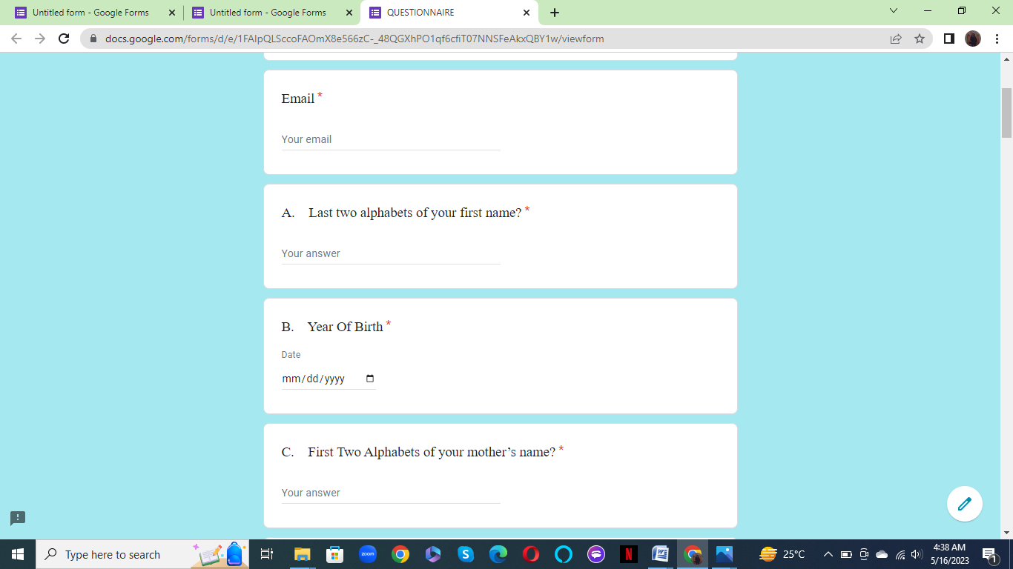

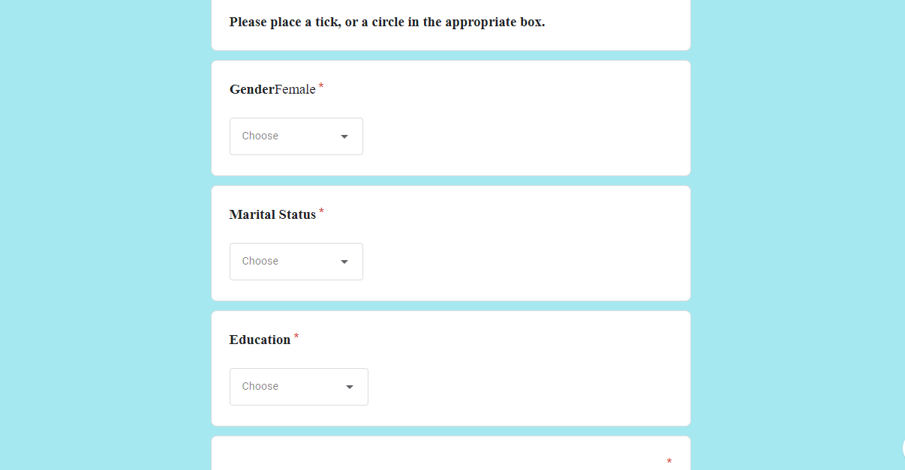
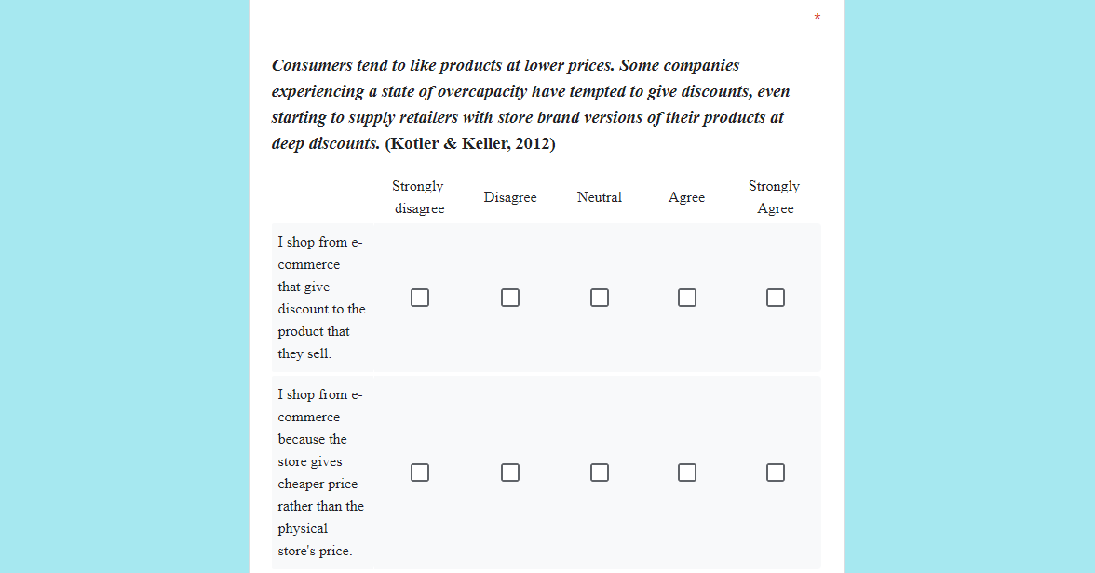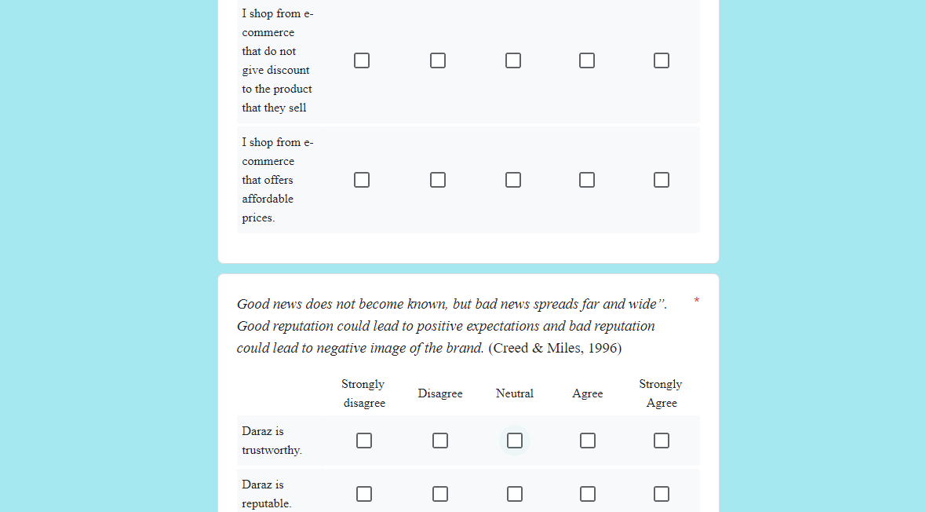

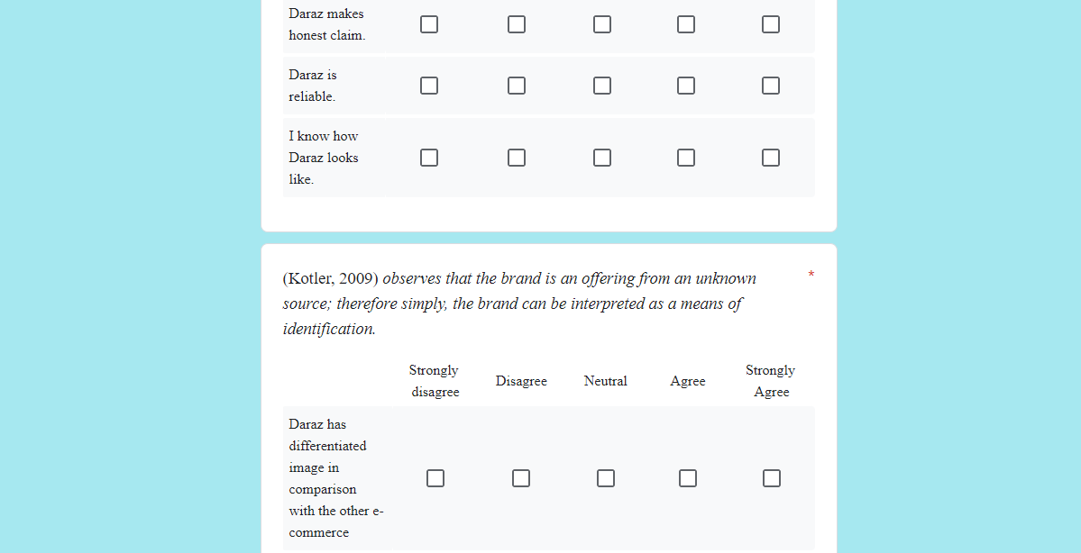

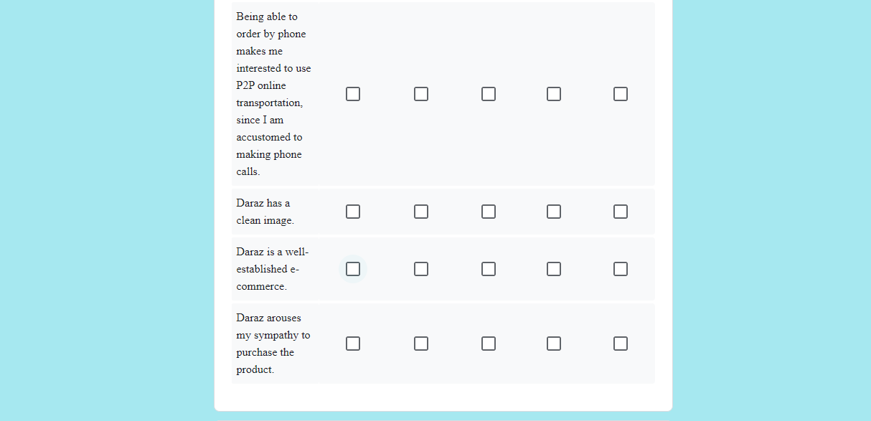
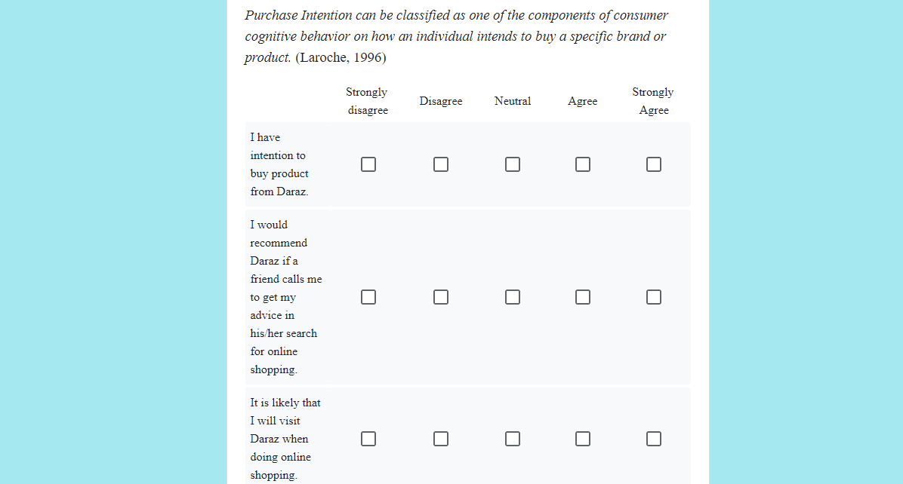
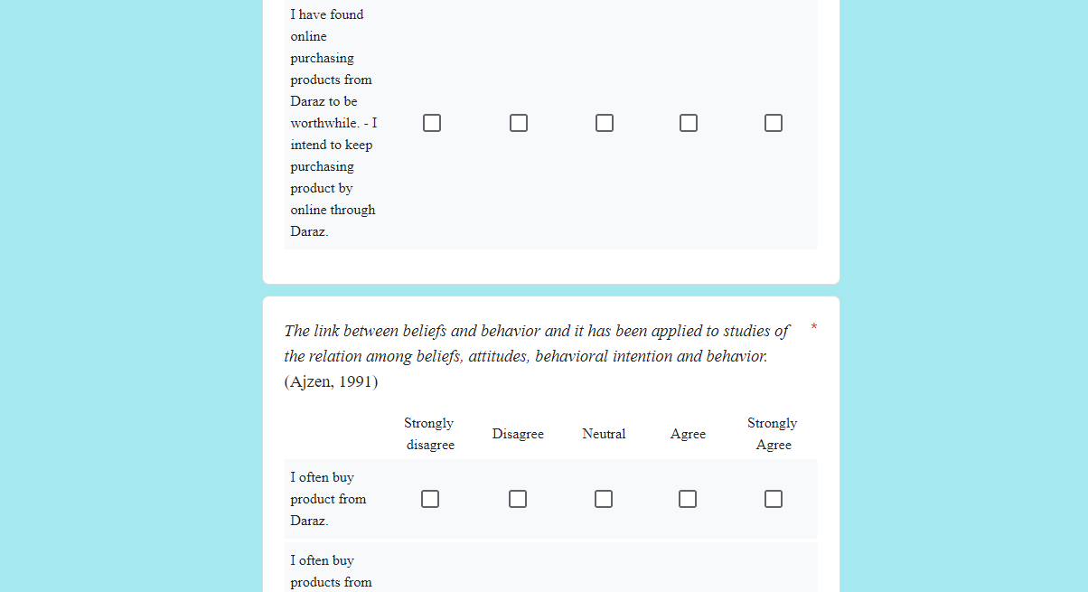

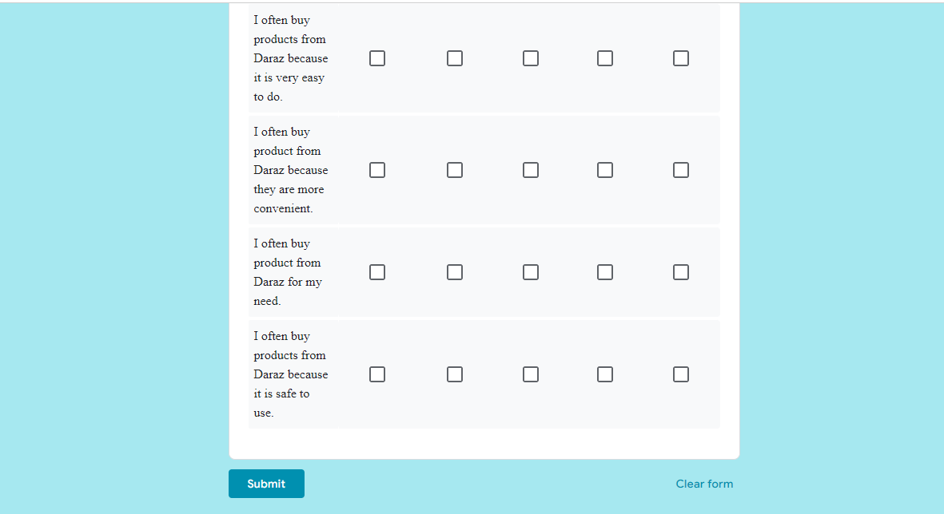

PLAGIARISM REPORT
