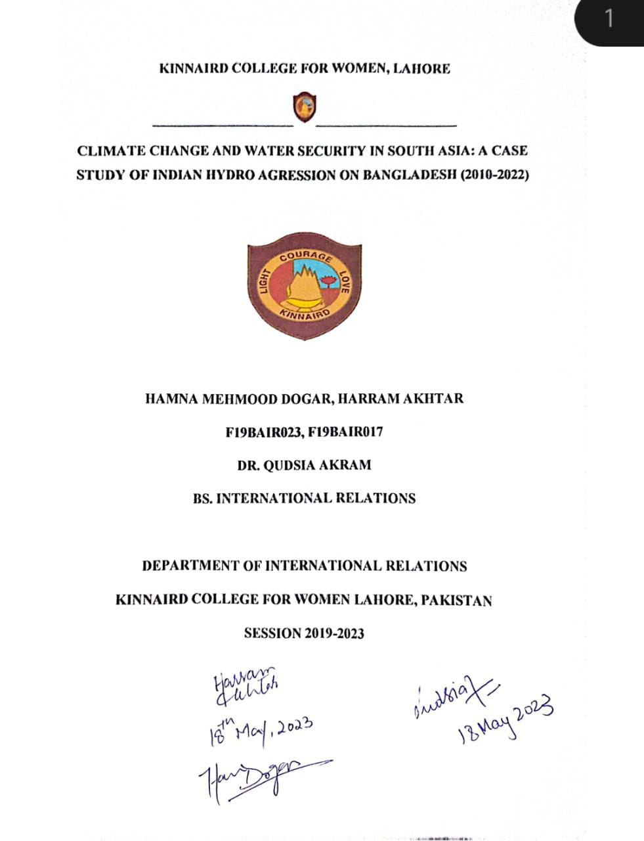

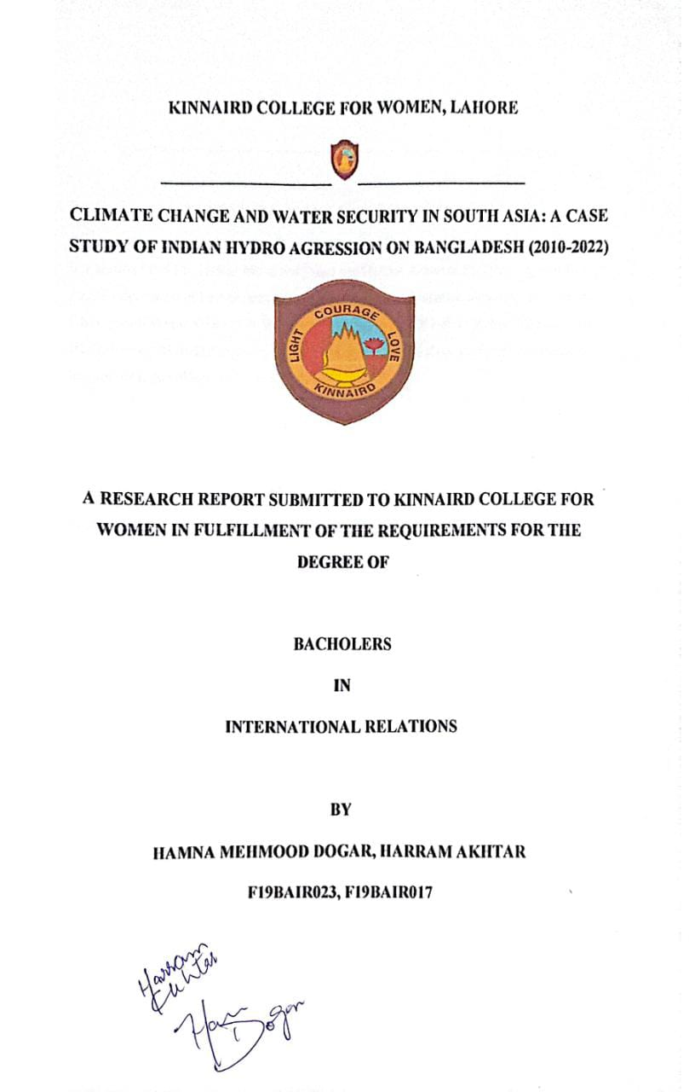

KINNAIRD COLLEGE FOR WOMEN, LAHORE


RESEARCH COMPLETION CERTIFICATE

It is certified that Ms. Hamna Mehmood Dogar and Harram Akhtar of BS Hons (Session 2019 – 2023), Department of International Relations have carried out research work entitled “Climate Change and Water Security in South Asia: A Case Study Of Indian Hydro Aggression on Bangladesh (201-2022)” under my supervision. It is assured that research work is original and has not yet been published anywhere else.
"All changes suggested by examiners during defense are incorporated in this final copy",

Signature of Supervisor Dated: 18-5-2023

Signature

Head of Department

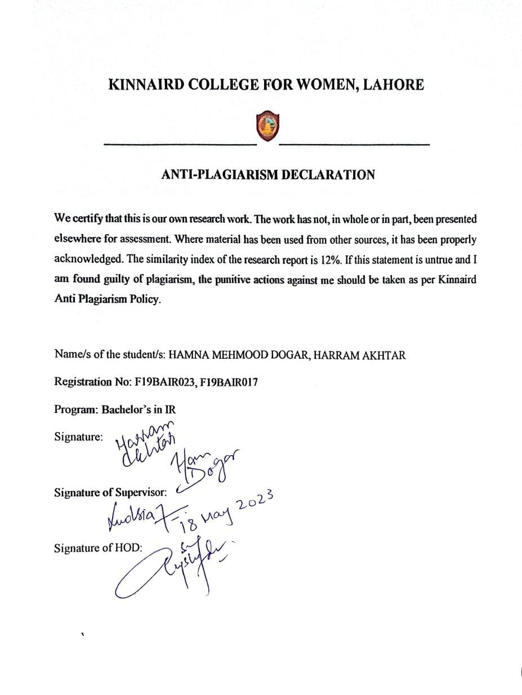



Abstract
Climate change and water security are among the most pressing issues faced by South Asian countries. This case study examines the Indian Hydro Aggression on Bangladesh from 2010 to 2022, which highlights the impact of climate change on water resources and the geopolitical implications of water security in the region. The research focuses on the significance of this case study in understanding the complex interplay between climate change, water security, and geopolitical tensions in South Asia. The study addresses the problem of the unequal distribution of water resources and the effects of water scarcity on vulnerable populations, particularly in Bangladesh. The methodology used in this study includes a qualitative analysis of secondary sources, including academic articles, government reports, and news articles. The study also analyses primary sources, such as interviews with experts in the field, to provide a comprehensive understanding of the Indian Hydro Aggression and its impact on Bangladesh. The results of the study indicate that climate change has resulted in a reduction in water resources, which has led to an increase in geopolitical tensions between India and Bangladesh. The Indian Hydro Aggression, which involves the construction of dams and the diversion of water from rivers that flow into Bangladesh, has exacerbated water scarcity, and affected the livelihoods of millions of people in Bangladesh. The study’s implications suggest that the issue of water security must be addressed urgently to mitigate the adverse effects of climate change and reduce geopolitical tensions in South Asia. This requires a shift in focus from national interests to regional cooperation, including the adoption of integrated water resource management policies that prioritize the needs of all stakeholders. The Indian Hydro Aggression on Bangladesh is a clear example of the ongoing issues related to unequal distribution of water resources and the geopolitical tensions that arise due to the same. Despite signing several treaties between India and Bangladesh, the issue of water sharing remains contentious, and the Indian Hydro Aggression has further intensified the problem. Moreover, the impacts of climate change, such as floods and droughts, exacerbate the water scarcity issue in Bangladesh, affecting vulnerable populations and their livelihoods. The Indian Hydro Aggression in Bangladesh has caused reduced freshwater availability, salinization of soil, and a decline in fish production, emphasizing the need for integrated water resource management and regional cooperation to address water security and mitigate climate change effects.

LIST OF ABBREVIATIONS

ADB | Asian Development Bank
BIMSTEC | Bay of Bengal Initiative for Multi-Sectoral Technical and Economic Cooperation
BNP | Bangladesh Nationalist Party
CEPA | Comprehensive Economic Partnership Agreement
FAO | Food and Agriculture Organization
GCF | Global Climate Fund
GEF | Global Environment Facility
GHG | Greenhouses Gases
MOU | Memorandum of Understanding
NGOs | Non-Governmental Organization
SAARC | South Asian Association for Regional Cooperation
SANDEE | South Asian Network for Development and Environmental Economics
TRT | Teesta River Treaty
UN | United Nations
UNDP | United Nations Development Program

UNFCCC United Nations Framework Convention of Climate Change

Table of Contents

RESEARCH COMPLETION CERTIFICATE i
ANTI-PLAGIARISM DECLARATION ii
ACKNOWLEDGMENTS iii
Abstract iv
LIST OF ABBREVIATIONS v
CHAPTER 1 1
- INTRODUCTION 1
  - SIGNIFICANCE OF THE STUDY 3
  - PURPOSE AND DESIGN OF THE STUDY 4
    - Aims and objectives. 4
    - Research Questions 4
  - NATURE OF STUDY 5
  - LITERATURE REVIEW 5
CHAPTER 2 9
Theoretical Framework: Water Security and Climate Change as Concept 9
  - Introduction 9
  - Anthropocentrism 11
  - Water Security 12
  - Climate change as a concept relating to water security 15
  - Hydro aggression 18
    - Relation between water security and hydro aggression 20
    - Relation between water security and Climate Change 21
  - Climate Change and water security in India Bangladesh 22
  - Core Assumptions of Water Security 24
    - Hydro aggression examples globally 27
CHAPTER 3 28
Climate conditions in Bangladesh in past decades 2010 onwards 28
  - Introduction 28
  - Climate Crisis in South Asia 29
  - Climate Conditions in Bangladesh 32
  - Causes of Climate Change in Bangladesh 34
    - Impacts 35
  - Rise in the temperature of Bangladesh 36
    - Erratic rainfall and Long Monsoons 37
  - Natural Resources and environment in Bangladesh economy 37
CHAPTER 4 39
Indo-Bangladesh trans-boundary relations and Indian hydro aggression 39
  - Introduction 39
  - Indo-Bangladesh Economic ties and competition 40
    - Political Ties 42
  - India-Bangladesh Transboundary Relations 43
  - Indian Hydro-aggression 45
  - Transboundary Agreements and Indian Hydro-aggression 49
  - Impact on Living and Agriculture of Bangladesh due to Indian Hydro-aggression 54
  - Indo-Bangladesh relations impact on South Asia 58
CHAPTER 5 60
Role of Regional and International Community dealing with Indian Hydro-Aggression and Bangladesh Climate Crisis 60
  - Introduction 60
  - Bangladesh National Action Plan 60
  - Role of regional and international organizations in combating the Bangladesh climate crisis and hydro-aggression of India 61
    - Regional and international Community dealing with Climate Crisis 65
  - Role of Regional and International Community towards Bangladesh Climate Crisis 67
  - Is the community protecting or neglecting Bangladesh? 68
  - Forming a new group within the organizations might solve the problem. 69
CHAPTER 6 72
Policies for Bangladesh to tackle Water Security and Climate Crisis 72
  - Introduction 72
  - Challenges Faced by Bangladesh 73
    - Effect on Agriculture 73
    - Effect on Industries 73
6.2.2 Effect on Infrastructure 74
  - Government Response 74
  - Water Security Policies for Bangladesh 74
    - Integrated Water Resource Management (IWRM) 74
    - Groundwater Management Policy 74
    - Flood Management Policy 75
    - Water Quality Management Policy 75
  - Climate Change Policies for Bangladesh 75
    - National Adaptation Plan (NAP) 75
    - Climate Smart Agriculture Policy 75
    - Renewable Energy Policy 76
    - Sustainable Transport Policy 76
  - South Asian Integration Towards Bangladesh Climate Crisis since 2014 76
    - Climate Change Crisis in Bangladesh 76
    - Bangladesh's economic importance in South Asia 77
    - Economic Overview 77
    - Trade and Commerce 77
    - Investment 78
    - Current Affairs 78
  - Policies for Bangladesh to tackle water security and climate crisis. 79
    - Enhance Adaptation and Resilience Measures 79
    - Strengthen Water Governance 79
  - Promote Water Conservation 79
    - Promote Sustainable Irrigation Practices 80
    - Invest in Water Infrastructure 80
  - South Asian Integration towards Bangladesh Climate Crisis 80
  - Working of India and Bangladesh towards Hydro aggression 81
  - Conclusion 83
  - Analysis 87
References 90

CHAPTER 1

INTRODUCTION
In the present time, the climate is shifting to warmer patterns which are not normal as this climate change over the span of one century has taken a worse shift because of activities of the humans which is known to be the anthropogenic climate change. Global warming has increased with the increase in industrialization consuming coal and other fossil fuels releasing greenhouse gasses (GHG). The emission of Carbon-dioxide causes a rise in the sea levels to one-eighth per inch every year. This study focuses on the South Asian Climate Change as it is seeing hotter weathers with longer monsoon seasons and increasing drought by 1.5 Celsius Degrees in the coming decade impacting economies, livelihood opportunities, habitat, and climate vulnerability of the region. Pakistan, Bangladesh, Sri Lanka, and India are being and supposed to be affected the most as they are coastal countries in South Asia as Pakistan, India, Nepal, and Bangladesh are fed by the Himalayan River basins and these countries are facing water stress and resource depletion as well.
Global warming affected the coastal countries the most such as Bangladesh which is a densely populated country and is a riverside country located in the North-Eastern South Asia with a coastline of 580-700 km long on the Bay of Bengal in South; hills of India and Myanmar in the East, Himalayas in the North and West Bengal in the West which makes it a low-lying and flat land surface. It is located on the biggest delta on earth which is Ganges delta. It has a tropical monsoon climate causing floods; cyclones and erosion throughout the year are part of the effects. They bring drastic effects along with them such as socio-economic issues including poverty, health, land loss, and population displacement. Bangladesh’s location is already infelicitous as it is a lower riparian country. It needs more suitable action plans for water resource management along with coastal zone management to compete with the disasters and move forward to the development in the future with less deforestation and land loss.
The water resource management in South Asia is being neglected as Pakistan, India and Bangladesh are water stressed and dependent on the Gangs, Indus, and Brahmaputra. In Bangladesh, management is required for a sustainable future because it faces the worst monsoon and drought. It shares fifty-four rivers with India but of no use because of less power production

in Bangladesh and more hydropower plants in India within those rivers. Out of all the rivers it has signed a treaty on the Ganges River 1996 and an unsigned one because of disputes on Teesta River from 1983-2021 on the share, allocation, and development of this specific water resource. India and Bangladesh have a dispute on the sharing percentage of Teesta River as a water resource having India at 55% and Bangladesh with the other 45% in which India flows most of the water to Bangladesh in the seasons of monsoon and less in the drought season. The37% area and 33% population of Bangladesh depend on the Ganges River between the two states. India has planted its Hydro plants on certain rivers that it utilizes the water to produce electricity. Bangladesh has the potential to build hydro powers, but India does not share it with Bangladesh and export electricity to Bhutan and Nepal. It would be a win-win situation for both the states if they share the hydropower projects thus Bangladesh tried to present a ‘Power Corridor’ to India in 2013 for the electricity transmission that would benefit Bangladesh with 500MW as it is a power deficit country, but this agreement was opposed by BNP and other leagues in Bangladesh. The problem lies here in the form that Bangladesh has the potential to form its own hydro power plants but due to the absence of high head and high flow rate and least cooperation with India regarding hydropower, it cannot make it up to the needs of reserving water. India does not do the fair water distribution on Farakka barrage that has caused the 33% population of Bangladesh to suffer with floods every year such as the recent one in June 2020 affecting 5.4 million people and in June 2022 with 7.2 million in all parts of the country. The super cyclone Amphan originated from the North Indian Delta hitting India, Bay of Bengal and mostly Bangladesh at the end with the loss of 0.2 million hectares of agricultural land and ten million people because of not controlling the hydro aggression by India. The BNP and Bangladeshi government think that India is drawing excessive amounts of water from the rivers regardless of the Ganges River treaty in 1996 and the allocation and division of water towards Bangladesh is unjust. The South Asian countries will have to deal with the crisis because of close boundaries and ties with both the countries. Also, Pakistan is also dependent on India for water due to their Water Treaty and less water available to Pakistan.
Water Security is not where water is absent but where there is too much it needs to be saved as this concept has emerged in the 21st century. According to Grey. D and Sadoff, C.W. As for the professors of Water Policy, the concept of Water security is the capacity to save an adequate amount of water that would leave a sustainable access for livelihood, wellbeing, and socio- economic development. It depends on populations and through mass collaboration between

countries to protect quality and quantity of water to protect them from water related catastrophes and disasters. In Bangladesh, due to maximum flooding, deforestation, and salinity of water, they do not have access to drinkable water. This issue rises with the Indian policies not adhering to just division but sticking to the hydro aggression towards Bangladesh that has been causing serious environmental and socio-economic hazards. It leads to mismanagement of water. The water security is imbalanced on both sides thus India and Bangladesh need to stay on the same page because if water security is not regulated between them their bilateral relations may get complicated, and it may affect the multilateral relations in south Asia as well. Both countries need to develop balanced treaties for equitable sharing, keeping in view the water security that would benefit both states and reduce conflicts.

SIGNIFICANCE OF THE STUDY
The significance of this research work is that it aims to find comprehensive answers to the questions surrounding the climatic conditions of Bangladesh as the Climate Change is a crisis that the entire world is facing and if we are not going to find solutions to curb this problem then the world will have the worst circumstances leading poverty, political instability, and economic collapse. The study aims to find out how we can curb or control it, what suggestions can be made or what changes can we make to protect it from the verge of the worst climate crisis. This research will explore the causes in which we have its geostrategic location and its relations with neighbors such as the Indian hydro aggression as the longest dispute between India and Bangladesh over the distribution of rivers that are adding more to the climate chaos. Bangladesh is ranked seventh in the Global Climate Risk Index 2021, so it surely does need research to find the solutions to protect Bangladesh from further disastrous effects. The importance of this research work is that it will help other students of International Relations and related fields in their research regarding the severe climatic conditions affecting the world in a fast manner and to control it through different steps according to the circumstances.

PURPOSE AND DESIGN OF THE STUDY

Aims and objectives.

The aim of this study is to analyze the climatic calamities occurring in Bangladesh and observe the impacts of Indo-Bangladeshi hydro relations.
      - To explore the current climate crisis and its effects in Bangladesh overall
      - To study the concept of water security affecting the climate within the perspective of Bangladesh in South Asia region in the climatic stress
      - To study the impact of trans-boundary relations between Bangladesh and India on South Asia as well while keeping in view the hydro aggression by India
      - To find out the hydro aggression and water disputes among India and Bangladesh
      - To assess Bangladesh’s economy and to overcome the crisis by climatic conditions.
      - To gauge the role of regional and international organizations in the water dispute between India and Bangladesh.

Research Questions

- What are the internal and external causes of the rise in climate change in Bangladesh during 2010-2022?
- What would be the impact of Indo-Bangladeshi trans-boundary relations and Indian hydro aggression on South Asia?
- What policies should Bangladesh adopt to tackle the current challenges presented by the climate and water security to its economy?
- What roles have national and international organizations played in protecting Bangladesh climate and implementing a sturdy protocol to combat the issue of hydro aggression as the main dispute causing disasters?

NATURE OF STUDY
This research study's technique is the qualitative method of research. Books, journals, journal articles, and newspaper articles will all be studied for this purpose. There will also be references to certain original data sources, such as the official reports issued by the governments of Bangladesh, India, the United Nations, and other south Asian nations.

LITERATURE REVIEW
The book “Climate Change adaptation actions in Bangladesh” is written by “Rajib Shaw, Faud Mallick, Aminul Islam.” In this book there are five main concerns of the writers. This includes the risk disasters, their methods, approaches, and practices towards the climate change of Bangladesh. This book is divided into four parts; these are Climate Change impacts, strategic and action planning of region, the Socio-Economic impacts caused by multiple Hazards in Bangladesh, the Adaptive Actions that what region should take for its betterment or to overcome its challenges and the role of governance on Climate Change. Climatic change was acknowledged as an important global issue during the First World Climate Conference in 1979, necessitating coordinated government preparation for future climatic dangers. The Intergovernmental Panel on Climate Change (IPCC) was founded in 1988 because of this understanding to evaluate the scope and timing of changes as well as their effects. In 1990, the IPCC released its First Assessment Report, which laid the groundwork for discussions on a climate change treaty at the UN General Assembly. Between February 1991 and May 1992, the General Assembly hosted five meetings of the Intergovernmental Negotiating Committee for a Framework Convention on Climate Change, and on May 9, 1992, the Convention's text was approved. Although it is well acknowledged that disaster risk reduction (DRR) and climate change adaptation (CCA) are related in certain respects, they have not yet been seen as a comprehensively integrated complement of activities needing cooperative and coordinated effort by all interested parties. The complex relationships between cross-sectoral development activities, their environmental impact, the negative effects of a degrading environment on human life, and the integrated strategy needed to address the combined threat of climate change and disasters have been clarified by recent work by researchers and policymakers. The growing emphasis on local governments, the emphasis on interdisciplinary methods, and the emphasis on theory to practice are three recurring problems in CCA and DRR development. Additionally, under the Comprehensive Disaster Management Programmed

(CDMP) of the Ministry of Food and Disaster Management, the United Nations Food and Agriculture Organization and the Department of Agricultural Extension are working together to implement the LACC (Livelihood Adaptation to Climate Change) project. Here, they tested various workable adaptation options for drought areas and discovered various adaptation practices beneficial for the livelihood, such as mini ponds. Additionally, DAE has provided farmers with drought-tolerant crop types created by the Bangladesh Agricultural Research Institute (BARI) and Bangladesh Rice Research Institute (BRRI)(Shaw, 2013).
The book “Hydro Politics in GBM Basin: The Case of Bangladesh-India water relations” is written by Nitya Nanda. Abu Sleh Khan, K Dwivedi. This book explains the key issues faced by the south Asian region and its water resource management with respect to GBM Basin. The concept of bilateral and multilateral water cooperation along with its approaches, frameworks and instruments are also discussed. Various conventions and treaties are made for it under international law which is also elaborated in it. The case study for this working is India-Bangladesh and their resource management, which is explained with both countries’ perspectives and their relations with each other, and challenges faced by them, are elaborated in it. To maintain an economic and ecological balance is important for India and Bangladesh, and it is also a challenge for them to take care of the environment and in the meantime to work for the betterment of their economy as well. But this perspective is not given as much light as it needs. The failure of water resource management is also a crucial factor which is explained with its multifunctional focuses and ideas as well (Nanda, 2015).
In their article on "Climate Change adaptation and disaster risk reduction in Bangladesh," the United Nations Climate Change notes that the initiative is led by women and helps Bangladeshi communities adapt to climate change by addressing extreme weather events like cyclones and flooding as well as the effects of rising salinity conditions in the country's agriculture. The Action Aid to Women in Bangladesh is the article's main topic. Through the Action Aid Bangladesh program, teams of women collaborate to do vulnerability analyses of climate hazards and then create action plans. The same groups of women that the campaign brought together then carry out these ideas. Parts of the nation are frequently affected by flooding, drought, storms, and saline intrusion into freshwater sources. Women in Bangladesh are particularly vulnerable to the consequences of climate change because they are usually excluded, ignorant of their rights, and

unable to engage in their communities. Bangladeshi women can adapt to climate change at the local level thanks to Action Aid Bangladesh. Women's organizations direct the development of action plans and vulnerability assessments of climate hazards. The same women's organizations that ActionAid Bangladesh got together then carry out these action plans. Women are better able to articulate their demands thanks to this community-based strategy, which also increases their adaptability to climate change. This effort, which provided funding to local governments to boost their capability, prioritizes scalability. To guarantee that the successful techniques tested by women-led organizations are repeated, the project encourages communication between local governments and communities. These organizations may then exchange best practices and lessons learned, which can then be reproduced and spread to have a bigger impact. This strategy is versatile, allowing it to be customized to the requirements of specific communities (United Nations Climate Change, 2022).
"Water Crisis or What Are Crises? Roshani Jain wrote "A Case Study of India Bangladesh Relations." The author of this post concentrates on the final and most significant aspect of water scarcity. It tries to investigate how this impacts ties between India and Bangladesh. The Farakka Barrage, which is largely acknowledged as the root cause of Bangladesh's water issue, is used as a case study to achieve this. Over 4,000 kilometers separate India and Bangladesh, with the International Boundary serving as India's longest land border. This border's porousness and the absence of a distinct line delineating the land's boundary used to be a major point of controversy since it had unanticipated consequences. This is so that man-made borders won't be able to bend the natural terrain contours to their whims. As a result, illegal immigration flourished in the Indian and Bangladeshi enclaves that bordered each other's countries. This problem compounded unfavorable effects, such as drastically changing demographics in the neighboring Indian states of West Bengal and Assam, and it also sparked a conversation about citizenship that is being used as a platform for political propaganda in India. Although it is not common, water is a crucial factor when assessing interstate connections. A positive sum game will come from a review of Indo- Bangladesh ties that places a renewed emphasis on and commitment to fair and effective management of the Ganga Basin. If India is serious about establishing constructive bilateral relations with her neighbor, she will need to temper the Realist paradigm she has up until now with principles of cooperative responsibility and solidarity. India has always taken pride in following a

dynamic foreign policy tradition, with no strict adherence to any one mode of philosophy (Roshani., 2020).

CHAPTER 2

Theoretical Framework: Water Security and Climate Change as Concept

Introduction
The earth contains 71% of water and the other part as land but this percentage of water presence on earth does not mean that it is enough for as long as the earth lives because water is an irreplaceable natural resource that is viable for human development as well as living. This idea of too much of water on earth raises another question whether the water needs to be taken care of or the land because sometimes, excess of water or the absence of conservation or preservation of water may be the reason behind catastrophes on the land and the other times, land causes the rise of water which ultimately leads to destruction of water. In both cases, it is the land i.e., the living is going to be affected in which all species on earth that maintain life are going to get the maximum damage and there would be no sustainable life on earth left. This fact of water being the major key player of maintaining life on earth is the most important thing to be taken care of because life depends on water and in the contemporary era, water is a resource of living so its use should be accounted for.
The global issue of excessive water usage has a major impact on both water scarcity and climate change. The quantity and quality of available water is crucial to the maintenance of ecosystems, economic growth, and human well-being.
One of the most immediate problems caused by excessive water use is the exhaustion of underground water sources. Many communities rely on groundwater for drinking water, as well as for agricultural uses including irrigation and livestock watering. Yet, groundwater depletion due to excessive removal threatens both ecosystem health and water supply reliability. By 2050, water use is expected to increase by 55 percent, and 1.8 billion people would experience water scarcity, according to a United Nations report. One of the main causes of this issue is the overconsumption of water. Water waste also adds to global warming. Irrigation is one of the major users of water in the world, using more than 70% of all freshwater withdrawals. Pumping water from deep underground, for example, uses a lot of energy and may contribute to global warming if it were used for irrigation instead.
Land use shifts due to water management practices can contribute to global warming. Carbon trapped in the soil and vegetation is released when forests are cut down to make way for additional

agriculture, for example, which can increase greenhouse gas emissions. According to studies, reducing overall water use is an effective strategy for dealing with both global warming and the threat of water scarcity. One strategy to achieve this goal is to enact rules and regulations that promote sustainable water usage, such as supporting water-saving technology and practices, using efficient irrigation systems, and so on. The environment, human health, and water security are all seriously threatened by excessive water use. Individuals, corporations, and governments need to work together to promote sustainable water usage and minimize water use to address this problem and battle climate change.
There is no way that all the water bodies and ocean water can be completely used and stored but there are ways that the usable water can be preserved to make living possible for a longer run. Humans use water excessively for industrial and commercial purposes so that the drinkable water also gets used in it and only 1% (3% out of 100%) out of the 71% water is fresh water that is both for the aquatic species, animals, humans, and the land. The water in the oceans is 97% of total water and is saline which is unusable because of the amount of salt in it and all of it cannot be renewed and processed. The other 1% of 71% of water is for the living and humans must take control of using water wisely and make a better living out of it. Therefore, water security is the most important phenomenon that should be adopted for the sake of water security. Water needs to be conserved or preserved. The focus here is that water should be available and left in a pretty amount for living.
Due to its prohibitive cost and high energy consumption, desalination can be a major financial and environmental burden. A reliable source of freshwater in areas with scarce supplies, it may not be practical for widespread usage in places with inadequate energy infrastructure or high desalination costs. Decentralized and environmentally friendly approaches to water management have gained popularity in recent years. Precipitation collection, wetland restoration, and groundwater recharge are all viable possibilities. It is necessary to collect and store rainwater for later use in irrigation, drinking water, or other applications. In areas where rainfall is insufficient, this method can assist in cutting down on the need for alternative sources of freshwater. Repairing degraded wetland regions has many benefits, including better water quality, less flooding, and an increase in biodiversity. By naturally filtering out harmful substances, wetlands can serve as a form of water purification. Depleted aquifers can be replenished with groundwater through infiltration basins and regulated recharge systems. This has the potential to improve water availability and aid in the

revitalization of aquifers. Water prices, public awareness campaigns, and the installation of water- efficient techniques and technologies are all examples of interventions that can help encourage water efficiency and conservation in addition to these natural answers. Desalination is not always the most cost- or environmentally efficient solution, even if it may supply a reliable source of freshwater. Instead, the problems associated with water scarcity can be mitigated and water security improved through the implementation of a more all-encompassing approach to water management that incorporates decentralized and natural solutions as well as initiatives to promote water efficiency and conservation.

Anthropocentrism
Human centricity, or anthropocentrism, has been related to climate change and water security issues. This way of thinking puts human wants and needs ahead of those of other organisms and the environment, which in turn leads to actions that are not sustainable and have a negative impact on ecosystems and natural resources. Climate change and water scarcity are just two examples of the many negative outcomes for the environment that can be attributed to human activity. For instance, the emission of greenhouse gases has contributed to global warming and altered weather patterns; these effects have been exacerbated using fossil fuels, the spread of industrial agriculture, and urbanization. The overexploitation and pollution of freshwater sources like rivers, lakes, and aquifers have also contributed to water scarcity and lowered water quality. The growing human population, increased consumerism, and unsustainable agricultural techniques are all to blame. It is possible to challenge anthropocentrism by shifting to more holistic and eco-friendly worldviews. For instance, adopting an eco-centric worldview that recognizes the interdependence of all living things, and the importance of ecosystem health might help spread more sustainable behaviors that prioritize environmental and human happiness. Anthropocentric thinking has negative consequences for climate change and water security, which can be mitigated in part by encouraging sustainable habits and policies. This can include fostering renewable energy, reducing waste and pollution, protecting natural habitats, and advocating for environmentally responsible practices in agriculture and water supply. Natural resource management that takes this viewpoint into account must be more holistic and environmentally aware. The challenges of climate change and water scarcity can be traced back in great part to an anthropocentric perspective. (Padwe, 26 August, 2021).

Water Security
Water security is defined by the United Nations as "the capacity of the population to safeguard sustainable access to adequate quantities of water of acceptable quality for sustainable development." This means that water security does not imply that water resources are not accessible or available, but rather that water is used in a sufficient amount so as to prevent its scarcity and lack (Hamilton, 2013). This concept gives the importance of the presence of water that humans should be aware of the importance that water is the key source to life and if the factors like importance of water for nature, development of humans in context to economy and healthy or productive life are not kept in check, then it will lead to water insecurity. Water insecurity can be in the form of water scarcity or shortage of water both in physical form or its delivery, lack of economic development, natural hazards like floods and droughts, and loss of aquatic and wildlife depending on water. For sustainable development, water is essential to give maximum gains and benefits to life on earth and have a long-lasting sustainable future for the population on earth (Pacheco-Vega, 2019).
The concept of water security has evolved to cover larger security concerns related to the management and control of water resources, going beyond the original premise of water supply and access. The idea originated in the 1990s, when a reevaluation of traditional approaches to managing and administering water resources was prompted by concerns about global water scarcity and a growing appreciation of the significance of water for sustainable development.
According to studies published on the Water Security and Climate Change Conference's website, the concept of water security emerged as a means of addressing the challenges posed by growing water scarcity, shifting climatic patterns, and other environmental stressors. Instead of solely focusing on water availability and access, water security refers to the ability to manage water resources in a sustainable and equitable manner that protects social, economic, and environmental well-being. There is widespread agreement that access to clean water is an essential component of national and international security, with knock-on effects for economic development, public health, and political stability. When water becomes scarcer, competition among users and between regions is likely to intensify, potentially leading to conflicts. Lack of access to clean water can also exacerbate social and economic disparities, especially among vulnerable people and marginalized communities. An integral part of the concept of water security is the need for integrated water resource management, which calls for the coordination of several actors and industries to ensure

the efficient and equitable distribution of water. Efforts to achieve this goal can include promoting democratic decision-making, funding water infrastructure, protecting natural habitats, and encouraging water efficiency and conservation.
The concept of water security refers to a more comprehensive strategy for water management and governance, one that considers the vital role that water resources play in sustainable development and the need to balance different users’ water demands fairly and equitably.
Water security’s key aspects are to meet fundamental needs such as sanitation and hygiene which would safeguard health and well-being of society. States are the ones who control their processes, so they need access to safe and drinkable water and their livelihoods, human rights, and cultural values along with international status are protected through their policies of securing water. The conservation and preservation for water allocation, distribution, supply, and management are required to perform productive potentials. Water resources are not just required for everyday living or fulfilling the purposes of needs of water but socioeconomic development and activities for a heavenly future are also dependent on water security in the contemporary era. There is a particularly important and common way of water security as the used water must be collected, renewed through water institutions and infrastructures, or treated to prevent pollution and to protect human life and the environment by which water can be a source of healthy life and well- being of society (siwar, 2014).
Water policy experts like Grey D. and Sadoff C.W. define water security as the availability of an acceptable quantity and quality of water for health, livelihoods, ecosystems, and production. This allows for the potential productive use of water while minimizing the destructive impact with an acceptable level of water-related risks to people, environments, and economies. Sustainable water management is necessary but is absent in communities that do not properly comprehend hydrology. Hydrology studies how the water is distributed on and under the earth’s surface leading to variability of water which is the mismanagement or handling of water due to the natural phenomenon of less rainfall, climate changes, population growth and human activities causing water pollution or contamination. There are many factors leading to the variability or the hydrology that states do not recognize the patterns present in their systems such as if there are naturally less resources and mediums available, states tend to preserve their water resources as they might suffer from water scarcity in future. The other is states with extra usage of water for their infrastructure and with this, their economic behaviors are judged in which they must maintain their policies and

potential use leading to either production or destruction. As poor states who already suffer in many aspects politically, economically, and socially need to be aware of their water availability and what is affecting their resources or causing the variability so they can be aware of their remains and ongoing processes. The rich countries often with their trans-boundary relations sometimes over- use or do the unfair distribution of water to the other country which makes the other one aggressive or unable to perform productively. Either they get unfair distribution as less in the drought season causing scarcity and more in the rainfall causing floods. The rich countries get benefits according to their needs and interests and the poor do not even get the minimum out of it (D & Sadoff, 2007). This is where in the international Relations, states hydrology and their behavior impact the relations as well as their resource management leading to poverty and vulnerability. Also, if there is no adequate quality and quantity of water, states tend to have water wars because of their vulnerability being generated and their risk to survival being caused. The states that achieve water security by investing in infrastructures such as hydro-plants, dams and institutions are more likely to have a sustainable future and the other side of the story is that this hydro-politics between states with trans-boundary relations make the international system chaotic and a more challenging time to tackle with the water demands and more destructive mismanagements. There must be developed strategies that promote collaboration and sustainability in the management of transboundary freshwater resources within nations by building Institutions that are open, inclusive, and responsible according to well-planned, managed, and maintained infrastructure with the help of rational policies that remain under the laws and within the peaceful treaties, agreements, or healthy bilateral relations (Young, 2015).
For instance, many parts of the United States, especially the western states, have an issue with water security. This is due to a confluence of causes, the most significant of which being droughts, population increase, and wasteful use of water supplies. However, many areas in the United States have problems with water quality even though it is a basic human right to have access to clean water. Both urban and rural areas are included since industrial and agricultural practices can contaminate drinking water. Water infrastructure in the United States is aging and in need of major maintenance. This includes the construction of dams and other water purification facilities.
Considering these threats, the US government has taken a number of steps to make water security a priority in its foreign policy. One such example is the new Global Water Strategy unveiled by the Biden administration to improve water security in marginalized populations around the world.

Sustainable water management methods and improved funding for water-related initiatives make up the strategy.
The United States government also supports innovation in water security through funding for R&D. Water SMART is only one example of a program that helps promote innovative approaches to water management. The United States works with other countries and international organizations to ensure safe and reliable access to water. The United States, for instance, is among the eleven nations that make up the High-Level Panel on Water, which is dedicated to enhancing water safety around the world.
Water security is a foreign policy priority for the United States, and this is even though the country faces major water security challenges. To guarantee that all people have access to safe, clean water, the United States works with other countries and invests in innovative technology and environmentally responsible water management techniques. The United States needs to take a more holistic and united strategy to water management if it is to overcome these problems. Incentives for water efficiency and conservation, investments in water infrastructure, and the passage of laws and regulations to safeguard water supplies and limit pollution are all ways to achieve this goal. Water security problems are intricate, but they can be solved with collaboration and coordination between federal, state, and local governments and stakeholders (Kruzman, 2022).

Climate change as a concept relating to water security.
When scientists discuss long-term changes in average temperatures, precipitation amounts, and other climatic variables, they are referring to these changes through time. Only a few of the human activities that contribute to this issue include the burning of fossil fuels, the loss of forest cover, and the emissions from factories and other industrial operations. Throughout Earth's history, there have been times when the climate has warmed and cooled. Yet, the current warming trend is especially worrisome because of how quickly it is developing and since it is widely believed that human activity may be to blame. As a result of this warming trend, sea levels are rising, heat waves are getting more frequent and intense, and droughts and floods are occurring more frequently.
Most scientists concur that climate change is real, and that human activity is its main cause. This information is based on extensive research and analysis of climate data from around the world as well as sophisticated computer models that simulate the Earth's climate system. Future Earth and human civilization will be significantly impacted. Everyone's cooperation will be needed to reduce

greenhouse gas emissions and transition to more environmentally friendly energy and resource use. In many regions of the world, droughts are growing worse and more frequent. A recent drought in Cape Town is observed, South Africa, which was caused by a combination of natural and climatic factors. Water in the city was depleted due to the severity of the drought, and conservation measures were implemented. The increasing frequency and severity of reported inundation is another issue highlighted by the report. A recent flood in Bangladesh exemplifies how climate change exacerbates natural calamities. After the typhoon, many villages lacked access to potable water for weeks, affecting over ten million people. Some regions rely on glaciers for their freshwater supply, but climate change is causing them to disappear at an alarming rate. In the Hindu Kush Himalayan region, for example, glaciers could shrink by as much as two-thirds by the turn of the century. The repercussions for populations that depend on glacial meltwater for their water supply could be disastrous. With rising sea levels comes the potential for saline intrusion into freshwater sources, rendering them ineffective. Saltwater intrusion is already impacting groundwater in several coastal regions around the globe, including some locations in California, Indonesia, and Bangladesh. Due to climate change, the frequency of storms and cyclones has increased. As an illustration, the catastrophic repercussions of Hurricane Maria in 2017 on the island of Puerto Rico are used. As a result of the hurricane's destruction of water infrastructure, there were extensive cases of waterborne diseases, and the recovery effort was hampered by the fact that many villages were without electricity for weeks.
All these instances illustrate how climate change exacerbates existing water supply concerns. If allowed to worsen, these problems could result in political instability, violent conflict, and other hazards to national security. To ensure that everyone has access to pure water, it is imperative that governments and other stakeholders act against these issues (Qattan, 2023).
There is a close relationship between water security and climate change, particularly in regions like South Asia with limited water supplies and where climate change is expected to exacerbate current water-related problems. Climate change is altering precipitation patterns, which could affect water supply and quality. For instance, increased droughts in northern India and Pakistan have been linked to increasing monsoon rainfall variability in South Asia. Social and economic issues, such as food insecurity and forced relocation, have arisen as a direct result of the reduced availability of water for industrial, drinking, and agricultural purposes.

In addition to changing precipitation patterns, climate change is also increasing the frequency and intensity of extreme weather events like floods and cyclones. These events threaten the already precarious water supply in the region by damaging infrastructure, contaminating supplies, and causing human suffering and economic devastation. South Asian researchers and policymakers are exploring several approaches to resolving these problems, including the development of legal and institutional frameworks for water resource management, the promotion of water-efficient technologies, and the introduction of sustainable water management practices. These steps can improve water security and make communities more resistant to climate change. The difficulty that has arisen because of India's appropriating water from rivers that flow from Tibet to Bangladesh. The water supply in Bangladesh is in jeopardy due to India's dams, barrages, and reservoirs, which have drastically reduced the flow of water down these rivers. Farmers in Bangladesh, who rely heavily on irrigation water, have been hit particularly hard by this act of hydro-aggression. The paper argues that water diversion has reduced surface water flows during the dry season by 30%, causing crop productivity to decline. Bangladesh's wetland and marine habitats have suffered due to water diversion by India. Devastating effects on biodiversity and the livelihoods of local communities. Water security in Bangladesh is attributable to two factors: climate change and hydro-aggression. One of these is a need for greater cooperation and understanding between Bangladesh and India on shared water supplies. Bangladesh's water management systems still have a long way to go before they are where they need to be. New infrastructural development and the adoption of sustainable agricultural practices fall under this umbrella. Bangladesh faces significant challenges due to India's hydro-aggression and other issues with water security. It also stresses the importance of finding new ways to manage water resources, cut down on greenhouse gas emissions, and promote sustainable development. If different parties work together, Bangladesh and other vulnerable countries can improve their water security and achieve sustainable development.
Bangladesh's government has enacted a variety of legislation and programs to improve water security and mitigate climate change. This includes advocating for more water-efficient farming practices and constructing flood barriers and rainwater collection systems. In regions like South Asia, where water-related issues are already significant, research on the effects of climate change on water resources and the role played by human activities can provide insightful information for

stakeholders and policymakers in developing effective strategies to address water insecurity and increase resilience to the effects of climate change (Kirby, 2022).

Hydro aggression
In International Relations, the term "hydro-aggression" is used in International Relations to describe conflicts between states or groups over the ownership or control of water sources. First used in "The Significance of Hydrologic Data in International Water Conflict Prevention and Settlement" by Aaron T. Wolf and John Ross in 1999. They provide a definition of hydro aggression as a purposeful act by a state or entity to diminish the volume or caliber of water that flows downstream to another state or entity. The activities encompass water diversion, dam erection, and pollution. According to scholarly discourse, hydro aggression is a prominent factor contributing to water-related disputes among nations and can potentially have substantial repercussions on the water safety of communities located downstream. The assertion is made that hydrologic data plays a pivotal role in the prevention and resolution of water-related disputes, by providing valuable insights that can facilitate the process of negotiation and consensus-building among different states.
So, to understand the meaning of hydro aggression, split the word into two halves and understand its meaning. The term “hydro aggression” is derived from two words i.e., “hydro” and “aggression.” In American English the word “hydro” means the combination of hydrogen and oxygen compounds that made up the water. The word “aggression’ comes from the Latin word, “aggression” which means “attack,” which means that the word aggression is used during war times or in terms of violence. So, in politics the term “hydro aggression” collectively means the aggression of states towards each other in terms of water politics. The term hydro aggression is used in terms of water politics (Williams, fall 2001).
From disputes over water allocation to more serious conflicts like water-based terrorism, sabotage, or military activities, hydro-aggression can take on a wide variety of forms. Diverting water or constructing dams are two examples of indirect actions that can have far-reaching consequences for cities located downstream or for neighboring countries. Another factor that can spark hydro- aggression is a power imbalance, either real or imagined. Some examples of how upstream states could potentially harm downstream states include: attempting to control water resources for

upstream state benefit. In other cases, factors such as population growth, climate change, and environmental deterioration can cause competition over scarce water resources, which can lead to hydro-aggression (A. T. & J, 1999).
Hydro-aggression is becoming more of a focus in international relations in regions with scarce water resources and where control of the water supply can have significant economic and political consequences. This includes, among other regions, parts of Latin America, South Asia, and North Africa. One of the main reasons for hydro-aggression is the unequal allocation of water resources within and between countries. This could lead to disagreements over plans to improve water distribution systems, construct new dams, or reroute rivers. The current conflict between Ethiopia, Sudan, and Egypt over the Great Ethiopian Renaissance Dam is a prime example of how violently these types of disagreements may escalate. Climate change's impact on water supplies is another factor contributing to hydro-aggression. Climate change is expected to exacerbate water scarcity in many parts of the world, leading to more competition for water resources and potentially exacerbating existing conflicts.
Several methods have been proposed for countering hydro-aggression. Promoting cooperation between states, developing environmentally friendly techniques for water management, and establishing appropriate institutional and legal frameworks all fall under this category. Some authorities have proposed setting up early warning systems to spot potential water wars, while others have advocated for the development of conflict resolution strategies to help warring factions find common ground. To stop hydro-aggression, it needs to have a comprehensive approach to water management and administration. This can include establishing solid institutional and legal frameworks, increasing collaboration and communication across states, and developing sustainable techniques for managing water resources.
Water is always an important part of our lives, and humans cannot survive without water. In the contemporary world due to climate change as well, in future the states will face the water shortage and to solve the water problems states are becoming aggressive towards their hydro politics which results in the aggressiveness of states in terms of water and results in hydro aggression among states. The aggression between India and Bangladesh is also seen as well. Due to the lengthening of the dry season and increased risk of floods, the Farakka Barrage project, which is being built along the Ganges in India, has made water scarce in Bangladesh. India and Bangladesh have

participated in several stages of discussions but have not yet come to an agreement on a plan to expand the Ganges to fulfill the demands of both governments, particularly considering the changing climate circumstances (Newton, 2014).
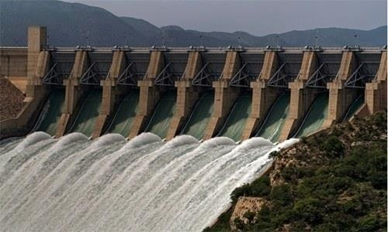

Relation between water security and hydro aggression

The term water security refers to the water management and water policies, that what measures states take to secure their water. The states must formulate various policies and work on numerous projects to secure their water in terms of recycling the water, finding ways to reuse water and store water. Some states like India and Pakistan or India and Bangladesh share rivers as well. These states must sign treaties among them in terms of water division or the usage of water, for instance” Indus water treaty” between India and Pakistan on India river.
The term hydro aggression refers to the aggression of states towards each other to fulfill their policies in terms of securing the water. When the treaties are made, they are also implemented and sometimes states become aggressive for their interests, like India aggression towards Pakistan. During dry days when Pakistan needs water those rivers which are under the control of India their doors are closed and stop the access of water towards Pakistan. However, on the other side during

wet or flood days India opened the doors of those rivers and led the water to enter Pakistan's rivers which can also lead to floods and destruction in Pakistan. This shows that the states not only work for their water security but also use the water in politics as well.
So, water security and hydro aggression are closely related to each other in terms of water security in the making up of policies to secure water and the hydro aggression is the implementation of those policies to prevent water. In the global world it is mandatory for the states to follow up their signed agreements but for the sake of national interest and greed states become selfish and think only for themselves which makes them aggressive towards achieving their goals.
Following flow chart can explain the relation between water security and hydro aggression better:
Water- imporatnt part
of living
those policies to wor
Implementaion of
k
better for water busage
hydro aggression is generated for securing water
In contemporary world-states are facing water shortage
states are selfish in terms of their interest (water security)
Hydro aggression is genetrated among states
for water securtiy- creating multiple policies for securing water and managmnet
states become aggrssive- for their water security
for water security
Source: Author

Relation between water security and Climate Change

Climate change is becoming increasingly clear that our planet's water resources are under threat. Water security, or the availability and accessibility of clean water, is intimately linked to climate change. One way in which climate change impacts water security is through changes in precipitation patterns. As temperatures rise, so does the rate of evaporation, leading to more frequent and severe droughts in some regions. Conversely, other areas may experience heavier

rainfall and flooding, which can also pose a threat to water security. Another way in which climate change affects water security is through the melting of glaciers and ice caps. These natural reservoirs of freshwater are rapidly disappearing, which not only affects the availability of drinking water but also has far-reaching impacts on agriculture, energy production, and other industries.
According to researchers, to maintain a wet habitat, many species depend on snow cover lingering high on hills until late spring or perhaps summer. Additionally, they claimed that plants that flourished on lower land in warmer climates were moving into mountain ecosystems. Significant effects of these changes on ecosystems, biodiversity, and human health include a rise in the danger of respiratory illnesses, a lack of food and water, and the spread of infectious diseases. It is crucial to reduce greenhouse gas emissions to combat climate change through a variety of strategies, such as increasing reliance on renewable energy sources, higher energy efficiency, and enhanced transportation infrastructure. Through measures like the Paris Agreement, which seeks to keep global warming to below 2°C, over pre-industrial levels, several nations have pledged to lowering their carbon footprints.
The relationship between water security and climate change is complex and multifaceted, but there are many unique ideas that can help us better understand and address this critical issue. By investing in innovative solutions, recognizing the interconnectedness of water security and climate change with other social and environmental issues, and working together as a global community, humans can create a more just and sustainable world for all.

Climate Change and water security in India Bangladesh

As the world faces the growing threat of climate change, the issue of water security has become increasingly important. Nowhere is this more evident than in the recent hydro-aggression between India and Bangladesh, which has highlighted the urgent need for sustainable water management practices. Climate change is causing rising sea levels, melting glaciers, and changing weather patterns, all of which are affecting the availability and quality of water resources. This has led to increased competition for water resources, which in turn has led to conflict and aggression between nations. India and Bangladesh are two countries that are particularly vulnerable to the effects of climate change. Both countries rely heavily on the Ganges-Brahmaputra-Meghna River system, which is fed by melting glaciers in the Himalayas. However, as the glaciers melt, the flow of water

in the rivers is becoming increasingly erratic, leading to water scarcity and increased competition for resources. This has led to tensions between India and Bangladesh, with both countries accusing each other of stealing water from the rivers. However, instead of engaging in aggressive behavior, both countries should work together to find sustainable solutions to the water crisis. One solution could be the implementation of rainwater harvesting systems, which can help to capture and store rainwater for use during dry periods. This would help to reduce the pressure on the rivers and ensure that water is available for all. Another solution could be the implementation of water conservation measures, such as the use of drip irrigation systems and the promotion of water- efficient farming practices. This would help to reduce the amount of water used in agriculture, which is one of the biggest users of water resources in both countries. Finally, both countries should work together to develop renewable energy sources, such as solar and wind power. This would help to reduce the reliance on hydropower, which is often the cause of conflict between nations. In conclusion, the issue of water security in the face of climate change is a complex and urgent one.
One solution to this problem is to invest in sustainable water management practices. This includes implementing rainwater harvesting systems, promoting water conservation, and investing in water treatment technologies. By taking a proactive approach towards water management it can be ensured that communities have access to clean, reliable water sources, even in the face of changing weather patterns. Another solution is to promote cross-border cooperation and dialogue. Rather than engaging in hydro aggression, countries should work together to find solutions that benefit all parties involved. This could include the development of joint water management plans, the sharing of data and information, and the creation of regional water management organizations. The issue of water security is a complex one that requires a multifaceted approach. By recognizing the link between water security and climate change, and by promoting sustainable water management practices and cross-border cooperation, work towards a more secure and sustainable future for all can be done.

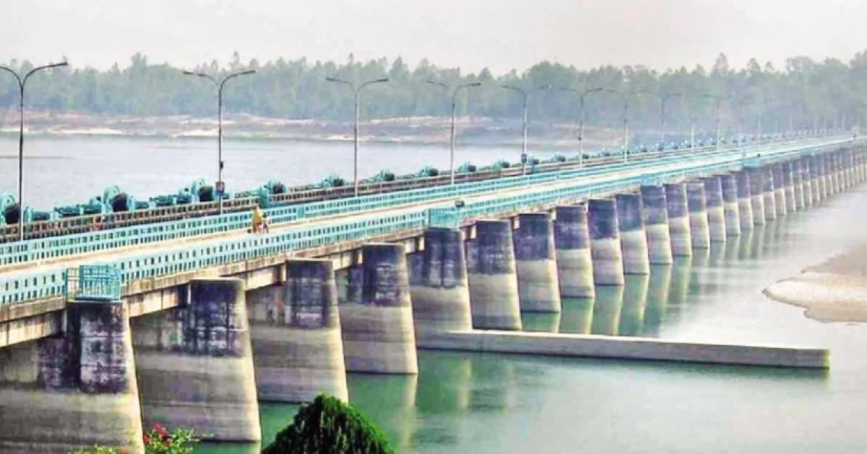
India water aggression against Bangladesh Source: 24 NEWS HD

Core Assumptions of Water Security
The core assumptions are the beliefs on which the concept is based. These assumptions make up the concept as it gives the components on which the concept is based, the effectiveness of the concept and the impact in the positive or negative manner. The core assumptions are judged through the events that occur and formulate the importance of one thing. Core assumptions help in drawing conclusions and analysis from the available belief sets and their viability. These also make up the mindsets of humans and impose an effect on human activities that would either protect or destroy the environment. So, the core assumptions of water security are as follows.
Water security is about water safety, water accessibility and water affordability. If the water is preserved or conserved like in poor states (less privileged economically or absence of natural water resources), if there is already less availability of water, they need to keep check and balance on their usage and let the water remain in the state it already is left. For the states heavily using water, they need to conserve water so that they use water wisely and maintain a sustainable human interaction with water resources. Thus, their water could be saved. If water is not saved by adopting policies, their dependency on other states would increase and would lead to difficult affordability

and the states with less access to water already would also have the same situation generated (Vaneashta, 2021).
Water security mismanagement or non-achievement leads to water insecurity which may cause heavy destruction as natural hazards, water pollution and less developed nations and states. There would be no sustainable environment available as the world would come to a point where they are forced to have less developed structure and chaos would prevail. So, there needs to be a fair distribution for humans and the ecosystems to avoid destruction. This is where it is said, there should be a productive potential rather than destructive potential. Water security absence leads to water wars such as India and Pakistan getting into a dispute over water of the Indus River just after 8 months of independence. Water wars are held between states sharing the same water bodies. Trans-boundary relations often lead to hydro-aggression in which one state dominates over the water reserves and plays hydro-politics by building its own infrastructure and achieving water security. On the other hand, these states make the neighboring water insecure with the unfair allocation and distribution of water. So, there needs to be a rational political order in which communication and foreign policy needs to be adjusted (Thapliyal, 2011). Water security is not just affected by politics, but it is also happening due to the climate changes, water pollution, over- extraction, population growth and limited infrastructures which are obviously generated due to human activities. Thus, here comes the anthropogenic view of water insecurity which means that humans cause limited access to fresh water and make it difficult for the environment and life. There needs to be a balance in the amount of water taken and water given, which means if the states are already suffering from water scarcity due to natural causes, they need to take less water out of the ground. The land is subsiding which means that the erosion and vulnerability is increasing, and the water is getting in shortage. Thus, this abstraction needs to be checked and humans need to understand that water is about to become unavailable if their activities are not held accountable and corrected. States to achieve a sustainable environment need to keep balance in their policies. They need to focus on water and risk management institutions. Because, when water security is not focused, not only the state but the region also gets affected. As in the India and Bangladesh case, India needs to look after its policies and strategies because its hydro-aggression in Bangladesh is not just causing trouble for the latter state but producing major damage to the South Asian region as well (Warner, 2010). For international peace and security, water security is necessary. For water security, not only availability but water efficiency is also essential because

humans use water for agriculture, drinking, food purposes, hygiene, and livestock. Thus, water needs to be renewed and treated well through capable infrastructure. So, it may also be available for the economic sector as is used for industrial and agricultural purposes. The water availability and affordability should be according to the power generation also as to achieve self-reliance in the economic and international system. Water distribution should be metered and evaluated and there should be water audits who control the access and availability of water. States should spread awareness over water access and shortages from primary to secondary sectors. Water security is achieved if the water use is regulated, and the states achieve national water security. If the states achieve it on a national level, they can maintain sustainability and self-reliance and would not need to get in trouble internationally. So, states need to have a check and balance system within. Water security needs cooperation and less-conflicted relations among domestic groups and international actors. It has better water security on a global platform as if states recognize the need of water as not just for national interest but for a world need, water security is easily achievable. This is fulfilled by the idea if states cooperate well and form agreements to formulate institutions on water control and management. The United Nations also recognized the importance of including water security in the development of the Sustainable Development Goals which was a major step forward to development. In international relations, to attain water security there is a need for a supportive policy framework in their domestic and foreign policies, including techniques and reforms of financing structures which increase in sustainable development for needs, including environmental solutions, human, financial, capacity building of institutions, and technological services (Delges, 2018).

In South Asia, a water dispute between India and Pakistan can also be seen which has been going since 1948. The recent issue of transboundary relations is present within India and Bangladesh as there are natural allocation issues, but the water international politics also resides there and water security for Bangladesh stays in trouble. The already existing issues like climate change in Bangladesh due to its natural location are causing extra difficulties to maintain her survival. Thus, water security is attained, the issues can go from maximum to minimum in a peaceful form. Humans play a significant role in either productivity or destruction which proves that water security depends on human activities, choices, and priorities.

Hydro aggression examples globally

Two hydrogen atoms are chemically linked to one oxygen atom to form the compound known as water. On Earth, water exists in a wide variety of forms, including water vapor, clouds, ocean, icebergs, glaciers, and rivers. To help with water is vital for livelihoods. Water is essential for developing ecosystems and ecological function. Humans take water for granted even though it is essential to our survival. They can survive for no more than three days without water before we pass away. In addition, they require it for cooking, washing, cleaning, and even in some cultural and religious acts. Water is not dispersed equitably around the world, though.
Hydro Aggression refers to the construction of large dams and reservoirs on rivers that cross international borders, without considering the impact on downstream communities. India has built several such dams on the Brahmaputra River, which flows through Tibet, India, and Bangladesh. The construction of these dams has caused severe environmental and social impacts on the downstream communities in Bangladesh.
Water security issue is not onlkainaty in the South Asian region, it is a worldwide issue that most of the states are facing and many of them will face in the future if they do not take any measures to solve this issue. There are numerous examples of water security and hydro politics which can be seen in numerous regions. These include water security in the Middle east, countries like Iraq, Syria, Morocco, and other countries are facing water crisis and food shortage. The driest continent i.e., Africa; it is seen that the African countries are also facing a water crisis.

CHAPTER 3

Climate conditions in Bangladesh in past decades 2010 onwards

Introduction
The most common weather patterns in a certain area over an extended period are referred to as the climate. The weather may radically shift day to day and the days can be warm and dry and those days can be cold and wet. The climate of the place cannot be described on a daily monthly or annual scale (Climate Change Knowledge portal).
The climate of south Asia has six climate zones. These include the: tropical wet, tropical savannah, the semi-arid, highlands, humid subtropical and the deserts. These climates are found in the various areas of the region. Due to its hot and humid temperature the tropical wet region is often found in the rainforests. The average annual rainfall is greater than 150cm, which is almost fifty-nine inches. The season in these climates does not alter all. The strong wet and dry seasons that characterize the tropical wet and dry environment are known as tropical savannah. The tropical monsoons often usher in the rainy season by ending dry seasons, bringing up water, and reviving the area. Like the arid climate, the semi-arid climate receives 20-50 cm of rain on average every year, which is sufficient to maintain grasslands. High-elevation climates like those in the highlands are characterized by colder temperatures higher up and warmer temperatures lower down. The humid subtropical climate is a warm environment with hot, muggy summers and very frigid winters. The annual rainfall in these areas ranges from 76 to 165 millimeters (30 to 65 inches). The yearly rainfall in the desert region ranges from 10 to 30 cm or 4-12 inches. These regions have some of the warmest climates in the world with temperatures above 50 degrees Celsius.
Being a part of the south Asian region, Bangladesh also faces these climate conditions. Bangladesh experiences tropical cyclones and considerable precipitation on a regular basis, and it's humid, warm climate is influenced by pre-monsoon, monsoon, and post-monsoon circulations. Bangladesh's yearly temperatures historically have ranged from 150°C to 340°C, with an average of 260°C. The drier and cooler winter months from December to February follow the hot and humid rainy season from April to September. Bangladesh is a wet country with an annual average rainfall of 2,200 millimeters (mm). Most locales see annual rainfall of at least 1,500 mm, although certain areas like the northeastern border regions experience as much as 5,000 mm. The greatest

amounts of humidity are seen during the monsoon season, particularly from June to October. Rain is produced by the Southwest monsoon, which rises over the Indian Ocean and delivers warm, unstable air. A tropical cyclone with an intensity rating of Tropical Storm or higher makes landfall in Bangladesh every two to three years, bringing with it heavy rain, very powerful gusts, and coastal flooding (Mahbub, October 31, 2022).
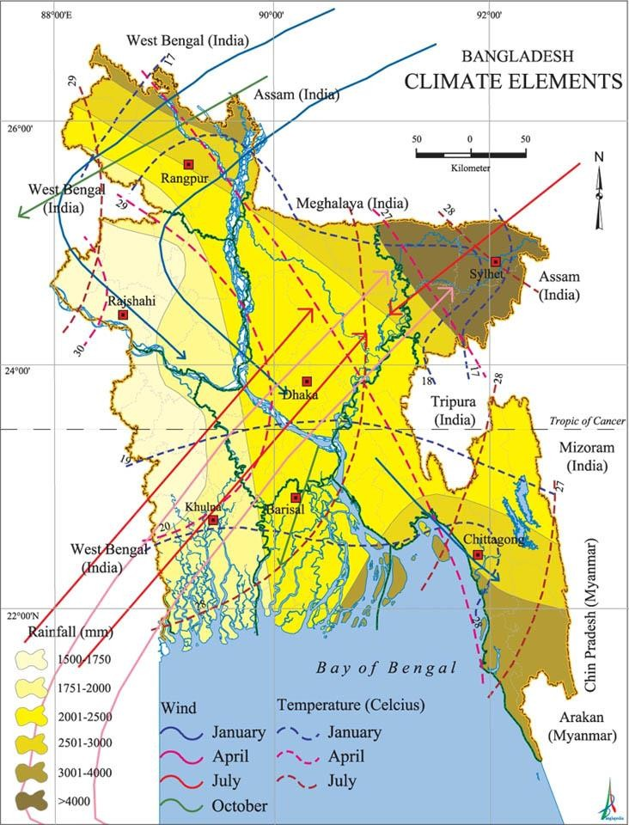

Sources: National Encyclopedia of Bangladesh

Climate Crisis in South Asia
The climate crisis and environmental problems that people are facing is because of humans and their anthropocentric point of view. Humans believe that this universe belongs to humans and

humans can do whatever they can do but they do not know that this universe belongs to other creatures as well. All the luxuries like industries, vehicles, air conditioners, burning of fossil fuels and more all the developments humans have made played a vital role in destroying the environment (Butt, 17th October 2022).
Over a fifth of the world's population resides in South Asia, which is thought to be the region most prone to natural disasters. When it comes to climate change, South Asia is one of the most vulnerable regions. This is because of the rapid population growth, depletion of natural resources, persistently high rates of poverty, and food insecurity. The past, present, and future climate patterns and variability in South Asia may be described by the daily increase in air temperatures and the rise in the severity and frequency of severe events during the previous century. There are six different climatic types in South Asia. While the western half mostly has dry, semi-arid, and highland climatic types, the eastern half primarily has tropical wet, tropical savannah, and humid subtropical climates.
According to various reports and predictions, the temperature of South Asia is expected to increase far faster in the twenty-first century than it did in the twentieth. On 2nd August 2017, a detailed report was also proposed by the MIT NEWS Office that explains in detail that during the 21st century the south Asian countries will face deadly heat waves. Corresponding to recent modeling studies, the Himalayan Highlands, the Tibetan Plateau, and dry Asia all would also see considerable warming. In South Asia, it is anticipated that there would be an increase in the frequency of extreme weather phenomena such heat waves and strong precipitation events, as well as an increase in the interannual variability of daily rainfall precipitation during the Asian summer monsoon. South Asia's anticipated climate change effects will differ depending on the industries, regions, and people. In South Asia's tropical regions, where these crops are already produced close to their temperature tolerance limit, temperature rise will have a severe influence on agricultural output. Even though the rise in temperature has direct effects, it also has indirect effects on the availability of water, the state of soil moisture, the occurrence of pests and diseases, and other factors. Small holder rainfed farmers, who make up most farmers in this region and have limited financial and technical capability to adjust to climate unpredictability and change, are expected to endure most of the repercussions. There is a description of the predicted effects of climate change in several regions of South Asia. The rural poor have a limited ability to adapt, particularly in

marginal regions, hence it is important to incorporate effective climate change adaptation strategies into regional planning for sustainable development. This process may be aided by greater comprehension of the vulnerabilities caused by climate change and the methods of adaptation (BANK, 2O21).
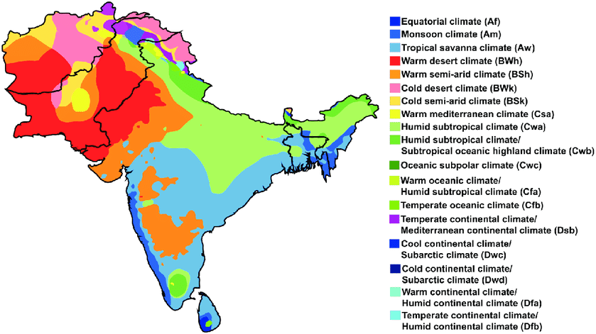

Climate regions in South Asia Resource: Research Gate

Climate Change in Bangladesh 2010-2022

Climate change in Bangladesh has been a major concern since 2010, with rising sea levels and increased frequency of natural disasters such as floods and cyclones. The government of Bangladesh has taken steps to mitigate the effects of climate change, including implementing early warning systems and investing in climate-resilient infrastructure.
Climate change in Bangladesh has been a pressing concern for years, and the effects are expected to increase in severity over the next decade. While temperatures throughout Bangladesh have increased overall, certain regions of the country such as Dhaka could expect average temperature increases up to 2-4 degrees Celsius by 2022. Consequently, warmer temperatures will lead to an

increase in extreme weather events like flooding and droughts. Sea levels across south Asia are also projected to rise at least 0.5 meters within this period due to melting ice caps caused by global warming; areas near coastal cities like Chittagong are likely to be affected most severely. Evaporation rates are rising too, resulting in water shortages which cause difficult problems such as food insecurity and hygiene issues that span rural villages into urban centers alike. Resilience building strategies must now become top priority if Bangladesh wants to better cope with climate change. Going forward more efficient forms of energy production along with effective public policies focused on adaptation can only provide some solution against these daunting long-term consequences of climate change.
Bangladesh is experiencing the effects of climate change, with rising temperatures leading to extreme weather events such as floods, sea level rise and cyclones. According to a report by Bangladesh Institute of Development Studies in 2019, since 2010-2022 there has been an increase in average temperature from one °C (1970-1989) to two °C (2010-2019). This increase could be linked with climatic changes occurring globally due to increasing levels of greenhouse gases. Other impacts include increased soil erosion and salinization along coastal areas caused by decreased agricultural production due to sea level rises and flooding from tropical storms. In addition, biodiversity loss species extinction is being seen occur at an alarming rate resulting from human activities causing further degradation ecosystems throughout Bangladesh. Climate change is a significant challenge for Bangladesh. The country is highly vulnerable to the impacts of climate change and has experienced several devastating disasters in recent years. While the government has taken steps to address the issue, more needs to be done to reduce the vulnerability of communities to the impacts of climate change and to build a more resilient future for the country.

Climate Conditions in Bangladesh
A total of 147,570 square kilometers, including inland and estuarine water, makeup Bangladesh. Bangladesh as a south Asian country due to its geographical location and its delta area it will suffer from climate disaster more as compared to the other countries of south Asia. Bangladesh's geography renders it particularly vulnerable to natural calamities. Because of its location at the meeting point of the Himalayan Mountains in the North and the Bay of Bengal in the South, the nation is subject to two very distinct climatic conditions, which cause prolonged monsoons and devastating natural catastrophes. Rivers and other inland waterways make up 7% of the nation.

Bangladesh was created by the alluvial deposits that these three powerful Himalayan rivers, the Ganges, the Brahmaputra, and the Meghna carried down for thousands of years before converging to empty into the Bay of Bengal. Bangladesh is situated between 20034' N and 26033' N latitudes and 88001' E and 94041' E longitudes, north of the Tropic of Cancer. It is situated in the northeastern region of the Indian subcontinent and is surrounded by Myanmar to the southeast and India to the west, north, and east. The whole south is dominated by the Bay of Bengal. Most of the nation is ten meters or above sea level. Bangladesh features three diverse types of landscapes: hills are scattered over 12% of the country's total area, terraces cover 8%, and floodplains encompass 80% of it. The Padma, Meghna, and Brahmaputra are the three principal rivers, and there are around seven hundred more rivers, distributaries, streams, and canals combined.
The problem is becoming worse due to new phenomena like climate change and sea level rise. Only 10% of the land in the nation is above one meter above sea level, making it also incredibly low and flat. With hundreds of rivers cutting across it and one of the greatest river systems in the world, Bangladesh routinely sees enormous cyclones and floods including the estuarial region of Padma, Meghna, and Brahmaputra rivers (Ahmed, 2006).
The citizens of Bangladesh are now becoming more sensitive to the effects of climate change due to the geographical location and socioeconomic circumstances of the country. If the country takes adaptation strategies to deal with those circumstances, it might be a chance that it can lessen the negative impact on agriculture, environment, health, and way of life especially in coastal regions. Diverse types of scientific and Indigenous knowledge are being used to mitigate the effect of climate change. However, several obstacles prevent sustainable adaptation. Numerous individuals are moving to metropolitan areas because of the frequency and difficulty of catastrophes, which is making it more difficult for them to adjust sustainably. The obstacles of climate change adaptation have also been noted as a lack of comprehensive knowledge about the vulnerabilities, ignoring the demands of the local population and insufficient integration of policies and programs. Bangladesh is seeing persistent increase in temperature and perception as well as irregular weather patterns. The incidence and variety of infectious diseases as well as mental health illness ailments including depression and anxiety disorders have increased because of the negative effects that changing climatic circumstances have had on physical and mental health. To lessen the effects of climate change on physical and mental health it is crucial to strengthen healthcare and responsive systems.

Bangladesh is extremely vulnerable to the negative consequences of climate change due to its low- lying Delta River lengthy coastline and floodplains that make up approximately 80% of the nation. However, cyclones and floods are only one aspect of climate change in Bangladesh. Our physical and emotional health have been impacted by the irregular and changing weather patterns. Hydrazine respiratory illness, mosquitoes' illness like dengue and poor mental health conditions are all science in Bangladesh. Changing the environment is having an adhesive effect on the country's health (Group T. W., 2021).

Causes of Climate Change in Bangladesh

Climate change has had a significant impact on Bangladesh over the last decade. Rising sea levels due to glacial melting, increased flooding from rising precipitation and monsoon rains, changes in temperature patterns, as well as extreme weather events have caused severe damage throughout the country. In addition to devastating economic losses and human suffering, climate-related impacts are exacerbating poverty and inequality for vulnerable populations such as women and children. With current trends continuing without any major interventions or action taken to mitigate climate risk factors prevalence of disaster risks is expected to further rise by 2022 in terms of magnitude, frequency, and prolongation across Bangladesh’s coastal region's existing threats: including riverbank erosion; surface water salinity intrusion & soil quality degradation; crop loss & food insecurity; displacement and insecurity of livelihoods.
Bangladesh is one of the many countries in South Asia that are facing growing threats from climate change. During the period from 2010 to 2022, extreme weather events are expected to increase with changes in rainfall patterns and rising temperatures causing a rise in sea levels that threaten millions of people living on coastal land. Annual extreme precipitation events have risen due to an increased rate of atmospheric warming, leading to storms and floods which cause destruction throughout numerous cities and villages around Bangladesh. Temperature increases combined with reduced amounts of river flow stemming from melting glaciers leads to droughts across much of the south-western region during summer seasons while large parts along coastlines experience saltwater inundation threatening water supply sources as well as agricultural productivity. The frequency and intensity of these natural disasters will continue unless government efforts move closer toward achieving their goals outlined by the Paris Agreement within this time frame, aiming

for further reduction or limitation of global warming up till 2° Celsius above preindustrial level through decreasing greenhouse gas emission worldwide. It therefore requires commitment both internationally and at home including enhanced economic measures such as incentives for green energy usage instead more emissions prone activities if lasting solutions towards better management strategies against current trends shall be reached any time soon.
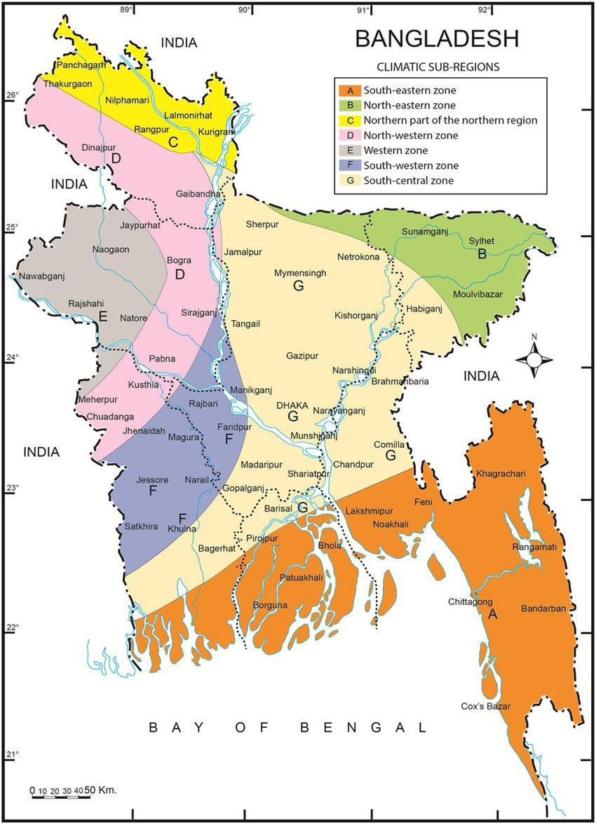

Impacts
The impacts of climate change in Bangladesh from 2010 to 2022 are multi-faceted and far reaching. In the years leading up to 2020, the country has witnessed an increase in extreme weather events that have affected local populations with devastating consequences. This includes heat

waves which caused a 3% rise in average air temperature by 2019 as well as flooding due to changing monsoon patterns which led to more frequent occurrences of riverbank erosion and increased salinity levels along coastal areas causing mass displacement for inhabitants.
Increasingly warmer temperatures also contributed to water shortages across various regions, posing a risk for approximately thirty-two million people who rely on surface water sources such as rivers and ponds. Additionally, built environments were highly impacted due to rising sea level resulting from both global warming and subsidence effects; these effects induced significant changes in mangrove cover loss while increasing vulnerability of settlements located at low lying areas near coasts or estuaries exposed them regularly destruction caused by cyclones exacerbating existing poverty conditions among communities living nearby making income sources increasingly difficult access like fishing or agricultural farming activities potential catastrophes being determined by their socio economic status creating even wider gaps between different sectors society further escalating already existing inequality issues throughout region additions threats posed ocean acidification threatening marine life ecology food security reserves putting primary reliance agriculture production subsistence crops households poorest segment now faced challenges securing alternative resources respond these systems combined produce variegated wide range asymmetric environmental climatic health problems put organisms occupied area multiple hazardous stress facilities essential basic services including energy education diminishing short term prospects long term safety sustainable development .

Rise in the temperature of Bangladesh

Between the years 1976 and 2019, the temperature of Bangladesh increased up to 0.5 degree Celsius on an average. It has been demonstrated that the increase in the maximum temperature throughout this period is constant from month to month with the warmest months falling between February and November. The maximum temperature recorded in the nation has not increased steadily. For example, maximum temperatures rose by 0.9°C in the eastern regions, which include Chattogram and Sylhet divisions, between 1976 and 2019, compared to a 0.5°C rise in the center parts, which encompass Dhaka and the nearby regions. Winters are growing warmer, summers are getting longer on average, and the monsoon is becoming more unpredictable. Concerns about the impact of climate change on Bangladesh's health have already expanded to encompass poor mental

health conditions, as well as increased incidence of respiratory disorders and vector-borne diseases like dengue.

Erratic rainfall and Long Monsoons

Due to its location on the edge of the tropics, Bangladesh has some of the wettest monsoons in the whole globe. The peak monsoon season, which runs from June through August, had a sixty millimeter drop in monthly average precipitation. The monsoon season is now formally from March through October, according to an increase in the mean monthly rainfall for September and October of forty-three millimeters. Bangladesh's distinctive seasonality has been undermined by rising winter temperatures and erratic rainfall patterns.

Natural Resources and environment in Bangladesh economy
Bangladesh's natural resources include natural gas, oil, coal, hard rock, limestone, white clay, glass sand, and mineral sand, as well as a variety of other minerals. Natural gas is the only mineral product now making a major contribution to the national economy. Bangladesh's luxuriant vegetation is a result of the tropical climate of the nation. (I)Tropical evergreen or semi-evergreen woodlands can be found in Sylhet, the eastern districts of Chittagong, Cox's Bazar, and Chittagong, together known as Hill Forest. (ii) Sal (Shorea robusta) woodland, a kind of dry or moist deciduous forest mostly found in the northeastern freshwater regions and central plains. (iii) The Sundarbans, which are in Khulna's southwest corner, as well as tidal mangrove forests and other mangroves in the coastal regions of Chittagong and Noakhali.
Bangladesh is home to a wide variety of plants and animals. According to the report of IUCN (2000a) almost 266 species of freshwater fish and 442 marine species were listed. There are 125 species of mammals, 750 species of birds, five hundred species of fish, 125 species of reptiles, and nine species of amphibians in the fauna, particularly the animals. There is uncertainty on Bangladesh's species diversity, particularly about its flora and invertebrates. There are about 2,259 kinds of blooming plants in the Chittagong zone alone. Over seven hundred species of blooming plants, five hundred types of medicinal plants, three hundred species of mangrove and mangrove related plants, and three hundred species of wetland plants have been recorded in Bangladesh.

Bangladesh has 130 million inhabitants overall, with a density of 720 persons per square kilometer and an annual growth rate of 2.17%. Eighty-six percent of the population is Muslim, 12% are Hindu, and the remaining 2% are Buddhist and Christian. In the middle of the 1970s, the infant mortality rate (IMR) was 153 deaths per one thousand live births. The most current estimate places the number at 62 for 2000. Early in the 1970s, there were approximately 250 fatalities per one thousand births; by two thousand, this number had dropped to eighty-three. In the early 1980s, the human poverty index was 61 percent; by the late 1990s, it had dropped to 35 percent (BANK, 2O21).

CHAPTER 4

Indo-Bangladesh trans-boundary relations and Indian hydro aggression

Introduction
Relationships between India and Bangladesh, two South Asian neighbors, are referred to as Indo- Bangladesh relations. Since Bangladesh's independence from Pakistan in 1971, there have been substantial changes in the relationship between India and Bangladesh. India initially played a significant part in aiding Bangladesh's independence. India and Bangladesh established diplomatic ties following the Liberation War, and India also acknowledged Bangladesh's independence. Yet, there was an extended period of mistrust and suspicion in the two nations' relationship. Nonetheless, India and Bangladesh have worked hard in recent years to strengthen their bilateral ties. India and Bangladesh have been collaborating closely on a number of areas, including infrastructure, energy, security, and trade. Bangladesh has also received assistance from India in a number of development projects, including the building of bridges, roads, and railroads. A number of agreements and memoranda of understanding (MoUs) have been made between India and Bangladesh to advance their cooperation in a variety of fields, including trade, energy, defense, and culture. Also, the two nations have been collaborating to handle shared security issues like border security, transnational crime, and terrorism. The Indo-Bangladesh relationship has improved recently as both nations see the value of cooperating to further regional economic growth, peace, and stability. To improve their diplomatic ties, India and Bangladesh have opened high commissioners in each other's capitals and held several high-level visits. For instance, on his historic visit to Bangladesh in 2015, Indian Prime Minister Narendra Modi inked multiple agreements to advance bilateral cooperation through private investments and trade (Mullen, 2015). India and Bangladesh have solidified deep economic and cultural relations in addition to their political ties. India has helped Bangladesh with several developmental initiatives, and the two nations have inked multiple agreements to increase commerce and investment. Events and festivals created to highlight the rich cultural legacy of both countries have served to promote cultural exchanges between the two countries. On regional and international concerns including climate change, counterterrorism, and peacekeeping, India and Bangladesh collaborate closely as well. A number of collaborative institutions, like the Joint Rivers Commission and the Joint Consultative Commission, have been established by the two nations to promote communication and

collaboration on a range of topics of shared interest such as getting benefit from joint rivers on mutual agreement calling it a new way to work together not just on rivers but cyber security and artificial intelligence as well (Roy S. , 2020).

Indo-Bangladesh Economic ties and competition

Bangladesh and India enjoy a close economic partnership, with trade and investment connections between the two nations booming recently. India is currently one of Bangladesh's top commercial partners, and the two nations have inked several agreements to strengthen their economic ties. Data from the Indian Ministry of Commerce shows that during the 2019–20 fiscal year, bilateral commerce between India and Bangladesh totaled USD 9.2 billion. While Bangladesh exports textiles, apparel, leather, and agricultural products to India, India exports a variety of items to Bangladesh, including petroleum products, cars, machinery, and pharmaceuticals.
Both India and Bangladesh have recently taken several actions to further increase trade, including the creation of border haats (markets) along their shared borders to enable trade in local commodities and the formation of collaborative working groups to identify and remove trade impediments. Akhaura in Bangladesh and Agartala in India will now have a new train link that will connect the two nations, and a new waterway will be opened to move products between the two nations. This railway link is supposed to reduce the distance between the two countries through a railway link which would be completed in 2023 (Shonchay, 2022).
The two nations have also signed several agreements to increase connectivity and infrastructure. India has been an important source of foreign investment for Bangladesh in addition to commerce. Indian businesses have made investments in a variety of industries, including textiles, pharmaceuticals, energy, and infrastructure, which has helped Bangladesh's economy grow and created jobs. The signing of agreements to create an environment that is favorable for investors and to establish a Joint Economic Commission to improve bilateral economic cooperation represents another indication of both nations' commitment to working together to increase investment through connection with the relevant ministers. Since both nations see the value of cooperating to advance economic growth and prosperity in the area, the economic links between India and Bangladesh have only been stronger over time. The visit of Sheikh Hasina to Delhi in September 2022 also paved the way for more bilateral ties between them as the Ministers signed 7 MoUs on trade, security, railway, and water-sharing (Mukhtar, 2022).

The economic connection between Bangladesh and India is complicated, with both nations competing in some areas and working together in others. Even if there have occasionally been conflicts and disagreements between the two nations on economic matters, there is no proof that there is a significant economic rivalry between the two nations that exists despite their economic ties. According to the Comprehensive Economic Partnership Agreement, this may be to the advantage of both countries. In Bangladesh, there will be a potential increase in the number of job openings because of the investments. Hence, the officials from both sides should get to work immediately on laying the groundwork for this agreement and making the most of any exclusive investment opportunities that exist to make bilateral trade easier (Muzamdar, 2022). The textile and apparel industries are one area of competition between India and Bangladesh because both nations are significant exporters of textiles and apparel to the international market. There have been some worries in Bangladesh because of this that India's competitive advantage in this industry could cause it to dominate the world market at Bangladesh's expense. Indians are opposed to the idea of exporting cotton and yarn from the country because it would give rival countries, such as Bangladesh, an advantage over Indian exporters by allowing them to offer tougher competition after gaining access to cheaper raw materials. It demonstrates that the Indian textile sector needs to strengthen itself and produce an efficient strategy in preparation for when CEPA goes into force. On the other hand, there are experts who believe that both countries may recognize their strong points and work together to complement each other rather than compete with one another. (UNB, 2022).
The potential for cooperation in this area has been acknowledged by both nations, with India offering technology and equipment to help Bangladesh increase the quantity and caliber of its textile and apparel exports. Another area of competition is the energy sector, where Bangladesh and India both want to establish themselves as major regional energy producers. There have been arguments on occasion regarding the cost of natural gas imports from Bangladesh to India, but there are also agreements that both nations have signed to work together on energy projects and to broaden their sectoral cooperation. Well, Nepal and Bangladesh need India’s approval to let electricity and power of 40-50 MW pass to Bangladesh through Indian transmission infrastructure. This would increase the trilateral relations allowing all three countries to work in reciprocity (Ashrat, 2023). Even though Bangladesh and India may compete in some economic sectors, both nations are working to strengthen their economic connections because they understand the value

of cooperation. To increase commerce and investment, the two nations have signed a number of agreements and collaborated to remove trade obstacles, enhance connectivity, and upgrade infrastructure.

Political Ties

The historical, cultural, and linguistic linkages that exist between India and Bangladesh are among the main elements that have contributed to bolstering their political relationships. The two nations have strong cultural and social ties and speak Bengali, which they also share with one another. As a result, the two nations have grown closer and more understanding of one another. The understanding of the strategic significance of the relationship for both nations has also contributed to the strengthening of the political ties between India and Bangladesh. With its location in the region and potential as a gateway to other nations, Bangladesh is seen by India as a key neighbor and partner. India is an essential partner for regional cooperation, a significant source of investment and technology, and a significant economic partner for Bangladesh. The two nations have signed a series of agreements to increase their cooperation in a variety of areas, including defense, security, trade, energy, and connectivity, in recent years to further strengthen their political connection. India and Bangladesh have a solid and cordial political relationship. Both nations are aware of the strategic significance of their relationship and have taken action to strengthen it through routine high-level meetings, bilateral agreements, and collaboration in a number of fields. Since Bangladesh's independence in 1971, their political ties have been cordial and constructive. Political competition between the two nations does not exist despite their political ties, even though there have been sporadic disagreements and tensions over political matters between the two nations. The issue of illegal immigration has been one of the points of contention between the two nations, with India expressing worry over the influx of migrants from Bangladesh into its borders. With Bangladesh attempting to address the core causes of migration, such as poverty and a lack of economic opportunities, and India taking steps to tighten its border security and deport undocumented immigrants, this problem has occasionally put strain on their relationship. Now India needs to make a law with Bangladesh to get back its nationals from their territory as it is risking Indian national security and restraining its resources (Tripathi, 2016). Both nations have also been proactive in addressing open problems and resolving disagreements through

communication and collaboration. For instance, the historic Land Boundary Agreement that the two nations agreed in 2015 allowed for the exchange of enclaves and the resolution of land boundary disputes while also resolving a long-standing border dispute. This agreement was made to share territories for the enclaves to be considered as citizens of the respective territory (Guha, 2017).
The sharing of river waters, notably the Teesta River, has been a source of contention between Bangladesh and India. The construction of dams and barrages on the river by India, which Bangladesh claims has decreased water flows downstream and affected Bangladeshi agriculture and livelihoods, has long been a cause of hostility between the two nations. A formal deal has not yet been achieved despite years of negotiations between India and Bangladesh to settle this matter. Notwithstanding occasional political difficulties and disagreements between India and Bangladesh over specific topics, both nations understand how crucial it is to keep their political connections strong and have taken attempts to resolve their differences through communication and collaboration. In addition to improving connectivity and infrastructure to support regional cooperation and development, the two countries have inked several agreements to strengthen their political and security cooperation.

India-Bangladesh Transboundary Relations
When it comes to transboundary problems like water sharing, border control, and security cooperation, India and Bangladesh have a complicated and reliant relationship. Since handling these concerns for the benefit of both countries is crucial, the two nations have taken action to resolve their transboundary challenges through conversation and collaboration.
There has been a long-running disagreement between India and Bangladesh about the distribution of water from the Ganges and Teesta rivers, known as the Ganges and Teesta River issue. The Ganges River, or Padma River as it is known in Bangladesh, is a major waterway that begins its journey in the Himalayas and travels through India and into Bangladesh before emptying into the Bay of Bengal. Whereas the Teesta begins in the Indian state of Sikkim, it travels across India and Bangladesh before draining into the Bay of Bengal. As the Teesta River is so important for agriculture and irrigation in Bangladesh's northern regions, the country has been fighting for a more equitable distribution of water from these rivers. Because of worries over its own water security and the interests of its own farmers in the upstream states, India has been hesitant to share

the water. For a long time, this topic has been a source of disagreement between the two countries, despite numerous attempts at compromise. To yet, however, no compromise has been achieved, and the problem persists. Since the conflict began, tensions and disagreements have arisen between the two countries on occasion. The two nations are continuing to talk to reach an agreement on how to move forward (Banerji, 2021).
The Indian state of West Bengal is home to the Farakka Barrage, a dam built over the Ganges River. The Kolkata Port was intended to be protected against siltation; hence the dam was constructed on the Bhagirathi and Hooghly rivers. The downstream flow of the Ganges River, especially in Bangladesh, has been significantly impacted by the construction of the Farakka Barrage. Problems like salinization of agricultural land, loss of fish habitat, and erosion of riverbanks have resulted from the reduced flow of water downstream of the barrage. Water for irrigation, shipping, and human use has all been negatively affected by the reduced water flow in Bangladesh. India and Bangladesh's disagreements date back to the issue of the Farakka Barrage. Considering the barrage's potential negative effects on Bangladesh's economy and environment, the country's leaders have frequently voiced their displeasure and called on India to implement measures to ensure a more equitable and sustainable flow of water downstream.
India and Bangladesh have negotiated a number of treaties and pacts to solve this problem on a bilateral level, the most important of which is the Ganges Water Sharing Treaty of 1996. Yet, there is still contention between the two nations about the distribution of Ganges River water (Kawser, 2016). The sharing of river waters, notably those of the Teesta and Ganges rivers, is one of the most important transboundary disputes between India and Bangladesh. Although the two nations have been negotiating to settle this matter for several years, no definitive deal has yet been reached. As a result of India's construction of dams and barrages on the river, which Bangladesh claims has decreased water flows downstream and negatively impacted Bangladeshi agriculture and lives, the issue has caused conflict between the two nations. Border management has been a serious transboundary issue between India and Bangladesh in addition to water sharing.
The 4,096-kilometer border between the two nations is one of the world's most heavily guarded and populous frontiers. Border walls have been installed, joint patrols have been conducted, and information on border-related issues has been exchanged as part of India and Bangladesh's efforts to improve border management and security cooperation. The topic of security cooperation between India and Bangladesh is another significant cross-border concern. To improve security

cooperation and intelligence sharing, notably in the areas of counterterrorism, cybercrime, and border security, the two nations have signed a number of accords. As both nations work to confront shared security challenges and stop the development of extremism and terrorism in the area, collaboration is crucial for both nations. Although there have been occasional disputes and conflicts between India and Bangladesh about transboundary concerns, both nations understand how crucial it is to resolve these issues via communication and collaboration. The two nations have taken action to improve collaboration in several areas, such as water sharing, border management, and security cooperation, for the benefit of both nations. They have signed multiple agreements to address these concerns. The transboundary relation between both the countries led to not just water sharing issues but security, environmental and management of disasters like drought and flooding in Bangladesh (Iyer, 2015).

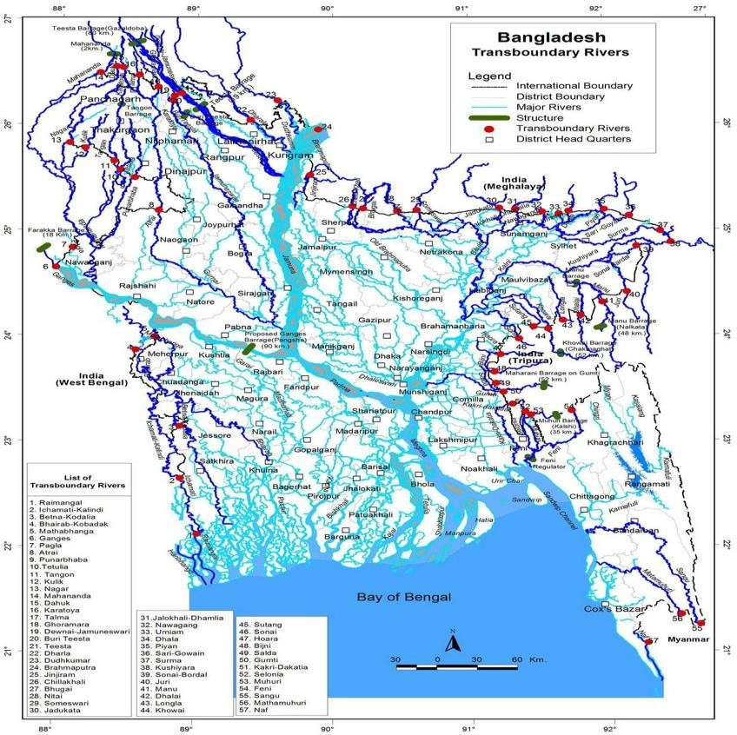

Sources: ResearchGate

Indian Hydro-aggression

Bangladesh and India's transboundary water sharing has been a contentious issue for a long time. The two countries have been at odds over how to handle the 54 rivers they share. Bangladesh is concerned that Indian infrastructure developments on rivers they share, such as the Ganges, Brahmaputra, and Teesta, would negatively impact the availability and quality of water in Bangladesh. The Tipaimukh dam, the Teesta barrage, and the Farakka barrage are all examples of such constructions.
The Farakka Barrage, built in India over the Ganges River in the 1970s, is a major point of contention between the two countries. The barrage reduces water flows in Bangladesh, affecting agriculture, fisheries, and drinking water supplies. This is because the Ganges River is being diverted to India. Concerns have been made in Bangladesh regarding India's plan to construct many dams on the Brahmaputra River and the potential effects on downstream water supply and quality. Others have called India's activities toward Bangladesh an act of "hydro-aggression," in which an upstream country exploits and controls shared water resources to the detriment of a downstream country. Many water-sharing agreements are just one example of the many attempts at cooperation and conversation between the two countries to address these issues. There are still a lot of issues that need to be worked out between the two countries, but things are moving slowly. To settle these issues, both countries will need to collaborate to create a win-win solution that considers the needs and concerns of all parties involved. The building of dams and other hydroelectric projects by India on rivers shared with nearby nations like Bangladesh, Pakistan, and Nepal has been referred to as "Indian hydro aggression" by certain critics and academics. The phrase is frequently used in reference to worries about the potential environmental and socioeconomic effects of major projects on downstream nations. Opponents contend that building dams and other hydroelectric projects in India on rivers that are shared with other countries can limit water flows downstream, causing water scarcity and having other negative environmental and socioeconomic effects. They further claim that India's unilateral development of these projects may result in conflicts and tensions with its surrounding nations.
Yet, proponents of India's hydroelectric dams contend that these initiatives are crucial for satisfying the nation's expanding energy needs and encouraging economic growth. They also contend that by signing water sharing treaties and other accords, India has taken action to allay the worries of upstream nations. A difficult and divisive topic, "Indian hydro aggressiveness" has arguments and viewpoints on both sides. While the development of hydroelectric projects by India

on rivers that are shared with other nations may have unfavorable effects, the nation has also taken attempts to allay these worries and encourage collaboration with its neighbors.
Bangladesh was meant to receive its fair share of the Teesta river's water during the dry season after then-Indian Prime Minister Manmohan Singh and current Bangladesh Prime Minister Sheikh Hasina signed a draft deal on water sharing in 2011. But Chief Minister of West Bengal Mamata Banerjee's opposition prevented the deal from being signed. The distribution of water resources between India and Bangladesh is a difficult problem due to the various levels of government in each country. Since water is considered a state matter in India, it is up to the individual states to make the most important decisions regarding water policy. Because of this, there is friction between the upstream states, who want to use the water for their own purposes, and the downstream states, which require the water for irrigation and other purposes (Rather, 2022).
The Indian federal structure has exacerbated tensions between the federal government and the states over water sharing with Bangladesh. India's construction of dams and barrages on rivers flowing into Bangladesh has been a source of tension between the central government and the state governments, particularly those in West Bengal, where the Teesta River water sharing agreement signed by the central government in 2011 could not be implemented due to opposition from the Chief Minister. Because it could hinder their own economic growth, several state governments are hesitant to share water with Bangladesh. The difficulty in resolving the dispute between India and Bangladesh over water sharing is an example of the difficulties inherent in a federal system for managing shared resources. The federal and state governments, as well as the governments of the other countries, need to work together on this. An ongoing effort is being made to develop a long- term, win-win solution to the water-sharing problem that benefits everyone involved (Ghosh, 2022).
The conflict between the necessity for economic growth and the potential harm that hydroelectric projects could do to the environment and nearby communities is at the core of Indian hydro politics. Hydroelectric projects' proponents contend that they are crucial for satisfying India's expanding energy needs and fostering economic growth. They also contend that by lowering greenhouse gas emissions from energy sources based on fossil fuels, hydroelectric projects can aid in minimizing the effects of climate change. On the other hand, opponents of hydroelectric projects assert that these projects may have considerable negative effects on the environment and society, including displacing residents, eradicating biodiversity, and reducing water flows downstream.

They further contend that India's efforts in developing these projects unilaterally could result in conflicts and tensions with its neighbors over shared water supplies.
If India maintains its inflexible stance on water sharing from international rivers, Bangladesh will face significant difficulty in the future decades meeting the increased water needs of its rapidly expanding population. In this context, a lack of water will cause unrest and instability, the repercussions of which may spread over national boundaries, and regional tensions will pose a danger to global stability. Bangladeshi water security is under jeopardy due to India's dam and barrage development on rivers that flow into the country, such as the Farakka Barrage on the Ganges and the Tipaimukh Dam on the Barak.
India built the Farakka Barrage in 1975 to redirect the Ganges River's flow through Bangladesh so that it can be used to irrigate crops in the Indian state of West Bengal. As a result, water flow has been curtailed downstream in Bangladesh, which has had devastating effects on irrigation, agriculture, and the livelihoods of millions. There are also environmental and social problems over the proposed Tipaimukh Dam on the Barak River, a significant tributary of the Meghna River in Bangladesh. Because of the dam, water will be diverted upstream instead of downstream, which will have negative consequences for irrigation, farming, and fishing in Bangladesh (Singh, 2018). Bangladesh's water security has been compromised because of India's hydro-aggression, and the country is now struggling to keep up with its rapidly expanding water needs. Agriculture and drinking water supplies have been impacted by the incursion of salt water into the deltaic region because of decreased river water flow. Bangladesh has consistently voiced its concerns to India about these matters, and the two nations have been in conversation to find a solution that works for everyone involved. But the problem has not been solved, and the effects of India's hydro- aggression on Bangladesh's water security remain a source of worry. Indian hydro politics is a complicated and divisive issue, involving a variety of political actors and interests. India will need to strike a balance between these objectives and the need to protect the environment and the rights of residents, as well as the worries of neighboring countries about shared water supplies, as it pursues economic development and energy security (Islam M. S., 2019).

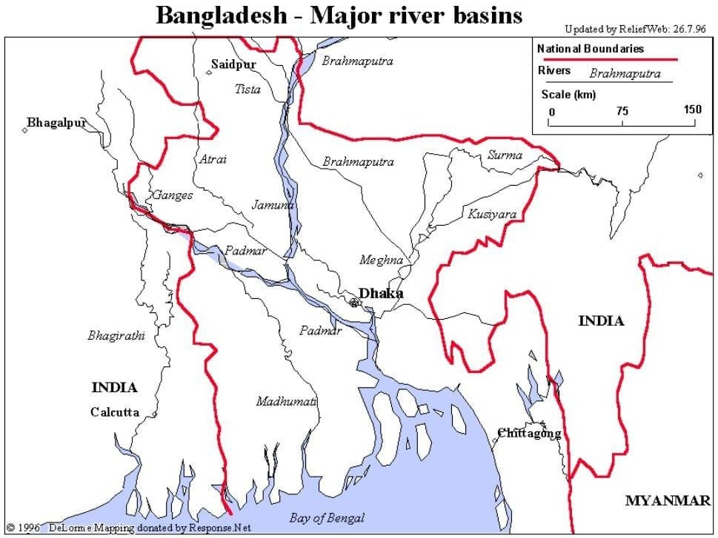

Transboundary Agreements and Indian Hydro-aggression
In the areas of water sharing, border management, and security cooperation, India and Bangladesh have signed several agreements to resolve transboundary challenges. The following are a few of the most important agreements between the two nations:
Ganges River Treaty 1977: The 1977 Ganges Barrage Treaty regulates the construction and maintenance of India's Farakka Barrage on the river. To ensure that sufficient water is supplied downstream to Bangladesh, the agreement details the operational processes of the barrage and calls for a synchronized monitoring system. During the dry season, India agreed to provide Bangladesh with a minimum flow of water and to keep Bangladesh apprised of water levels and flow rates. The accord also established a Joint Commission to oversee its implementation and to mediate any disputes that may arise.
There are ongoing concerns about India's management of the Farakka Barrage and its impact on downstream water flow in Bangladesh, despite the treaty. India has been accused of using the barrage to hydro-aggress against Bangladesh by diverting water for its own use and reducing the

flow of water downstream. Concerns have been raised about the river's ecosystem and the way of life for individuals who live near the barrage. As a result of the barrage's construction, environmental activists argue, the river's natural flow was disrupted, severely harming the environment. Moreover, farmers and fisher in Bangladesh are unhappy with the decreased water flow and declining fish populations. Nonetheless, concerns remain about how India's water infrastructure may affect countries further downstream and the prospect of hydro-aggression, despite the fact that the Ganges Barrage Treaty has helped to build a framework for India and Bangladesh to work collaboratively on water management issues (Salman, 2000).
Ganges Water Sharing Treaty: In 1996, India and Bangladesh signed the Ganges River Treaty, which allocates water resources between the two countries. The pact was signed to settle water disputes and guarantee both countries' access to clean water in the future. The deal stipulated that during the dry season, India would allow Bangladesh to draw water from the Ganges at a set rate (January to May). The pact also created a Joint River Commission to oversee water distribution and mediate any conflicts that may emerge. Because it resolved an ongoing problem and established a basis for future collaboration in water management, the treaty marked a watershed moment in ties between India and Bangladesh. The deal, which has helped to ease tensions and improve relations between the two countries, is still in effect as of this writing.
Some have argued that the deal does not do enough to solve the water-sharing problems and does not take into consideration the effects of climate change on the river system. The Ganges River Treaty is still a prime illustration of South Asian countries working together to share a vital resource: water. India and Bangladesh have been able to work together more effectively on water management issues thanks to the peace and collaboration fostered by the Ganges River Treaty. The treaty has helped to secure water security for both countries by establishing a framework for sharing water from the Ganges River. Yet, it must be stressed that the pact has not resolved all water-related issues between India and Bangladesh. Several problems have arisen throughout the treaty's implementation, and there are worries about how climate change would affect the river system. Considering India's hydro aggression, the deal is considered as a move in the right direction toward easing tensions and fostering collaboration between the two countries. India's construction of dams and other infrastructure on shared water bodies has been criticized by some as a kind of hydro aggression towards Bangladesh.

Teesta River Water Sharing Treaty: Bangladesh and India's Sikkim state both rely on the water that the Teesta River provides as it flows through both countries. In 2011, an agreement on the Teesta River to share water almost came to fruition between India and Bangladesh, but West Bengal, an Indian state, objected. After negotiations fell, India's construction of numerous dams and barrages on the Teesta River has been a major source of contention between the two nations. India has come under fire from Bangladesh for allegedly hoarding water throughout the dry season and releasing it all at once during the monsoon season, resulting in flooding and other problems downstream. India, on the other hand, argues that it needs the water to generate energy and for irrigation, and has blasted Bangladesh for being implacable in negotiations. Development of hydropower projects has been hampered by the lack of a regional water-sharing agreement.
The Teesta River has been the subject of numerous debates, but no definitive agreement has been achieved. Bangladesh, which is already feeling the effects of water scarcity brought on by upstream infrastructure projects, has charged India of hydro-aggression as a result (Rehman, 2019).
Protocol on Inland Water Transit and Trade: Bangladesh and India signed the Protocol on Inland Water Transit and Trade in 1972, which legalized the transit of goods and people along the Brahmaputra and Ganges River systems and other inland waterways. The goal of the treaty is to facilitate trade and economic cooperation between the two countries by making it simpler to access each other's markets and resources. Permits, licenses, and customs clearance requirements are all laid out in detail in the protocol as are other procedures and rules developed by the two countries for the use of inland waterways. The convention also mandates the development and repair of ports and navigational aids to facilitate inland water trade and transportation.
There have been several revisions to the process since its inception to account for changing circumstances and opportunities. For instance, in 2008, the Fifth Protocol was signed, allowing for the use of containerized freight and the opening of new trade routes. Bangladesh and India's commercial and trade ties have been significantly strengthened thanks to the treaty. Nonetheless, there have been issues with the protocol's implementation, including construction delays, navigational difficulties, and difficulties clearing customs. Disagreements over the distribution of river waters, particularly the Teesta, have prevented the protocol's full potential benefits from being realized. India has been accused of violating the Convention on Inland Water Transport and Trade on occasion. For example, in 2016, Bangladesh accused India of blocking its access to the Brahmaputra River by constructing a dam in Assam, which Bangladesh claimed would reduce the

water flow downstream. India disputed these assertions, saying the dam was just another routine river project that would not significantly affect water flow.
Stories of Indian cargo ships breaching safety standards by carrying too much cargo and flooding while traveling on inland rivers have generated concerns for the safety of travelers and the environment. Even though trade and transit between India and Bangladesh have been enabled by the Protocol on Inland Water Transit and Commerce, India's actions have occasionally been questioned. The Protocol on Inland Water Transport and Trade has been allegedly occasionally violated by India. For example, in 2016, Bangladesh accused India of blocking its access to the Brahmaputra River by constructing a dam in Assam, which Bangladesh claimed would reduce the water flow downstream. India disputed these assertions, saying the dam was just another routine river project that would not significantly affect water flow. Stories of Indian cargo ships breaching safety standards by carrying too much cargo and flooding while traveling on inland rivers have generated concerns for the safety of travelers and the environment. Although the Agreement on Inland Water Transport and Commerce has improved trade and transit between India and Bangladesh, India's actions have occasionally been criticized. (Shuvra, 2021).
Border Management and Border Haats: The Border Security and Crime Prevention Agreement and the Agreement to Build New Border Haats were both signed in 2013. There have not been any instances of Indian hydro aggression against Bangladesh, as per the Border Haats Agreement. The agreement has helped increase cross-border trade and business, especially in border regions, between the two countries. However, it should be highlighted that the ongoing disagreement over water distribution and Indian dams on shared rivers could have an impact on other areas of the two nations' bilateral relations (Mitra, 2018).
Kushiara River Agreement: The Kushiara River begins in the Indian state of Tripura and flows into Bangladesh's Sylhet region, where it combines with the Surma River. India and Bangladesh inked an agreement to share water from the Kushiara River during the dry season in 2019. The arrangement allows Bangladesh to receive at least 1,000 cubic seconds of water from January to May, during the arid season. However, since the signing of the agreement, there have been allegations that India has released less water than agreed upon, causing water shortages in certain regions of Bangladesh. Concerns have also been raised about India's announced intentions to dam the river upstream, which may affect Bangladesh's water supply and flow downstream.

It only addresses one of the numerous rivers shared by Bangladesh and India. Some have advocated for a comprehensive water-sharing agreement that covers all shared rivers and addresses the effects of climate change on water supplies. Indian hydro aggression remains a concern in the region, as Bangladesh is impacted by India's use of its upstream position to regulate water flow (Rieu-Clarke, 2018).
The Mahakali Treaty 1968: On February 12, 1996, India and Nepal signed the Mahakali Treaty. Bangladesh joined as the agreement's third signatory later. The pact laid the groundwork for India and Nepal to cooperate in developing and managing the Mahakali River's water resources for their mutual benefit. The pact called for the establishment of a joint Mahakali Commission with representation from both India and Nepal. The commission oversees implementing the treaty's stipulations, such as the improvement of the river's water resources and the settlement of conflicts between the two countries.
Despite the treaty, India has occasionally engaged in "hydro aggression" against Nepal by diverting river water or building dams in Nepal's territory. Nepal's downstream districts depend on the Mahakali River for their water supply, and in 2009 India began building the Pancheshwar Multipurpose Project on the river, which includes a dam. As a result, Nepal voiced its displeasure and questioned India's commitment to the Mahakali Treaty. India and Nepal have been working hard over the past few years to negotiate a peaceful solution to these problems. In 2020, the two countries will establish a joint technical committee to investigate how the Pancheshwar project will affect the Mahakali River and its downstream areas, which will hopefully alleviate Nepal's fears and guarantee the treaty's compliance ( Bharati, Sharma, & Scott, 2007).
Security Cooperation: In 2018, India and Bangladesh signed a Joint Declaration on Security Cooperation to strengthen their bilateral cooperation against terrorism, information sharing, border management, and contraband. Additionally, the agreement seeks to enhance coordination between marine authorities in the areas of security, disaster preparedness, and response. Similarly, India and Bangladesh signed a Memorandum of Understanding on Cyber Security Cooperation in 2017 to strengthen their ties in the field through increased communication, the exchange of best practices, and cyber defense training.
There have been no reports of Indian hydro aggression against Bangladesh despite these agreements on security cooperation and intelligence sharing. However, as stated previously, India

has a history of hydro aggression, and water security and administration continue to be significant issues between the two nations.
These pacts underscore the need of India and Bangladesh working together to address water- related concerns and strengthen regional peace and prosperity, and that much is true. Yet, there remain open questions, and India has been blamed for "hydro aggression" in the past. India's building of dams and other infrastructure on the Brahmaputra and Teesta rivers, for example, has exacerbated tensions between the two countries. India has been accused of breaking the Ganges Barrage Treaty and the Teesta River Water Cooperation Treaty, two treaties that regulate water distribution in the two rivers. Protests and opposition from local communities have occurred in both nations because of worries about a lack of transparency and consultation in the creation of certain water infrastructure projects. There is still a need for more cooperation, transparency, and compliance with the agreements between India and Bangladesh on water management and security cooperation to address hydro-aggression and promote sustainable water management in the region.

Impact on Living and Agriculture of Bangladesh due to Indian Hydro- aggression
There are worries that Bangladesh's way of life and agricultural production may suffer because of India's construction of dams and other hydroelectric projects on shared rivers like the Ganges and the Brahmaputra. Reduced water flow downstream, which can cause water scarcity and lower agricultural output, is one of the main effects of Indian hydro aggression on Bangladesh. Millions of people in Bangladesh who depend on agriculture for their livelihood and food security may suffer grave consequences as a result. Reduced water flows can also have an impact on wetlands and fisheries, which are significant food and income sources for many populations. The heightened risk of floods during the monsoon season is a further consequence of Indian hydro warfare against Bangladesh. Dam building and other upstream projects can alter a river's normal flow, causing sediment to build up and increasing the danger of flooding downstream. The ecosystem and biodiversity of Bangladesh may potentially be negatively impacted by the development of dams and other hydroelectric projects. Reduced water flow has the potential to result in environmental degradation and the loss of wetlands, while infrastructure development has the potential to uproot local communities and destroy important cultural and historical monuments. The effects of Indian

hydro aggression on Bangladesh are complicated and wide-ranging, with serious repercussions for the country's living standards, agricultural output, and environmental health. To address these issues and encourage sustainable development in the area, it is crucial that Bangladesh and India cooperate.
The nation has implemented several measures to tackle the issue of climate change, such as the formulation of the Bangladesh Climate Change Strategy and Action Plan (BCCSAP) and the creation of the Bangladesh Climate Change Trust Fund (BCCTF). Notwithstanding, Bangladesh is confronted with noteworthy obstacles in tackling climate change, owing to diverse political, economic, and institutional determinants. The significance of the upcoming COP26 conference in tackling the worldwide climate emergency is paramount. Additionally, it is imperative for developed nations to extend assistance to vulnerable countries such as Bangladesh to enhance their resilience and ability to cope with the consequences of climate change. The significance of collaborative efforts and worldwide unity in tackling climate change is paramount, with a corresponding imperative for developed nations to assume greater accountability and pledge to decrease their greenhouse gas emissions. By advocating for prompt measures and heightened funding towards climate change adaptation and mitigation efforts in Bangladesh and other susceptible nations, the aim is to prevent the most severe consequences of climate change (Islam M. S., 2022)
Multiple instances of Indian hydro-aggression have had devastating effects on Bangladeshi society and the environment. Bangladesh, because of India's construction of the Farakka Barrage on the Ganges, is experiencing a decrease in water pressure as well as a decrease in agricultural productivity. During the dry season, the Padma River (a Ganges tributary) experiences severe water shortages, jeopardizing the region's ability to continue providing agricultural and drinking water.
Wetlands and fish populations have suffered because of India's construction of the Tista Barrage, which has restricted downstream water flow. The millions of Bangladeshis who rely on fishing and wetland agriculture for a livelihood have been severely affected by this.
Dams and other upstream developments can alter the natural flow of rivers, increasing silt accumulation and the risk of flooding downstream. This has had a significant impact on Bangladesh because of the country's susceptibility to monsoon-season inundation. The construction of the Kaptai Dam in India triggered massive flooding in Bangladesh in 1987, forcing

the relocation of thousands of people and causing extensive damage to buildings and infrastructure. As a result of the release of water from dams on the Brahmaputra River, which had been swollen by intense monsoon rainfall in India, flooding in Bangladesh in 2017 affected approximately seven million people and caused considerable damage to property and infrastructure.
Loss of wetlands and forests, soil erosion, and an increase in water contamination are just some of the environmental deteriorations that can result from the construction of hydroelectric dams and other projects. Consequently, the area's biodiversity and ecological health may suffer. Loss of marsh and forest habitat is only one of the environmental effects of hydropower dam construction. For instance, the devastation of the Barak Valley Wetlands due to the construction of the Tipaimukh Dam in India could endanger several endangered species.
Communities are routinely displaced when dams and other hydropower projects are constructed. In addition to causing economic and social disruption, this has the potential to obliterate irreplaceable cultural artifacts. Due to the Farakka Barrage and other hydroelectric developments, a number of individuals in Bangladesh have been relocated. Thousands of people were displaced during the construction of the Kaptai Dam in the 1960s, and tens of thousands of people in Bangladesh will be displaced during the construction of the Tipaimukh Dam in India.
Bangladesh's people, environment, and economy have all suffered tremendously due to India's hydro aggression. It is crucial that the two countries collaborate to find solutions to these issues and advance sustainable development in the region. (Swain, 2016).

Indian Hydro-aggression and water security issues adding to the climate change crisis in Bangladesh.
India's dams and hydropower projects on common rivers like the Ganges and Brahmaputra have reduced water flow to Bangladesh's downstream region. This has increased desertification, a major contributor to global warming, by reducing water availability and reducing agricultural productivity in the country. Water limitations in the Padma River during the dry season have impacted irrigation and drinking water supplies in the southwest region of Bangladesh due, in part, to the Farakka Barrage on the Ganges River, which has restricted the water flow downstream.
The delta region of Bangladesh is vulnerable to a rise in salinity if river flow is reduced. Soil deterioration reduced agricultural output, and a rise in seawater levels can all contribute to climate change if freshwater supplies are reduced in the delta because of upstream dam and water project construction.

The capacity of ecosystems to sequester carbon and manage the water cycle can be diminished if their natural flow is disrupted by the construction of dams and other water projects, leading to the loss of wetlands and other habitats. This can have a negative effect on global climate since ecosystems play an important part in maintaining a stable temperature and carbon balance for the planet. Millions of Bangladeshis depend on fishing and wetland agriculture for a living, but because India built the Tista Barrage, fish stocks have dropped.
Due to the lack of rain during the dry season, the Padma River (a tributary of the Ganges) often reaches dangerously low levels, threatening the safety of the water used for cultivation and consumption in the southern part of Bangladesh. India's Farakka Barrage on the Ganges River is to blame for this, as it restricts the river's downstream flow. Dams and other upstream projects can change the normal flow of rivers, increasing the danger of flooding and sediment buildup further downstream. At the same time, drought can be brought on by reduced water flows downstream during the dry season. The people, economy, and ecosystem of Bangladesh are all vulnerable to the combined effects of these factors. Construction of dams and other water projects can cause large methane emissions from submerged flora and soils, despite hydropower's reputation as a clean energy source. Methane is a powerful greenhouse gas that contributes to global warming and so exacerbates the climate issue.
Bangladesh exhibits a distinctive susceptibility to the impacts of climate change, owing to its low- lying topography and dependence on agriculture. This renders the country especially vulnerable to the occurrence of severe weather phenomena, including floods and cyclones.
Bangladesh has implemented noteworthy measures to mitigate the effects of climate change, such as devising a national adaptation strategy and establishing a trust fund dedicated to climate change to bolster adaptation endeavors.
Bangladesh has implemented innovative solutions to mitigate the impacts of climate change, such as the promotion of solar power and the development of floating gardens that exhibit resilience against flooding. Notwithstanding the endeavors, Bangladesh is confronted with noteworthy obstacles in adjusting to climate change, which encompass the requirement for supplementary resources to bolster adaptation initiatives and the necessity for augmented international collaboration to tackle worldwide climate change.
The development of integrated approaches to climate change adaptation is significant, particularly considering the interconnections between various sectors, including but not limited to agriculture,

water, and energy. Bangladesh encounters in mitigating the effects of climate change, alongside the inventive strategies and methodologies that the nation has adopted to tackle these challenges. The article underscores the significance of global collaboration in tackling the issue of climate change on a worldwide scale. It also highlights the necessity of comprehensive strategies for adaptation that consider the intricate interdependencies among various sectors and systems (Irfanullah, 2023).

Indo-Bangladesh relations impact on South Asia
Indo-Bangladesh relations have a significant impact on South Asia, as the two countries are among the largest and most influential in the region. Some of the effects of Indo-Bangladesh relations on South Asia include:
The Indo-Bangladesh water crisis may indirectly affect Pakistan. India-Bangladesh relations may deteriorate due to the conflict, complicating South Asian geopolitics. Any upheaval in South Asia might have economic and security repercussions for Pakistan, a crucial participant. Pakistan's security could also be affected by India-Pakistan hostilities. South Asia's water problem might potentially disrupt regional cooperation on transboundary water management, affecting Pakistan's water security. Pakistan and India have water-sharing difficulties, particularly over the Indus River. So, any disruption to regional water management collaboration could threaten Pakistan's water security and worsen its water problem. Regional geopolitics, security, and transboundary water management could indirectly affect Pakistan from the Indo-Bangladesh water problem. So, all countries in the region should encourage sustainable and equitable water resource management and stability in South Asia
Stability and security in the region: For South Asia to advance and expand, the region must be stable and secure. Strong relations between India and Bangladesh are crucial for peace and security in the region, as any tension or conflict between the two countries can have repercussions for the entire region. Also, cross-border terrorism and extremism are significant issues in the region, and India and Bangladesh must collaborate closely to address them.
India and Bangladesh can make the region secure if they collaborate more on their economies. This is since economic growth and development can generate jobs and reduce poverty, both of which are crucial for addressing security issues. In addition, increased economic cooperation can

aid in addressing issues such as illegal trade and cross-border smuggling, which pose a security danger for the region.
Cross-border cooperation and security: Bangladesh and India can contribute to the safety of the region by cooperating to manage transboundary water resources, respond to natural disasters, and combat terrorism. Sharing information and cooperating with law enforcement can aid in preventing transnational offenses and making the area safer.
Consequences for the security of other nations: A stable and secure South Asia is essential not only for India and Bangladesh, but also for neighboring Nepal, Bhutan, and Myanmar. Because any insecurity or instability in the region can extend to India and Bangladesh, India and Bangladesh must work together to keep the region secure.
Food security: It is crucial to the stability and security of any nation, and any change in the water flow can affect the quantity of food available in the region, thereby causing social and economic instability. Addressing issues with water resources and agriculture can contribute to the region's security.
Climate change and security: The effects of climate change on water resources and agriculture can have a significant impact on the security of a region, as it can contribute to an increase in resource conflicts and food shortages. To ensure the safety of the region, it is essential to address climate change issues, such as reducing greenhouse gas emissions and adopting additional adaptation measures.
The problem of climate change and water security between India and Bangladesh has already made South Asia a less safe place to live. There have been disagreements between the two countries over water supplies that flow through both. If they are not solved quickly and peacefully, these conflicts could threaten the peace and safety of the region. Climate change has made natural disasters like floods and cyclones happen more often and with more force in the region, causing people to suffer and destroying property. Because of these disasters, governments and humanitarian groups have lost money and resources, making it harder for them to respond quickly and effectively. Because these resources are so important to people's ability to make a living and get basic needs, crises that affect them can have a significant impact on the stability of the region.
To solve the crises of water security in Indo-Bangladesh and climate change, which could have a big effect on the security and stability of South Asia, there needs to be regional cooperation and collaboration.

CHAPTER 5

Role of Regional and International Community dealing with Indian Hydro-Aggression and Bangladesh Climate Crisis

Introduction
The Indo-Bangladesh water dispute has been going on for an exceptionally long time and is an overly complicated problem in South Asia. This disagreement arises from unsolved disputes regarding water-sharing between the two countries of India and Bangladesh. The waters of the Ganges, Brahmaputra, and Meghan rivers flow through both countries, and the issue centers on who has the rights to use those rivers' water resources. As a result of India's development of dams, barrages, and other water management infrastructure that has a significant impact on the flow of water downstream, there have been rising concerns regarding the environment, as well as water security and people's ability to maintain their livelihoods. There has been an increase in tensions and mistrust between Bangladesh and India as a direct result of Bangladesh's perception of India's hydro-aggression as posing a significant threat to the country's water security. The ongoing water crisis in South Asia has the potential to worsen the geopolitical tensions and instability that are already present in the region. Damage to the environment, the relocation of populations, and the loss of livelihoods are only some of the potential ripple effects that could be caused by this tragedy. Attempts at integration and collaboration between the two countries may also be hampered because of the situation, which may put the economic and security of the region at risk. Finding a solution to the water problem that is affecting both India and Bangladesh are therefore necessary for the long-term development and stability of South Asia. Communication and collaboration between the two countries is something that requires the support of the global community, and there is a necessity for a collaborative strategy that prioritizes the needs and concerns of all parties involved, particularly the communities that are located on the ground. If the region's shared water resources are managed in a way that is both sustainable and equitable, it is possible that South Asia's peace, stability, and economic progress will all benefit from this.

Bangladesh National Action Plan
To combat the negative effects of climate change on the country's people and economy, Bangladesh has created a National Adaptation Plan (NAP). The NAP details the nation's short-

term and long-term priorities and strategies for adjusting to climate change. The NAP of Bangladesh consists primarily of the following elements:
    - Economic sectors like agriculture, water resources, and coastal areas are only some of the areas where the effects of climate change need to be identified and evaluated.
    - Improvements in water management, promotion of climate-resilient crops, and the construction of protective infrastructure are all examples of adaptation techniques that can lessen the impact of climate change on local communities and ecosystems.
    - Enhancing the ability of public agencies and non-governmental groups to prepare for and respond to climate change's effects.
    - The best way to get the money and tools needed for adaptation is to improve international collaboration and partnerships.
As was said earlier, water sharing has been a sensitive matter in India and China's transboundary ties. Bangladesh and India have formed joint committees to manage the shared rivers and have signed many agreements to handle this issue. The Ganges Water Sharing Treaty of 1996 is the most recent of these treaties and it tries to ensure an equitable distribution of the waters of the Ganges River between Bangladesh and India.
Furthermore, Bangladesh and India have signed agreements to work together on other climate change concerns, such as the promotion of renewable energy and the reduction of greenhouse gas emissions. For instance, in 2018, India and Bangladesh inked an MOU to create a cooperative framework to generate solar-powered electricity (Stock & Vj, 2020).

Role of regional and international organizations in combating the Bangladesh climate crisis and hydro-aggression of India
The issue of hydro aggression as the primary conflict producing disasters in Bangladesh is something that can be addressed by a comprehensive protocol, and regional and international organizations can play a significant role in the execution of the protocol. The United Nations is one such organization; the United Nations Framework Convention on Climate Change and the United Nations Development Program are just two of its many agencies that can assist countries in developing and putting into practice climate adaptation measures. The South Asian Association for Regional Cooperation (SAARC), which has a regional centre for climate change, and the Bay of Bengal Initiative for Multi-Sectoral Technological and Economic Cooperation (BIMSTEC),

which focuses on disaster management, are both examples of regional organizations that have the potential to play a part in the situation.
The problem with the climate and the water concerns in Bangladesh, in addition to the difficulties generated by India's water politics, necessitate the active intervention of the United Nations. Consider the following data to gain a deeper comprehension of the role that the United Nations (UN) plays in this matter:
    - According to the United Nations, Bangladesh is one of the nations that faces the greatest threat from the effects of climate change. Agriculture, food security, and infrastructure are already facing the effects of climate change, which include rising sea levels, more flooding, and more frequent and severe cyclones. These effects can be attributed to the fact that greenhouse gas emissions have increased over the past century.
The United Nations has launched a number of initiatives in Bangladesh to mitigate the effects of climate change and address the country's severe water shortage. Both the United Nations Development Program (UNDP) and the Food and Agriculture Organization (FAO) have launched programs to help Bangladesh improve its water management and make the country more resistant to the effects of climate change. Agreements on the distribution of water resources have been made between Bangladesh and India with the assistance of the United Nations. The United Nations (UN) gave its backing to the establishment of the Ganges Water Treaty in 1996 to facilitate a more equitable distribution of the river's resources between the two countries. The United Nations has given its support to the ongoing negotiations between the two countries to resolve their dispute over water. The United Nations has issued a call to action to the people of the globe, urging them to increase their support for Bangladesh in its fight against the effects of climate change and the depletion of its water supply. On his trip to Bangladesh in 2019, the Secretary-General of the United Nations, Antonio Gutierrez, called with the rest of the international community to give more money to Bangladesh so that the government might utilize it to undertake climate adaptation and mitigation policies. The United Nations has emphasized the importance of collaboration between Bangladesh and India to meet the challenges posed by climate change and water scarcity. In 2018, the United Nations and the World Bank issued a statement in which they urged the two countries to work together to find solutions to their shared water issues and to promote the cause of sustainable water resource management. In Bangladesh's fight against the effects of climate change and the depletion of its water supply, the United Nations has played a critical role in

encouraging collaboration between Bangladesh and India. Several issues have been brought to the attention of the public and effective solutions have been pushed for as a direct result of the activities, discussions, and lobbying efforts of the United Nations.
By giving technical assistance, capacity building, and financial support, these groups can help Bangladesh create and implement measures to decrease the consequences of hydro aggression. They can do this by assisting Bangladesh in developing methods. They are also able to assist countries in the region in cooperating with one another to discover answers to the challenges that they all face (Roy R. , 2016).
    - As a regional organization, the South Asian Association for Regional Cooperation (SAARC) has contributed to efforts to alleviate the situation in Bangladesh. Some numbers are provided below to further demonstrate SAARC's role in this matter: Afghanistan, Bangladesh, Bhutan, India, Maldives, Nepal, Pakistan, and Sri Lanka are the eight founding members of SAARC, which was established in 1985.
The group's mission is to foster regional and economic cooperation among its member states. As a result of recognizing climate change as a pressing problem, SAARC has started a number of programmers to mitigate its effects across the area. The South Asian Association for Regional Cooperation (SAARC) developed the SAARC Framework Agreement on Energy Cooperation in 2010 to facilitate regional collaboration on energy challenges and encourage the use of renewable energy sources. As an organization, SAARC has also helped Bangladesh and India come to terms on how to divide up their water resources. When the Teesta River Accord was signed in 2010, it was a joint effort by the two countries and SAARC to secure a fair distribution of the river's resources. There are still open disputes, though, so the deal has not been put into action. South Asian Association for Regional Cooperation (SAARC) has appealed to the global community for help in combating climate change and water scarcity. The SAARC Framework Agreement for Energy Cooperation was established in 2014 to foster greater regional collaboration on energy concerns and to encourage the use of renewable energy sources.
When it comes to addressing climate change and water scarcity, SAARC has also underlined the significance of member country cooperation. The SAARC member countries published a joint statement in 2015, pledging to cooperate in advancing sustainable development and mitigating climate change's effects in the region. SAARC has helped alleviate the crisis in Bangladesh and has fostered regional collaboration to address climate change and water challenges in South Asia.

As a result of their activities, negotiations, and lobbying, SAARC has helped bring attention to these problems and advance strategies for resolving them (Hossain P. D., 2014) .
    - In addition to the UN, a number of regional organizations assisted in managing the situation in Bangladesh. One such regional organization is the Bay of Bengal Initiative for Multi-Sectoral Technical and Economic Cooperation (BIMSTEC), which brings together seven countries from South and Southeast Asia: Bangladesh, Sri Lanka, Bhutan, India, Burma, Nepal, and Thailand. Here are some numbers that show how BIMSTEC is affected by this problem: Founded in 1997, BIMSTEC's primary objective is to foster economic and technological cooperation among its member nations. Trade and investment, energy, transportation, tourism, and climate change are just some of the topics that the group focuses on.
BIMSTEC has recognized climate change as an urgent problem and has begun working on a number of projects to mitigate its effects throughout the region. In 2021, the group hosted a workshop in Bangladesh to address the issue of how to prepare for climate-related disasters.
With the help of BIMSTEC, Bangladesh and India have come to terms on how to divide up their water resources. A meeting of the Joint Working Group on Water Resources between the two countries was held at the organization in 2018 to talk about dividing up the Feni River's water.
To combat climate change and water scarcity in the region, BIMSTEC has reached out to the world community for help. The United Nations and the group released a joint statement in 2020 urging greater regional collaboration to mitigate the effects of climate change. BIMSTEC's efforts have helped with crisis management in Bangladesh and have encouraged regional cooperation to address climate change and water challenges in South and Southeast Asia. BIMSTEC has promoted awareness of these concerns and remedies through initiatives, agreements, and advocacy (Khatun, 2019).
The UN and the World Bank have been instrumental in helping India and Bangladesh come to an agreement on how to divide up their water supply. The United Nations has also offered the countries technical support in the management of their water supplies. In 1996, India and Bangladesh signed the Ganges Water Treaty, which laid the groundwork for the equitable sharing of Ganges River water.
Water distribution debates have also included regional groups like the South Asian Association for Regional Cooperation (SAARC). The organization set up the South Asia Water Resource

Information Network (SAWIRN) to facilitate coordination between its members in managing water supplies.
The subject of water sharing, and the rights of communities affected by hydro-aggression have received substantial attention thanks in large part to the efforts of civil society organizations as well as international and regional organizations. The Bangladesh Environmental Lawyers Association (BELA) has taken issue with India's plans to dam rivers that flow through both countries.
However, despite these attempts, tensions remain between India and Bangladesh over water sharing. Even though water sharing talks have taken place between India and Bangladesh with the help of international and regional organizations, tensions persist. In addition to government efforts, civil society organizations have been vocal in their support for the rights of those who have been affected.

5.3.1 Regional and international Community dealing with Climate Crisis
The issue of climate change is an urgent one that calls for concerted action on the part of the international community as well as the communities of various regions. Several nations in South Asia, in addition to India and Bangladesh, are also among those that have been negatively impacted by climate change and have begun to act to
address the problem. For instance, Bhutan has committed to the goal of achieving carbon neutrality, which indicates that the country would not generate more carbon emissions than it is able to take in. The nation has made efforts to promote sustainable development and has made investments in hydropower because of its reputation as an environmentally friendly kind of electricity. The melting of glaciers, landslides, and floods have all had a huge influence on Nepal's population as well as the country's environment. Nepal is home to the Himalayas, which are the world's highest mountains. To lessen the impact of climate change on the nation's environment, efforts have been focused on lowering the probability of natural disasters, boosting the use of renewable energy sources, and expanding forest cover. In addition, Sri Lanka has been impacted by severe weather, such as floods and droughts, both of which have had a considerably negative effect on agricultural production and on people's ability to make a living. In an effort to cut emissions of greenhouse gasses, the nation has been placing an emphasis on the development of

renewable sources of energy, efficient use of energy, and environmentally responsible modes of transportation (Bhandari, 2021).

Regional Community
There are several initiatives and programs that serve as evidence of the significant role that the local, national, and international communities have played in the fight against climate disaster. With efforts such as the SAARC Action Plan on Climate Change, the South Asian Association for Regional Cooperation (SAARC), which aims to promote regional collaboration on issues relating to climate change, has been doing so. The Bay of Bengal Initiative for Multi-Sectoral Technological and Economic Cooperation (BIMSTEC) has established the BIMSTEC Centre for Weather and Climate with the intention of providing climatic information services as well as help for the reduction of catastrophe risk. SANDEE, which stands for the South Asian Network for Development and Environmental Economics, has been lending its support to studies in South Asia that investigate the economics and policy of climate change.

International Community
The United Nations Framework Convention on Climate Change (UNFCCC) has been collaborating with nations all around the world to find solutions to the current climate issue. The Paris Agreement, which was ratified under the UNFCCC in 2015, has a goal of limiting the rise in global temperature to well below 2 degrees Celsius above pre-industrial levels. This objective was established to combat the effects of climate change. The Green Climate Fund (GCF) has been providing funding for projects in developing nations, especially those in South Asia, which are aimed at adapting to and mitigating the effects of climate change. As of the year 2021, the Global Climate Fund has given its blessing to the expenditure of more than $5 billion on various projects located in South Asia. South Asian initiatives aimed at mitigating the effects of climate change and adapting to those changes have received funding from the World Bank. A project to assist climate-resilient agriculture and disaster risk reduction in Bangladesh was approved for a total of two hundred million dollars by the World Bank in the year 2021.
In addition, the Asian Development Bank has been financing initiatives in South Asia that are addressing climate change. The Asian Development Bank (ADB) gave its approval in 2021 for a loan of 231 million dollars to assist clean energy projects in Bangladesh. Even with all these efforts, South Asia is still being affected by the negative effects of climate change. For instance, Bangladesh was hit by severe flooding in the year 2020, which impacted the lives of millions of

people. Also, various nations in the region have been impacted by an increase in the frequency and intensity of cyclones. Although there have been substantial efforts made by the regional and worldwide community to address the climate catastrophe, there is still a lot more work that needs to be done to lessen the severity of its effects and assist people in South Asia that are particularly vulnerable. To reach a future that is both sustainable and resilient in the face of the challenges posed by climate change, sustained cooperation and collaboration among states and organizations is required.

5.5 Role of Regional and International Community towards Bangladesh Climate Crisis

Bangladesh is one of the nation’s most susceptible to climate change's consequences due to the rising sea level, the cyclone and flood frequency and intensity increases, and the changing patterns of rainfall. Numerous regional, national, and international initiatives and projects have been carried out with the goal of reducing the severity of the effects that climate change would have on Bangladesh.

Regional Community
The South Asian Association for Regional Cooperation (SAARC) has been working towards the goal of encouraging regional collaboration on climate change by facilitating the exchange of information and the development of cooperative initiatives. With the SAARC Regional Strategy on Climate Change, the SAARC Climate Change Adaptation Framework is currently undergoing the implementation process.
The Bay of Bengal Initiative for Multi-Sectoral Technological and Economic Cooperation (BIMSTEC) established the BIMSTEC Centre for Weather and Climate with the goals of providing information services related to climate and assisting in the reduction of risks associated with natural disasters. In addition, BIMSTEC has developed the BIMSTEC Plan of Action on Climate Change (BIMSTEC Plan of Action on Climate Change) for trans-regional efforts towards climate change (Biswas, 2020).
The South Asian Network for Development and Environmental Economics has provided funding for economic and policy research on climate change in South Asia, particularly in Bangladesh (SANDEE) (Balouch, 2023)

International Community
The Green Climate Fund has also provided funding for projects in Bangladesh that try to adapt to the effects of climate change as well as minimize the severity of those effects (GCF). The Global Climate Fund has approved thirty-one projects in Bangladesh and will invest a combined total of
565.3 million dollars in the country by the year 2021.
The World Bank has provided funding for initiatives in Bangladesh that assist the nation in adapting to the effects of climate change and in mitigating the severity of those effects. The World Bank will provide the government of Bangladesh with $250 million in 2021 to fund a project that will assist coastal cities in Bangladesh in adapting to changing weather patterns (Dewan, 2020). In collaboration with the United Nations Framework Convention on Climate Change (UNFCCC), Bangladesh has been trying to develop national climate action plans and secure access to climate funds. As of the year 2021, the amount of money that Bangladesh has withdrawn from the Global Environment Fund (GEF) thanks to the United Nations Framework Convention on Climate Change is 515.5 million dollars. The Asian Development Bank has also provided financial support to Bangladesh climate change programs (ADB). With the assistance of a loan from the ADB in the amount of $500 million, Bangladesh would be able to construct climate-proof infrastructure by the year 2021 (Yusuf, 2022).
Despite these efforts, Bangladesh is continuing to endure significant hardship as a direct result of the effects of climate change. The terrible floods that occurred in Bangladesh in 2020 affected millions of people, and it is anticipated that the country could lose up to 9% of its GDP as a direct result of climate change by the year 2050. The local, national, and worldwide communities have been of tremendous assistance to Bangladesh in its fight against the effects of the climate crisis. For Bangladesh to successfully adjust to the effects of climate change and establish a future that is both sustainable and resilient, maintaining support from these communities is important.

Is the community protecting or neglecting Bangladesh?
The question of whether the assistance that Bangladesh has received from regional and worldwide communities to counteract the effects of climate change is still open for discussion. Bangladesh has received a significant amount of assistance in this fight. The provision of financial assistance, the transfer of technological resources, and the sharing of knowledge are some of the ways in which the local, regional, and worldwide communities have assisted Bangladesh in its efforts to

adapt to the effects of climate change. Because of the assistance provided by these organizations, Bangladesh has been able to formulate policies and start projects that will mitigate the consequences of climate change and improve the country's resilience to upcoming climate shocks. Despite this, there are many people who believe that the international and regional aid that Bangladesh is receiving is insufficient considering the size of the situation that Bangladesh is facing. Bangladesh is very susceptible to the effects of climate change, and the country is already reeling from the far-reaching repercussions that these effects are having in a variety of different spheres of society and the economy. Even though the amount of funding and assistance that is required to solve these issues is enormous, there are many who maintain that the current levels of support are insufficient. Despite the significant role that the regional and international community has played in supporting Bangladesh's efforts to address the climate crisis, there is still a lot of work to be done to ensure that Bangladesh can effectively adapt to the impacts of climate change and build a sustainable and resilient future. This is the case even though there is still a lot of work to be done.

  - Forming a new group within the organizations might solve the problem. The people of Bangladesh are particularly at risk from the effects of climate change due to the country's geography and socioeconomic status. Three major rivers—the Ganges, the Brahmaputra, and the Meghna flow through Bangladesh, making it a low-lying country in a delta region. This makes the nation especially vulnerable to natural disasters like hurricanes, typhoons, and floods. In addition, with over 160 million people crammed into an area of about 147,570 square kilometers, Bangladesh is one of the world's most densely inhabited countries. Bangladesh already faces substantial difficulties adapting to the effects of climate change due to the country's large population, widespread poverty, inadequate infrastructure, and low literacy rates (Hassan, Chowdhury, & Labib ul Isllam, 2022). Although organizations such as BIMSTEC, SAARC, and the United Nations have all played significant roles in assisting Bangladesh in its recovery from the crisis, the ongoing nature of the disaster raises the possibility that more specialized groups will be required to address it going forward. While these organizations have all played significant roles in helping Bangladesh recover from the crisis, it is possible that more specialized groups will be required to address it going forward.

The establishment of a group that deals with Bangladesh’s concerns within the organization presents the possibility of realizing a number of different benefits. It is possible that a group may be established with the exclusive mission of assisting Bangladesh with the climate change and water issues it is experiencing with India. To better address the climate catastrophe and water politics in Bangladesh, it should consider the following.
    - To better grasp the local context and difficulties, the organizations can work with local groups in Bangladesh. This can assist in making sure that the group's efforts are specifically geared towards meeting the requirements of each community it serves.
    - The organizations can lobby for new laws and regulations at the state and federal levels to combat climate change and water politics. Advocating for more equal methods of water resource management between Bangladesh and India is one example.
    - Organizations and communities in Bangladesh can be better prepared to deal with the effects of climate change and more efficiently manage their water supplies if the organization's capacity-building efforts are successful.
    - To address the climate problem and water politics in Bangladesh, the organizations can form cooperation with other international and regional organizations.
Collaboration with local organizations, advocacy for policy change, capacity building, and partnerships with other organizations are all ways in which a new organization might focus on climate and water concerns in Bangladesh in a way that is unique to its mission. By doing so, the organizations may better target its resources on the problems Bangladesh has.
If the organizations prepare plans and make efforts for Bangladesh, there is a possibility that funding, and resources may increase. This would make it possible for service delivery and other endeavors to be expanded.
To put this another way, if Bangladesh was able to have a strong voice in regional and international talks about the difficulties posed by climate change and water, the outcomes may be more equitable for the country. It is of the utmost importance that any new organization does not result in the needless duplication of efforts or undermines ongoing projects; but, to do so would need an enormous investment of money and political commitment. Following these guidelines, a new group within the existing organizations formed to address the climate problem and water politics in Bangladesh will be able to attract more funding and members.

- The group can solve the climate problem and water politics in Bangladesh by forming relationships with other organizations, such as governments, NGOs, and the commercial sector.
- Several international development banks, philanthropic groups, and government aid programs are among the potential sources of funding for the group's activities and objectives.
- The group can campaign for support from national and international governments and other stakeholders to increase awareness of the problems Bangladesh is facing and the need for more aid to solve them.
- To expand its sphere of influence, the group might try to fortify its relationships with other groups and individuals involved in issues such as climate change and water resource management.
- The group can help ensure that Bangladesh is accurately represented in international talks and negotiations about water and climate change. This can assist in making sure that the country's concerns and interests are considered when major decisions are being made.
Hence, a group within the existing organizations can have more power and influence through forming alliances, raising funds, arguing for support, fortifying networks, and boosting Bangladeshi participation in international talks and negotiations. This can help guarantee the group has the power and resources it needs to tackle the climate problem and water politics in Bangladesh.

CHAPTER 6

Policies for Bangladesh to tackle Water Security and Climate Crisis

Introduction
Bangladesh is a South Asian nation with a low-lying delta region. Adopting policies that enable sustainable management of water resources and reduce the negative effects of climate change is crucial since the nation is extremely exposed to problems with water security and climate change (Bangladesh).
Bangladesh has recently made some noteworthy progress in addressing the climate crisis. The nation's resolve to reach zero carbon emissions by 2050 is among the most important developments. At the UNGA in September 2020, Bangladesh's Prime Minister Sheikh Hasina declared the country's intention to generate all its electricity from renewable sources by the year 2041. The Paris Agreement, which seeks to keep global warming below 2 degrees Celsius, was ratified in 2015 thanks in large part to Bangladesh. The Kigali Amendment to the Montreal Protocol, which aims to limit the use of hydrofluorocarbons (HFC), a strong greenhouse gas, has also been ratified by the nation. Bangladesh has also started several measures to improve its climate resilience. For instance, to fend against floods, sea level rise, and erosion, the government built over 4700 cyclone shelters and over 8,000 km of embankments. A policy called the Bangladesh Climate Change Strategy and Action Plan, which intends to cut greenhouse gas emissions by 5% by 2030, is one of the nation's several regulations on carbon emissions. With an estimated 1.2 million deaths annually linked to climate change, Bangladesh is the nation's most vulnerable to it, according to the Climate Vulnerability Monitor 2012. According to the Intergovernmental Panel on Climate Change (IPCC), Bangladesh could experience a 1.4-meter sea level rise by 2100, which would affect about twenty million people. With a total of 7,244 fatalities between 2000 and 2019, Bangladesh has the highest number of natural disaster-related deaths, according to the UN Office for Disaster Risk Reduction. According to the Bangladesh Climate Change Strategy and Action Plan, the nation will require almost $5 billion a year to meet its climate ambitions (INOUE, NOVEMBER 14, 2022).

Challenges Faced by Bangladesh

Bangladesh is particularly vulnerable to climate change because of its geographical location in the delta of the Ganges-Brahmaputra-Meghna (GBM) river system, where more than 80% of the nation's landmass is found. According to the Intergovernmental Panel on Climate Change (IPCC), sea levels might increase by up to one meter by the year 2100, drowning large portions of Bangladesh and displacing millions of people. In addition, climate change has increased the country's susceptibility to natural catastrophes including floods, cyclones, and droughts. Because of these natural catastrophes, which have a detrimental effect on industry, infrastructure, and agriculture, Bangladesh has experienced significant economic losses.

Effect on Agriculture

Bangladesh's economy is based primarily on agriculture, which employs around 40% of the labor force and accounts for about 16% of the country's GDP. Nonetheless, the country's agricultural industry has been severely hit by the climate crisis, with droughts and floods harming cattle and crops, resulting in reduced yields and increased food prices. The World Bank estimates that the 2017 floods cost the agricultural sector $610 million in losses due to crop failure and damage to irrigation systems. Also, the intrusion of saltwater brought on by rising sea levels has reduced agricultural production, particularly in coastal regions where farmers have trouble cultivating crops due to the salinity of the soil.

Effect on Industries

The impact of the climate problem extends to sectors like clothing and textiles, which together make up around 80% of Bangladesh's exports. Natural disasters like floods, which can halt production, harm factories, and delay transportation, are a threat to the nation's manufacturing sector. Also, the climate problem has increased energy costs, which has a negative impact on business profitability. The World Bank estimates that the 2017 floods damaged the infrastructure

of the textile and apparel industry to the tune of $184 million, damaging over 1,000 firms and displacing thousands of workers.

6.2.2 Effect on Infrastructure

Bangladesh's infrastructure, particularly its transportation and communication systems, have been harmed by the climate crisis. Roads, bridges, and other crucial infrastructure have been harmed by natural disasters like floods and cyclones, which have disrupted trade and raised transportation costs. Also, because of rising sea levels, important cities like Chittagong and Dhaka, which are essential for trade and commerce, could be submerged. The World Bank calculated that the 2017 floods damaged infrastructure, such as roads, bridges, and buildings, to the tune of $545 million.

Government Response

To lessen the effects of the climate catastrophe on its economy, the government of Bangladesh has taken several steps, including investing in infrastructure, implementing climate-resilient agricultural techniques, and encouraging renewable energy. To address the issues brought on by the climate catastrophe, the government introduced the Bangladesh Climate Change Strategy and Action Plan in 2009. In addition, the nation has been in the forefront of international climate change debates, arguing for support from richer nations to lessen the effects of the problem on weaker nations like Bangladesh.

Water Security Policies for Bangladesh

Integrated Water Resource Management (IWRM)

Integrated water resource management refers to a comprehensive plan for the ethical and sustainable management of water resources. The strategy places a strong emphasis on the need to balance social, economic, and environmental considerations while developing and protecting water resources. IWRM can help Bangladesh deal with its water shortage problems by promoting efficient use of water resources and reducing waste.

Groundwater Management Policy

In Bangladesh, groundwater is an essential resource for drinking, industrial, and agricultural uses. Unfortunately, excessive groundwater extraction has resulted in its depletion, which makes populations who depend on it vulnerable. Hence, to control groundwater extraction and encourage sustainable development practices, the government should create a groundwater management policy.

Flood Management Policy

In Bangladesh, flooding is a persistent issue that negatively affects the social, economic, and environmental spheres. The goal of the flood management strategy should be to safeguard the environment, lessen loss of life and livelihood, and minimize flood damage. Early warning systems, community-based flood management strategies, and the construction of infrastructure like embankments, drainage channels, and flood shelters should all be part of the policy.

Water Quality Management Policy

It is a fundamental human right to have access to clean and safe water. Nonetheless, urbanization, poor sanitation standards, and pollution from industrial and agricultural operations have all contributed to a decline in Bangladesh's water quality. To improve public understanding of the value of preserving clean water sources, the government should create a water quality management strategy that establishes water quality standards, controls pollutant discharges, and supports public education.

Climate Change Policies for Bangladesh

National Adaptation Plan (NAP)

The aims and objectives for the nation's adaptation are laid forth in the National Adaptation Plan, a strategic policy document. Bangladesh already has a NAP in place, but it needs to be updated to reflect the most recent findings in climate science and the most recent data regarding the nation's susceptibility to climate change. Strategies to lower climate risks, boost resilience, and mainstream adaptation into development planning should all be included in the new NAP.

Climate Smart Agriculture Policy

Around 47% of the workforce in Bangladesh is employed in the agriculture industry, which also considerably boosts the GDP of the nation. With increased frequency and intensity of extreme weather events resulting in crop losses and decreased productivity, climate change poses a substantial danger to the sector. A climate-smart agriculture policy should encourage sustainable agricultural methods that improve the agriculture industry's resistance to climate change while addressing challenges with food security.

Renewable Energy Policy

Bangladesh's energy requirements are satisfied by fossil fuels. Yet, one of the main contributors to greenhouse gas emissions, which affect climate change, is the burning of fossil fuels. By encouraging the creation and uptake of renewable energy sources like wind, solar, and hydropower, a renewable energy strategy can aid in the transition of the nation towards a cleaner energy sector.

Sustainable Transport Policy

In Bangladesh, the transportation industry has a substantial impact on greenhouse gas emissions. To promote the use of low-carbon modes of transportation including electric cars, bicycles, and public transportation, the nation must create sustainable transportation policy. The strategy should also encourage the construction of infrastructure that supports sustainable transportation and encourages a move away from private automobiles.

  - South Asian Integration Towards Bangladesh Climate Crisis since 2014 Bangladesh is one of the country’s most vulnerable to climate change in South Asia. Since 2014, the country has been facing an unprecedented crisis due to climate change, including cyclones, flooding, and sea-level rise. Despite its limited resources, the government of Bangladesh has shown remarkable progress in addressing the issue of climate change and integrating with other South Asian countries to tackle the crisis collectively.

Climate Change Crisis in Bangladesh

Bangladesh is experiencing the devastating effects of climate change, leading to the displacement of millions of people, and causing severe damage to the country's infrastructure and economy. Cyclones, floods, and sea-level rise are the most significant natural disasters that frequently affect Bangladesh. In recent years, the frequency and intensity of these disasters have increased dramatically, resulting in a significant loss of lives, homes, and livelihoods.
According to the Global Climate Risk Index 2021, Bangladesh is the fifth most affected country worldwide by climate change. The report states that the country has suffered the most from extreme weather events in the last two decades. Approximately one million people in Bangladesh are affected by natural disasters each year, and the annual economic loss caused by the climate crisis is around 2% of the country's GDP.

Bangladesh's economic importance in South Asia

Bangladesh, the eighth-largest country in the world, is situated at the intersection of South and Southeast Asia. The country has experienced significant economic growth, attracting global attention for its success in improving social and economic indicators despite many challenges. Bangladesh is one of the fastest-growing economies in South Asia, with a population of approximately 165 million people. This assignment will shed light on Bangladesh's economic importance in South Asia, including current affairs, facts, and figures.

Economic Overview

The economy of Bangladesh has made significant improvements in recent years. It is now considered an important player in Asia's trade and commerce. The country's real gross domestic product (GDP) has grown at an average rate of 6% over the past decade. According to the International Monetary Fund (IMF), Bangladesh's GDP stood at USD 317 billion in 2020, making it the 33rd largest economy in the world. Bangladesh also recorded a GDP growth rate of 5.2% in 2020, despite the COVID-19 pandemic.

Trade and Commerce

Bangladesh's strategic location makes it a gateway to the South and Southeast Asian markets. It borders India, Myanmar and is close to China, Nepal, and Bhutan. Bangladesh's trade is heavily

focused on the garment industry, which generates over 80% of total export earnings. In addition, Bangladesh is developing into a center of the pharmaceutical industry; The country's rapid growth was fueled by the production and export of generic drugs. In 2018, Bangladesh exported $40 worth of goods.5 billion, up 11.5% over a year. The main export partners were the United States, Germany and the United Kingdom, accounting for more than 40% of total exports. Conversely, imports from Bangladesh rose 10.2% to $54.6 billion in 2018. China, India, and Malaysia are Bangladesh's top import partners, accounting for about 40% of total imports.

Investment

The government of Bangladesh is committed to improving the investment climate in the country. To attract foreign direct investment (FDI), the government has implemented several measures, such as tax incentives and improved infrastructure. Bangladesh offers one of the most liberal investment regimes in South Asia, with unrestricted access to most sectors of the economy for foreign investors. In recent years, several multinational companies have invested in Bangladesh, including Coca-Cola, Unilever, and Nestle.
According to the United Nations Conference on Trade and Development (UNCTAD), Bangladesh received FDI inflows of USD 3.6 billion in 2020, a decrease of 8% from 2019. Singapore, China, and the United Kingdom were among the top investors in Bangladesh. The major sectors for FDI inflows were textile and clothing, power, and telecommunication.

Current Affairs

Bangladesh is making efforts to become a middle-income country by 2021. The country has achieved significant success in poverty reduction, with the poverty rate having declined from 44.2% in 1991 to 24.3% in 2016. However, the COVID-19 pandemic has posed a challenge to Bangladesh's economic growth. The country was hit hard by the pandemic, with the country enforcing strict lockdowns that led to a decline in manufacturing output.
The government of Bangladesh has taken several measures to address the economic fallout due to the pandemic. These measures include the allocation of USD 727 million to support the textile and apparel sectors, which have been severely impacted by the pandemic. Additionally, the country has implemented cash transfer programs to support vulnerable households.

Policies for Bangladesh to tackle water security and climate crisis.
Water security is a critical issue faced by Bangladesh due to its geographical location and prevailing climate conditions. The country is in the deltaic region of three major rivers, Brahmaputra, Ganges, and Meghna, which makes it highly prone to flood and riverbank erosion. At the same time, climate change has exacerbated the situation by increasing the frequency and severity of natural disasters such as cyclones, floods, tidal surges, and droughts. To address these challenges, Bangladesh needs comprehensive policy recommendations that can provide solutions for water security while tackling the climate crisis.

Enhance Adaptation and Resilience Measures

Bangladesh requires a multi-disciplinary and integrated approach to achieve long-term water security. Comprehensive adaptation measures should be taken at national, regional, and local levels. The first step towards this is to establish a robust early warning system to detect emerging hazards and plan timely responses. The focus should be on developing adaptation strategies that leverage nature-based solutions like afforestation, wetland restoration, and sustainable land use. It is essential to involve communities and stakeholders in the process of planning and implementing these measures to enhance their resilience to water insecurity.

Strengthen Water Governance

Strong governance frameworks are crucial for ensuring effective water management and distribution of resources. The government needs to take measures to ensure equitable access to water resources among all stakeholders, including farmers, urban communities, and industries. At the same time, water pricing policies must be devised to reflect the actual cost of supply and demand. Revenue generated from water pricing can be used to improve water infrastructure, management, and conservation. Lastly, regulation should impose penalties on those who pollute water bodies and groundwater resources.

Promote Water Conservation
Conservation measures can significantly reduce water consumption, and hence increase water security. One way to promote conservation would be to introduce water-efficient appliances, such

as washing machines, dishwashers, and toilets, through incentives to manufacturers and consumers. Additionally, promoting drip irrigation and investing in modernizing agricultural practices can help reduce water wastage in agriculture. The promotion of low-cost rainwater harvesting techniques can also help communities conserve water.

Promote Sustainable Irrigation Practices

Irrigation is critical for agriculture, which is one of the primary sectors of the economy in Bangladesh. However, unregulated, and excessive use of irrigation has led to waterlogging and salinization, which have negatively impacted soil health and agricultural productivity. To counter this, the government needs to invest in modern and sustainable irrigation technologies, such as micro-irrigation, laser-leveling, or furrow-bed planting, to improve the efficiency of water use. Additionally, regulatory frameworks must be created to prevent over-extraction of groundwater and ensure responsible use of irrigation water.

Invest in Water Infrastructure

Investment in water infrastructure is vital for ensuring sustainable access to water resources. A coordinated approach is required to expand and maintain water supply, treatment, and distribution infrastructure. Investment can be made in constructing dams, barrages, embankments, and canals to store and convey water. Additionally, wastewater treatment plants should be constructed to treat and reuse city wastewater in agriculture or other non-potable uses. These investments will improve the quality, access, and distribution of water and contribute to sustainable development.

South Asian Integration towards Bangladesh Climate Crisis
With over 25% of the world's population living there, South Asia is one of the world's most densely inhabited regions. Therefore, cooperation among South Asian nations is essential if they are to lessen the effects of climate change on their people. In recent years, a number of initiatives have been launched to unite South Asia and confront the global climate catastrophe.One such endeavor is the South Asian Association for Regional Cooperation (SAARC), whose members include Bangladesh, India, Pakistan, Nepal, Bhutan, Afghanistan, Sri Lanka, and the Maldives. Regional energy planning and cooperation has advanced significantly because of the SAARC agreement on

energy cooperation and the SAARC framework agreement on energy cooperation. Critical challenges including climate change, natural catastrophes, and sustainable development are also on the SAARC environment agenda.
Bangladesh has made efforts to strengthen its relations with other South Asian countries regarding climate change. An example of this is the establishment of the South Asian University (SAU) in New Delhi, India, in 2010, where SAARC countries can address regional issues such as climate change, sustainable development, and energy security.

Working of India and Bangladesh towards Hydro aggression
Hydro Aggression refers to the construction of dams and other hydroelectric projects by one country that adversely affects the water flow and availability of another country.
India's construction of dams and barrages on the Ganges and Brahmaputra rivers has been causing severe water scarcity and flooding in Bangladesh. The climate crisis in both countries has only exacerbated this issue further. With rising temperatures and unpredictable weather patterns, the availability of water has become even more crucial. India's construction of dams has caused a significant reduction in water flow downstream, leaving Bangladesh with limited access to water for irrigation, drinking, and other essential needs. Furthermore, the construction of dams has also led to flooding in Bangladesh during monsoon season. The sudden release of water from upstream dams causes flash floods that destroy crops, homes, and livelihoods. This has led to a severe economic crisis in Bangladesh, with farmers and fishers being the worst affected.
It is high time that both India and Bangladesh come together to find a sustainable solution to this problem. Instead of working in isolation, both countries should collaborate to manage their shared water resources. This could include the construction of joint hydroelectric projects, the implementation of water-sharing agreements, and the adoption of eco-friendly practices.
Hydro aggression, which refers to the aggressive behavior of water bodies such as rivers, lakes, and oceans, has been a growing concern in India since 2010. The country has witnessed a significant increase in the number of hydrological disasters, such as floods, landslides, and droughts, which have caused massive damage to infrastructure, property, and human lives. According to a report by the National Disaster Management Authority (NDMA), India witnessed 3,146 flood-related deaths and 7,706 flood-related injuries between 2010 and 2019. The report

also highlights that over 70% of the country's districts are prone to floods, and the situation is expected to worsen in the coming years due to climate change. Apart from floods, landslides have also become a major concern in India. In August 2020, the state of Kerala witnessed one of the worst landslides in its history, which claimed the lives of over fifty people. The landslide was triggered by heavy rainfall, which is becoming increasingly common in the state. Droughts are another hydrological disaster that has been affecting India for decades. In 2019, several states in the country faced severe drought conditions, which led to a water crisis in many areas. The situation was particularly dire in the state of Tamil Nadu, where people were forced to travel long distances to fetch water. To address the growing threat of hydro aggression, the Indian government has launched several initiatives, including the National Disaster Management Plan (NDMP) and the National Water Mission (NWM). The NDMP aims to reduce the loss of life and property caused by disasters, while the NWM aims to conserve water resources and improve water use efficiency.
Hydro aggression, also known as water aggression, is a growing concern in India from 2010-2022. It refers to the act of using water as a weapon to gain power, control, or dominance over others. This can include the manipulation of water resources, such as dams and irrigation systems, to impact the livelihoods and well-being of neighboring communities. In recent years, India has seen an increase in hydro aggression due to its rapidly growing population and the resulting demand for water resources. This has led to conflicts between different regions and communities, as well as between the government and local populations. One example of hydro aggression in India is the dispute over the sharing of the Cauvery River between the states of Karnataka and Tamil Nadu. The two states have been in conflict for decades over the distribution of water from the river, leading to protests, violence, and even deaths. Another example is the construction of large dams, such as the Sardar Sarovar Dam in Gujarat, which has displaced thousands of people and disrupted the local ecosystem. The government has been accused of using these dams as a means of asserting control over marginalized communities and consolidating power. To address the issue of hydro aggression in India, it is important to promote sustainable water management practices and ensure that the rights and needs of all communities are considered. This includes involving local communities in decision-making processes and implementing policies that prioritize equitable access to water resources. Overall, hydro aggression is a complex issue that requires a multi-

faceted approach to address. By working together to promote water security and social justice, they can create a more sustainable and equitable future for all.

Conclusion

When it comes to transboundary issues, particularly water management, India and Bangladesh have a complicated relationship. The two nations have a lot in common geographically, culturally, and historically, but they also must contend with issues like regional competition, border disputes, and environmental sustainability. There have been attempts to encourage better cooperation between India and Bangladesh on transboundary issues, despite occasional tension and disagreements, including through the signing of numerous treaties and agreements. These initiatives have given a framework for resolving conflicts and encouraging sustainable regional development and have assisted in addressing some of the difficulties associated with water management and other transboundary issues. Both nations must however continue to cooperate to find a cooperative solution to the problems associated with transboundary water management. This may entail adopting a long-term sustainable development perspective and considering the requirements of all parties, including populations and ecosystems that rely on transboundary water resources. It is crucial that India and Bangladesh continue to cooperate to tackle their common difficulties and advance regional security and prosperity. They have the capacity to serve as role models for regional cooperation and sustainable development in South Asia.
Historically, transboundary ties between India and Bangladesh have been distinguished by both collaboration and conflict. Both opportunities and challenges have arisen from the abundance of rivers and long geographical borders that connect the two countries. The exchange of enclaves and the signature of the Land Boundary Agreement in 2015 marked a breakthrough in India and Bangladesh's efforts to resolve their long-standing border issues. Yet, the Teesta River water sharing deal and other water-related concerns continue to be a sore spot between the two nations. Concerns regarding water security have been expressed in Bangladesh because of India's construction of dams and barrages on rivers flowing into the country. This has a negative impact on irrigation, agriculture, and fisheries. India's hydro-aggression has become a fundamental problem for cross-border cooperation.
Bangladesh's water security, agricultural output, and quality of life have all been negatively impacted by ongoing disputes with India over water use. India's construction of dams and barrages

on rivers flowing into Bangladesh has been a major cause of conflict between the two countries. Bangladesh has been reaching out to international organizations for help in addressing this problem and spreading information about the effects of India's hydro-aggression and the need for a more equitable water-sharing deal. Bangladesh has brought this up in international venues including the United Nations and the World Bank and has pushed these institutions to take a more active role in finding a solution. To ensure that all parties' interests are considered in any water-sharing deal, international organizations can play a critical role in facilitating communication and cooperation between India and Bangladesh. They can help both nations improve their water management policies and adapt to the effects of climate change with financial and technical assistance. More so, international organizations can serve as a neutral ground where India and Bangladesh can have productive talks and work out an agreeable water-sharing arrangement for both parties. With the support of international organizations, the two countries can establish a foundation of trust and confidence that will allow for long-term cooperation on transboundary water management. Despite difficulties, India and Bangladesh have shown they can work together for their mutual benefit. Trade, energy, and connectivity are just a few areas where the two nations are working together more closely than ever before, thanks to ongoing talks and negotiations. Transboundary interactions between India and Bangladesh have the potential to improve the lives of people in both nations if both are committed to making the necessary efforts and working together. Bangladesh faces major challenges related to water security and climate change. The devastating effects of climate change are becoming increasingly clear that water security is one of the most pressing issues of our time. The relationship between water security and climate change is complex and multifaceted, but there are several unique ideas that can help us better understand and address this critical issue. Primarily, humans must recognize that climate change is exacerbating water scarcity in many regions of the world. As temperatures rise and precipitation patterns shift, many areas are experiencing more frequent and severe droughts, which in turn threaten food security, economic stability, and human health. To address this challenge, it is needed to invest in innovative solutions such as rainwater harvesting, desalination, and water reuse technologies that can help us conserve and manage our precious water resources more effectively. Another important idea is to recognize the interconnectedness of water security and climate change with other social and environmental issues. For example, many communities that lack access to clean water are also vulnerable to the impacts of climate change, such as flooding and sea level rise. By addressing

these issues together, humans can create more resilient and sustainable communities that are better equipped to adapt to the challenges of a changing climate. It should be recognized that water security and climate change are global issues that require global solutions. This means working together as a global community to reduce greenhouse gas emissions, protect natural ecosystems, and promote sustainable development practices that prioritize water security and climate resilience.
However, policies can be implemented to mitigate these challenges. For Bangladesh to achieve sustainable development and prosperity for its citizens, priority must be given to the implementation of these policies. The climate crisis has had a significant impact on Bangladesh's economy since 2015, particularly on agriculture, manufacturing, and infrastructure. Natural disasters such as floods, hurricanes and droughts have caused extensive damage to crops, livestock, factories, and infrastructure, resulting in economic losses and increased costs. However, the Bangladesh government has taken several initiatives to mitigate the impact of the climate crisis, including investing in infrastructure, promoting renewable energy, and adopting climate-resilient agricultural practices. In addition, the country continues to prioritize climate change adaptation and mitigation measures to ensure sustained economic growth and development. In summary, the climate crisis in Bangladesh requires urgent attention from the international community. Regions in South Asia must work together to mitigate the impact of climate change on Bangladesh and its citizens. Bangladesh has made considerable progress in tackling the crisis with initiatives such as pledging to be carbon neutral by 2050 and implementing policies to regulate carbon emissions. However, much remains to be done to ensure the country's resilience to climate change and prevent further environmental degradation. Integration of South Asian countries. Water security and climate crisis are two related issues facing Bangladesh today. Solving these two problems requires a global, multidisciplinary, and integrated approach. By strengthening adaptation and resilience measures, strengthening water stewardship, promoting water conservation, sustainable irrigation practices and investing in water infrastructure, Bangladesh can address its water security challenges and transition to sustainable development. Measures to ensure sustainable access to water resources, efficient management of water resources and promotion of water conservation would also mitigate the impact of climate change and increase resilience to future natural disasters. The economic importance of Bangladesh in South Asia cannot be overestimated. Over the years, the country has made significant strides in improving its economy, attracting foreign investors,

and engaging in international trade. The country's population and strategic position make it an important market with growth potential in various sectors. With continued state support, Bangladesh can consolidate its position as an economic powerhouse in South Asia.
The government of Bangladesh has created a National Adaptation Plan to deal with the effects of climate change, as Bangladesh is one of the country’s most susceptible to such effects. Many factors, such as hydropower projects, population increase, agricultural expansion, and climate change, contribute to the complexity of water sharing between Bangladesh and India. Even though India's hydroelectric project development may have negative effects on Bangladesh's water resources and ecosystems, the two countries should approach the problem together, with an eye towards the long-term viability of their shared water supply and the mutual satisfaction of their respective demands. Agreements to work together on climate change issues have been signed by both Bangladesh and India. These agreements focus on promoting renewable energy and lowering greenhouse gas emissions. The United Nations, the South Asian Association for Regional Cooperation (BIMSTEC), and other international organizations have been instrumental in helping Bangladesh deal with the climate change and water challenges that have arisen with India. Nonetheless, the persistent crisis raises the possibility that additional groups will be needed to address it. It is possible that a new organization would be better equipped to represent Bangladesh's interests in regional and international talks, have a more narrowly defined mission, and devote more resources to those efforts. To avoid duplicating or undermining existing efforts, a new organization would need substantial funding, political will, and thorough analysis of existing programs. Any final choice to form a new organization would have to consider the unique requirements of the crisis in Bangladesh. A thorough evaluation of the efficacy of existing programs and organizations would be necessary before deciding to form a new organization in response to the situation in Bangladesh. Any new group needs to be carefully evaluated to make sure it will not be duplicating efforts or undermining existing projects, and that it will have enough funding and support to succeed. Furthermore, it will be crucial for any new organization's success to involve and engage key stakeholders, such as civil society organizations, local communities, and government officials.

Policy Recommendations
Some policy suggestions for how Bangladesh and India should work together to address climate change and water shortages:
- Bangladesh and India should keep talking until they reach an agreement on how to share the water from the major rivers that flow through both countries. To ensure that Bangladesh’s agriculture, fisheries, and other economic sectors have access to enough water resources, these agreements should consider the effects of climate change on water availability.

- Bangladesh should create and put into action climate adaptation policies that account for the unique effects of climate change in the country, including rising sea levels, more frequent and intense floods, and more powerful cyclones. Efforts to better manage water resources, such as encouraging rainwater collection, developing more effective irrigation systems, and erecting flood shelters, should be a part of these plans.
- Bangladesh should encourage the use of renewable energy sources like solar and wind power to lessen its dependency on fossil fuels and its contribution to global warming. This can contribute to international efforts to cut carbon emissions and lessen the effects of climate change.
- Bangladesh should maintain its investment in disaster preparedness and response measures to lessen the effects of natural disasters like floods and cyclones. To better prepare for and respond to catastrophes, communities can be provided with training and resources, such as improved early warning systems and more robust infrastructure.
- Bangladesh should collaborate with global bodies like the United Nations and the World Bank to tackle climate change and water scarcity. Effective policies and strategies to address these issues can be developed and implemented with the aid of these collaborations.
Overall, Bangladesh can take meaningful steps to tackle climate change and water issues with India by negotiating water-sharing agreements, developing, and implementing climate adaptation strategies, promoting renewable energy, improving disaster preparedness and response, and building partnerships with international organizations.

6.12 Analysis
Hydro aggression has become a major challenge for India in recent years, and the situation is expected to worsen in the coming years. The Indian government's initiatives to address the issue

are crucial, and it is important for all stakeholders to work together to mitigate the impact of hydrological disasters. Hydro Aggression is a significant issue that requires urgent attention from both India and Bangladesh. By working together, strategists can find sustainable solutions that benefit both countries and help us tackle the climate crisis together.
India and Bangladesh have a complicated relationship when it comes to transboundary problems like water management. While the two countries share many commonalities, they also must deal with problems like territorial disputes and environmental protection. Water concerns, like the Teesta River water sharing arrangement, continue to be a source of contention between the two countries. India's plans to dam and flood rivers that flow into Bangladesh have prompted fears for the safety of the region's water supply. The effects on agriculture, fishing, and irrigation have been detrimental. To address the problem and raise awareness about the effects of India's hydro- aggression and the need for a more equitable water-sharing deal, Bangladesh has reached out to international groups for help. To guarantee that all sides' interests are considered in any water- sharing deal, international organizations can play a significant role in encouraging dialogue and cooperation between India and Bangladesh. By providing financial and technical assistance, both countries will be better able to improve their water management strategies and adapt to the effects of climate change. To reach a mutually agreeable water-sharing agreement, India and Bangladesh could benefit from an unbiased platform provided by an international institution. The two countries may establish trust and confidence in one another with the help of international organizations, paving the way for long-term cooperation in the administration of transboundary water supplies. The urgent problem of climate change in Bangladesh requires prompt attention and action on the part of the international community. By taking steps like promising to become carbon neutral by 2050 and establishing legislation to control carbon emissions, the country has shown considerable progress in addressing the challenge. Although much has been done, much remains to be done to ensure the resilience of the nation to climate change and to stop further environmental degradation. The effects of climate change could be mitigated, and resilience could be strengthened against future natural disasters, if measures were taken to ensure the reliability of access to water resources, improve the management of those resources, and encourage water conservation. In sum, it is critical that India and Bangladesh continue working together to combat common threats and advance regional peace and prosperity. Bangladesh is a major economic player in the South Asian

region. With steady government support, Bangladesh might become the economic powerhouse of South Asia.

References
Ahmed, A. U. (2006). Bangladesh Climate Change Impacts and Vulnerability. Bangladesh: Comprehensive Disaster Management Programme Government of the People’s Republic of Bangladesh .
Ashrat, S. (2023). Power Corridor: A New Dimension of India-Bangladesh Relations. My Republica.
Bakker, K. (2013). The governance dimensions of water security: a review. The Royal Society.

Banerji, A. (2021). India Must Settle the Teesta River Dispute With Bangladesh for Lasting Gains.
The Diplomat.

Bangaldesh, D. (n.d.). Bangaldesh Geographic Features . Discoverybangladesh.com.

BANK, A. D. (2O21). Climate Chnage in South Asia- Strong Responses for building a sustainable future. Dhaka: South Asian Department.
Bank, A. D. (July, 2004). Country Environmental Analysis Bangladesh. ADB.

Bank, T. W. (2021, Januay 15). Water Security Diagnostic Initiative. Retrieved from https://www.worldbank.org/en/topic/water/publication/water-security-diagnostic- initiative#:~:text=%E2%80%8BWater%20security%20is%20much,people%2C%20envir onments%20and%20economies.%E2%80%9D
Bank, T. W. (7th October, 2021). Climate Change in Bangladesh: Impact on Infectious Diseases and Mental Health. Washington D.C: IBRD+IDA.
Bhandari, M. P. (2021). Climate Change Impacts on Agriculture, a Case Study of. ARMG Publishing.
Biswas, N. R. (2020). Bangladesh beyond Borders: Its Trans-Regional Experience in BIMSTEC.
ResearchGate.

Butt, A. (17th October, 2022). It’s Time for South Asia to Talk Climate. United States Institute of peace making peace possible.
Chakraborty, S. (2022). India, Bangladesh sign deal on water sharing, six other treaties. Business Standard.
Change, U. N. (2022). Climate Change Adaptation and Disaster Risk Reduction in Bangladesh. Retrieved from UNFCCC Sites and Platform: https://cop23.unfccc.int/climate- action/momentum-for-change/activity-database/climate-change-adaptation-and-disaster- risk-reduction-in- bangladesh#:~:text=Climate%20Change%20Adaptation%20and%20Disaster%20Risk%2 0Reduction%20in%20Bangladesh%20is,conditions%2
D, G., & Sadoff, C. W. (2007). Sink or Swim? Water security for growth and development. Water Policy.
Delges, A. (2018). International Water Cooperation and Environmental Peacemaking.
Environmental Water Politics.

Dewan, C. (2020). ‘Climate Change as a Spice’: Brokering Environmental Knowledge in Bangladesh’s Development Industry. Taylor & Francis Online.
Florian Krampe, L. V. (2020). Water security and governance in the Horn of Africa. SIPRI Policy Paper.
Gain, M. A.-U.-R. (08 January 2023). Water Security in the Coastal Region of Bangladesh. In
Palgrave Studies in Climate Resilient Societies book series (PSCRS).

Ghosh, N. (2022). Bangladesh-India hydro politics: Sweet deals and contentious issues. Observer Research Foundation.
Grandi, M. (2020). Hydropolitics. Oxford Research Encyclopedia.

Group, T. W. (2021). Climate Change in Bangladesh: Impact on Infectious Diseases and Mental Health. Washington D.C.: The World Bank.

Group, W. B. (n.d.). Climate Chnage Knowledge portal. Retrieved from Climate Change Knowledge Portal for Development Prcatitioners and Policy Makers.
Grünwald, R. (2018 ). Role of water security in International relations: The Mekong River Basin Case Study. METROPOLITAN UNIVERSITY PRAGUE, 201.
Guha, A. (2017). The 2015 India-Bangladesh land boundary agreement: Identifying constraints and exploring possibilities in Cooch Behar. Observer Research Foundation.
Hamilton. (2013). “Water Security”: Experts Propose a UN Definition on Which Much Depends.
United Nations University.

Hassan, M. K., Chowdhury, M. A., & Labib ul Isllam, S. (2022). Climate change adaptation in Bangladesh: Current practices, challenges and the way forward. The Journal of Climate Change and Health.
Hossain, P. D. (2014). 18th SAARC Summit: A Perspective from Bangladesh. Institute of Peace and Conflict Studies.
Hossain, P. D. (2014). India-Bangladesh: Enhancing Ties through a ‘Power Corridor. Institute of Peace and Conflict Studies.
IBRD+IDA. (OCTOBER 31, 2022). Urgent Climate Action Crucial for Bangladesh to Sustain Strong Growth. DHAKA: THE WORLD BANK.
INOUE, W. A. (NOVEMBER 14, 2022). Water and Health: Impact of Climate Change in 6 Hotspots of Bangladesh. Published on End Poverty in South Asia.
Islam, M. S. (2019). Bangladesh-India Water Sharing Disputes: Possible Policy Responses.
researchGate.

Iyer, R. R. (2015). Neighborhood Tensions: India’s Trans-Boundary Water Relations. Global Asia.

J. Krausme and C. King Mallory, I. (2011). Afghanistan, Pakistan and Strategic Change: Adjust Western regional policy. Moscow: Routledge.

Jain, R. (2020, June 11). E-INTERNATIONAL RELATIONS. Retrieved from Water Crisis or What are Crises? A Case Study of India-Bangladesh Relations.
Jain, R. (2020). Water Crisis or What are Crisis? A Case Study of India-Bangladesh Relations. E- International Relations.
Kawser, M. A. (2016). Political history of Farakka Barrage and its effects on environment in Bangladesh. SpringerOpen.
Khan, M. I. (2019). Water War Thesis: Perspective from South Asia. Journal of Political Studies, Special Conference Issue, 1-14.
Khatun, F. (2019). BIMSTEC countries and climate change: Imperatives for action. Observer Research Foundation.
Kirby, M. M. ( 26 December 2022). The impact of climate change, population growth and development on sustainable water security in Bangladesh to 2100.
Kugelman, M. (2021). South Asia is on the Front Line of the Climate Crisis. Foreign Policy South Asia's Brief.
MacQuarrie, P. (2004). WATER SECURITY IN THE MIDDLE EAST. Trinity College, Dublin, Ireland, 84.
Mahbub, M. A. (31st October, 2022). Urgent Climate Action Crucial for Bangladesh to Sustain Strong Growth. The World Bank LBRD. IDA.
Mukhtar, M. (2022). Issue Brief on “Sheikh Hasina’s recent visit to India – an Assessment”Issue Brief on “Sheikh Hasina’s recent visit to India – an Assessment”. Institure of Strategic Studies Islamabad.
Mullen, R. (2015). Prime Minister Narendra Modi’s Visit to Bangladesh: Deepening Economic Cooperation and Development Assistance. Center for Policy Research.
Muzamdar, K. U. (2022). CEPA: A doorway to Bangladesh-India trade. Pakistan Today.

N.RAWAN. (Apr 2020). Importance of Afghanistan for Regional Security in South and East Asia.
DOAJ, Vol.7, no.1 pp.94-103.

Nanda, N. (2015). Hydro-Politics in GBM Basin: The Case of Bangladesh-India Water Relations.
The Energy and Resources Institute, TERI.

NATIONS, U. (08 May, 2013). What is Water Security? UN WATER.

Newton, W. (2014). India and Bangladesh Conflict Over the Ganges River. Retrieved from Climate Diplomacy.
Ngai Weng Chan1, R. R. (5 September 2016). Water Governance in Bangladesh: An Evaluation ofInstitutional and Political Context . MDPI, 18.
Pacheco-Vega, R. (2019). (Re)theorizing the Politics of Bottled Water: Water Insecurity in the Context of Weak Regulatory Regimes. MDPI.
Padwe, J. (26 August, 2021). Anthropocentrism. Oxford Bibliographies.
Peace, U. S. (2010). Hydropolitics in Pakistan's Indus Basin. Washington D.C: www.usip.org. Quddusi, F. J. (2013). Climate Change and Bangladesh:Geographical and Socio-economic
Impacts. Dhaulagiri Journal of Sociology and Anthropology.

RaniMullen. (2015). Prime Minister Narendra Modi’s Visit to Bangladesh: Deepening Economic Cooperation and Development Assistance. Center for Policy Research.
RoshaniJ. ( 2020, June 11). Water Crisis or What are Crises? A Case Study of India-Bangladesh Relations. Retrieved from E-Internatioanl Relations: https://www.e- ir.info/2020/06/11/water-crisis-or-what-are-crises-a-case-study-of-india-bangladesh- relations/
Roy, R. (2016). Water Governance in Bangladesh: An Evaluation of Institutional and Political Context. MDPI.
Roy, S. (2020). 7th round of India-Bangladesh Joint Consultative Commission: Looking forward to working on new areas of cooperation, says Jaishankar. The Indian Express.

Shaalaa.com. (n.d.). How are the external powers influencing bilateral relations in South Asia?

Shaw, R. (2013). Climate Change Adaptation Actions in Bangladesh . Springer. Sholtis, T. (2014). Military Strategy as Public Discourse. New York: Routledge.
Shonchay, A. (2022). Bangladesh part of Akhaura-Agartala rail line 65% completed. The Business Standard.
siwar, C. (2014). Cocepts, Dimensions and Elements of Water Security. Pakistan Journal of Nutrition.
Stock, R., & Vj, S. (2020). Powering and puzzling: climate change adaptation policies in Bangladesh and India. SpringerLink.
Sultani, A. A. (2021). Afghanistan Pays the Price of its Strategic Geographical Location. Daily outlook Afghanistan.
Swain, A. (2016). Displacing the Conflict: Environmental Destruction in Bangladesh and Ethnic Conflict in India. Sage Journals.
Tellis, A. J. (2017). U.S. Policy in Afghanistan: Changing Strategies, preserving gains.
CARNEGIE, 34pgs.
Thapliyal, S. (2011). Water Security or Security of Water? A Conceptual Analysis. JSTOR. Tripathi, S. (2016). Illegal Immigration From Bangladesh to India: Toward a Comprehensive
Solution. Carneige India.

UNB. (2022). Bangladesh, India don’t compete with each other in garment sector, says BGMEA President. The Business Standard.
United Nations Climate Change, U. (2022). Climate Change Adaptation and Disaster Risk Reduction in Bangladesh. Retrieved from UNFCCC Sites and Platforms: https://cop23.unfccc.int/climate-action/momentum-for-change/activity-database/climate- change-adaptation-and-disaster-risk-reduction-in-

bangladesh#:~:text=Climate%20Change%20Adaptation%20and%20Disaster%20Risk%2 0Reduction%20in%20Bangladesh%20is,conditions%2
Vaneashta, A. (2021). Water Safety, Security and Sustainability. SpringerLink.

Verhoeven, H. (2012). Water, Civilisation and Power: Sudan’s Hydropolitical economy and Al- Ingaz Revolution. St Cross College, University of Oxford, 365.
Warner, J. (2010). Is water politics? Towards international water relations. ResearchGate. Williams, P. K. (fall 2001). Aggression. Purdue University, 1-18.
Young, G. (2015). Hydrological sciences and water security: An overview. ResearchGate.

Yusuf, D. M. (2022). Accessing climate finance from GCF & GEF: Hurdles and way forward. The Financial Express.

